Exhibit No.:
Issues: Tariff Issues

Witness: James M. Russo
Sponsoring Party: MO PSC Staff
Type of Exhibit: Rebuttal Testimony
Case No.: GC-2004-0305
Date Testimony Prepared: August 2, 2004

MISSOURI PUBLIC SERVICE COMMISSION

UTILITY OPERATIONS DIVISION

REBUTTAL TESTIMONY

OF

JAMES M. RUSSO

MISSOURI GAS ENERGY

CASE NO. GC-2004-0305

Jefferson City, Missouri
August 2004
NP
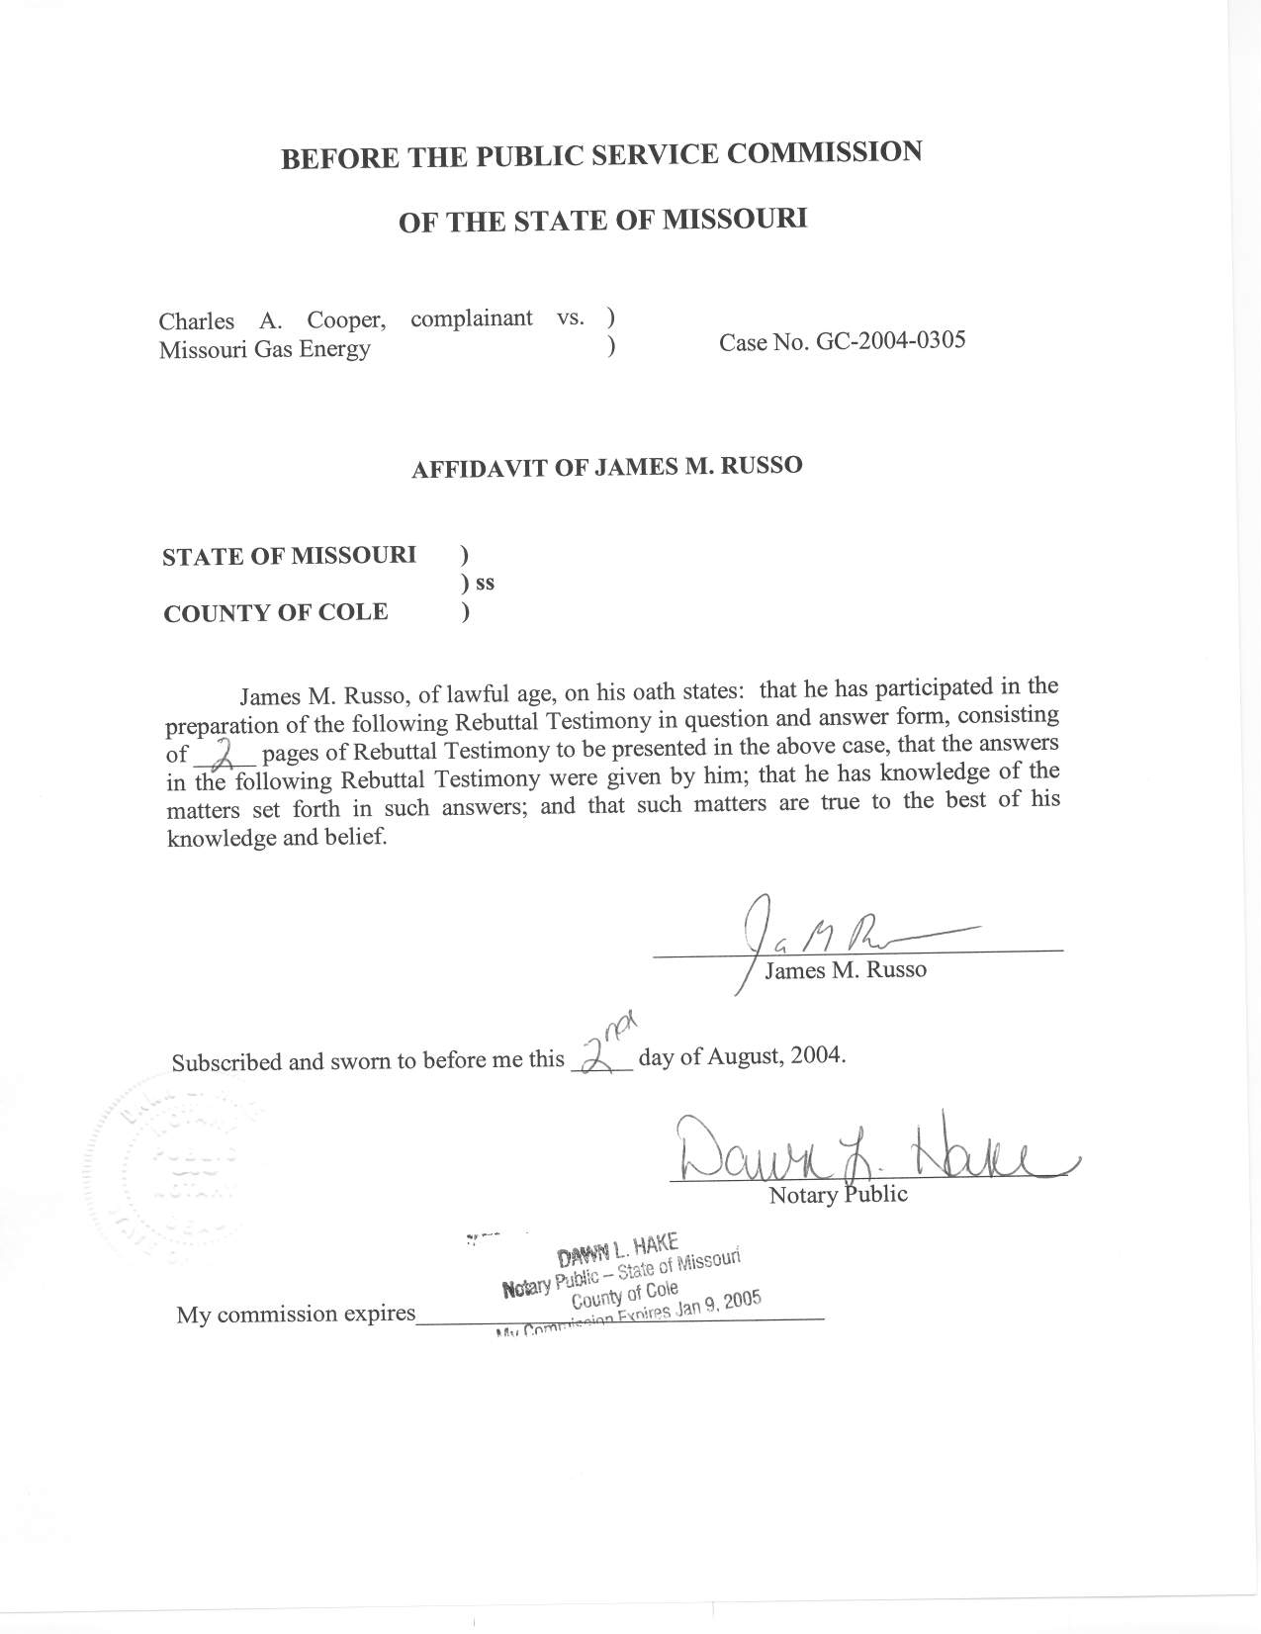

REBUTTAL TESTIMONY

OF

JAMES M. RUSSO

MISSOURI GAS ENERGY

CASE NO. GC-2004-0305

Q. Please state your name and business address.
A. James M. Russo, P. O. Box 360, Jefferson City, Missouri 65102.
Q. Are you the same James M. Russo who filed Direct Testimony in Case No. GC-2004-0305?
A. Yes I am.
Q. What is the purpose of your Rebuttal Testimony?
A. The purpose of my Rebuttal Testimony is to clarify the circumstances related to several statements in the Direct Testimony of Charles A. Cooper (Complainant) in this proceeding.
Q. Mr. Cooper states in his direct testimony that the unauthorized gas usage started occurring on January 8, 2003. Did your investigation and review of MGE’s records support this date?
A. No. My investigation and review of MGE’s records indicate that the CSS department of MGE identified unbilled gas usage on January 8, 2003. This indicates that the unauthorized use of gas began some time between when the previous customer had their gas service discontinued and the meter turned off on December 18, 2002 and January 8, 2003.
Q. Mr. Cooper states that he had electric service placed in his name on March 26, 2003. Did your investigation support that date?
A. No. I contacted Aquila and obtained a copy of their records for the property at 6303/6305 Evanston in Raytown Missouri. Aquila’s records indicate that
Mr. Cooper started electric service on August 1, 2002. Aquila’s records also indicate that the type of service being provided to Mr. Cooper changed to a demand meter and a new rate on March 25, 2003, taking effect on March 26, 2003. These documents are highly confidential because they contain customer specific information. These documents are attached as Schedule 1 to my Rebuttal Testimony.
Q. Does this conclude your Rebuttal Testimony?
A. Yes, it does.

