BEFORE THE PUBLIC SERVICE COMMISSION
OF THE STATE OF MISSOURI

The Staff of the Missouri Public Service )
Commission, )
)
Complainant, )
) Case No. TC-2004-0409
- )
)
Officeplus Corporation of Missouri, )
)
Respondent. )'

REQUEST OF OFFICEPLUS
FOR ONE-WEEK EXTENSION OF DEADLINE TO FILE BRIEF

Comes now Officeplus Corporation of Missouri (“Officeplus”), and for its Request for Extension of Deadline to File Brief states as follows:
1. The Commission’s July 9 Order scheduled a deadline of July 29 for the filing of Officeplus’ Brief.
2. Officeplus requests a continuance of seven (7) days, until August 5, to file its brief.
3. Counsel for Officeplus has contacted counsel for the Commission Staff and she does not object to this request.
WHEREFORE, Officeplus respectfully requests a one week extension of the deadline to file its brief.
Respectfully submitted,

BRYAN CAVE LLP
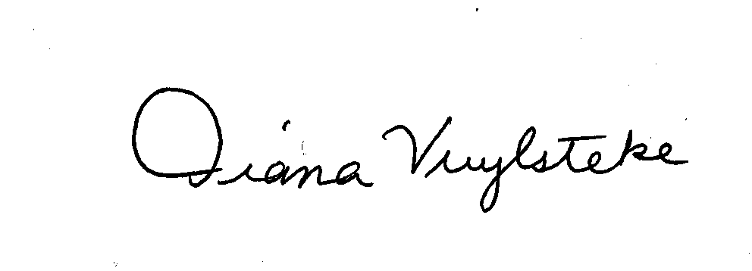

By:______________________
Diana M. Vuylsteke
211 N. Broadway, Suite 3600
St. Louis, Missouri 63102
Telephone: (314) 259-2543
Facsimile: (314) 259-2020
E-mail: dmvuylsteke@bryancave.com

CERTIFICATE OF SERVICE

I hereby certify that the foregoing has been sent by electronic mail to Mary E. Weston, Assistant General Counsel for the Staff of the Missouri Public Service Commission, this 26th day of July, 2004.
________________________

