

July 13, 2005

RE: Cold Weather Rule Amendments; Case No. GX-2006-0434

Missouri Public Service Commissioners:

AARP, on behalf of its 755,000 members in Missouri, welcomes this opportunity to express support for the proposed amendment to the state’s Cold Weather Rule (“CWR”), 4 CSR 240-13.055, as filed with the Secretary of State on May 15, 2006. AARP urges the Commission to act promptly on these amendments so as to prevent an unnecessary and risky level of disconnections in advance of the upcoming 2006-2007 winter heating season.

The proposed changes, similar to the changes adopted by the Commission on
an emergency basis in December 2005, reflect a reasonable policy for protecting the health and safety of Missouri’s most vulnerable consumers. The proposal is appropriate in response to recent natural gas prices and the critical need for this essential monopoly service during the cold winter months. We applaud the Commission for taking up this matter well in advance of next winter by proposing these changes, and ask that they be approved on a permanent basis at this time.

The CWR is an extremely important rule, without which, many vulnerable customers, including lower income households and seniors, would be unable to maintain heat during the cold winter months. For older Missourians in particular, access to heat during the winter at an affordable rate is an absolute necessity. Although they consume approximately the same amount of energy as do younger people, older Americans devote a higher percentage of their total household spending to residential energy costs, even after adjusting for weather and home size.

With energy prices on the rise, all household budgets are being stretched. AARP recently surveyed a representative sample of Americans and found that almost two-thirds of those surveyed (63%) have limited the use of energy in their homes as a result of higher energy costs. Some are also limiting or doing without food (15%), telecommunications (15%), medical services (11%), or prescription drugs (11%) as a result of higher energy costs.

Older Missourians and lower income families should not have to risk their lives by cutting back on heating, food and need medications. The people most susceptible to death from hypothermia include those 60 and older, infants and small children, the sick, and those taking certain prescription. The Missouri Department of Health and Senior Services reports that people who are 65 and older account for just over half of the hypothermia deaths in this state. Household incomes and energy assistance programs such as the Low Income Home Energy Assistance Program, have not kept up with soaring home heating costs. The result is that too many households are put in a literal life or death situation.

Home heating costs have also been extremely volatile over the past few years. Unlike the utilities themselves, most residential customers have no tools to manage or mitigate against sharp changes in home heating costs that can be precipitated by unpredictable energy markets and by unpredictable weather changes. Volatile energy prices, combined with unpredictable cold weather, create the need for the permanent changes to the CWR proposed by the Commission. The need is already great as a result of high natural gas prices, and if severe weather strikes, as it did during the winter of 2000-2001, a dire emergency is entirely possible. The proposed changes will allow more homes to be reconnected, or to avoid disconnection, and thus significantly reducing the risk to public health and safety.

The proposed amendment to the CWR would allow more reasonable connection policies, as well as require the waiver or deferral of deposits and late payment fees, and reconnection fees, while mandating payment plans to enable customers to pay off outstanding balances. Further, the provisions of the current rule limiting disconnection during the winter months would be applied to all customers. The current rule’s disconnection prohibition (day-to-day temperature moratorium) is limited to registered low income “elderly” and low income “disabled” customers. Households that do not qualify under the current rule are nonetheless at risk whenever energy prices climb dramatically. These new provisions were effective in protecting health and safety last winter when they were adopted on an emergency basis, and when implemented at that time did not cause any reported financial disruption for the affected natural gas companies.

It is important to note that these CWR provisions are actually far less protective of the public than the protections now in place in other states in our region. Several states have implemented a blanket moratorium on utility shutoffs for low income customers throughout the winter months, and many states require service to be restored with much less than 50% of existing arrears. Moreover, studies have shown that states that have adopted higher levels of cold weather protection than Missouri’s CWR have not necessarily experienced significant changes in payment practices by those consumers participating.

It is speculative to assume that the modest changes proposed by the Commission to the existing CWR would result in any dramatic changes to the current assumptions regarding the levels of uncollectible expense. In fact, it is reasonable to assume that some consumers will make more payments after reconnection under the new changes to the CWR than they would have made otherwise.

The Commission’s proposed amendment to the CWR includes an Accounting Authority Order (AAO) provision that would permit any additional costs resulting from this amendment to be recovered by the utilities in their subsequent rate cases. This allows such costs to be recorded, reviewed by the Commission for reasonableness after the impact is known, and then recognized in a rate case based on actual data. This AAO is a remedy that is not granted for most costs in a rate case, and the Commission is not required by law to grant this extraordinary benefit to the affected natural gas companies. Nonetheless, in this particular situation, AARP will not oppose the use of a limited AAO mechanism for treating additional reasonable costs to the utilities, if any.

The Commission’s CWR proposal serves the dual purpose of enabling families to keep the heat on while making on-going payments to address past-due balances. Reducing the cycle of disconnections and reconnections each year can save utilities money in the long run while protecting public health and safety.

Respectfully submitted,

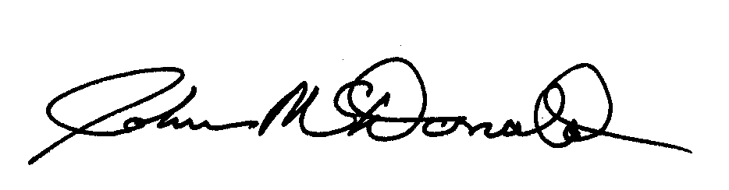
John McDonald
State Director

http://www.dhss.mo.gov/Hypothermia/

