Exhibit No.:
Issues: Corporate Allocations; UEC Missouri
Gas Allocation; CILCORP Allocations; Rent Expense; Maintenance of General Plant Expense; Lease Agreements; Employee Relocation Expense
Witness: Paul R. Harrison
Sponsoring Party: MoPSC Staff
Type of Exhibit: Direct Testimony
Case No.: GR-2003-0517
Date Testimony Prepared: October 24, 2003

MISSOURI PUBLIC SERVICE COMMISSION

UTILITY SERVICES DIVISION

DIRECT TESTIMONY

OF

PAUL R. HARRISON

UNION ELECTRIC COMPANY
d/b/a AMERENUE

CASE NO. GR-2003-0517

Jefferson City, Missouri
October 2003
TABLE OF CONTENTS
DIRECT TESTIMONY OF
PAUL R. HARRISON
UNION ELECTRIC COMPANY
d/b/a AmerenUE
CASE NO. GR-2003-0517
BACKGROUND OF WITNESS 1
PURPOSE OF TESTIMONY 2
CORPORATE ALLOCATIONS 4
UEC MISSOURI GAS ALLOCATION 9
CILCORP ALLOCATIONS 10
RENT EXPENSE 12
MAINTENANCE OF GENERAL PLANT EXPENSE 13
LEASE AGREEMENTS 13
EMPLOYEE RELOCATION EXPENSE 14

DIRECT TESTIMONY
OF
PAUL R. HARRISON
UNION ELECTRIC COMPANY
d/b/a AmerenUE
CASE NO. GR-2003-0517
Q. Please state your name and business address.
A. Paul R. Harrison, P. O. Box 360, Jefferson City, Missouri 65102.
Q. By whom are you employed and in what capacity?
A. I am a Regulatory Auditor for the Missouri Public Service Commission (PSC or Commission).

BACKGROUND OF WITNESS
Q. Please describe your educational background.
A. I graduated from Park College, Kansas City, Missouri, where I earned a Bachelor of Science degree in Accounting and Management in July of 1995. I also earned an Associate degree in Missile Maintenance Technology from the Community College of the Air Force in June 1990. In addition, I graduated from the Non-Commission Officer (NCO) Leadership School in July 1977, the NCO Academy in March 1983 and the Senior NCO Academy in February 1992. These professional military education schools trained and prepared Non-Commissioned Officers for increased levels of responsibility as Supervisors and Managers in the United State Air Force (USAF).
Q. Please describe your work background prior to working at the Commission.
A. Prior to coming to work at the Commission, I was the manager for Tool Warehouse Inc. for four and one-half years. As the manager, I supervised eight sales representatives and managed merchandise and inventory in excess of $1.5 million.
Prior to that, I was in the USAF for 23 years. During my career in the USAF, I was assigned to many different duty positions with varying levels of responsibility. I retired from active duty on May 1, 1994 as Superintendent of the 321st Strategic Missile Wing (SMW) Missile Mechanical Flight. In that capacity, I supervised 95 missile maintenance technicians and managed assets valued in excess of $50 million.
Q. Please describe your duties while employed by the PSC.
A. My duties at the Commission include performing audits of the books and records of regulated public utilities under the jurisdiction of the PSC, in conjunction with other Staff members. Acting in that capacity, I am also required to prepare testimony and serve as a Staff expert witness on cases involving the accounting issues that I am assigned.
Q. Have you previously filed testimony before this Commission?
A. Yes, Schedule 1 lists the cases in which I filed testimony, the issues that I have worked and the small informal cases that I have completed.

PURPOSE OF TESTIMONY
Q. Did you make an examination and analysis of the books and records of AmerenUE (UEC or Company) in regard to matters raised in this case?
A. Yes, in conjunction with other members of the Commission Staff (Staff). I specifically examined information provided by the Company in response to Staff’s Data Requests, portions of the Company’s general ledger, 19607 Reports, Financial and Statistical Report, as well as workpapers supplied by AmerenUE to support its case filing. I also examined Board of Director Meeting Minutes, Annual Reports to Shareholders and other information contained on the Company’s Website.
Q. What is your primary responsibility in Case No. GR-2003-0517?
A. My primary areas of responsibility are corporate allocations, rents, maintenance of general plant, lease agreements, and employee relocation expenses.
Q. What knowledge, skill, experience, training or education do you have in these matters?
A. I have performed duties as a Regulatory Auditor within the Auditing Department at the Commission since January 18, 2000. During that time, I have acquired general knowledge of these topics through my experience and analysis in prior rate cases before the Commission and through several other means:
Formal Training
Q. Please describe the formal training for your position that you have received.
A. I attended the National Association Regulatory Utilities Commissioner's (NARUC) Water Rate School in San Diego, California in May of 2000. I also attended NARUC’s “On The Missouri” 2003 seminar conducted in Jefferson City, Missouri in January 2003.
Informal Training
Q. Please describe the informal training for your position that you have received.
A. I have successfully completed each of my assigned issues, as listed in Schedule 1, and have had the opportunity to interact with other auditors concerning these and other issues that involved the Auditing Department of the Commission.
I've reviewed Auditing Department position papers, training manuals and technical manuals dealing with accounting issues in this and other cases.
I've reviewed the Commission's Report And Orders, testimony and transcripts of cases filed by this and other utilities within the jurisdiction of this Commission.
Q. What is the purpose of your testimony?
A. The purpose of my testimony is to sponsor and discuss the following Income Statement adjustments, which appear, on Accounting Schedule 9:
UEC Missouri Gas Allocations S-12.2
CILCORP Allocations S-12.3
Rent Expense S-12.4, S-12.5 and S-12.6
Maintenance of General Plant Expense S-12.7
Lease Agreements S-12.8
Employee Relocation Expense S-12.9

CORPORATE ALLOCATIONS
Q. Please generally describe the business structure of Ameren Corporation (AMC).
A. AMC is a public utility holding company registered under the Public Utility Holding Company Act of 1935 (PUHCA) and is headquartered in St. Louis, Missouri. As of June 30, 2003, Ameren has three regulated affiliated companies under its umbrella: AmerenCILCO, AmerenCIPS and AmerenUE. In addition, AMC has 20 affiliates that are non-regulated. Ameren employs a total of approximately 8,300 people and it provides energy services to approximately 1.7 million electric and 500,000 natural gas customers over 49,000 square miles in Missouri and Illinois.
Q. What was the source for this information?
A. The source for this information is Ameren’s Security Exchange Commission (SEC) filing, April 01, 2003; Ameren’s quarterly 10Q and annual 10K reports; and the responses to Staff Data Request Nos. 153, 242 and 243.
Q. Please provide a description of the regulated affiliates of AMC.
A. The descriptions of AMC’s regulated affiliates are:
- CILCORP Inc., parent of Central Illinois Power Company, (CILCO), was acquired by Ameren on January 31, 2003. AmerenCILCO has approximately 203,000 electric customers and 208,000 natural gas customers in east and central Illinois. AmerenCILCO employs approximately 883 full time employees and 22 part time employees.
- Ameren Central Illinois Public Service Company (AmerenCIPS) operates a rate-regulated electric generation, transmission and distribution business, and a rate-regulated natural gas distribution business in Illinois. AmerenCIPS, which was acquired by AMC in 1997, provides electric and natural gas services in 66 counties throughout a 20,000-square-mile area in Illinois. AmerenCIPS serves 323,000 retail electric and 170,000 natural gas customers in 557 communities with a service territory that includes about seven percent of the Illinois state population and 35% of its service area. AmerenCIPS employs approximately 878 employees.
- Union Electric Company (UEC) operates a rate-regulated electric generation, transmission and distribution business, and a rate-regulated natural gas distribution business in Missouri and Illinois as AmerenUE. AmerenUE provides electric and natural gas services across the eastern half of Missouri, including the greater St. Louis area, and in southwestern Illinois. AmerenUE today serves more than 1,200,000 retail electric and 130,000 natural gas customers in 65 Missouri counties and 500 towns, and four Illinois counties. More than half (55%) of AmerenUE’s electric customers are located in the St. Louis metropolitan area. AmerenUE employs approximately 4,304 employees.
Q. Please provide a description of the largest non-regulated affiliates of AMC.
A. The descriptions of AMC’s largest non-regulated affiliates are:
- Ameren Services Company (AMS) provides shared support services to AMC and its subsidiaries, including the regulated affiliates. There are approximately 1,398 employees assigned to AMS.
- Ameren Energy (AME) serves as a power marketing and risk management agent for the affiliated companies for all transactions of primarily less than one year. Ameren Energy employs approximately 72 employees.
- Ameren Energy Resources Company (IHC) consists of subsidiaries including Ameren Energy Generating Company (GEN), which operates non-regulated electric generation in Missouri and Illinois; Ameren Energy Marketing Company (GMC), which markets power for periods over one year; and Ameren Energy Fuels and Services Company (AFS), which procures fuel and manages the related risks for all affiliated companies, including Ameren Energy Medina Valley Cogen (No. 4), LLC, which indirectly owns a 40 megawatt, gas fired electric generation plant. On February 4, 2003, AMC completed the acquisition of AES Medina Valley Cogen (No. 4), LLC.
There are approximately 703 GEN employees, 14 GMC employees, and 53 AFS employees.
Q. How does AMS charge affiliated companies for the support services it provides?
A. AMS provides services that would normally be considered as corporate overhead for AMC affiliates. These corporate overhead costs are distributed to AMC affiliates and are classified either as direct or indirect costs.
Direct costs are costs identified as applicable to service performed for a single affiliate or group of affiliates. Costs applicable to a single affiliate will be directly charged to that entity. Costs applicable to two or more affiliates will be distributed based on direct allocation factors. These factors are assigned to service requests based on the nature of the activity being performed by AMS.
Indirect costs include costs of a general overhead basis that cannot be identified to a single affiliate or group of affiliates. These indirect costs are defined as either functional or corporate in nature.
Functional indirect costs such as office supplies and secretarial labor, and corporate indirect costs such as AMS property taxes and insurance costs will be accumulated and distributed to affiliates based on the ratio of total direct and direct allocated costs charged to the affiliates by AMS.
Overhead costs associated with labor, such as pensions and benefits, payroll taxes, and injuries and damages expense are charged to the affiliate based on AMS labor costs charged to a particular service request.
Q. Please provide a description of the AMS service requests.
A Service requests are AMC’s mechanized system for collecting and allocating costs. AMC allocates costs to its affiliates through the use of either a direct or indirect service request.
Q. How often are allocation factors developed by the Company?
A. Direct allocation factors are only changed when there is a request to change the allocation factor or a need for the change. Indirect cost allocation factors are developed monthly and Missouri jurisdictional allocations are developed annually, based on the previous years’ data.
Q. Please provide the amount of AMC corporate overhead costs, in total and as allocated to AmerenUE.
A. During the test year (the 12 months ending December 31, 2002), AMS total billings allocated to AMC’s business divisions and subsidiaries were $312,620,910. This amount includes approximately $269,735,713 in direct charges and $42,885,197 in indirect charges. Of the $312,620,910 total billing costs allocated, the UEC portion is approximately $199,930,580, or 63.95% of the total AMS billings. The UEC gas allocation portion is approximately $6,779,646, or 3.391% of the total allocated costs of $199,930,580.
Q What are some examples of the different support service functions performed by AMS employees and then allocated to affiliates?
A. Examples of some of the different functions that were provided to Staff in response to Data Request No. 289 are:
- The Controllers (CT) function performs all accounting services necessary to properly maintain and report on the books and records of AMC and its subsidiaries. In addition, they provide investor relations services and regulatory services.
- The Executive (EX) function provides executive management duties for all applicable activities at the department, function and officer levels.
- The Human Resources (HR) function administers and negotiates employee benefits including pensions, major medical, long term disability, life insurance, defined contribution plans, executive benefit and flexible spending plans. It also provides employment services; including required regulatory reporting and maintenance of personnel records, and employee training and communications services.
- The Information Technology (IS) function provides for the development and operation of computer software, telecommunications and other equipment used to conduct business and engineering activities. IS also maintains all billing records and processes customer meter readings.
- The Other Departments (OD) function is made up of Resource Management Centers (RMC) used to make entries that are not specifically assigned to a particular business center. These entries are for interest charges, depreciation, taxes, inter-company rentals, and other accounting adjustments.

UEC MISSOURI GAS ALLOCATION
Q. Please explain Income Statement adjustment S-12.2.
A. Adjustment S-12.2 annualizes the AMS allocation dollar amount booked to UEC Missouri gas for the test year ended December 31, 2002 based on current allocation factors for Missouri jurisdictional gas at June 30, 2003. I multiplied the UEC portion of AMS billing charges as of December 31, 2002, $199,930,580, by the 2002 Missouri jurisdictional gas allocation factor of 3.391%. I compared this amount to the UEC portion of AMS billing charges as of December 31, 2002 multiplied by the current Missouri jurisdictional gas allocation factor as of June 30, 2003 of 3.313%. The difference between the dollar amounts of these calculations creates the adjustment for the Missouri gas portion of AMS billings during the test year.

CILCORP ALLOCATIONS
Q. When did AMS start booking corporate costs as attributable to CILCORP and its subsidiaries separately?
A. During the month of August 2003.
Q. What impact does the inclusion of CILCORP in the allocation of AMS billings have on this case?
A. AMS provides the same shared support services for CILCORP that it provides for all of the other AMC subsidiaries. As CILCORP absorbs its portion of the AMS billing charges, the distributed AMS billing charges for the other subsidiaries, including UEC, declines. During the first two months that AMS started booking costs for CILCORP, August and September 2003, the UEC allocation factor significantly decreased from June 30, 2003 levels as a result of spreading the shared costs of AMS total billing dollars over a broader range of subsidiaries.
Q. Please describe the significance of CILCORP's corporate and overhead costs on AMS billing allocations.
A. During the month of August 2003, CILCORP's portion of the total AMS billing of allocated corporate costs ($24,403,145) was $2,644,188, or 10.84%. This amount includes approximately $2,300,952 in direct charges and $343,236 in indirect charges. Of the $24,403,145 total-billing costs allocated by AMS during the month of August 2003, the UEC percentage decreased from 60.69% as of June 30, 2003 to 57.55%.
Q. What was the CILCORP allocation amounts and percentage in September 2003?
A. During the month of September 2003, CILCORP's portion of the total AMS billing of allocated corporate costs ($28,295,795) was $3,391,143 or 11.98%. This amount includes approximately $2,946,833 in direct charges and $444,310 in indirect charges. Of the $28,295,795 total billing costs allocated by AMS during the month of September 2003, the UEC percentage further decreased from the August 2003 percentage of 57.55% to approximately 54.38%.
Q. Pease explain Income Statement adjustment S-12.3.
A. Adjustment S-12.3 adjusts the allocation of AMS dollars charged to UEC Missouri gas operations for the test year to reflect the inclusion of CILCORP as an operating subsidiary of Ameren.
Q. Please describe how the adjustment was developed.
A. The charges from AMS assigned to CILCORP for August and September 2003 were summed ($6,035,331) and multiplied by six to reflect a full year of costs ($36,213,740) attributable to the allocation of AMS charges to CILCORP. The $36 million of CILCORP expenses was subtracted from the total AMS billing for the 12 months ended June 30, 2003 of $325,709,575. This amount equates to $289,495,835. The $289 million is then multiplied by the weighted UEC June 30, 2003 allocation factor of 63.010%. This amount equates to $182,411,326 million. The $182 million is then multiplied by the June 30, 2003 Missouri jurisdictional gas allocation factor of 3.313%. The difference between the dollar amounts created by this calculation and the amount created by the Missouri jurisdictional gas annualized calculation, described earlier in my testimony, is the adjustment for the Missouri gas portion of total AMS billing reflecting the acquisition of CILCORP.

RENT EXPENSE
Q. Please explain how rent is determined for buildings owned by UEC in which AMS employees and other AMC affiliate employees work.
A. UEC charges rent to AMS and the other AMC affiliates by dividing the total occupancy costs of each building based on the number of employees working in the buildings. The occupancy costs include return on equity, operation and maintenance expense, snow removal, security costs, copier costs, depreciation and amortization, insurance, taxes other than income taxes, and income taxes. The ratio of the number of AMS employees in each of the UEC owned buildings establishes a percentage that is then multiplied by the building occupancy costs to determine the AMS portion of rent. AMS, in turn, allocates those charges back to UEC through rent expense and a percentage of these charges are allocated to Missouri gas operations.
Q. Please explain Income Statement adjustment S-12.4.
A. Adjustment S-12.4 eliminates the portion of rent booked to Missouri gas operations through the general ledger allocation that occurs from the electric rental expense. The buildings are owned by UEC and are included in rate base for the gas cost of service. UEC gas operations also receive an allocated portion of the maintenance of general plant expenses of the buildings through AMS service requests to UEC electric. Therefore, Missouri gas operations should not be allocated a charge for AMS rent.
Q. Please explain Income Statement adjustment S-12.5.
A. Adjustment S-12.5 eliminates from the portion of rent expense that was booked to Missouri gas as a direct allocation of rental expense from AMS. The Company refined its internal rent calculation beginning in 2000 when it modified the rent revenue process for AMS occupancy of UEC buildings assigned to common plant. The general ledger allocation that occurs from the electric rental expense caused a double allocation effect for rent expense to Missouri gas operations that must be eliminated.
Q. Please explain Income Statement adjustment S-12.6.
A. Adjustment S-12.6 eliminates from Missouri gas operations rent charged in error to Missouri gas instead of AmerenCIPS.

MAINTENANCE OF GENERAL PLANT EXPENSE
Q. Please explain Income Statement adjustment S-12.7.
A. Adjustment S-12.7 eliminates a portion of the maintenance of general plant account. This adjustment eliminates the maintenance of general plant expense of buildings that are not included in the Company’s Missouri jurisdictional gas plant accounts.

LEASE AGREEMENTS
Q. Please explain Income Statement adjustment S-12.8.
A. Adjustment S-12.8 eliminates lease agreement expenses for the Unix servers and disk storage array that were eliminated during the test year. The Unix servers and disk storage array leases were retired over time and eliminated during the test year. There were no new lease agreements added during the test year or update period.

EMPLOYEE RELOCATION EXPENSE
Q. Please explain Income Statement adjustment S-12.9.
A. Adjustment S-12.9 eliminates relocation expenses charged to Missouri gas operations. The majority of all charges being booked to Missouri gas for relocation is an apportionment through an allocation process and is not a direct result of actual Missouri gas employees relocating. In response to Staff Data Request No. 325, the Company stated that there have been no relocations for Missouri gas employees for the year ending December 31, 2002 through October 26, 2003. Therefore the Staff’s adjustment eliminates expenses for relocations, which occurred outside the Staff’s test year.
Q. Did the Staff review whether the Company complied with the Commission’s affiliated transaction rules as part of this case?
A. No. Staff did not review, as part of this case, Company’s compliance with the Commission’s affiliated transaction rules. AMC had obtained a stay of the implementation of these rules that was ordered by the Missouri Circuit Court. The Missouri Supreme Court lifted this stay on April 22, 2003. There was insufficient time between the lifting of the stay and the timing of this case for AMC to be in compliance with the Commission’s affiliated transaction rules.
Q. Does this conclude your direct testimony?
A. Yes, it does.
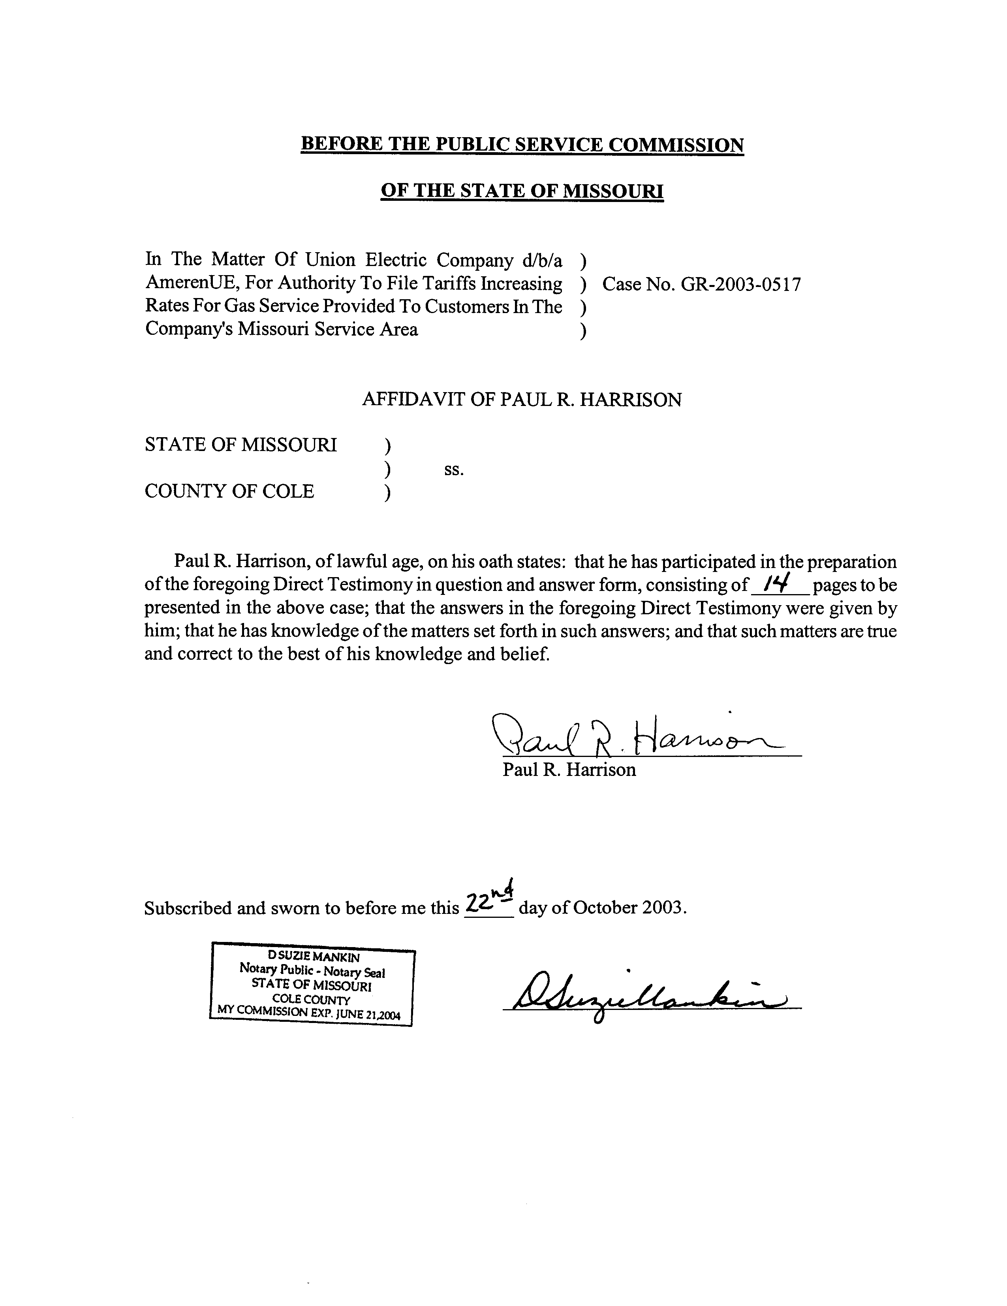

SUMMARY OF RATE CASE TESTIMONY FILED

PAUL R. HARRISON

COMPANY |  | CASE NO. | DATE FILED/ISSUES
Union Electric Company d/b/a AmerenUE |  | EC-2002-1 | June 24, 2002  Coal Inventory; Venice Power Plant Fire; Tree Trimming Expense; Automated Meter Reading Service  March 1, 2002  Materials and Supplies; Prepayments; Fuel Inventory; Customer Advances for Construction; Customer Deposits; Plant in Service; Depreciation Reserve; Venice Power Plant Fire Expenditures; Tree-Trimming Expense; Automated Meter Reading Expense; Customer Deposit Interest Expense; Amortization of Year 2000 Computer Modification Expense; Regulatory Advisor’s Consulting Fees; Property Taxes  July 2, 2001  Materials and Supplies; Prepayments; Fuel Inventory; Customer Advances for Construction; Customer Deposits; Plant in Service; Depreciation Reserve; Power Plant Maintenance Expense; Tree-Trimming Expense; Automated Meter Reading Expense; Customer Deposit Interest Expense; Year 2000 Computer Modification Expense; Computer Software Expense; Amortization of Year 2000 Computer Modification Expense; Regulatory Advisor’s Consulting Fees; Board of Directors Advisor’s Fees
Laclede Gas Company (Gas) |  | GR-2002-356 | June, 20, 2002  Payroll; Payroll Taxes; 401k Pension Plan; Health Care Expenses; Pension Plan Trustee Fees; Clearing Account
Union Electric Company d/b/a AmerenUE (Last EARP) |  | EC-2002-1025 | April 12, 2002  Revenue Requirement Run; Plant in Service; Depreciation Reserve; Other Rate Base Items; Venice Power Plant Fire; Coal Inventory
Union Electric Company d/b/a AmerenUE (Gas) |  | GR-2000-512 | August 4, 2000  Cash Working Capital; Advertising Expense; Missouri PSC Assessment; Dues and Donations; Automated Meter Reading Expenses; Computer System Software Expenses (CSS); Computer System Software Expenses (Y2K); Computer System Software Expenses (EMPRV); Generation Strategy Project Expenses; Regulatory Advisor’s Consulting fees; Board of Directors Advisor’s fees
AmerenUE Electric (5th EARP) |  | EM-96-149 | March 2001  Coal Inventory

SUMMARY OF SMALL RATE CASES WORKED
Roark Water and Sewer | QW-2002-0005  QS-2003-0006 |  | February 2, 2003  Lead Auditor
Mill Creek Sewer | 2002-00682 |  | January 21, 2003  Lead Auditor

