Exhibit No.:
Issues: Tariff Issues

Witness: James M. Russo
Sponsoring Party: MO PSC Staff
Type of Exhibit: Direct Testimony
Case No.: GR-2001-388
Date Testimony Prepared: January 9, 2003

MISSOURI PUBLIC SERVICE COMMISSION

Utility Operations Division

direct TESTIMONY

OF

James M. Russo

Southern Missouri Gas Company, L.P.

CASE NO. GR-2001-388

Jefferson City, Missouri
January 2003

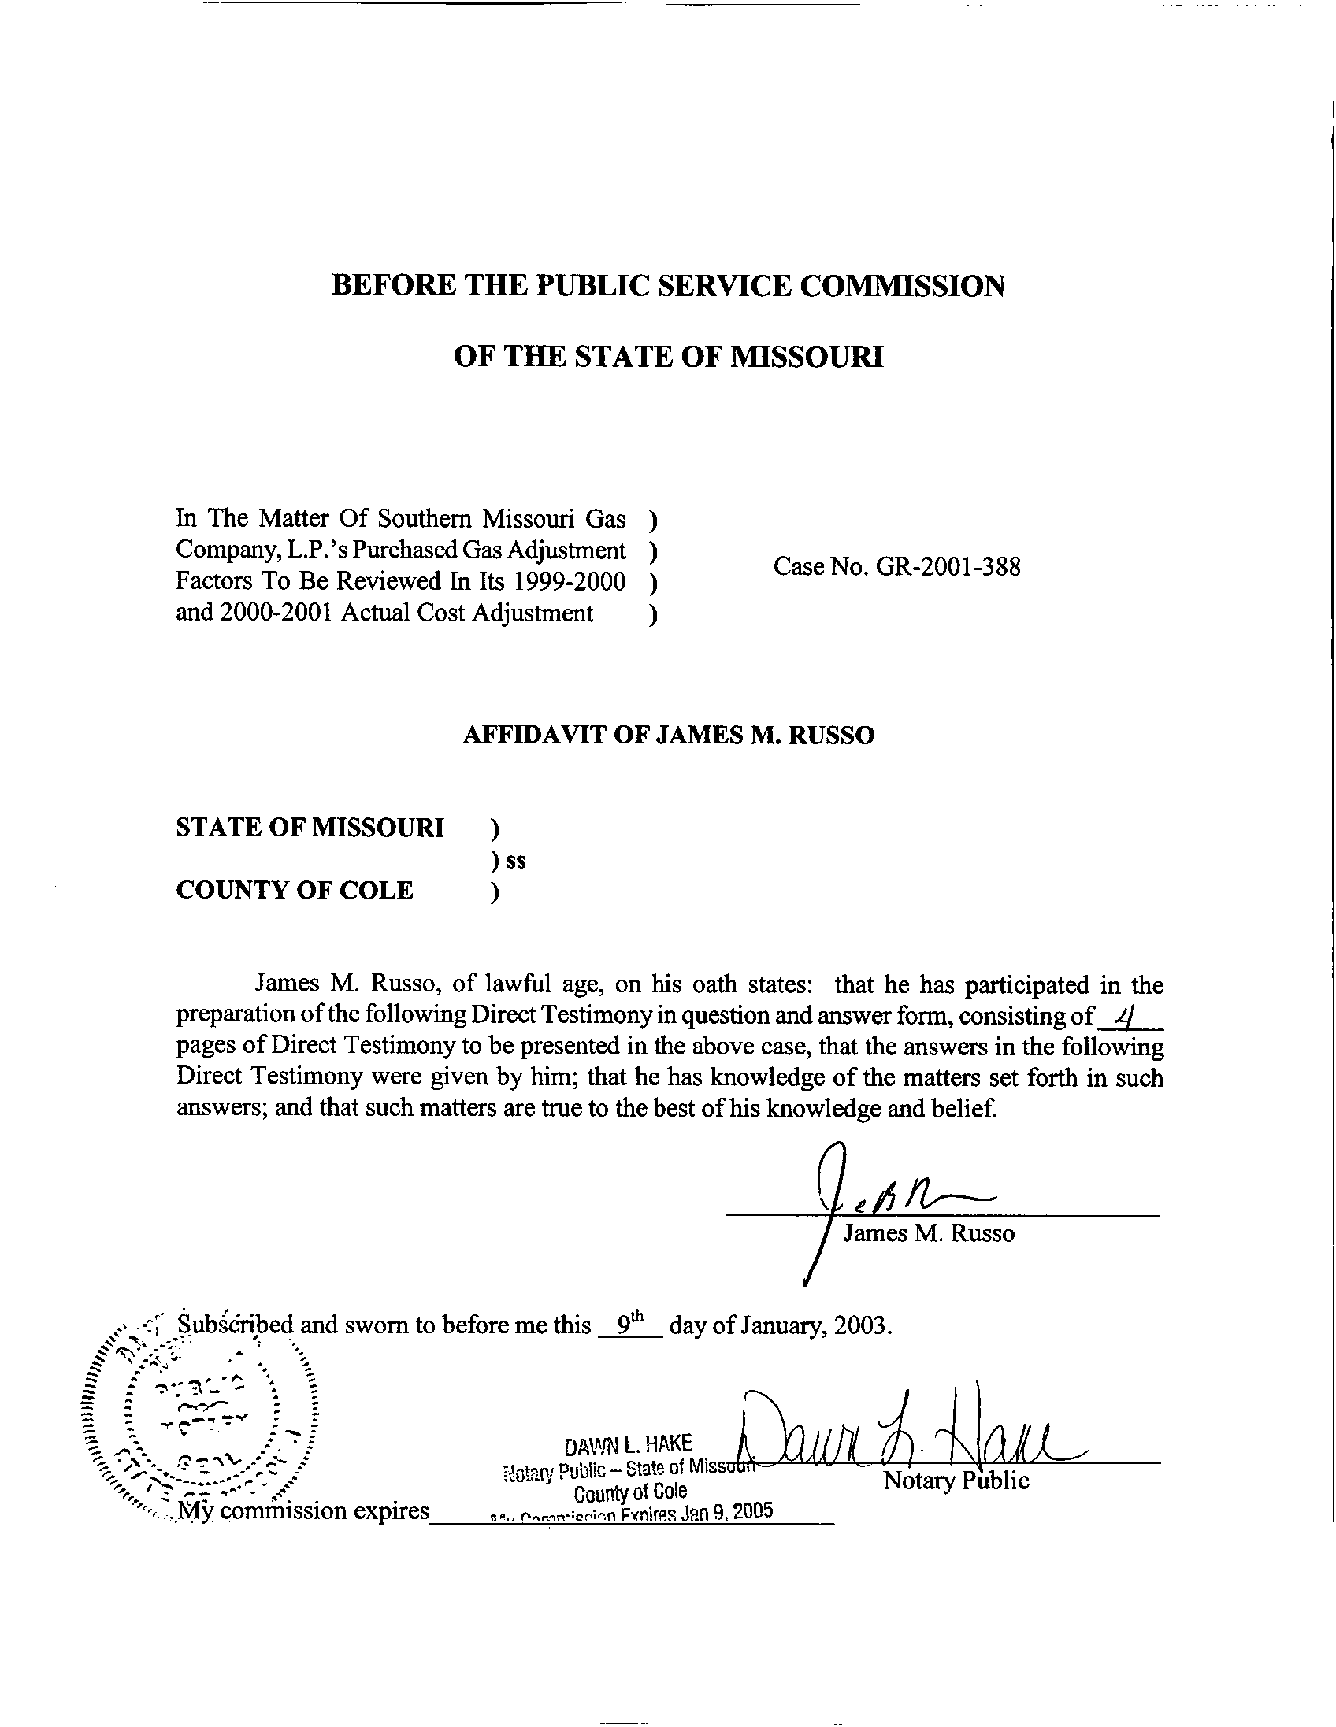
DIRECT TESTIMONY
OF
JAMES M. RUSSO
SOUTHERN MISSOURI GAS COMPANY, L.P.
CASE NO. GR-2001-388
Please state your name and business address.
James M. Russo, P. O. Box 360, Jefferson City, Missouri 65102.
By whom are you employed and in what capacity?
I am a Regulatory Auditor IV with the Missouri Public Service Commission (Commission).
Please describe your educational background and other qualifications.
I graduated from California State University-Fresno, Fresno, California, and received a Bachelor of Science degree in Accounting. Prior to my employment with the Commission, I was employed in various capacities by local elected officials in county government. I was the assistant treasurer-tax collector for San Joaquin and El Dorado Counties in California. My responsibilities included all financial dealings of the counties and all accounting activities of the agency. In addition, I was the supervising accountant auditor in El Dorado County for two years. My division was responsible for internal audits of all county agencies, special districts, and franchise/lease agreements.
What has been the nature of your duties with the Commission?
From April 1997 to December 2001, I worked in the Accounting Department of the Commission, where my duties consisted of directing and assisting with various audits and examinations of the books and records of public utilities operating within the State of Missouri; under the jurisdiction of the Commission. On December 16, 2001, I assumed the position of Regulatory Auditor IV in the Energy Tariffs/Rate Design Department where my duties consist of analyzing applications, reviewing tariffs, and making recommendations based upon these evaluations.
Have you previously filed testimony before this Commission?
Yes, I have. Please refer to Schedule 1, which is attached to this testimony, for a list of cases in which I have filed testimony.
With reference to Case No. GR-2001-388, have you made an examination and study of the Southern Missouri Gas Company, L.P. (SMG or Company) tariff currently on file with the Commission?
Yes, in conjunction with other members of the Commission Staff (Staff).
Is SMG currently following the Transportation Service section of their tariff?
No. In violation of Commission rules and SMG’s existing tariff on file with the Commission, SMG has added a customer class entitled: “Internal Transport Customers Service.” SMG did not seek Commission approval for this customer class. The Company is currently providing “Internal Transport Service” to two industrial customers at rates that are less than the approved current tariff rates on file with the Commission. Staff cannot support any regulated utility creating additional customer classes without prior approval from the Commission.
What action does Staff recommend the Commission take at this time for this violation of Rules and Regulations by SMG?
Staff requests that the Commission order that a conference be held on January 16, 2003, with all parties involved to attempt to resolve this violation to the satisfaction of all parties. This conference will allow ample time for the Staff to provide the Commission with details of any settlement of the violation, or other alternatives available to the Commission during the scheduled hearings on this case.
Does Staff have other concerns regarding SMG delivering gas to a class of customers at an unauthorized reduced rate?
Yes. By not seeking prior Commission approval for this service, and allowing Staff the opportunity to review the new customer class and rate, Staff was unable to perform any review to analyze any positive or detrimental impact upon any other customer class. Staff Witness Annell Bailey, of the Commission’s Procurement Analysis Department (PAD) discusses the impact of this customer class on the Company’s other customers as it relates to the Actual Cost Adjustment (ACA) in her Direct Testimony.
What steps should SMG have followed as it relates to the Company’s Internal Customer Class?
SMG should have filed proposed tariff sheets or proposed special contracts for Staff’s review and Commission approval before any special contracts went into effect. Staff would want to perform a cost-benefit analysis as part of Staff’s overall review process of any special contract proposed by SMG.
What are the possible advantages of allowing SMG the ability to negotiate special contracts with customers qualifying as transportation customers?
SMG and its customers may benefit through a retention of existing customers that otherwise may be lost to alternative markets, by serving qualifying customers at a market competitive rate. SMG’s customers benefit by SMG keeping existing customers by spreading its costs over a larger volume, thereby lowering all customers overall cost of service. Also, there are no additional customer classes requiring additional record keeping and data review by the Company and Staff in the PGA and rate case processes.
What is Staff’s concern with Section IV. of the Purchased Gas Adjustment Clause of the Company’s tariff?
Staff notes that on Sheet 26, Section IV. (a), states: “No carrying costs shall be applied in connection with any PGA-related item, until such time as the net “Deferred Carrying Cost Balance” (DCCB) exceeds an amount equal to ten percent (10%) of SMG’s average annual level of gas costs for the then most three recent ACA periods…” Sheet 26.1 Section (b) states: “In the event the DCCB exceeds ten percent of the LDC’s Annual Gas Cost Level, a carrying cost equal to simple interest at the prime rate minus one percentage point shall be applied to such portion of the balance amounts as exceeds five percent for the period such excess balance amounts exist.”
Schedule 2 attached to my Direct Testimony is a copy of the Stipulation and Agreement filed in Case No. GO-97-407, which states in Section D Carrying Costs, subsection 2, on page 7: “… shall be applied to such portion of the balance amounts as exceeds ten percent for the period such excess balance amounts exist.” Staff recommends that the Company file new tariff sheets changing the five percent on Sheet 26.1 Section (b) to ten percent. This change will make the SMG’s tariffs sheets consistent with the last Stipulation and Agreement.
Does this conclude your testimony?
Yes, it does.
RATE CASE PROCEEDING PARTICIPATION

JAMES M. RUSSO

COMPANY CASE NO.
Union Electric Company GR-97-393
Gascony Water Company WA-97-510
St. Joseph Light and Power Company EC-98-573
St. Joseph Light and Power Company HR-99-245
St. Joseph Light and Power Company GR-99-246
St. Joseph Light and Power Company ER-99-247
UtiliCorp United Inc./St. Joseph Light and Power Company EM-2000-292
UtiliCorp United Inc./Empire District Electric Company EM-2000-369
Osage Water Company WR-2000-557
Osage Water Company SR-2000-556
Missouri Gas Energy GR-2001-292
Environmental Utilities WA-2002-65
Laclede Gas Company GR-2002-356
Laclede Gas Company GA-2002-429
Missouri Gas Energy GT-2003-0033
Aquila Networks L & P GT-2003-0038
Southern Missouri Gas Company, L.P. GT-2003-0031
Atmos Energy Corporation GT-2003-0037
Fidelity Natural Gas, Inc. GT-2003-0036
Laclede Gas Company GT-2003-0032
Union Electric Company GT-2003-0034

