October 14, 2011

Secretary / Chief Regulatory Law Judge
Missouri Public Service Commission
200 Madison Street
Jefferson City, MO 65102

Re: Missouri Gas Utility, Inc. (MGU) Winter PGA Filing

Attached are the electronic copies of P.S.C. MO No.1, Substitute Eleventh Revised Sheet 51 and Fifth Revised Sheet 52, reflecting a change in the Purchased Gas Cost, the Actual Cost Adjustment, and Total PGA for each of the various Schedules listed in the MGU Purchased Gas Adjustment (PGA) Clause.

The MGU Purchased Gas Adjustment Clause requires the filing, between October 15 and Nov 4 each year, of the Regular Purchased Gas Adjustment (RPGA), which is defined on P.S.C. MO No.1, First Revised Sheet 47 as the Company’s best estimate of the volumes and gas costs for the next period from the date of the first full billing after the filing is approved until the date of the first full billing after approval of a subsequent PGA filing. The Clause also requires a reconciliation of the PGA cost from the prior period with the actual costs incurred, and from that information and the projected volumes, the calculation of the annual Actual Cost Adjustment. The clause also includes provisions for Adjustments based on upstream pipeline Refunds and on Take-Or-Pay (T.O.P.) costs. MGU did not receive any Refunds or incur any T.O.P. costs during the past PGA period.

Attachment 1 is provided for both the Northern and Southern Divisions of MGU, and presents the spreadsheets used to calculate the RPGAs for the next PGA period and are titled accordingly.

Attachment 2 is the spreadsheet used to calculate the Actual Cost Adjustment balance by month for the prior PGA period, along with the amortization of that balance over the next PGA period volumes for both the Northern and Southern Divisions. Interest, calculated in accordance with Second Revised Sheet 46 instructions, are imbedded in the monthly Account 191 balances as shown on Attachment 2.

Attachment 3 is also provided for both the Northern and Southern Divisions and reflects the seasonal revenue impact of the change in Total PGA between existing and proposed gas cost factors. The seasonal revenue impact for the Northern Division is a decrease of $41,904, or 7.84%. The seasonal revenue impact for the Southern Division is a decrease of $51,726, or 11.47%

The proposed Northern Division decrease will cause an average winter month residential gas bill to decrease by approximately $ 4.50. This represents a 3.77% decrease for the average month in the heating season. The proposed Southern Division decrease will cause an average winter month residential gas bill to decrease by approximately $7.00. This represents a 5.33% decrease for the average month in the heating season.

Missouri Gas Utility, Inc. respectfully requests that these rates become effective for volumes sold on and after November 1, 2011.

Sincerely,
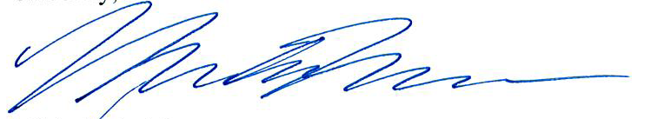

Michelle A. Moorman
Manager Regulatory Affairs

