Exhibit No.:
Issues: Income Taxes;
Deferred Income Taxes
Witness: Doyle L. Gibbs
Sponsoring Party: MoPSC Staff
Type of Exhibit: Direct Testimony
Case No.: GR-2003-0517
Date Testimony Prepared: October 24, 2003

MISSOURI PUBLIC SERVICE COMMISSION

UTILITY SERVICES DIVISION

DIRECT TESTIMONY

OF

DOYLE L. GIBBS

UNION ELECTRIC COMPANY
d/b/a AMERENUE

CASE NO. GR-2003-0517

Jefferson City, Missouri
October 2003

TABLE OF CONTENTS

DIRECT TESTIMONY OF

DOYLE L. GIBBS

UNION ELECTRIC COMPANY

d/b/a AMERENUE

CASE NO. GR-2003-0517
ACCOUNTING SCHEDULES 3
INCOME TAXES 4

DIRECT TESTIMONY OF

DOYLE L. GIBBS

UNION ELECTRIC COMPANY

d/b/a AMERENUE

CASE NO. GR-2003-0517
Please state your name and business address.
Doyle L. Gibbs, 1845 Borman Court, Suite 101, St. Louis, Missouri 63146.
By whom are you employed and in what capacity?
I am employed by the Missouri Public Service Commission (Commission) as a Regulatory Auditor.
Please describe your educational background.
I attended the University of Missouri – St. Louis, where I received a Bachelor of Science degree in Business Administration with a major in Accounting in 1976. I passed the Uniform Certified Public Accountant examination in 1988. I have been licensed as a Certified Public Accountant in the state of Missouri since February 1989.
What has been the nature of your duties while in the employ of this Commission?
I have conducted and assisted with the audits and examinations of the books and records of utility companies operating within the state of Missouri.
Have you previously filed testimony before the Commission?
Yes. Please see Schedule 1, attached to my testimony, for the list of cases in which I have previously filed testimony. Included on Schedule 1 are the issues covered in some of my recent testimony filings.
With reference to Case No. GR-2003-0517, have you made an investigation with respect to AmerenUE’s (Company) rate change request?
Yes, with the assistance of other members of the Commission Staff (Staff).
What did your investigation entail?
My investigation included the review and examination of the Company’s filing, its supporting work papers and underlying financial reports and records including tax returns. Information and data was further obtained through the issuance of Data Requests and conversations with Company personnel, review of workpapers and other information generated from past Company cases, Commission Orders and Staff testimony on related issues in filed cases for other utility companies.
What is your primary responsibility in this case?
My primary area of responsibility in this case is income taxes.
What knowledge, skill, experience, training or education do you have in this matter?
As previously stated, my college degree had an emphasis in Accounting and I successfully passed the Certified Public Accounts Exam, which included sections on accounting practice, theory and auditing. During my 27 years of employment with the Commission, I have acquired general knowledge of this topic through my experiences and analyses in prior rate cases before this Commission. I have also acquired knowledge through review of Staff testimony and Commission decisions with regards to this area and I have reviewed the Company’s testimony, work papers and responses to Staff’s Data Requests in this case addressing this topic.
What is the purpose of your direct testimony?
The primary purpose of my direct testimony is to sponsor and discuss Accounting Schedule 1, Revenue Requirement, Accounting Schedule 11, Tax Calculation and explain the Staff’s adjustments to income taxes. The Staff’s adjustments to income taxes are contained in Accounting Schedule 10, Adjustments To Income Statement and identified as Adjustment S-16.1 to current income tax expense and Adjustment S-17.1 to deferred income tax expense.
Additionally, my testimony will address Deferred Income Taxes reflected on Accounting Schedule 2, Rate Base.

ACCOUNTING SCHEDULES
Please explain Accounting Schedule 1.
Accounting Schedule 1, Revenue Requirement, is the Staff’s calculation of the Revenue Requirement based on the rates of return sponsored by Staff witness Ronald L. Bible of the Financial Analysis Department.
Please describe Accounting Schedule 11.
Accounting Schedule 11, Income Tax, reflects the Staff’s calculation of current income taxes expense for the adjusted test year and for the recommended revenue requirements based on the recommended rates of return. A more detailed discussion of the mechanics of this schedule appears on the following pages in the discussion of Income Taxes.

INCOME TAXES
Q. Please explain the mechanics employed in Accounting Schedule 11 to calculate current income tax expense.
A. Net operating income (NOI), as calculated on Accounting Schedule 9, Income Statement, is the starting point of the test year income tax calculation (column B) on Accounting Schedule 11. The NOI for each rate of return (Line 1, columns C, D and E) was calculated on Accounting Schedule 1, Revenue Requirement. The adjusted current and deferred income taxes are added back to NOI to determine the NOI before income taxes (NOIBT). NOIBT is then adjusted for various tax-timing differences to determine the amount of taxable income. The Federal and State income taxes are calculated based on current statutory rates applied to the taxable income after allowances for applicable income tax deductions and credits. State income taxes are deductible in the determination of Federal taxable income and one-half of Federal income taxes are deductible for State taxable income.
Q. What is the justification for the additions and subtractions that were used to adjust NOIBT?
The justification for any difference between NOIBT (as reported on the books and adjusted by the Staff) and taxable income is dictated by the Internal Revenue Code (Code). These differences are referred to as timing differences or Schedule M items. Schedule M is the Federal tax form in which the Company annually reconciles the difference between book income and taxable income. The Staff has added or subtracted the Schedule M items from NOIBT necessary for ratemaking purposes.
Please discuss the depreciation adjustments to NOIBT.
Tax depreciation, not book depreciation, is the appropriate expense for tax purposes. Mechanically, to reflect the appropriate deduction for the calculation of income tax, on Accounting Schedule 11 Staff adds back the book depreciation (Line 9) and subtracts tax depreciation, which is the sum of Lines 15 and 16.
Why is there a difference between book depreciation and tax depreciation?
A difference exists between book and tax depreciation because the depreciable tax basis for plant is different from what is recorded on the books. The bases difference is the result of items capitalized or expensed on the books, but treated differently for tax purposes. The tax bases of the property can be more or less than what is recorded on the books depending on how the Code dictates the item to be treated for tax purposes. In addition, the Code provides for a quicker recovery of the tax basis plant investment through the use of accelerated depreciation methods.
Q. Why is tax depreciation separated into the components tax straight-line and excess?
A. Each of these components of tax depreciation has a distinct impact on total income tax expense. Tax straight-line depreciation is the equivalent of book depreciation, restated to reflect the tax basis of the plant in service, and is provided “flow-through” rate treatment. The difference between total tax depreciation and tax straight-line depreciation, identified as excess tax depreciation, is required by the Code to be “normalized.”
Q. What is meant by the terms “flow-through” and “normalization?”
A. Flow-through is the tax treatment that equates the amount provided by the ratepayer for income tax expense with the amount paid to the taxing authority. Under normalization, the impact of a tax timing difference on current income tax expense is offset by the creation of a deferred income tax expense. The ratepayer provides the funds to the Company as if the tax timing difference did not exist and the deferred income taxes were actually paid.
Q. How were the two components of tax depreciation determined?
A. In response to a Staff Data Request, the Company provided the tax basis of its plant in service as of the end of the historical test year, December 31, 2002. A calculation was then made to develop the ratio of that tax basis to the per book basis of plant in service at December 31, 2002. That ratio was applied to the Staff’s annualized book depreciation in order to get the equivalent straight-line depreciation for tax purposes. The tax straight-line depreciation was then subtracted from the total tax depreciation calculated by the Company to determine the amount of excess tax depreciation.
Please describe the other adjustments to NOIBT to compute taxable income on Accounting Schedule 11.
A. The other adjustments to NOIBT, other than depreciation, include additions for Miscellaneous Non-Deductible Expenses and Contributions in Aid of Construction (CIAC) and a deduction for interest. Miscellaneous Non-Deductible Expenses includes such items as travel, meals, dues, gifts and lobbying and are only 50% deductible for tax purposes. An add-back to NOIBT is necessary to reflect the limit imposed by the Internal Revenue Service (IRS). For tax purposes, CIAC received is reported as income. This timing difference is normalized and, as a result, has no effect on total income tax expense. The deduction for interest expense was calculated by multiplying rate base by the Staff’s calculated weighted cost of debt, sponsored by Staff witness Ronald L. Bible. This method of determining interest expense is known as interest synchronization because the interest used in the calculation of income tax expense is matched with the interest expense the ratepayers are required to provide to the Company in rates. Interest synchronization has been consistently used by the Staff and adopted by the Commission in past orders.
Q. How was the income tax adjustment you are sponsoring for current income tax expense quantified?
A. The adjustment to current income tax expense, adjustment S-16.1, was determined by subtracting the test year recorded income tax expense from the current income tax calculated on Accounting Schedule 11.
Q. Please describe adjustment S-17.1.
Adjustment S-17.1 adjusts deferred income tax expense to reflect the normalization of the timing difference related to excess depreciation and CIAC, as discussed above with regard to adjustments made to determine the level of taxable income. The balance of accumulated deferred income taxes related to depreciation, which incorporates the normalization of CIAC, at June 30, 2003 has been included in the determination of Rate Base.
Does this conclude your direct testimony?
Yes, it does.
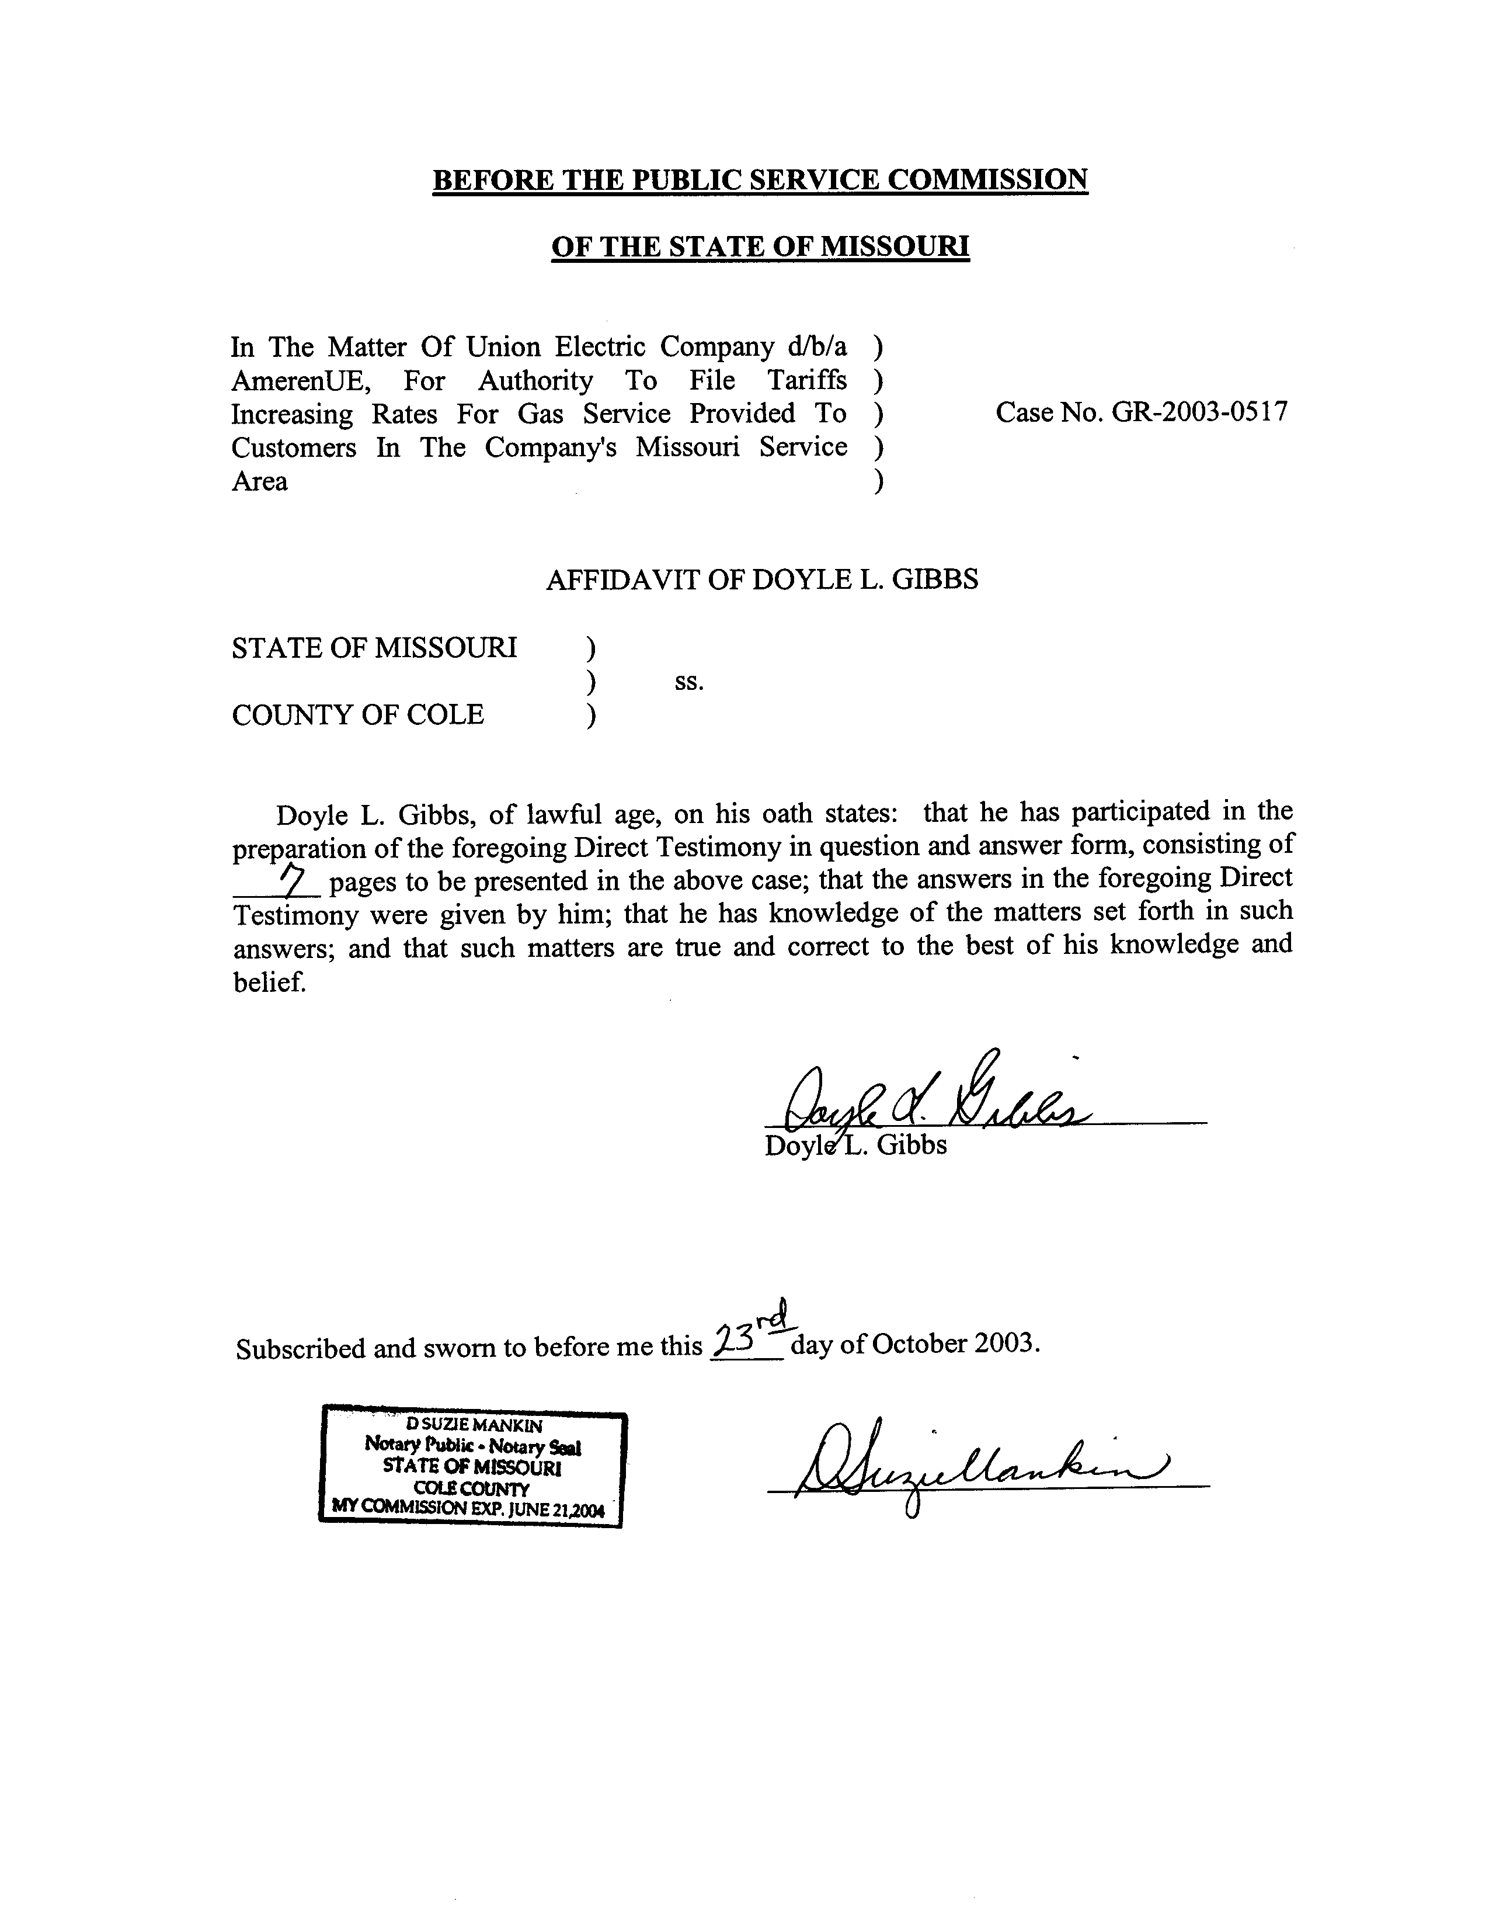

CASE PROCEEDING PARTICIPATION

DOYLE L. GIBBS

PARTICIPATION |  | TESTIMONY
COMPANY | CASE NO. | ISSUES
Missouri-American Water Company | WR-2003-0500 and  WC-2004-0168 | Direct - Pensions; Other Post Employment Benefits (OPEBs); Income Taxes; Reserve Deficiency Amortization
Union Electric (dba AmerenUE) | EC-2002-1025 | Direct-Allocations, Territorial Agr & I&D
Union Electric Company | EC-2002-1 | Direct - Revenue, Uncollectibles, Gross Receipts Tax, Territorial Agreements, Allocations, Payroll, Incentive Compensation, Payroll Taxes, Injuries & Damages, Depreciation
Laclede Gas Company | GR-2001-629 | Environmental Costs; Cost of Removal Accounting Authority Orders; Incomes Taxes
St. Louis County Water Company | WR-2000-844 | Direct – Accounting Schedules, Revenue, Purchased Water, Fuel & Power, Chemicals, Uncollectibles, Pensions, OPEBs, Outside Services
Missouri-American Water Company | SR-2000-282 | True-up Rebuttal – Chemicals, Property Taxes
Missouri-American Water Company | SR-2000-282 | True-up Direct – Impact of True-up audit
Missouri-American Water Company | SR-2000-282 | Direct - True-up, Plant, Depreciation Reserve, Depreciation Expense, Materials & Supplies, Prepayments, Deferred Income Tax, Customer Deposits & Advances, Property Tax, Income Tax
Missouri-American Water Company | WR-2000-281 | True-up Rebuttal – Chemicals, Property Taxes
Missouri-American Water Company | WR-2000-281 | True-up Direct – Impact of True-up audit
Missouri-American Water Company | WR-2000-281 | Direct - True-up, Plant, Depreciation Reserve, Depreciation Expense, Materials & Supplies, Prepayments, Deferred Income Tax, Customer Deposits & Advances, Property Tax, Income Tax
United Water Missouri | WR-99-326 | Accounting Schedules
Laclede Gas Company | GR-99-315 | True-up Direct – Impact of True-up audit
Laclede Gas Company | GR-99-315 | Direct – True-up, Plant, Depreciation Reserve, Depreciation Expenses
Laclede Gas Company | GR-98-374 | Direct – Income Tax, Injuries & Damages, Rate Case Expense
Missouri-American Water Company | WO-98-204 | Direct – Revenue Requirement for District Specific Pricing
Missouri-American Water Company | WR-97-237 | Payroll, Employee Benefits, Payroll Taxes, Other Insurance, Non-recurring Credits, True-up
Atmos Energy Corporation/ United Cities Gas Company | GM-97-70 | Rebuttal – Public Detriment, Accounting for merger, Merger Premium
Laclede Gas Company | GR-96-193 | Direct – Income Tax, AAO's, Pensions, OPEBs, PSC Assessment
Empire District Electric Company | ER-95-279 | Direct - Income Tax, Non-group insurance
Laclede Gas Company | GR-94-220
St. Louis County Water Company | WR-94-166
Missouri-American Water Company | WM-93-255
Southwestern Bell Telephone Company | TC-93-224
Missouri-American Water Company | WR-93-212
St. Joseph Power & Light | ER-93-41
Missouri Pipeline | GR-92-314
Laclede Gas Company | GR-92-165
St. Louis County Water Company | WR-91-361
Missouri Cities | WR-91-172
Missouri Cities | WR-90-236
Missouri-American Water Company | WR-89-265
Missouri Cities Water Company | SR-89-179
Missouri Cities Water Company | WR-89-178
St. Louis County Water Company | WR-88-5
St. Louis County Water Company | WR-87-2
Missouri Cities Water Company | SR-86-112
Missouri Cities Water Company | WR-86-111
Southwestern Bell Telephone Company | TR-86-84
Arkansas Power & Light Company | ER-85-265
Missouri Cities Water Company | SR-85-158
Missouri Cities Water Company | WR-85-157
Arkansas Power & Light Company | ER-85-20
Union Electric Company | ER-84-168
St. Louis County Water Company | WR-83-264
Union Electric | ER-83-163
Missouri Cities Water Company | SR-83-15
Missouri Cities Water Company | WR-83-14
Laclede Gas Company | GR-82-200
Capital City Water Company | WR-82-117
Union Electric Company | ER-82-52
Union Electric Company | HR-81-259
Laclede Gas Company | GR-81-245
Union Electric Company | ER-81-180
Citizens Electric Cooperative | ER-81-79
Southwestern Bell Telephone Company | TR-80-256
Laclede Gas Company | GR-80-210
Lake St. Louis Sewer Company | SR-80-189
Union Electric Company | ER-80-17
Southwestern Bell Telephone Company | TR-79-213
Associated Natural Gas Company | GR-79-126
Citizens Electric Cooperative | ER-79-102
St. Louis County Water Company | WR-78-276
Laclede Gas Company | GR-78-148
Missouri Cities Water Company | SR-78-108
Missouri Cities Water Company | WR-78-107
St. Joseph Water Company | WR-77-226
Union Electric Company | ER-77-154
Laclede Gas Company | GR-77-33
Missouri Cities ** | 18510

