Exhibit No.:
Issues: Class Cost of Service

Witness: Hong Hu
Sponsoring Party: MO PSC Staff
Type of Exhibit: Direct Testimony
Case No.: ER-2004-0570
Date Testimony Prepared: September 27, 2004

MISSOURI PUBLIC SERVICE COMMISSION

UTILITY OPERATIONS DIVISION

DIRECT TESTIMONY

OF

HONG HU

THE EMPIRE DISTRICT ELECTRIC COMPANY

CASE NO. ER-2004-0570

Jefferson City, Missouri
September 2004
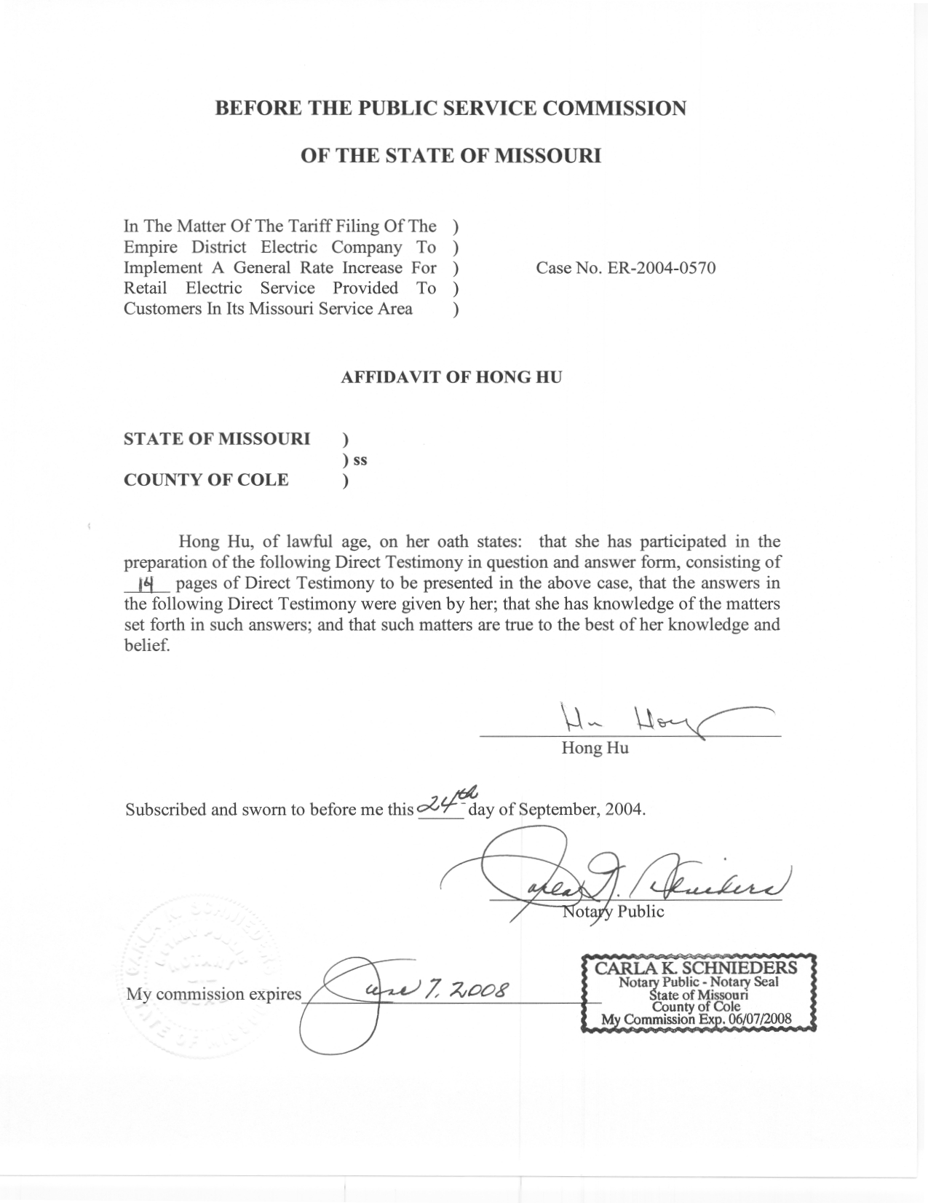
TABLE OF CONTENTS

I. Class Cost Of Service Study – A Brief Introduction 2
II. Staff’s Class Cost Of Service Study 4

DIRECT TESTIMONY

OF

HONG HU

THE EMPIRE DISTRICT ELECTRIC COMPANY

CASE NO. ER-2004-0570

Q. Please state your name and business address.

A. My name is Hong Hu and my business address is Missouri Public Service Commission, P. O. Box 360, Jefferson City, Missouri 65102.
Q. What is your present position with the Missouri Public Service Commission?

A. I am a Regulatory Economist in the Economic Analysis Section, Energy Department, Operations Division.
Q. Would you please review your educational background and work experience?
A. I hold a Bachelor of Engineering degree in Management of Information Systems from Tsinghua University of Beijing, China and a Masters of Arts degree in Economics from Northeastern University. I have completed the comprehensive exams for a Ph.D. in Economics from the University of Missouri at Columbia. I worked as a regulatory economist with the Office of Public Counsel (Public Counsel, OPC) from 1997 to 2003. I have been employed as a Utility Operations Regulatory Economist III with the Staff of the Public Service Commission (Staff) since March 2003. A list of the cases in which I have filed testimony before the Commission is shown on Schedule 1.
Q. What is the purpose of your testimony?

A. The purpose of my Direct Testimony is to present the Staff’s Class Cost of Service (CCOS) study results.

I. Class Cost Of Service Study – A Brief Introduction
Q. What is the main purpose of performing a CCOS Study?
A. The main purpose of a CCOS Study is to determine the relative class cost responsibility for each customer class by allocating total costs or revenue requirement in a reasonable manner. The total costs of a utility include its expenses plus a reasonable return on its rate base. A CCOS study estimates how well a customer class fulfills its revenue responsibility by comparing its share of the total cost to the current revenue it provides. CCOS study results also provide guidance for determining how rate elements should be designed to collect revenues from customers within a class, depending on customer usage levels and patterns. In other words, the overall goal of a CCOS study is to match service received to the cost of providing that service, plus a reasonable return, so that each customer is paying his/her/its “fair share”.
Q. What was the general procedure followed by Staff in its CCOS study?
A. Staff used the procedure described in Chapter 2 of the National Association of Regulatory Utility Commissioners (NARUC) ELECTRIC UTILITY COST ALLOCATION MANUAL, January, 1992 (NARUC Manual). The CCOS studies the Staff performs are embedded cost studies. The historical information required to develop cost allocations, including the Company’s plant investment, operating costs, current revenues, and load information, are contained in the books and records maintained by the Company, and are examined by the Staff’s auditing and rate design personnel. Once the relevant data are gathered, a CCOS study can be performed through the following three primary steps: the functionalization, classification, and allocation of costs.
Q. Please explain the first step of performing a CCOS study.
A. The first step of a CCOS study is functionalization. Functionalization of costs involves categorizing plant investment and operation cost accounts by the type of function with which an account is associated. Each major account was categorized by whether the costs associated with that account were related to the utility's function of production, transmission, distribution, or customer services and facilities; or, to some combination of these functions.
Q. Please explain the second step of performing a CCOS study.
A. The second step is to separate the functionalized costs into classifications based on the components of utility service being provided. In addition, some costs can be identified as logically incurred to serve a particular customer or customer group. For example, costs in each of the distribution accounts can be classified as demand related (costs that vary with KW demands) or customer related (costs that vary with the number and type of customer served), and primary (utilized by both customers taking service at the primary voltage and customers taking service at the secondary voltage) or secondary (utilized by only customers taking service at the secondary voltage). Another example is that certain plant investments can be identified as exclusively serving a special contract customer, and thus can be directly assigned.
Q. Please explain the third step of performing a CCOS study.
A. The third step of performing a CCOS study is called allocation. After costs have been properly classified, the analyst chooses allocation factors that will allocate a reasonable share of jurisdictional costs to each customer class. Allocation factors are based on ratios that represent the proportion of total units (total number of customers, total annual energy consumption, etc.) attributable to a certain customer class. These ratios are then used to calculate the proportions of various cost categories for which a class is responsible.

II. Staff’s Class Cost Of Service Study

Q. What was the source of the data used in Staff’s CCOS study?
A. The Empire Electric District Company (EDE) provided revenues and costs by major FERC account for the test year ending December 31, 2001, updated to June 30, 2002, to various Missouri Public Service Commission Staff (Staff) witnesses as found in the Staff Accounting Schedules filed on September 20, 2004.
Class level revenue and load data were prepared by Staff witness Ms. Janice Pyatte, and other staff members under Ms. Pyatte’s supervision from the information provided by EDE. I used these sources for the data input into Staff’s CCOS study.
Q. What customer classes are used in the Staff’s study?
A. Empire currently has the following rate schedules: Residential Service (RG), Commercial Service (CB), Small Heating Service (SH), General Power Service (GP), Large Power Service (LP), Electric Furnace Primary Service (PF), Feed Mill and Grain Elevator Service (PFM), Total Electric Building Service (TEB), and Special Transmission Service Contract: Praxair (SC-P). Due to the fact that customers in the CB and SH rate codes as well as the GP and TEB rate codes have similar characteristics, the Staff has combined CB and SH rates into the Small General Service (SGS) class, and the GP and TEB rate codes into the Large General Service (LGS) class.
The only PF customer that the Company had has ceased operations; therefore, the PF class is not included in the Staff’s CCOS study. In addition, the number of customers in the PFM rate class and other special rate classes, such as lighting, is so small that the Staff believes that the data currently available regarding those customers is not accurate enough to produce any meaningful results for those classes. Therefore, those classes were not included in the Staff’s CCOS study. The revenues from these classes were used as an offset against costs directly assigned to these classes, and the residual was applied against the revenue requirements of the classes that were included in the Staff’s CCOS study.
Q. What is the revenue requirement in this study?
A. For purposes of its CCOS study, Staff used Staff’s mid-point test year overall revenue requirement, i.e., a $7.4 million decrease in margin revenue requirement for EDE’s total revenue requirement. This number corresponds to the $11,983,480 overall revenue requirement increase including the Interim Energy Charge (IEC). The class cost-of-service study results were also calculated on a revenue neutral basis.
Q. Please describe the Functionalization step of the Staff’s study.
A. We have functionalized all plant accounts and expense accounts into the following categories:
The production function consists of generating plants where energy resources such as natural gas and coal are converted to electricity. It also includes cost of fuel and labor to operate these plants. As illustrated in the graph attached as Schedule 2, generation facilities are the first link in the chain in providing electricity to customers.
The transmission function moves electricity at a very high voltage, from generating plants over long distances to local service areas. Electricity is transferred at high voltages to minimize the current flow and thus the amount of electrical energy converted to heat in the wires, and thereby to lessen energy loss and the risk of fire. The transmission function consists of costs for high voltage lines and transmission substations, and labor to operate and maintain these facilities. Transmission lines typically consist of large steel or wood structures and wires.
The distribution function converts high voltage power from the transmission system into lower primary voltage and delivers it to large industrial complexes, and further converts it into even lower secondary voltage power which then be delivered into homes for lights and appliances. Distribution is the final link in the chain built to deliver electricity to the customers’ homes or businesses. A utility’s distribution plant includes distribution substations, poles, wires, transformers and meters, as well as service and labor expenses incurred for the operation and maintenance of these distribution facilities.
The customer function includes labor expenses incurred for billing and customer services.
The pie chart below shows the relative percentage of the costs for each of these functions.

Q. Please describe the Classification step of the Staff’s study.
A. The functionalized costs were further classified into the following categories:
Production – Energy
Production – Capacity
Transmission – Capacity
Distribution – Substations – Primary demand
Distribution – Feeder Lines – Primary demand
Distribution – Overhead Lines & Poles – Primary customer
Distribution – Overhead Lines & Poles – Secondary customer
Distribution – Underground Lines & Conduits – Primary customer
Distribution – Underground Lines & Conduits – Secondary customer
Distribution – Lines, Poles, & Conduits – Primary demand
Distribution – Lines, Poles, & Conduits – Secondary demand
Distribution – Transformers – Secondary customer
Distribution – Transformers – Demand
Distribution – Customer Installations
Distribution – Services
Distribution – Meters
Customer – Customer Deposits
Customer – Meter Reading
Customer – Billing, Customer Sales & Services
Assigned – Special Contract
Assigned – Large Power
Assigned – LGS/LPS/SC Classes
Assigned – RES/SGS Classes
Revenue Related
Excess Facility
Lighting

Q. Why is Production Plant classified into two different categories?
A. Production Plant includes the cost of land, structures and equipment used in connection with power generation. Both demand and energy characteristics of a system's loads are important determinants of production plant costs. Specifically, fuel expenses and purchased power cost are directly related to the amount of electricity sold, and are thus classified as energy related. The costs of generation facilities are directly related to a utility’s generation capacity, which is determined through the utility’s system planning, when many factors including both load factor and demand are considered, and are thus classified as capacity related.
Q. How was Production – Energy cost allocated?
A. Because production-energy costs are determined by loads throughout the year, each class's contribution to total energy sold was used to allocate production-energy costs.
Q. How was Production – Capacity cost allocated?
A. Since different types of generating units (base, intermediate, and peaking) have different operational and cost characteristics, utilities attempt to build the amounts and types of generating units that provide flexibility to match supply to demand in every hour throughout the year at the lowest possible cost. A reasonable allocator must be able to reflect this principle. In previous cases, the Commission accepted the Time of Use (TOU) method as the most reasonable method for allocating the production costs of serving various customer classes. However, the Staff did not have sufficicent resources to develop such TOU allocators in this case. Therefore, it was decided that the Production-capacity costs should be allocated on the basis of the 12-month non-coincident peak (NCP) average and peak allocators, which are a reasonably close approximation to the more accurate TOU allocators.
Q. How was Transmission Plant allocated?
A. The transmission plant is generally considered to be an extension of the production plant. It can be used as a substitute for generation facilities to provide reliable service throughout the year including periods of scheduled maintenance, and can be used to minimize the cost of generation facilities through the sales or purchase of power. The planning and operation of transmission plant is inexorably linked to the production plant, with the major factors that drive production costs tending also to drive transmission costs. Therefore, Transmission Plant costs can be equitably allocated on the same basis as the Production Plant. Accordingly, the same 12-month NCP average and peak allocators that were used for Production-capacity were also used to allocate Transmission-capacity costs.
Q. Why is distribution function classified into primary and secondary categories?
A. An electric utility’s distribution system includes a primary (higher voltage) system and a secondary (lower voltage) system. Some industrial customers and research centers require higher voltage or stricter voltage regulation than can be provided by the secondary distribution system, thus they receive services at the high voltage side of the transformer. In other words, the cost of the secondary portion of the distribution system is incurred only to serve the customers who take service at the secondary voltage level, while the cost of the primary portion of the distribution system is incurred to serve all customers.
Q. Why is the overhead and underground distribution function classified into customer and demand categories?
A. The cost of distribution conductors is directly related to their size as well as their length. Conductors are sized based on customers’ demand. The length of a conductor is determined by where the customers are located relative to the source of the electricity they use. In other words, a portion of the conductor costs is not directly related to the customers’ demand and should be reasonably separated from the portion of the conductor costs that varies directly with capacity or demand. The poles and underground conduits are used to support the conductors and thus should receive the same treatment.
Q. How are the primary/secondary, and customer/demand split determined?
A. Former Staff witness Eve A. Lissik developed these splits based on information provided by the Company. This information was used by the parties in cases No. ER-95-279, ER-94-174 and EO-91-74. I have continued to use these results, because there is no evidence to suggest any changes have occurred, and no more recent studies have been performed.
Q. Why was class contribution to the sum of annual class peak demands used to allocate the portion of substations, poles, and conductors related to primary demand?
A. Substations and primary conductors are sized to meet the diversified demands of the customers. Diversity incorporates the fact that customers do not all peak at the same time. However, since each substation serves a geographic area smaller than the total service territory, system coincident peak demands are not appropriate. The class peak demands incorporate the diversity within each class, but do not take that diversity all the way to the total system.
Q. How was the portion of poles, conductors, and transformers costs related to secondary demand allocated?
A. Secondary lines are sized to meet the diversified demands of the secondary customers and therefore class contribution to the sum of annual non-coincident class peak demands were used to allocate secondary poles, conductors, and conduits. Line transformers serve an even smaller group of customers. Class peaks incorporate too much diversity for allocating this cost, and customer maximum demand incorporates too little since it accounts for none of the diversity between customers within these small groups. Therefore, the Staff used class contribution to customer diversified demand at secondary, which is a mix of the non-coincident class peak and customer maximum demand, to allocate line transformer costs.
Q. Why was weighted customer used to allocate the customer portion of poles, conductors, and conduits?
A. The weighted customer allocator is developed based on the number of customers in each class, multiplied by a set of weights that approximately reflect customer density for each customer class. I believe it is a reasonable way to allocate the portion of costs of poles, conductors, and conduits that varies with length.
Q. How were costs associated with service lines allocated?
A. Costs of service lines were allocated on service-weighted customer allocators, each of which is equal to customer numbers for each particular class multiplied by the service weight. The weights used in the allocations reflect the cost of a "typical" service by class.
Q. How were costs associated with meters allocated?
A. Cost of meters were allocated on meter weighted customer allocators, which is equal to customer numbers for each class multiplied by the meter weight. The weights used in the allocation reflect the current cost of installing a meter (or meters) for each class of customer.
Q. Please discuss the methods that you used to classify and allocate expenses.
A. Expenses were directly assigned, if possible. For the expenses that could not be directly assigned, classification of costs are made consistent with the principle that "expenses follow plant," and the same allocators were applied to the expenses accounts as those that were applied to the Production, Transmission, and Distribution Plant accounts to which the expenses are related.
Q. Why was allocators based on weighted number of customers used to allocate the cost of meter reading?
A. Since meter reading costs are related both to the number of customers and customer density, these costs are allocated based on weighted customers, where the weights reflect the relative cost of meter reading by class.
Q. What formed the basis for the allocation of uncollectible accounts, billing and records, customer services, and sales promotion expenses?
A. The Staff allocated these costs on non-weighted customer numbers because they vary with the number of customers and no special studies have been done to determine what, if any, weighting would be the appropriate. A portion of customer services and sales promotion expenses were assigned to the classes based on the Company's assignments.
Q. How did you allocate property and payroll taxes?
A. I allocated property taxes on the basis of allocated total net plant, and payroll taxes on the basis of allocated payroll expenses.
Q. How did you allocate state and federal income taxes?
A. These taxes were allocated on the basis of rate base since a utility company's income taxes will be a function of the size of its rate base, and thus each class should contribute revenues for income taxes in proportion with the amount of rate base that is necessary to serve it.
Q. Please describe the results of Staff’s CCOS Study.
A. Schedule 3.1 and 3.2 shows the results of Staff’s CCOS Study on a revenue neutral basis and the Staff’s recommended revenue requirement, respectively. Our results show that on a revenue neutral basis, the Residential class is providing approximately 5% less operating revenues than the costs of serving that class, while the nonresidential classes are providing approximately 4.5% more operating revenue than the cost of serving them. The class specific information is provided in Schedule 3.1 and 3.2, and is summarized below in Table 1 and 2.
Table 1 – CCOS Indicated Revenue Neutral Class Revenue Deficiencies
 | TOTAL | Residential | SGS | LGS | LPS | SC  (Praxair)
Revenue Deficiency | 0 | 5,397,926 | (1,960,871) | (4,021,879) | 341,213 | 243,612
% | 0.00% | 4.88% | -6.28% | -6.29% | 1.12% | 10.06%
Table 2 – CCOS Indicated Class Revenue Deficiencies at Staff Recommended Mid Point ROR (8.09%)
 | TOTAL | Residential | SGS | LGS | LPS | SC  (Praxair)
Revenue Deficiency | (7,194,368) | 1,832,858 | (2,895,474) | (5,796,535) | (516,423) | 180,206
% | -2.96% | 1.66% | -9.27% | -9.07% | -1.69% | 7.44%

Q. Does this conclude your Direct Testimony?
A. Yes.

