Exhibit No.:
Issues: Weather Normalization
Witness: James A. Gray
Sponsoring Party: MO PSC Staff
Type of Exhibit: Direct Testimony
Case No.: GR-2003-0517
Date Testimony Prepared: October 24, 2003

MISSOURI PUBLIC SERVICE COMMISSION

Utility Operations DIVISION

DIRECT TESTIMONY

OF

JAMES A. GRAY

UNION ELECTRIC d/b/a

AMERENUE

CASE NO. GR-2003-0517

Jefferson City, Missouri
October, 2003

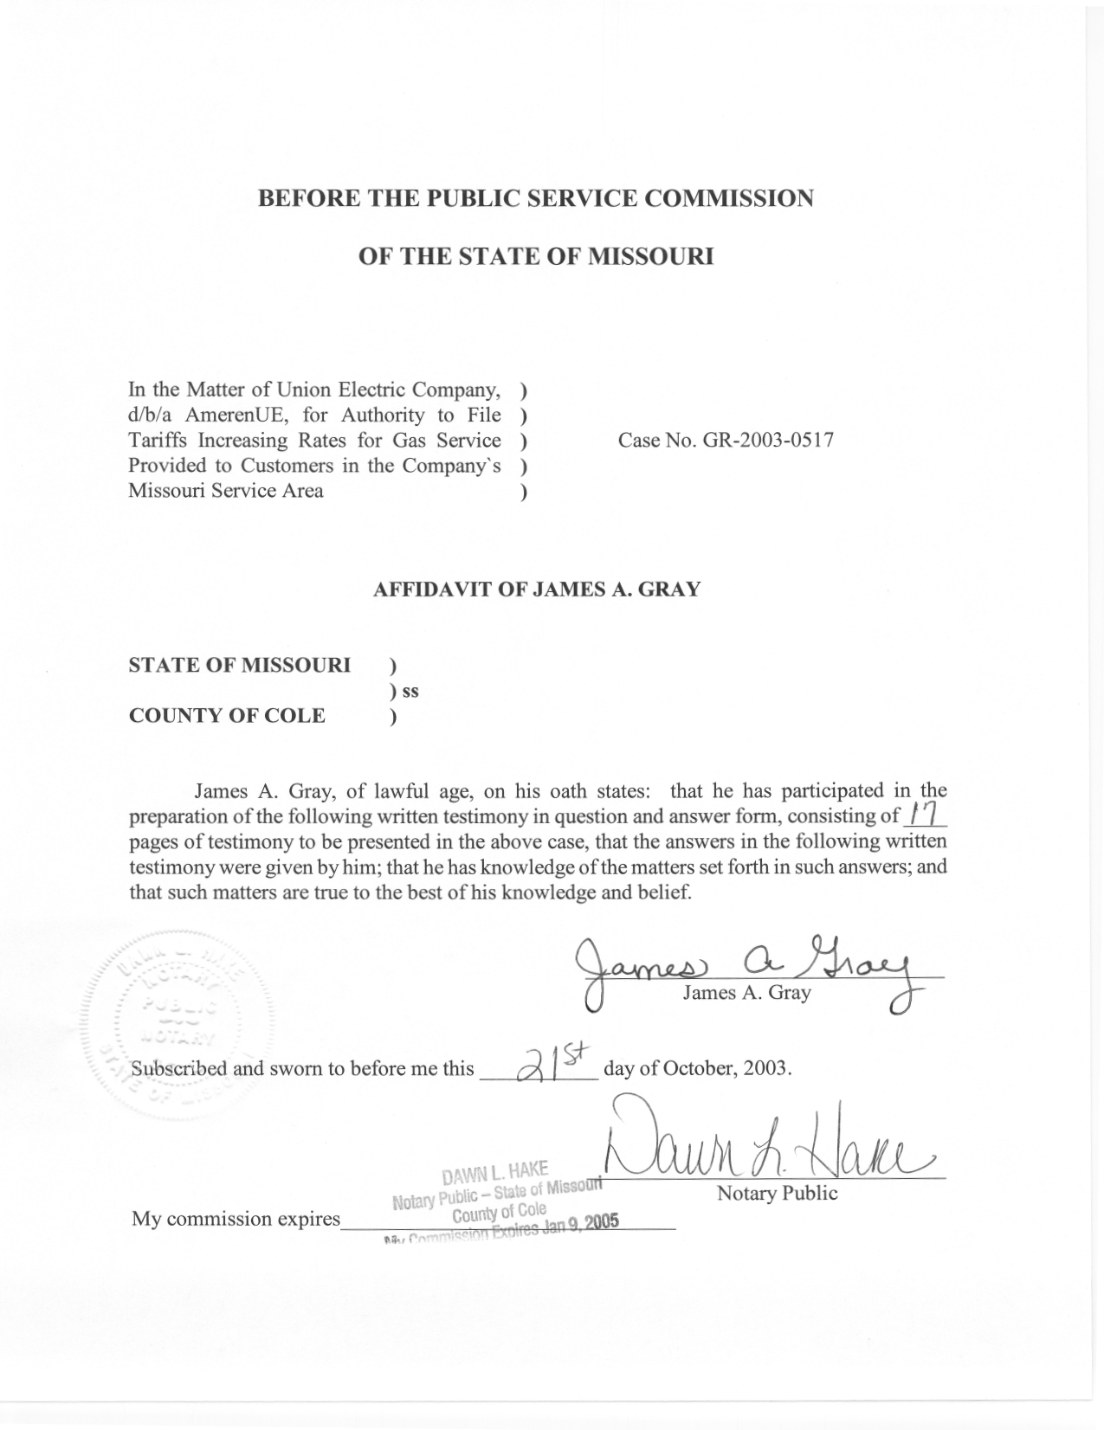

TABLE OF CONTENTS

WEATHER-NORMALIZED SALES 3
WEATHER-NORMALIZED COINCIDENT-PEAK-DAY DEMAND 13
RECOMMENDATIONS 17

DIRECT TESTIMONY
OF
JAMES A. GRAY

UNION ELECTRIC COMPANY

d/b/a AmerenUE

CASE NO. GR-2003-0517

Q. Please state your name and business address.
A. My name is James A. Gray. My business address is P. O. Box 360, Jefferson City, Missouri 65102.
Q. By whom are you employed and in what capacity?
A. I am employed by the Missouri Public Service Commission (Commission) as a Regulatory Economist in the Tariffs/Rate Design Section of the Commission's Energy Department.
Q. How long have you been employed by the Commission?
A. I have been employed with the Commission for approximately twenty-three years.
Q. Please state your educational background.
A. I received a degree of Bachelor of Science in Psychology as well as one in General Studies from Louisiana State University, and I received a degree of Master of Science in Special Education from the University of Tennessee. Additionally, I completed several courses in research and statistics at the University of Missouri - Columbia.
Q. Please state your professional qualifications.
A. Prior to being employed by the Commission, I was a Research Analyst for two and a half years with the Missouri Department of Mental Health where I conducted statistical analyses. In 1980, I began my employment with the Commission as a Statistician in the Depreciation Department where I submitted testimony regarding depreciation rates, trended-original cost, and trended-original cost less depreciation.
Beginning in 1989 in the Economic Analysis Department, I submitted testimony on weather-normalized sales for natural gas, water, and electric utilities. I reviewed residential electric-load forecasts with associated detailed end-use studies and marketing surveys in electric resource plans.
From December of 1997 through June of 2001, I was in the Tariffs/Rate Design Section of the Commission's Gas Department. Since July of 2001, I have been in the Tariffs/Rate Design Section of the Commission’s Energy Department. I have reviewed tariffs and applications of natural gas utilities. I have also submitted testimony concerning weather-normalized sales, complaints, certificates of convenience and necessity, and recommended minimum statistical-sample sizes for natural gas residential customer-billing reviews.
Q. Please list all the cases in which you have submitted prepared written testimony before this Commission.
A. The cases in which I have submitted prepared, written testimony are enumerated in Schedule 1, attached to my testimony.
Q. What is the purpose of your testimony?
A. My testimony addresses the Commission Staff’s (Staff) weather-normalization of natural gas sales for the residential and general service natural gas customers of Union Electric Company d/b/a AmerenUE (AmerenUE or Company). Then, I use the results of my weather-normalized sales studies to estimate weather-normalized coincident-peak-day demand.
Q. What is coincident-peak-day demand?
A. Coincident-peak-day demand is the day which a utility experiences a peak load on their system.

WEATHER-NORMALIZED SALES

Q. What firm customer classes did you adjust test year natural gas sales to normal weather conditions?
A. I weather adjusted the residential and general service customer classes of AmerenUE.
Q. How did you segregate AmerenUE’s Missouri natural gas service area for your studies?
A. AmerenUE is supplied by three natural gas pipelines. The Panhandle Eastern Pipe Line Company (PEP) supplies AmerenUE’s central and eastern Missouri communities, including Columbia, Jefferson City, Eldon, Mexico, Moberly, Louisiana, and Wentzville. Staff witness Dennis Patterson of the Commission’s Economic Analysis Department provided me with the weather data from the Columbia Regional Airport to study the PEP service area.
Natural Gas Pipeline Company of America (Natural Gas Pipeline or NGPL) and Texas Eastern Transmission Corporation (Texas Eastern or TET) supply southeastern Missouri communities, including Fisk, Dexter, and Cape Girardeau. I combined AmerenUE’s Texas Eastern service area and Natural Gas Pipeline service area into one area for my analyses. Mr. Patterson provided me with the weather data from the Cape Girardeau FAA Airport to study the combined NGPL/TET service area.
Q. Please identify the Staff witnesses who utilize the results of your weather-adjusted volumes.
A. I provided the results of my weather-normalized sales volumes to Staff witness Leasha S. Teel of the Commission's Auditing Department for the Staff’s customer-growth annualization and revenue calculations and to Staff witness Kim J. Elvington, of the Commission’s Energy Tariffs/Rate Design Department, for the Staff’s allocation of the weather-normalized sales to the block rates of the general service class. (AmerenUE’s general service class has different unit charges for natural gas volumes falling within blocks of consumption.)
Q. Why is it important to adjust test-year natural gas sales to normal weather?
A. Since rates are based on natural gas usage during the test year, it is important to remove the influence of abnormal weather. Otherwise, if natural gas usage volumes reflect the influence of abnormal weather, the rates will be distorted by these deviations from normal weather conditions during the test year. My adjustments to test-year sales set the test-year natural gas volumes at the levels that would be experienced under normal weather conditions.
Q. Why are natural gas sales dependent upon weather conditions?
A. The predominate use of natural gas in Missouri is for space heating, so natural gas sales increase during colder weather. Space heating refers to natural gas used to heat the inhabited area of a residence or business during colder weather.
Q. How do your analyses adjust test-year-natural-gas sales if the test year is warmer than normal?
A. Natural gas sales for the test year would be increased to reflect a normal year, because the Company would be expected to sell more natural gas volumes under the cooler, normal weather conditions than it sells during a warmer than normal test year.
Q. How do your analyses adjust test-year-natural-gas sales if the test year is colder than normal?
A. Natural gas sales for the test year would be decreased to reflect a normal year, because the Company would be expected to sell less natural gas volumes under the warmer, normal weather conditions than it sells during a colder than normal test year.
Q. What weather measure did you use in your analyses?
A. Staff witness Patterson provided me with daily actual and daily normal heating degree days (HDD) for the Columbia Regional Airport and the Cape Girardeau FAA Airport. Mr. Patterson’s testimony discusses the calculation of HDD.
Q. What was your source for the billed natural gas usage data?
A. AmerenUE provided monthly natural gas sales in hundreds of cubic feet (Ccf) and monthly numbers of customers for each billing cycle, by firm customer class broken into two service area classifications (PEP and NPGL/TET).
Because AmerenUE changed its billing system during the test year, the data I needed was unavailable for the first part of the test year. Therefore, my studies were based on usage data from July 1, 2002, through June 30, 2003. For the purposes of my studies, it was assumed that the normalized volumes for the twelve-month period of July 1, 2002, through June 30, 2003, would equal the normalized volumes for the twelve-month test year of January 1, 2002, through December 31, 2002.
Q. What are billing cycles?
A. The Company schedules groups of natural gas accounts into billing cycles that are to be read throughout a month, followed by mailing the associated bills throughout the month. Staggering the billing of customers’ accounts over the billing months reduces the effort to bill AmerenUE’s customers. Since there are approximately twenty-one working days in a month, customers’ accounts are usually grouped into one of twenty-one billing cycles.
These customers' natural gas meters are read approximately every thirty days (a billing month), not a calendar month, because not all natural gas meters are read on the first day of a calendar month. The number of days between meter readings varies among the billing cycles within a billing month. Moreover, individual billing cycles may exhibit month to month variations in the numbers of days between meter readings, due to holidays and variations in the number of days and in the placement of weekends, from one billing month to another.
Q. Have you prepared a schedule showing the meter read dates for the January 2003 billing month?
A. Yes, Schedule 2, attached to this testimony, shows how the twenty-one billing cycles’ meter-reading dates are staggered for the billing month of January 2003. The January-billing-month’s cycle numbers are shown in red. For clarification, a billing month, as used in this testimony, refers to the interval (days) needed to read all of AmerenUE’s twenty-one billing cycles. Schedule 2 shows the billing month of January starting on December 30, 2002, and ending on January 28, 2003.
Q. Why do you rely on billing cycle usage data?
A. The Company's customer billing records are based on monthly billing cycles. That is, the Company records maintain grouped summary natural gas statistics by billing cycle for each billing month. Using billing cycles allows each billing month’s customer numbers and usage for a particular rate class to be combined and recorded into the approximately twenty-one billing cycle groups.
It would be ideal to have daily measures of both natural gas usage and weather, so the two can be precisely matched and studied. However, daily usage data for AmerenUE’s residential and general service customers are unavailable. Therefore, I relied on the Company’s monthly billing cycle data.
Q. How did you analyze space heating natural gas volumes?
A. I performed the analyses for each of two service area classifications, PEP and NGPL/TET. I calculated two sets of twelve-billing-month averages by customer class. One set of these averages was the daily average natural gas usage in Ccf and another set was the daily average HDD. These billing month averages were calculated from the data on numbers of customers, natural gas usage-in-Ccf, and summed HDD from approximately twenty-one billing cycles for each billing month by customer class.
Q. Why did you sum Staff witness Patterson’s daily HDD by billing cycle?
A. To match the daily HDD by billing cycle with the Company’s customer-billing records, I summed the daily HDD for the dates encompassing each billing cycle. This matches Staff witness Patterson’s HDD daily weather series with the Company’s customer-billing records. These daily-weather measures are added over the dates between each billing cycle’s meter readings to calculate weather by billing cycle.
Calendar-month weather values cannot be accurately analyzed or quantified by date or day. Accordingly, calendar-month-weather measures would be inappropriate for billing cycles. Therefore, I relied on the summed HDD that each billing cycle encompasses.
Q. How do the twelve-billing month customer-weighted averages of HDD reflect different customer levels among the different billing cycles?
A. Each billing month’s daily average HDD in each billing cycle is weighted by the percentage of customers in that billing cycle. Thus, the billing cycles with the most customers are given more weight in computing the billing-month daily-average HDD.
Schedule 3, attached to this testimony shows the number of customers, Ccf used, and HDD for the billing month of January 2003 for AmerenUE’s general service customers in NGPL/TET service area. The customer numbers vary from 27 for billing cycle number 3 to 305 customers for billing cycle number 8. Also, the HDD vary from 852.5 for billing cycle number 9 to 1,162 HDD for billing cycle number 18. This shows that there are significant differences between billing cycles within a billing month. This demonstrates the need to carefully average the HDD across all the billing cycles for each of the twelve-billing months.
Q. How did you average billing month usage in Ccf?
A. I calculated twelve simple, unweighted-averages representing daily-usage-per-customer for each month. That is, I divided each cycle’s volumes by the number of customers and the number of days in each billing cycle. This stated the Company’s natural-gas-usage-by-billing-cycle on a daily basis. So, all billing cycles in a billing month are equated on a use-per-day, regardless of the variations in the number of days between meter readings among the billing cycles within a billing month. Then, I averaged the approximately twenty-one billing-cycles’ entire daily-usages-per-customer over each billing-month to calculate one month’s daily-average-usage-in-Ccf.
Q. How did you quantify the relationship of natural gas sales to HDD?
A. My studies estimate the change in usage-in-Ccf related to a change in HDD based on the two sets of twelve-monthly billing-month averages of the average-daily-usage-in-Ccf-per-customer and the customer-weighted-average-daily-HDD. These two sets of billing month averages (usage and weather) were used to study the relationship between space-heating natural-gas-usage-in-Ccf and colder weather.
I used regression analysis to estimate the relationship for each of the residential and general service customer classes in the two service areas. Regression analysis describes the relationship between daily space-heating-sales-per-customer-in-Ccf to the daily HDD.
Q. What are the advantages of using regression?
A. Regression develops quantitative measures that describe relationships. The regression equation calculates a straight line that best fits the relationship. The slope (or slant) of the best-fitting straight line estimates a change in the daily-natural-gas-usage-per-customer whenever the daily average-weather changes one HDD. For example in my analyses, the slope of the best-fitting regression line for AmerenUE’s residential class in the PEP service area is 0.11201. This means that, in AmerenUE’s PEP service area, a residential customer’s estimated usage will change approximately 0.11201 Ccf per day for every change of one HDD. The steeper the slopes of the regression lines or the larger the numerical value of the slope, the greater the estimated change in space heating usage-in-Ccf for a change of one HDD.
Also, regression calculates a measure of the goodness of fit. The measure is referred to as r squared (r²). The r² ranges from 0.00 to 1.00, with 1.00 being a perfect fit.
Q. How closely did your regression results match actual average daily natural gas sales per customer for the billing months?
A. Schedules 4-1 and 4-2, attached to this testimony, show the regression best-fitting lines and each billing month's actual-average-daily natural gas sales-per-customer plotted against the billing month's actual average-daily HDD. The plots demonstrate that the regression lines fit the data very closely. Moreover, all of Staff’s r² values were above 0.96844, which also indicates a good fit.
Q. Up to this point, is your daily estimated usage Ccf based on any normal values?
A. No, the estimated daily usage-per-Ccf-per-customer was based on actual HDD and the actual number of days in each billing cycle. I used the estimated relationship between space heating usage-in-Ccf and HDD to adjust the actual HDD to the normal HDD provided to me by Staff witness Patterson.
Q. How did you adjust monthly natural gas volumes to normal?
A. The first step is to equalize each billing cycle’s annual total normal HDD. I added or subtracted a few days to make each billing cycle’s annual total days match 365 days. This adjustment for days sets each billing cycle to the same total number of days and normal HDD. Failure to equalize the normal HDD will result in some billing cycles having the wrong annual or total number of normal HDD.
Once each billing cycle has the proper normal HDD, the second step is to calculate each billing cycle's difference between normal and actual (normal - actual) for HDD. The third step is to multiply these differences times the appropriate estimate from the regression results. I used the estimated relationship between space heating usage-in-Ccf and HDD from my regression studies to adjust the actual HDD to the normal HDD provided to me by Staff witness Patterson.
The fourth step is to sum each billing cycle’s adjustment volumes-by-billing month. The fifth step is adding the monthly adjustments in Ccf to total monthly natural gas sales to calculate normalized volumes.
Q. Why do you state natural gas usage on a per-customer-usage basis?
A. The Commission’s Auditing Department can multiply its customer levels by my weather-normalized sales-per-customer to calculate its customers’ growth annualization.
Q. Are your normalized sales stated in daily usage-per-customer equivalent to what a typical customer would use?
A. No, I did not select typical customers. AmerenUE provided me with all bills rendered during a year. The data include some partial bills, such as new customers receiving service in the middle of the month. Moreover, I did not segregate those customers into heating categories, such as, customers using natural gas for space heating and customers using natural gas only for water heating.
Q. What were the results of your weather-normalized-sales studies for the study period of July 1, 2002 through June 30, 2003?
A. My analyses resulted in a decrease to natural gas sales because the weather from July 1, 2002 through June 30, 2003, was colder than normal. My analyses result is an approximate 3.3 percent decrease from actual natural gas sales for the residential customer class and approximately a 3.0 percent decrease for the general service customer class. These decreases do not include the Staff's customer-growth annualization.
Q. What results did you provide to Ms. Teel for her customer-growth annualization and revenue calculations?
A. I provided monthly, normalized natural gas usage-in-Ccf-per-customer for each customer class for the PEP and NGPL/TET service areas. These results are contained in Schedule 5, attached to my testimony. Schedule 5 demonstrates the higher natural gas usage-per-customer in the colder, winter months because of space heating requirements.
Second, for Ms. Teel’s revenue calculations, I provided monthly weather-normalized volumes for the same firm classes and service areas. Schedule 6, attached to my testimony, contains the monthly weather-normalized volumes.

WEATHER-NORMALIZED COINCIDENT-PEAK-DAY DEMAND

Q. What are estimates of weather-normalized coincident-peak-day demand by customer class?
A. Briefly, it is the estimated usage-per-customer by firm customer class on Staff witness Patterson’s normally occurring coldest days. The daily peak is the highest daily load or draw of natural gas on a system, and the demand is the rate or amount of natural gas used on that day. My estimates of residential and general service natural gas peak usage are at the time (coincident) of a utility’s system daily peak.
Q. Why are estimates of weather-normalized coincident-peak-day demands important?
A. These estimates of weather-normalized coincident-peak-day demands quantify the relative contributions towards that estimated single-day system peak by the residential and general service customers. For cost-of-service studies, it is important to determine each class’ contribution to the peak-day responsibility.
Q. Are the residential and general service customers’ peak-daily demands weather-sensitive?
A. Yes, residential and general service customers would be expected to use more natural gas on those colder days since their demand for natural gas is dependent upon the daily weather in HDD. My studies of weather-normalized sales have verified this weather-sensitive usage through such measures as the r² and my plots of the relationship between space-heating daily usage in Ccf and daily HDD.
Q. What weather data did Staff witness Patterson provide to you for estimating weather-normalized coincident-peak-day demand?
A. Staff witness Patterson provided me with two sets (one for the PEP service area and one for the NGPL/TET service area) of thirteen HDD calculated from his estimated weather-normalized coldest day for each month as well as a weather-normalized estimate of an annually occurring coldest day. Staff witness Patterson’s testimony discusses how he calculated his estimated weather-normalized coldest days.
Q. Why did you calculate your weather-normalized coincident-peak-day demand estimates from the Company’s billing data?
A. Acceptable load research data are unavailable for the residential and general service customer classes. Load research is the systematic gathering, recording, and analyzing of data describing utility customers’ patterns of energy usage. The customer-billing data are the best available surrogate data to estimate weather-normalized coincident-peak-day demand-by-firm-customer class on Staff witness Patterson’s normally occurring coldest days.
Q. Why must peak-day estimates be adjusted to normal weather conditions?
A. They must be adjusted to normal weather conditions for the same reasons stated previously for my weather-normalized-sales studies. Briefly, it is important to remove the influence of abnormal weather.
Q. How did you estimate weather-normalized coincident-peak-day usage in Ccf per customer, by customer class, for each month?
A. I used the relationships between natural gas usage-per-customer and HDD from my weather-normalized sales studies based on the Company’s billing data. My regression studies were based on daily usage-per-customer. So, the results of my weather-normalized sales studies were directly applied to estimate weather-normalized coincident-peak-day demand.
My natural gas sales-regression studies estimated a change in space heating natural gas usage-per-customer for a change of one HDD. For example, the slope of the best-fitting line for the residential customers in the PEP service area is 0.11201. I multiplied that estimate times Staff witness Patterson’s thirteen-coldest HDD values calculated from his weather-normalized coldest days.
Then, I added these results or mathematical products to another estimate from my weather-normalized sales studies. It is an estimate of non-weather sensitive usage in Ccf per customer calculated from the regression equation. Non-weather sensitive usage occurs in the summer months when there is no space-heating requirement. That non-weather sensitive usage estimate is the left, bottom point on each regression line (intercept) in Schedules 4-1 and 4-2. It is non-weather sensitive because it does not depend upon HDD. Accordingly, I added the preceding thirteen products to the estimated non-weather sensitive usage-per-customer during the summer months to calculate a total estimated weather-normalized coincident-peak-day demand-per-customer. In this manner, I used my weather-normalized-sales studies results to estimate the natural gas usage-in-Ccf-per-customer on the weather-normalized coldest day of each month and for the entire year (annual). Thus, my studies allocate the weather-normalized coincident-peak-day responsibility to the residential and general service customer classes for the PEP and NGPL/TET service areas.
Schedule 7, attached to this testimony, shows the estimated weather normalized coincident peak day natural gas usage-in-Ccf-per-customer-by-billing-month-and-customer-class for the classes for the PEP and NGPL/TET service areas. This information was provided to Staff witness James M. Russo of the Commission’s Energy Tariffs/Rate Design department for his calculation of total-peak-day demand across AmerenUE’s firm customer classes.
Q. Why did you state the weather-normalized coincident-peak-day responsibilities on a per-customer basis?
A. This allows Staff witness Russo to multiply my weather-normalized coincident-peak-day demand estimates times the appropriate customer numbers to calculate total weather-normalized coincident-peak-day demand volumes-by-firm-customer-class.
Q. What is the primary difference in methodology between your adjusting sales volumes to normal weather and your weather-normalized coincident-peak-day demand studies?
A. My studies of weather-normalized sales start with sales volumes and adjust those volumes to normal weather conditions. In contrast, I lacked acceptable load research data to determine the actual coincident-peak-day demand by firm class to adjust it for normal weather conditions. Therefore, I used the regression results from my weather-normalized sales studies to directly estimate my weather-normalized coincident-peak-day demands by customer class on Staff witness Patterson’s normally occurring coldest days. If the actual peak-day demand were available, I would use approximately the same methodology as my weather-normalized-sales studies.

RECOMMENDATIONS

Q. Would you please summarize your recommendations?
A. I recommend that the Commission utilize the results of my weather-normalized usage per customer shown in Schedule 5, my weather-normalized total sales volumes shown in Schedule 6, and my estimated weather-normalized coincident-peak day demand in Ccf per customer shown in Schedule 7, attached to this testimony.
Q. Does this conclude your direct testimony?
A. Yes, it does.

