Exhibit No.:
Issues: Service Line Replacement

Witness: Gregory A. Williams
Sponsoring Party: MO PSC Staff
Type of Exhibit: Direct Testimony
Case No.: GR-2003-0517
Date Testimony Prepared: October 24, 2003

MISSOURI PUBLIC SERVICE COMMISSION

Utility Operations DIVISION

Direct TESTIMONY

OF

Gregory A. Williams

UNION ELECTRIC COMPANY
d/b/a AMERENUE

CASE NO. GR-2003-0517

Jefferson City, Missouri
October 2003

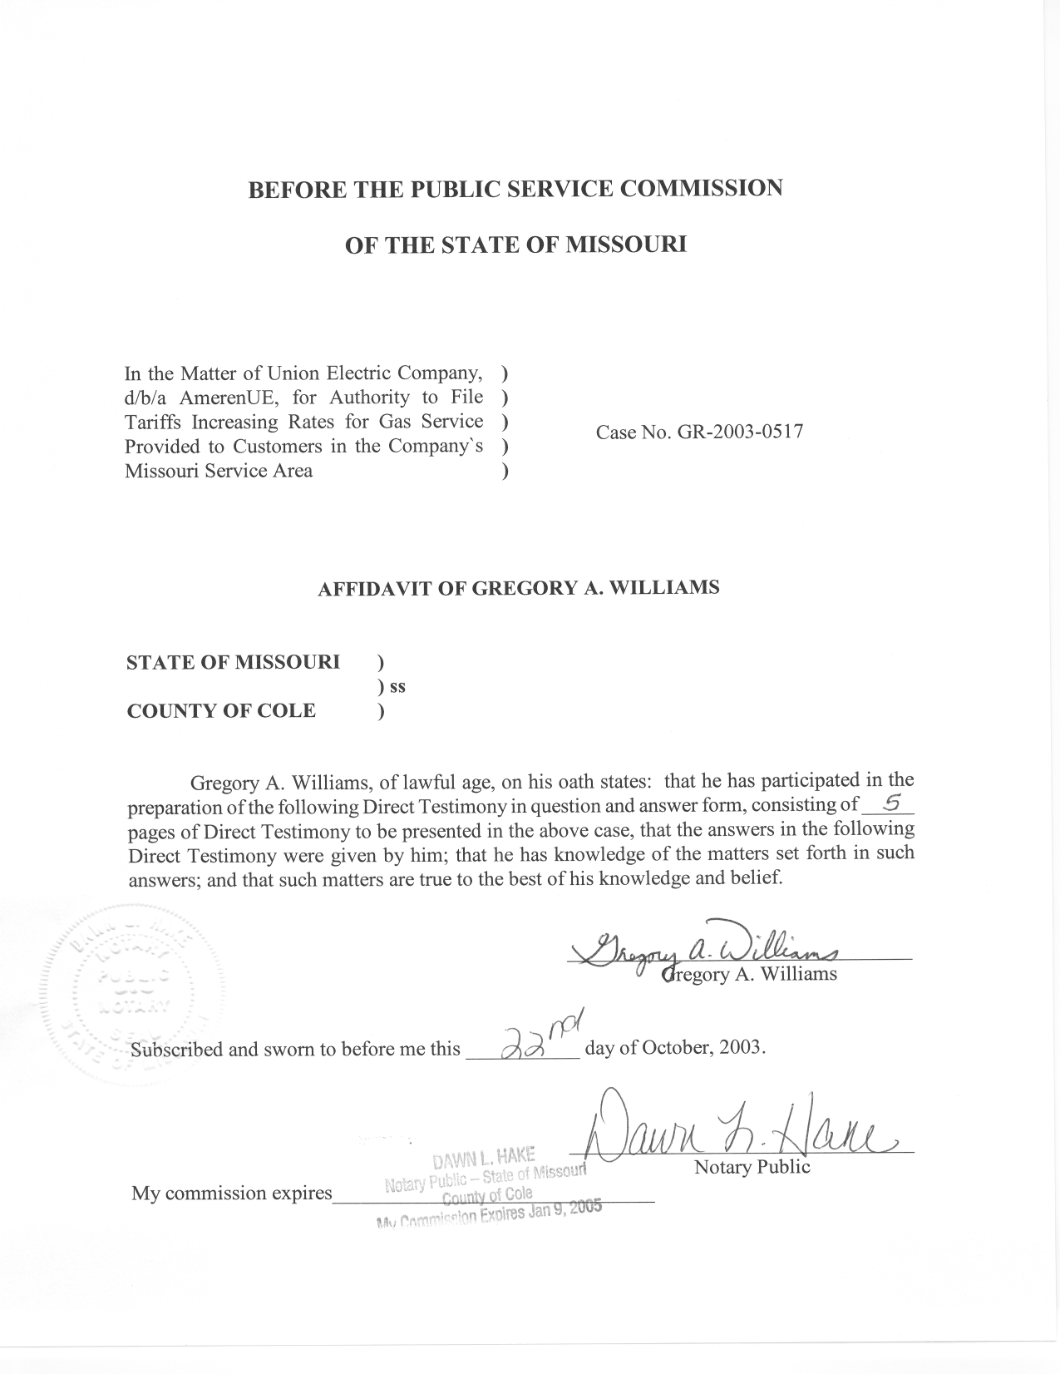
DIRECT TESTIMONY
OF
GREGORY A. WILLIAMS
UNION ELECTRIC COMPANY
D/B/A AMEREN UE
GR-2003-0517

Q. Please state your name and business address.
A. My name is Gregory A. Williams and my business address is P.O. Box 360, Jefferson City, Missouri, 65102.
Q. By whom are you employed and in what capacity?
A. I am employed by the Missouri Public Service Commission (PSC or Commission) as a Utility Engineering Specialist II.
Q. How long have you been employed by the Commission?
A. I have been an employee of the Commission since July 15, 1990.
Q. Please state your educational background and your professional qualifications.
A. In May of 1989, I received my Bachelor of Science degree in Mechanical Engineering at the University of Missouri-Rolla and I have successfully passed the Engineer-In-Training (EIT) Examination. Since July of 1990, I have served my present position in the Safety/Engineering Section of the Energy Department. While at the Commission, I have successfully completed the seven courses required and offered by the U.S. Department of Transportation at the Transportation Safety Institute in Oklahoma City, Oklahoma, regarding the enforcement of the Federal Pipeline Safety regulations (49 CFR, Parts 191 and 192). I am a Certified Fire and Explosion Investigator through the office of the National Association of Fire
Investigators (NAFI). My responsibilities in the Safety/Engineering section of the Energy Department include monitoring all phases of natural gas utility plant design, installation, operation, and maintenance. I conduct on site natural gas facility safety inspections, including new construction projects, review and analyze operator’s records, plans, procedures, and investigate natural gas related incidents, customer complaints, and outages.
Q. Have you previously filed testimony before the Commission?
A. No, I have not.
Q. What is the purpose of your testimony?
A. The purpose of my testimony is to discuss Union Electric Company d/b/a Ameren UE (Ameren UE or Company) gas line replacements. This includes the “actual” and “budgeted” costs associated with the replacement and/or retirement of natural gas cast iron mains, the replacement of both unprotected steel mains and steel service lines, and the replacement of unprotected steel yard lines for the calendar years of 2000 through 2003.
Q. Does the Commission require natural gas operators within Missouri to replace certain natural gas facilities like cast iron mains, unprotected steel mains and services, as well as, unprotected steel yard lines?
A. Yes.
Q. Could you give a brief explanation of the Commission’s pipeline safety regulations that require the replacement of these types of natural gas facilities?
A. Section (15) of the Commission’s Pipeline Safety Regulations discusses the various requirements associated with the replacement programs for cast iron mains, unprotected steel mains and service lines, and unprotected steel yard lines.
In particular, pipeline safety requirement 4 CSR 240-40.030(15)(D) discusses the requirements for the replacement of natural gas cast iron mains in which all Missouri operators had to submit a proposed replacement program by May 1, 1990, for Commission review and approval. Case No. GO-91-274 describes Ameren UE’s approved cast iron main replacement program.
Regulation 4 CSR 240-40.030(15)(E), defines the requirements for replacing unprotected steel mains that had no cathodic protection applied prior to December 15, 1989. All operators within Missouri were required to submit a proposed unprotected steel main replacement program by May 1, 1990 for Commission review and approval. Case No. GO-91-274 describes Ameren UE’s approved unprotected steel main replacement program.
For both operator-owned and customer-installed unprotected steel service lines and unprotected steel yard lines, pipeline safety regulation 4 CSR 240-40.030(15)(C) defines several replacement program options. Unless otherwise ordered by the Commission, all natural gas operators within Missouri were required to notify the Commission by May 1, 1990 which option, or combination of replacement program options, the respective operators would implement. In Case No. GO-93-119, the Commission granted Ameren UE a waiver from certain provisions of (15)(C). In particular, Ameren UE was granted permission by the Commission to replace unprotected steel yard lines and company-owned and installed unprotected steel service lines on a 20-year schedule ending January 2010. Ameren UE completed the replacement program for customer-installed unprotected steel service lines during January 2000.
Q. Could you describe the “actual costs” spent towards the replacement of Ameren UE’s cast iron mains during the fiscal years of July 1, 2000-June 30, 2003?
A. In response to Staff Data Request No. 3202, Ameren UE indicated that the “actual cost” for the replacement of cast iron mains during the fiscal years of July 1, 2000-June 30, 2003 were:
FY 2000: $1,935,900.00
FY 2001: $1,199,500.00
FY 2002: $2,219,900.00
FY 2003: $3,711,700.00
Q. Would you describe the Company’s “budgeted amount” for the cast iron main replacement program for the calendar years of 2000 through 2003?
A. In its response to Staff Data Request No. 3202, the Company indicated that the “budgeted amount” for the replacement of cast iron mains for calendar years 2000 through 2003 were:
2000: $2,253,300.00
2001: $1,810,200.00
2002: $4,272,200.00
2003: $3,149,100.00
Q. What was the “actual cost” Ameren UE spent towards the replacement or retirement of all unprotected steel mains, unprotected steel service lines, and all unprotected steel yard lines, during the fiscal years of July 1, 2000-June 30, 2003?
A. In the Company’s response to Staff Data Request No. 3201, the “actual cost” Ameren UE spent towards the replacement or retirement of the combined categories of unprotected steel mains and steel service lines, and unprotected steel yard lines for the fiscal years of July 1, 2000-June 30, 2003 were:
FY 2000: $942,700.00
FY 2001: $84,100.00
FY 2002: $195,200.00
FY 2003: $193,100.00
Q. Would you describe the Company’s “budgeted amount” that was made for the calendar years of 2000 through 2003 for the replacement or retirement of unprotected steel mains, unprotected steel service lines, and unprotected steel yard lines?
A. In the Company’s response to Staff Data Request No. 3201, the “budgeted amount” for the replacement or retirement of the combined categories of unprotected steel mains and steel service lines, and unprotected steel yard lines for the calendar years of 2000 through 2003 were:
2000: $450,000.00
2001: $90,200.00
2002: $116,700.00
2003: $168,100.00
Q. Does the Company currently have the capability to continue making these replacements?
A. Yes. The Staff has received no information either verbally or in written format that would lead one to believe that the Company does not have the resources currently to continue these programs.
- Does this conclude your testimony?
A. Yes.

