Exhibit No.:
Issues: MPS Revenues

Witness: Hong Hu
Sponsoring Party: MO PSC Staff
Type of Exhibit: Direct Testimony
Case No.: ER-2004-0034 &
HR-2004-0024
(Consolidated)
Date Testimony Prepared: December 9, 2003

MISSOURI PUBLIC SERVICE COMMISSION

Utility Operations DIVISION

Direct Testimony

OF

Hong Hu

Aquila, Inc.
d/b/a Aquila Networks -- mps
and Aquila Networks -- l&P

CASE NO. ER-2004-0034 & HR-2004-0024
(CONSOLIDATED)

Jefferson City, Missouri
December 2003

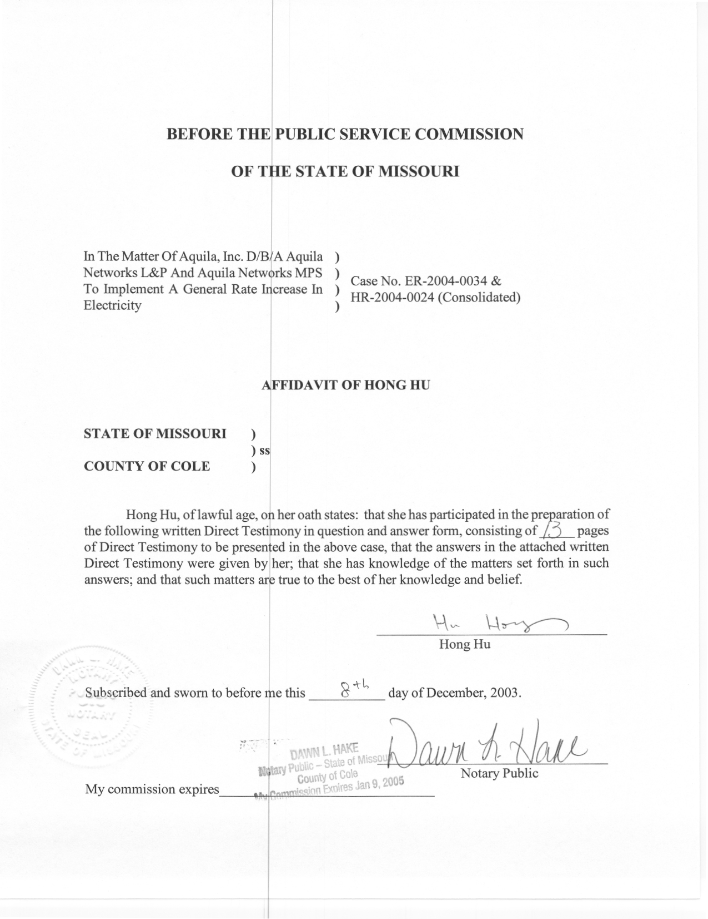
TABLE OF CONTENTS

RATEMAKING TREATMENT OF SALES AND REVENUE 3
MPS ELECTRIC KWH SALES AND RATE REVENUE 5

DIRECT TESTIMONY
OF
HONG HU
AQUILA, INC.
D/B/A AQUILA NETWORKS-MPS
AND AQUILA NETWORKS-L&P
CASE NOS. ER-2004-0034 AND HR-2004-0024
(CONSOLIDATED)

Q. Please state your name and business address.
A. My name is Hong Hu and my business address is Missouri Public Service Commission, P. O. Box 360, Jefferson City, Missouri 65102.
Q. What is your present position with the Missouri Public Service Commission?
A. I am a Regulatory Economist in the Energy-Economic Analysis Department, Operations Division.
Q. Would you please review your educational background and work experience?
A. I hold a Bachelor of Engineering degree in Management of Information Systems from Tsinghua University of Beijing, China and a Masters of Arts degree in Economics from Northeastern University. I have completed the comprehensive exams for a Ph.D. in Economics from the University of Missouri at Columbia. I worked as a regulatory economist at the Office of Public Counsel (OPC, Public Counsel) from March 1997 to March 2003. I have been employed by the Missouri Public Service Commission (Commission) since March 2003. A list of the cases in which I have filed testimony before the Commission is shown on Schedule 1.
Q. What is the purpose of your direct testimony in this filing?
A. My direct testimony on the issue of Sales and Revenue describes my role in the collaborative effort with Staff Witness Janice Pyatte and Staff Witness Amanda McMellen in development of specific adjustments to Missouri jurisdictional, test year sales and revenue from sales (rate revenue) for the electric operations of Aquila Networks-MPS (“MPS Electric”).
In this filing, I present two schedules for MPS Electric’s operations that summarize Missouri sales and rate revenue by rate schedule, based upon a test year of January 1, 2002 – December 31, 2002, updated for known and measurable changes through September 30, 2003. The adjusted Missouri retail sales for the updated test year shown on Schedules 2 are consistent with the normalized hourly system loads used in Staff’s production cost simulation model fuel run.
The specific adjustments to MPS Electric’s revenues shown on Schedule 3 are shown as adjustments in the Staff’s Income Statement (Accounting Schedule 9) for MPS Electric. Staff Witness Amanda McMellen is sponsoring the adjustments to annualize large customers for load changes and to reflect growth in the number of customers for the smaller customers.
Q. What is the relationship between the Missouri rate revenue shown on your Schedule 3 and the Missouri operating revenue shown on Accounting Schedule 9-Income Statement?
A. Total operating revenue, which is shown on Accounting Schedule 9-Income Statement, consists of two components: the revenue that the Company collects from the sales of electricity to Missouri retail customers (“rate revenue”), which is shown on my Schedule 3; and the revenue the Company receives from other sources (“other revenue”). My testimony addresses only Missouri rate revenue for MPS Electric. Please refer to similar schedules attached to the testimony of Staff witness Janice Pyatte for Missouri rate revenue for Aquila Networks-L&P (“L&P Electric” and “L&P Steam"). Any proposed adjustments to other revenue for L&P Electric, L&P Steam and MPS Electric are sponsored by Staff Witness Amanda McMellen.
Q. Do you have a recommendation for the Commission regarding MPS Electric sales and rate revenue?
A. I recommend that the Commission adopt the Staff’s adjustments to booked sales and rate revenue for MPS Electric that are shown on Schedules 2 and 3. If adopted, Staff’s rate revenue by rate schedule will be used to implement any Commission-ordered revenue change in this case.

RATEMAKING TREATMENT OF SALES AND REVENUE
Q. What is the rationale for making adjustments to test year sales and revenue?
A. The historical 12-month time period (“test year”) and “update period” (if any) that the Commission determines should be used for analyzing the costs of providing service to retail customers is also used for analyzing sales and revenue, based on the “matching principle” of ratemaking. The intent of adjustments to test year revenue is to estimate the revenue that the company would have collected on an annual, normal-weather basis, based on information “known and measurable” at the end of the analysis period.
Most adjustments to test year revenue correspond to adjustments to sales that, in turn, affect the Company’s fuel and purchased power costs. Net system loads, updated for these known and measurable changes in sales, are reflected in the production cost simulation model to ensure that sufficient generation and purchases exist to meet total net system requirements. Any change to revenue from historical levels that results from changes in underlying sales will result in corresponding changes to fuel and purchased power costs that reflect that same adjustment to sales.
Q. What categories of adjustments to kWh sales and revenue are typically made in a rate increase or a complaint (excess earnings) case?
A. The two major categories of adjustments are known as normalizations and annualizations.
Normalizations deal with test year events that are unusual and unlikely to be repeated in the years when the new rates from this case are in effect. Test year weather is an example. It is unlikely that the weather that occurred in the test year will, on average, be repeated in the future, but what weather will actually occur is not predictable. The objective of the weather normalization process is to restate test year sales and rate revenue on a “normal-weather” basis. Annualizations are adjustments that restate test year results as if conditions known at the end of the analysis period had existed throughout the entire test year.
Q. Please provide some examples of common annualizations that may occur in an electric rate case?
A. A common example of a revenue annualization is a rate change that occurs during the test year. Actual test year revenue in this situation will be understated or overstated by the difference between the amount that was actually billed to customers and the revenue that would have been realized by the company if the rates in effect at the end of the analysis period had been in effect throughout the entire test year.
An example of an annualization that affects both sales and revenue is a large customer that either begins or ceases service during the analysis period. In the situation where a large customer ceases business, test year revenue should be decreased by the amount of revenue the customer provided the Company. A corresponding reduction to sales and to fuel and purchased power expense should be made to reflect the costs the company will no longer incur. Conversely, when a large customer begins service, test year revenue, kWh sales, and fuel expense should be increased to reflect both the costs and the revenue associated with serving the new customer on an annual basis.
Customer growth adjustments are annualizations that reflect any additional sales and revenue (or reductions to sales and revenues) that would have occurred in the test year if all of the customers that were on the system at the end of the analysis period had been customers for all twelve months of the test year.

MPS ELECTRIC KWH SALES AND RATE REVENUE
Q. Which specific adjustments to MPS Electric’s sales and rate revenue from electric operations are you recommending?
A. I recommend that the Commission adopt the Staff’s adjustments to sales and revenues shown on Schedules 2 and 3, and identified on Accounting Schedule 9-Income Statement for MPS Electric. A description of these adjustments appears on Accounting Schedule 10-Adjustments to Income Statement.
Q. How does your testimony on MPS Electric sales and revenues relate to the testimony of other Staff witnesses in this case?
A. I am responsible for compiling the table labeled as Schedule 2, which summarizes the results of Staff’s work relating to Missouri sales (measured in kWh) for MPS Electric. In addition to the adjustments to kWh sales addressed in my testimony, Staff witness Richard J. Campbell addresses the normalization of kWh sales to account for the effects of deviations from normal weather in the test year, and Staff witness Amanda McMellen addresses the effect that growth (or decline) in the number of customers had on kWh sales. The annualization of kWh sales for the large customers was a collaborative effort between Ms. McMellen and myself.
I am also responsible for compiling the table labeled as Schedule 3, which summarizes the results of Staff’s work relating to Missouri rate revenue for MPS Electric. My testimony addresses the methodologies used to calculate annualized, normalized rate revenue for each affected rate code. Ms. McMellen’s testimony addresses the effect that growth (or decline) in the number of customers had on rate revenue. The annualization of rate revenues for the large customers was a collaborative effort between Ms. McMellen and myself.
Q. Please describe the characteristics of the Missouri kWh sales and rate revenue that have been developed in this case.
A. The Missouri kWh sales and rate revenue that I am presenting have these characteristics: (i) they have been developed by rate schedule (“rate code”); (ii) they have been normalized to remove the effects of deviations from normal weather in the test year; (iii) they have been developed on both a billing month and a calendar year (i.e., 365-day) basis; and (iv) they have been adjusted to reflect load growth/decline.
In addition, rate revenue has been annualized to reflect the decrease in permanent rates that occurred March 21, 2002, as an outcome of Case No. ER-2002-672 and the change in economic development rider (“EDR”) credits to 2003 levels.
Q. What specific annualizations to test year kWh sales and rate revenue were done in this case?
A. I determined a number of annualizations to individual Large Power Service customers that reflect significant increases or reductions in electric load. I computed a days adjustment for each customer, if required, to ensure that sales and revenue represented a 365-day period. I also “cleaned-up” the monthly billing information recorded in the Company’s financial records to properly reflect billing corrections.
Q. Please describe the rationale for annualizing Large Power customers individually rather than in aggregate.
A. Large Power customers are the largest electricity-using customers. This group of 188 customers is heterogeneous in terms of both size and load factor and, as a consequence, aggregate methods of analyzing them are generally not very accurate. To accommodate the pending Aquila rate design case, Case No. EO-2002-384, special care was taken in this case to reflect the unique circumstances of each customer.
Q. Please describe the process used to annualize billing corrections for individual Large Power customers.
A. A number of adjustments were made to individual Large Power customers to reflect selected billing corrections that Aquila made during the test year and/or update period. The typical situation was where an original bill was wrong and the correction is recorded in a month other than the month that the original, incorrect bill was recorded. Billing corrections are recorded as a “cancel” of the original bill and a separate bill for the “rebill” of the correct amount. In this situation, the monthly data that is required for Staff’s analysis of kWh sales and rate revenue is distorted. I adjusted the individual customer kWh sales and revenue, as recorded by Aquila, to what I believe the data would have looked like if the original bill had been correct in the first place, i.e., I moved the “cancel” and the “rebill” to the month in which the incorrect original bill was recorded. This had no effect on annual sales and revenues, except in those instances where the incorrect original bill was for a month that was prior to the test year and where the billing corrections occur in the update period. The annual differences associated with this “clean-up” of test year billing data were recorded as annualizations so that it would be clear that Staff’s starting point in this case was consistent with Aquila’s FERC Form 1 filing for the year 2002.
Q. Please describe the process used to annualize individual Large Power customers for significant increases or reductions in electric load.
A. The first step was to determine whether each customer experienced a significant increase or reduction in electric load that required annualizing. I graphically examined each customer’s monthly demand and energy use over the test year and update period to determine whether a change in the “size” of the customer had occurred. Aquila provided a list of customers that it had identified as being likely to experience a significant change in load. These customers received closer scrutiny to determine whether a measurable load change had occurred.
The most common method used to annualize a specific customer for load changes was to replace specific months of that customer’s January 2002-September 2002 test year data with its billing data for corresponding months in the January 2003-September 2003 update period. Care was taken to reflect the known, unique circumstances of each customer.
These annualizations are shown by rate schedule on Schedules 2 and 3, attached to this testimony, and, in aggregate, on Accounting Schedules 9 and 10, S-1.
Q. What normalizations to test year billed kWh sales were done in this case?
A. Two normalizations of test year kWh sales were done for this case. The first normalization restates test year kWh sales on a “normal weather” basis; i.e., to the level of kWh sales that would have occurred in the test year if test year weather had been “normal.” The second normalization represents the change in kWh sales associated with adjusting the twelve test year billing months to the equivalent of 365 days.
Mr. Campbell is sponsoring both the weather normalization to kWh sales and the “days” adjustments to kWh sales. His annual results are shown by rate schedule on Schedule 2, A Summary of Missouri kWh sales. Please refer to Mr. Campbell’s testimony for a more complete description of the weather normalization concept and methodology.
Q. What normalizations to test year rate revenue were done in this case?
A. I am responsible for calculating the adjustments to rate revenue that are associated with both of Mr. Campbell’s adjustments to kWh sales. Weather adjustments were computed for Residential rate codes (MO860, MO870, MO720, MO740), Small General Service rate codes (MO710, MO711), the Large General Service rate code (MO720), and the Schools & Churches rate code (MO740).
Three different methodologies for normalizing rate revenue were used. The assumption underlying all three methodologies is that the weather normalization process has no effect on either the number of customers or on the fixed charges those customers currently pay. I assumed that weather normalization only affects the energy usage of each existing customer and thus only affects those charges directly related to kWh usage.
Q. Why were multiple methodologies used?
A The methodology used for normalizing rate revenue for each rate code was determined by the rate structure.
Q. Please briefly describe each methodology and the situations where each was used.
A. The rate structure of rate code MO710 and MO740 consists of base energy and seasonal energy blocks for winter months and only one tariffed rate for energy usage in the summer months. Therefore, weather normalization adjustments are calculated for all monthly usage for summer months at the single summer rate. Weather normalization adjustments are directly assigned to the seasonal energy block for the winter months because I believe this rate structure is designed so that a customer’s base energy block reflects its non-weather sensitive usage and any weather effect should be captured in the seasonal energy block.
There are multiple energy rate blocks for residential rate codes MO860 and MO870. As customer usage increases the percentage of usage in each energy block in the total energy usage changes. Using a statistical regression technique, I modeled the relationship between average monthly use per customer and the percentage of usage in each block for each season of these two rate codes. After determining how the percentage in the blocks changed when use per customer changed, I applied this relationship to the monthly usage per customer before and after the weather adjustment that Mr. Campbell had provided me. I then calculated the monthly weather adjustment to revenue that corresponds to Mr. Campbell’s monthly weather adjustment to kWh sales based on that relationship.
Rate codes MO711 and MO720 have a rate structure where energy blocks are determined based on a customer’s hours of use. In other words, the energy blocks are different for each customer based on each customer’s level of demand. I was unable to develop a regression analysis technique for this rate structure that proved to be meaningful; therefore, the weather adjustments to revenue for these rate codes were calculated by the average realization method. This method applies the average energy charge per kWh for each specific month to the weather adjustment to that month’s kWh sales. The rationale for the average realization method is that a reasonable estimate of the change in revenue associated with a change in kWh sales can be calculated by assuming that the change in sales would be priced at the same average price as the actual sales in that month.
Schedule 3 shows the annual normalization adjustment to revenue for each rate schedule. This normalization adjustment to revenue is also included in Accounting
Schedule 9–Income Statement and Accounting Schedule 10—Adjustments to Income Statement.
Q. How was the effect of customer growth on kWh sales and revenue accounted for?
A. Conceptually, customer growth adjustments reflect the additional kWh sales and rate revenue that would have occurred if the number of customers taking service at the end of the update period (September 30, 2002) had existed throughout the entire test year. Ms. McMellen is sponsoring the aggregate customer growth adjustment to rate revenue shown on Accounting Schedules 9 and 10. My Schedules 2 and 3 display Ms. McMellen’s results by rate schedule, split between test-year-related growth and update-period-related growth. Please refer to Ms. McMellen’s testimony for a more complete description of the customer growth concept and methodology.
Q. How was the effect of the rate change accounted for?
A. The current Aquila MPS Electric rates became effective on March 21, 2002 as a result of the last rate case. For most of the rate codes, customers were subject to different rates before and after the rate change. Adjustments needed to be made so that the total rate revenue is as if the current rates have been in effect since the start of the test year.
Monthly revenues were calculated based on billing units I obtained from the Company for each rate code. For the month of January, February, and March, monthly revenues were calculated both under the old rates and the current rates, and the difference between the two results was retained as an adjustment. Due to billing cycles, it is possible that the rate change also affected the reported revenues in April. I have used the difference between revenue calculated based on the billing units under the current revenue and the revenue reported in the Company’s revenue report as an proxy of rate change adjustment for April.
Q. How was the change in Economic Development Rider (“EDR”) credits accounted for?
A. Under MPS Electric’s Economic Development Rider a customer who qualifies for EDR credits will receive a 30% revenue reduction in the first year of its operation, 25% revenue reduction in the second year, 20% in the third year, 15% in the fourth year and 10% reduction in the fifth year. For each customer, the EDR credits reduce by 5% each year until the last year when it reduces from 10% to zero. This effectively decreases the amount of EDR credits each year and increases revenue, unless new EDR customers are added.
I have adjusted the EDR credit for each EDR customer existing at the end of the update period by reducing its EDR credit by 5%, or by eliminating its EDR credit if its EDR contract has already expired. MPS Electric’s Economic Development Rider is not available to new customers after December 31, 2003.
Q. Why are the two Small General Service rate codes (MO710 and MO711) shown combined on your schedules?
A. These two rate codes represent small commercial customers taking service at secondary voltage. The MO710 rate code is used for those customers who do not have demand metering equipment installed; MO711 represents those who do. Despite this distinction, each MO711 customer is currently billed on both the MO710 and MO711 rates and is charged the “lesser of” the two amounts. In the past few years Aquila has pursued a policy of installing demand meters on many of the MO710 customers. As a consequence, the current data shows an overly high rate of growth of MO711 customers and a significant decline in MO710 customers, even though many of those customers continue to be billed on the MO710 rates. Staff’s methodology for calculating the increase (decrease) in sales and revenues based on the growth in the number of customers will overstate Small General Service revenues if computed separately, so Ms. McMellen computed them on a combined basis. Consequently my summary tables show them combined.
Q. Please restate your recommendation for the Commission regarding MPS Electric sales and rate revenue?
A. I recommend that the Commission adopt the Staff’s adjustments to booked sales and rate revenue for MPS Electric that are shown on Schedules 2 and 3.
Q. Does this conclude your direct testimony on the issue of sales and rate revenue in this case?
A. Yes, it does.

