Exhibit No.:
Issues: Seasonal Cost of Service

Witness: Hong Hu
Sponsoring Party: MO PSC Staff
Type of Exhibit: Direct Testimony
Case No.: ER-2004-0570
Date Testimony Prepared: October 4, 2004

MISSOURI PUBLIC SERVICE COMMISSION

UTILITY OPERATIONS DIVISION

DIRECT TESTIMONY

OF

HONG HU

THE EMPIRE DISTRICT ELECTRIC COMPANY

CASE NO. ER-2004-0570

Jefferson City, Missouri
October 2004
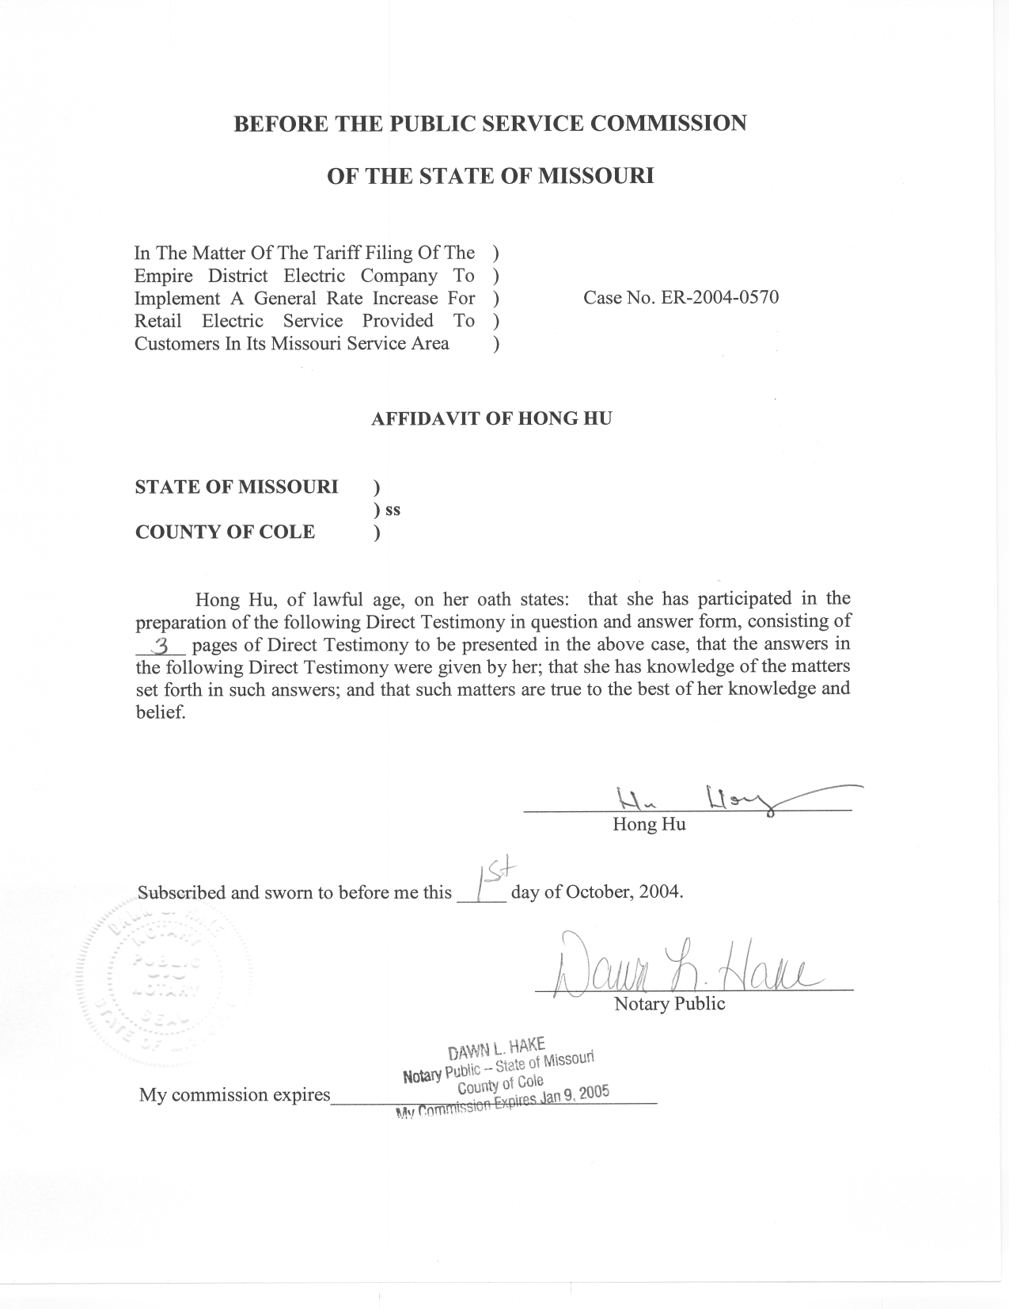

DIRECT TESTIMONY

OF

HONG HU

THE EMPIRE DISTRICT ELECTRIC COMPANY

CASE NO. ER-2004-0570

Q. Please state your name and business address.
A. My name is Hong Hu and my business address is Missouri Public Service Commission, P. O. Box 360, Jefferson City, Missouri 65102.
Q. Are you the same Hong Hu that previously filed direct testimony in this case?
A. Yes, I am.
Q. What is the purpose of your testimony?

A. The purpose of my Direct Testimony is to present the Staff’s Seasonal Cost-of-Service study results.
Q. What is a seasonal cost-of-service study?
A. Basically, a seasonal cost-of-service study is an extension to a class cost-of-service study, which further allocates class cost of service to the summer and winter seasons. A seasonal cost-of-service study can provide guidance in designing seasonally differentiated rates for each customer class.
Q. How did you allocate class cost of service into different seasons?
A. I allocated costs to the seasons on the same bases that costs were allocated to the customer classes, e.g., if certain costs were allocated to the classes based on number of customers, those same costs were allocated to the seasons based on the number of customers in each season. For the costs that were allocated on number of customers, I simply allocated the same amount of cost to each month because, on an annualized basis, each month has the same number of customers. For demand-related costs, I used the capacity utilization method describe below to allocate the costs to each month. I allocated the energy-related costs to each month based upon the monthly kWh sales of each customer class. I summed the costs for June, July, August and September to determine the summer costs, and summed the costs for the remaining months to determine the winter costs.
Q. Please describe the capacity utilization method.
A. I believe that the proper view of cost causality recognizes that certain equipment and facilities are sized to serve the maximum level of demand, but are utilized throughout the entire year. The capacity utilization method first identifies the proportion of capacity that is utilized each month, and then spreads the corresponding increment of cost into the months when these portions of capacity are actually being used. In this manner, each month would be allocated appropriate costs that correspond to only the proportion of the capacity that is being utilized in that month.
Q. Is the seasonal cost-of-service study based on the Staff’s class cost-of-service study that you filed on September 20, 2004?
A. The seasonal cost-of-service study is based on an update of the Staff’s previously filed CCOS. The input data has been updated to reflect updated revenue, sales and loads for the General Power Service rate class in the Large General Service CCOS class, updated load data for the Large Power Service CCOS class, and use of the capacity utilization method for the allocation of capacity related production and transmission cost. The results of the Staff’s updated CCOS study are shown in Schedule 1. The seasonal allocation of these costs by functional category is shown in Schedule 2.
Q. As a part of the seasonal class cost-of-service study, did you further classify the costs?
A. Yes. Staff witness Janice Pyatte requested that I further classify each functional cost category into the following components to provide information she needed for designing rates: Fixed, Variable and Energy-related. This classification is shown on Schedule 3.
Q. Does this conclude your Direct Testimony?
A. Yes.

