Exhibit No.:
Issues: Tariffs
Witness: James A. Gray
Sponsoring Party: MoPSC Staff
Type of Exhibit: Testimony
Case No.: GT-2003-0038
Date Testimony Prepared: September 9, 2002

MISSOURI PUBLIC SERVICE COMMISSION

Utility Operations DIVISION

TESTIMONY

OF

JAMES A. GRAY

AQUILA NETWORKS L&P

CASE NO. GT-2003-0038

Jefferson City, Missouri
September, 2002

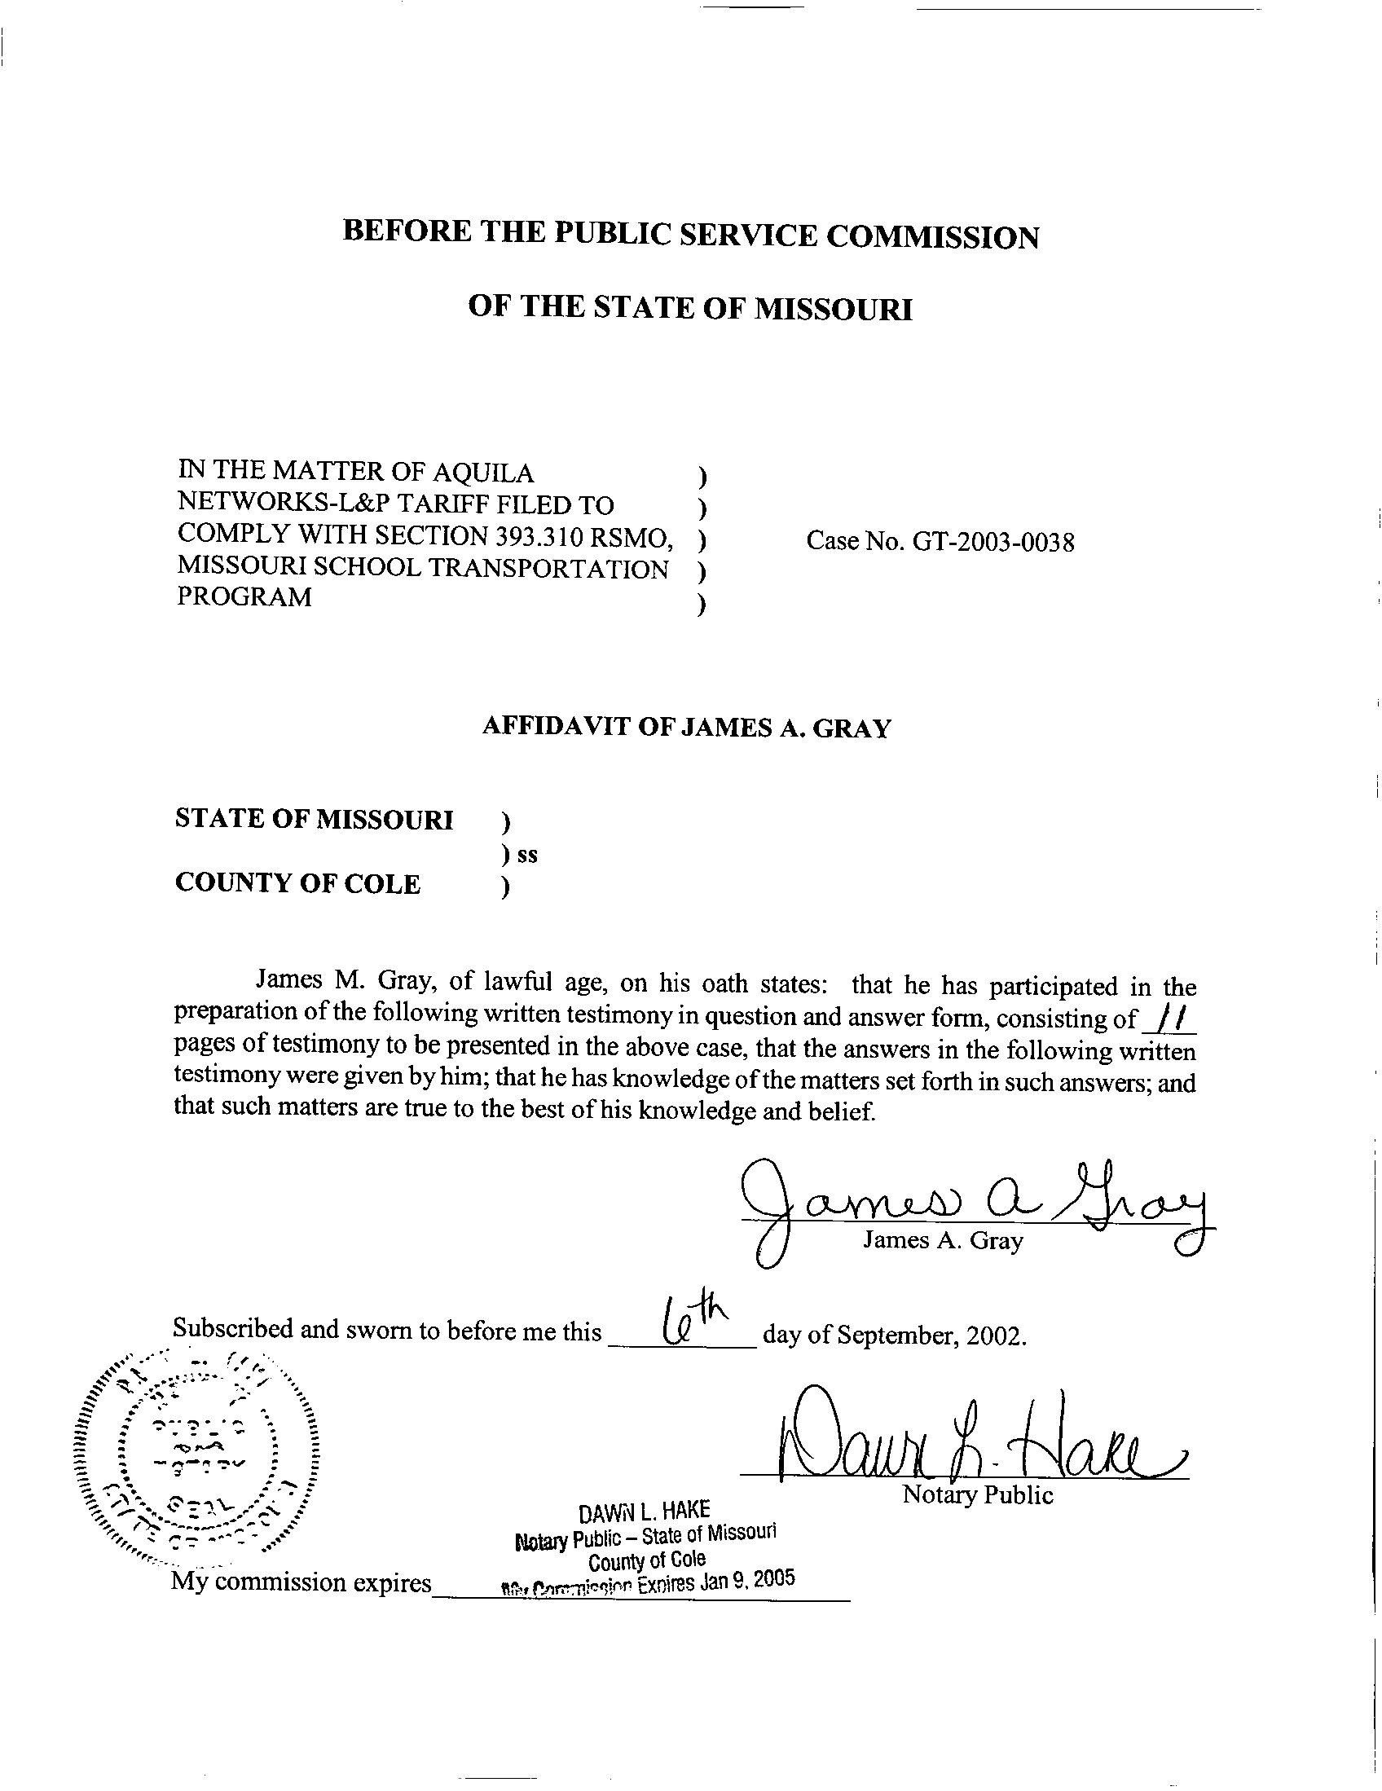
TESTIMONY

OF
JAMES A. GRAY
AQUILA NETWORKS L&P
CASE NO. GT-2003-0038

Q. Please state your name and business address.
A. My name is James A. Gray. My business address is P. O. Box 360, Jefferson City, Missouri 65102.
Q. By whom are you employed and in what capacity?
A. I am employed by the Missouri Public Service Commission (Commission) as a Regulatory Economist in the Tariffs/Rate Design Section of the Commission's Energy Department.
Q. How long have been employed by the Commission?
A. I have been employed with the Commission for approximately twenty-two years.
Q. Please state your educational background.
A. I received a degree of Bachelor of Science in Psychology as well as one in General Studies from Louisiana State University (LSU), and I received a degree of Master of Science in Special Education from the University of Tennessee. Additionally, I completed several courses in research and statistics at the University of Missouri - Columbia.
Q. Please state your professional qualifications.
A. Prior to being employed by the Commission, I was a Research Analyst for two and a half years with the Missouri Department of Mental Health where I conducted statistical analyses. In 1980, I began my employment with the Commission as a Statistician in the Depreciation Department where I submitted testimony regarding depreciation rates, trended-original cost, and trended-original cost less depreciation.
Beginning in 1989 as a member of the Economic Analysis Department, I submitted testimony on weather-normalized sales for natural gas, water, and electric utilities. I reviewed residential-electric-load forecasts with the associated detailed end-use studies and the marketing surveys in electric resource plans.
From 1997 through 2001, I was in the Tariffs/Rate Design Section of the Commission's Gas Department. Since July 2001, I have been in the Tariffs/Rate Design Section of the Commission’s Energy Department. I have reviewed tariffs and applications of natural gas utilities. I have submitted testimony concerning weather-normalized sales, complaints, certificates of convenience and necessity, and recommended minimum-statistical-sample sizes for natural gas residential-customer-billing reviews.
Q. Please list all the cases in which you have submitted prepared written testimony before this Commission.
A. The cases in which I have submitted prepared, written testimony are enumerated in Schedule 1, attached to my testimony.
Q. What is the purpose of your testimony?
A. My testimony addresses the proposed tariffs of Aquila, Inc. (Aquila or Company) d/b/a Aquila Networks – MPS (MPS) and d/b/a Aquila Networks – L&P (L&P) for compliance with § 393.310 RSMo Supp. 2002. The proposed experimental tariffs of MPS and L&P are identical, and I am filing one testimony for Case Nos. GT-2003-0038 and GT-2003-0039, which are consolidated.
First, I will address the timelines required by the statute and which Aquila customers are affected. Second, I will address the definitions or special terms used in the statute. Third, I will address the specific requirements of § 393.310 RSMo Supp. 2002 and whether Aquila’s proposed tariff complies with the statute. Fourth, I will address the tariff items proposed by Aquila that are not required by § 393.310 RSMo Supp. 2002.
Q. Which corporations are affected by § 393.310 RSMo Supp. 2002?
A. The statute states:
393.310.1. This section shall only apply to gas corporations as defined in section 386.020, RSMo.

The statute applies to Missouri investor-owned natural gas utilities, such as Aquila.
Q. When are the Missouri investor-owned natural gas corporations required to file tariff revisions pursuant to § 393.310 RSMo Supp. 2002?
A. The Missouri regulated natural gas utilities are required to file experimental tariffs with the Commission by August 1, 2002, to implement experimental tariffs. The statute states:
3. Each Missouri gas corporation shall file with the commission, by August 1, 2002, a set of experimental tariffs applicable the first year to public school districts and applicable to all school districts, whether charter, private, public, or parochial, thereafter. (§ 393.310.3 RSMo Supp. 2002)

Q. Did Aquila file its proposed experimental tariff sheets by August 1, 2002?
- No, Aquila made two filings, one for MPS and one for L&P, on August 2, 2002. The filings were one (1) day later than required by statute. On September 6, 2002, Aquila filed substitute tariff sheets for MPS and L&P. In my opinion, Aquila filings are not substantially out of compliance with § 393.310.3 RSMo Supp. 2002.
Q. When does the statute require the experimental tariff sheets to become effective?
A. The experimental tariff sheets are required to be in effect by November 1, 2002. Aquila’s proposed experimental tariff sheets bear an effective date of November 1, 2002. Therefore, Aquila’s proposed tariff sheets comply with § 393.310.5 RSMo Supp. 2002.
Q. Does § 393.310 RSMo Supp. 2002 expire?
A. Yes, the statute expires June 30, 2005. The statute states:
7. This section shall terminate June 30, 2005.
(§ 393.310.7 RSMo Supp. 2002)

Aquila’s proposed experimental tariff filing states:
This experimental program shall be in effect from November 1, 2002 to October 31, 2005. (Proposed Tariff Sheet No. 32.9 Gas Transportation Service) (emphasis added)

Aquila’s proposed termination date of the experimental tariff is beyond the statute’s termination date of June 30, 2005. Staff has been informed by Aquila that this date will be changed to June 30, 2003. If this change is made, then Staff believes that Aquila’s tariff complies with the effective dates of the statute.
Q. Which types of customers are affected by the statute?
A. Missouri school districts are affected by the statute. In the first year of the experimental tariff, only the Missouri public school districts are affected. The statute states:
(3) "Eligible school entity", shall include any seven-director, urban or metropolitan school district as defined pursuant to section 160.011, RSMo, and shall also include, one year after the effective date of this section and thereafter, any school for elementary or secondary education situated in this state, whether a charter, private, or parochial school or school district. (§ 393.310.2(3) RSMo Supp. 2002) (emphasis added)

In the second year, the proposed experimental tariff will expand to include other eligible school entities. In this docket, I only address the eligible school entities in Aquila’s natural gas service area.
Q. Do Aquila’s proposed tariff sheets permit Missouri eligible public school entities to aggregate their natural gas purchases?
A. Yes, it does. The Company’s proposed tariff sheets address aggregation for the Missouri school entities for the three years that § 393.310 RSMo Supp. 2002 is in effect:
7. Experimental School Aggregation Program: Pursuant to Sec. 393.310.1 RSMo, the fee for aggregation and balancing services for schools aggregating gas requirements under this schedule shall be $0.004 per Therm during the twelve (12) month period following the approval date of this schedule. After the initial twelve (12) months of this program, the charges described in paragraphs H and I will apply to all small volume customers, including schools. (Aquila Proposed Tariff Sheet No. 32.9, Gas Transportation Service)

Aquila’s proposed experimental tariff sheets do not describe which school entities are eligible for service in each of the three years of the program. However, the statue does clearly define the eligible school entities. Therefore, in my opinion, Aquila’s proposed tariff sheets comply with § 393.310.2(3) RSMo Supp. 2002.
Q. Does the statute address how school districts may purchase natural gas?
A. Yes, briefly, the statute allows an eligible school entity to pool or aggregate its natural gas purchases for all of its various locations. Then, a marketer may purchase the natural gas from the various suppliers, and the marketer may arrange the delivery of the gas to an Aquila delivery point on behalf of the eligible school entities. The statute defines aggregation as the following:
(1) "Aggregate", the combination of natural gas supply and transportation services, including storage, requirements of eligible school entities served through a Missouri gas corporation's delivery system;
(§ 393.310.2(1) RSMo Supp. 2002) (emphasis added)

The statute provides for pooling or aggregating of natural gas purchases by Missouri school entities. Also, the statute addresses purchases of natural gas:

(1) Provide for the aggregate purchasing of natural gas supplies and pipeline transportation services on behalf of eligible school entities in accordance with aggregate purchasing contracts negotiated by and through a not-for-profit school association; (§ 393.310.4(1) RSMo Supp. 2002) (emphasis added)

Q. Do Aquila’s proposed tariff sheets define aggregation?
A. Yes, Aquila’s proposed experimental tariff states:
B. DEFINITIONS
AGGREGATION - The practice of combining the nominations and balancing of gas delivered to more than one end-user from receipt point(s) served by a common pipeline. Aggregation of end-users is allowed only on a common pipeline. To qualify for aggregation service, end-users must be served by a common pipeline in the same pipeline operating zone.
AGGREGATION POOL – A group of one or more end-users, with each end-use meter qualifying under the applicable rate schedule for transportation service. Any energy seller, supplier, marketer or broker that serves more than one end-user that is eligible to be pooled for the purpose of forming an aggregation pool will be deemed to be an aggregator, and will be required to execute a Marketer Agreement.
AGGREGATOR – An entity (such as an energy seller, marketer, supplier, or other entity) responsible for the aggregation of gas delivered to more than one end-user. (Aquila Proposed Tariff Sheet No. 32.4, Gas Transportation Service)

Q. How is the Company compensated for aggregating and balancing natural gas between deliveries of natural gas and purchases of natural gas for the eligible school entities?
A. Balancing is the equalizing of the volumes of natural gas withdrawn from Aquila’s system, an interstate pipeline system, or both (in this instance, delivered to any eligible school entity under the proposed experimental tariff) with the volumes of natural gas injected into Aquila’s system. The statute permits the Company to charge a fee per therm of natural gas sales delivered to an eligible school entity’s various locations.
Q. What is a therm?
A. A therm is a unit of heat equal to 100,000 British thermal units (Btu), which is the quantity of heat required to raise the temperature of one pound of water by one degree Fahrenheit. In volume, a therm is approximately one hundred cubic feet (Ccf) of natural gas under physical conditions prescribed in FERC-approved interstate pipeline tariffs. A therm is usually slightly more than one (1) Ccf.
Q. What balancing fee does the statute allow?
A. The statute allows a $.004 cent per therm charge to be assessed on gas delivered to each school district. The statute states:
(2) Provide for the resale of such natural gas supplies, including related transportation service costs, to the eligible school entities at the gas corporation's cost of purchasing of such gas supplies and transportation, plus all applicable distribution costs, plus an aggregation and balancing fee to be determined by the commission, not to exceed four-tenths of one cent per therm delivered during the first year; and (§ 393.310.4(2) RSMo Supp. 2002) (emphasis added)

Q. What aggregation and balancing fees do Aquila’s proposed experimental tariff sheets permit?
A. Aquila’s proposed experimental tariff sheet no. 32.9 states:

…the fee for aggregation and balancing services for schools aggregating gas requirements under this schedule shall be $0.004 per Therm during the twelve (12) month period following the approval date of this schedule. (Aquila Proposed Tariff Sheet No. 32.9, Gas Transportation Service) (emphasis added)

In my opinion, Aquila’s proposed experimental tariff sheets conform to § 393.310.4(2) RSMo Supp. 2002.
Q. Does the statute exempt school districts from special metering devices?
A. Yes, special metering devices are not required for annual usage of one hundred thousand (100,000) therms or less annually. The statute states:
(3) Not require telemetry or special metering, except for individual school meters over one hundred thousand therms annually.
(§ 393.310.4(3) RSMo Supp. 2002)

Q. Does Aquila’s proposed experimental tariff sheets comply with § 393.310.4(3) RSMo Supp. 2002?
A. Yes, it does. Aquila’s proposed experimental tariff states:
No telemetry shall be required unless a facility is expected to consume over 100,000 Therms annually. (Aquila Proposed Tariff Sheet No. 32.9, Gas Transportation Service)

Only eligible school entities using more than one hundred thousand (100,000) Ccf usage per year will be required to use a special metering device. Therefore, Aquila’s proposed experimental tariff sheets do comply with § 393.310.4(3) RSMo Supp. 2002.
Q. Do Aquila’s proposed experimental tariff sheets contain provisions not in the statute?
A. Yes, Aquila’s proposed experimental tariffs include subsections on reporting to the Staff, an annual cost true-up, and collection of gross receipts taxes.
The proposed experimental tariff filing has a gross receipts tax subsection. § 393.310.5 RSMo Supp. 2002 requires the proposed experimental tariff to not have an affect on taxing authorities. Staff witness Jennifer Markway of the Energy Department will address this issue in her testimony in this case.
Aquila’s proposed experimental tariff filing has a subsection on capacity release. Aquila is currently taking delivery of natural gas to serve its firm customers from more than one natural gas pipeline. This subsection addresses the allocation of Aquila’s firm capacity on the different pipelines to the various eligible school entities in Aquila’s service territory. Staff witness Thomas M. Imhoff of the Energy Department will address this issue in his testimony in this case.
Since Aquila is modifying the existing Gas Transportation Service tariff provisions to include eligible school entities, there are many provisions that pertain to Aquila’s existing transportation customers. These general tariff provisions describe how nominations and deliveries are to be made. In my opinion, these general provisions comply with the statute since the current tariff contains similar wording for transportation customers.
Q. Which portions of Aquila’s proposed experimental tariff sheets do not comply with the statute?
A. The proposed experimental tariff sheets only partially comply with the statutory timelines. The termination date of the experimental program is later than the termination of § 393.310 RSMo Supp. 200, which is June 30, 2005. I would recommend that the experimental program be in effect from November 1, 2002, to June 30, 2005.
Q. Please summarize which portions of Aquila’s proposed experimental tariff sheets does comply with the statute.
A. First, the maximum balancing fee of $.004 per therm for natural gas delivered is not exceeded.
Second, Aquila’s proposed experimental tariff filing does not require any special metering equipment for any eligible school entity using less than one hundred thousand (100,000) Ccf annually.
Third, Aquila’s proposed experimental tariff filing is designed to allow local tax authorities to receive revenues in the same manner as if the school districts were still firm customers of Aquila.
Q. What are your recommendations?
A. With the exception of the Staff’s concerns with the termination date of the experimental tariff provisions, I would recommend approval of Aquila’s proposed experimental tariff filing on school aggregation, based on Aquila’s compliance with § 393.310 RSMo Supp. 2002.
Q. Does this conclude your testimony?
A. Yes, it does.
Aquila Networks L&P, Inc.
Case No. GT-2003-0038

Testimonies Submitted by James A. Gray
COMPANY CASE NO.

Missouri Public Service Company GR-81-312
Missouri Public Service Company ER-82-39
Missouri Public Service Company GR-82-194
Laclede Gas Company GR-82-200
St. Louis County Water Company WR-82-249
Missouri Public Service Company ER-83-40
Kansas City Power & Light Company ER-83-49
Osage Natural Gas Company GR-83-156
Missouri Public Service Company GR-83-186
The Gas Service Company GR-83-225
Laclede Gas Company GR-83-233
Missouri Water Company WR-83-352
Missouri Cities Water Company WR-84-51
Le-Ru Telephone Company TR-84-132
Union Electric Company ER-84-168
Union Electric Company EO-85-17
Kansas City Power & Light Company ER-85-128
Great River Gas Company GR-85-136
Missouri Cities Water Company WR-85-157
Missouri Cities Water Company SR-85-158
United Telephone Company of Missouri TR-85-179
Osage Natural Gas Company GR-85-183
Kansas City Power & Light Company EO-85-185
ALLTEL Missouri, Inc. TR-86-14
Sho-Me Power Corporation ER-86-27
Missouri-American Water Company, Inc. WR-89-265
The Empire District Electric Company ER-90-138
Associated Natural Gas Company GR-90-152
Missouri-American Water Company, Inc. WR-91-211
United Cities Gas Company GR-91-249
Laclede Gas Company GR-92-165
St. Joseph Light & Power Company GR-93-42
United Cities Gas Company GR-93-47
Missouri Public Service Company GR-93-172
Western Resources, Inc. GR-93-240
Laclede Gas Company GR-94-220
United Cities Gas Company GR-95-160
The Empire District Electric Company ER-95-279
Laclede Gas Company GR-96-193
Missouri Gas Energy GR-96-285
Associated Natural Gas Company GR-97-272
Union Electric Company GR-97-393
Missouri Gas Energy GR-98-140
Laclede Gas Company GR-98-374
St. Joseph Light & Power Company GR-99-42
AmerenUE GA-99-107
Laclede Gas Company GA-99-236
Laclede Gas Company GR-99-315
AmerenUE GR-2000-512
Missouri Gas Energy GR-2001-292
Gateway Pipeline Company, Inc., et al. GM-2001-585
Missouri Gas Energy, et al GC-2001-593
Laclede Gas Company GR-2002-356
Laclede Gas Company GA-2002-429
Missouri Gas Energy GT-2003-0033

