Exhibit No.:
Issues: Tariffs
Witness: James A. Gray
Sponsoring Party: MoPSC Staff
Type of Exhibit: Direct Testimony
Case No.: GT-2003-0032
Date Testimony Prepared: September 23, 2002

MISSOURI PUBLIC SERVICE COMMISSION

Utility Operations DIVISION

DIRECT TESTIMONY

OF

JAMES A. GRAY

LACLEDE GAS COMPANY

CASE NO. GT-2003-0032

Jefferson City, Missouri
September, 2002

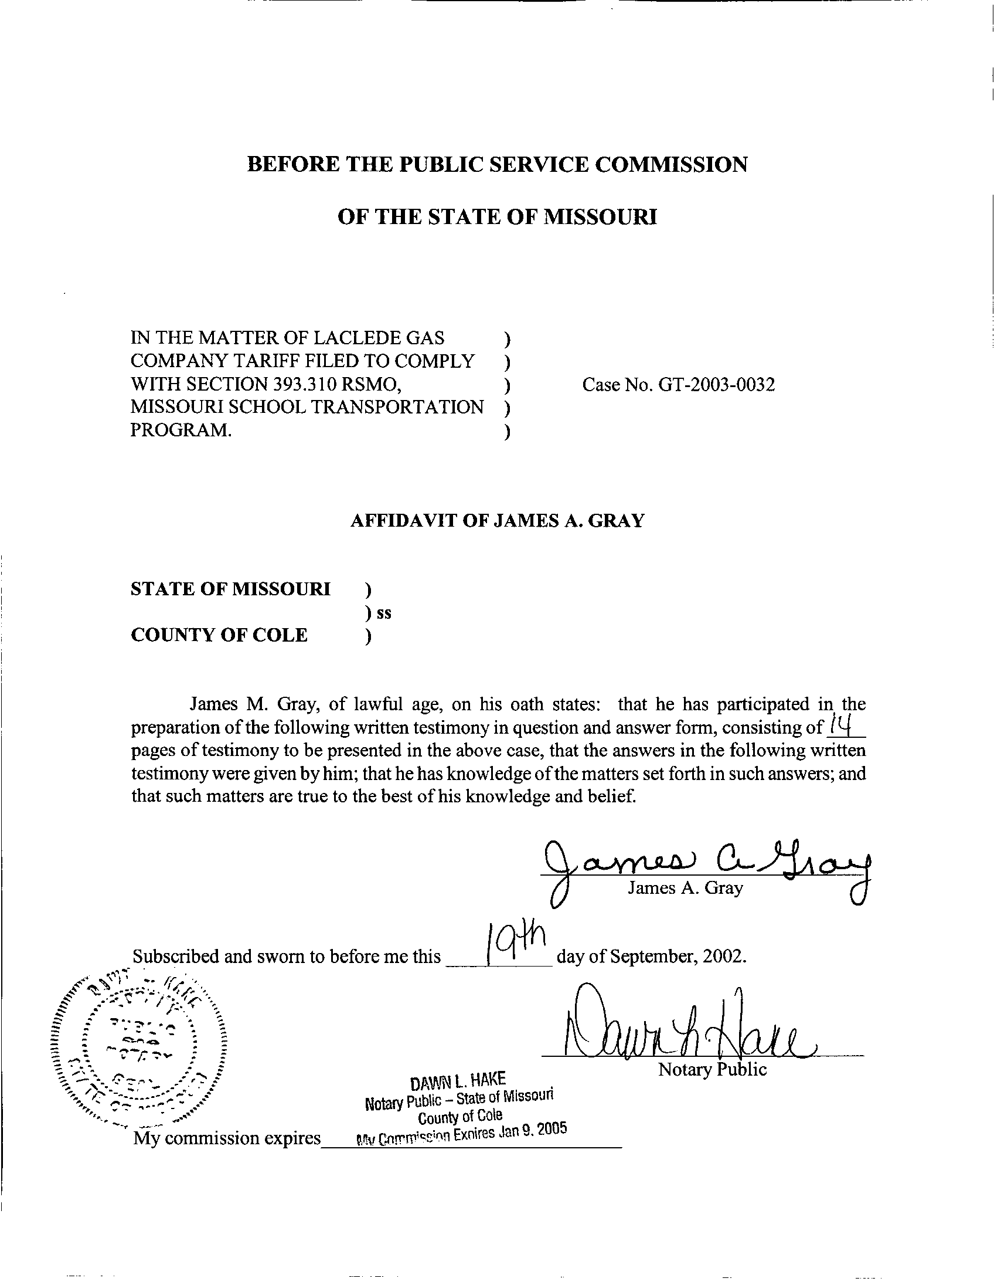
DIRECT TESTIMONY

OF
JAMES A. GRAY
LACLEDE GAS COMPANY

CASE NO. GT-2003-0032

Q. Please state your name and business address.
A. My name is James A. Gray. My business address is P. O. Box 360, Jefferson City, Missouri 65102.
Q. By whom are you employed and in what capacity?
A. I am employed by the Missouri Public Service Commission (Commission) as a Regulatory Economist in the Tariffs/Rate Design Section of the Commission's Energy Department.
Q. How long have been employed by the Commission?
A. I have been employed with the Commission for approximately twenty-two years.
Q. Please state your educational background.
A. I received a degree of Bachelor of Science in Psychology as well as one in General Studies from Louisiana State University (LSU), and I received a degree of Master of Science in Special Education from the University of Tennessee. Additionally, I completed several courses in research and statistics at the University of Missouri - Columbia.
Q. Please state your professional qualifications.
A. Prior to being employed by the Commission, I was a Research Analyst for two and a half years with the Missouri Department of Mental Health where I conducted statistical analyses. In 1980, I began my employment with the Commission as a Statistician in the Depreciation Department where I submitted testimony regarding depreciation rates, trended-original cost, and trended-original cost less depreciation.
Beginning in 1989 as a member of the Economic Analysis Department, I submitted testimony on weather-normalized sales for natural gas, water, and electric utilities. I reviewed residential-electric-load forecasts with the associated detailed end-use studies and the marketing surveys in electric resource plans.
From 1997 through 2001, I was in the Tariffs/Rate Design Section of the Commission's Gas Department. Since July 2001, I have been in the Tariffs/Rate Design Section of the Commission’s Energy Department. I have reviewed tariffs and applications of natural gas utilities. I have submitted testimony concerning weather-normalized sales, tariffs, complaints, certificates of convenience and necessity, and recommended minimum-statistical-sample sizes for natural gas residential-customer-billing reviews.
Q. Please list all the cases in which you have submitted prepared written testimony before this Commission.
A. The cases in which I have submitted prepared, written testimony are enumerated in Schedule 1, attached to my testimony.
Q. What is the purpose of your direct testimony?
A. My testimony addresses the proposed tariffs of Laclede Gas Company (Laclede or Company) for compliance with § 393.310 RSMo Supp. 2002. First, I will address the timelines required by the statute and which Laclede customers are affected. Second, I will address the definitions or special terms used in the statute. Third, I will address the specific requirements of § 393.310 RSMo Supp. 2002 and whether Laclede’s proposed tariff complies with the statute. Fourth, I will address the tariff items proposed by Laclede that are not required by § 393.310 RSMo Supp. 2002.
Q. Which corporations are affected by § 393.310 RSMo Supp. 2002?
A. The statute states:
393.310.1. This section shall only apply to gas corporations as defined in section 386.020, RSMo.

The statute applies to Missouri investor-owned natural gas utilities, such as Laclede.
Q. When are the Missouri investor-owned natural gas corporations required to file tariff revisions pursuant to § 393.310 RSMo Supp. 2002?
A. The Missouri regulated natural gas utilities are required to file experimental tariffs with the Commission by August 1, 2002, to implement experimental tariffs. The statute states:
3. Each Missouri gas corporation shall file with the commission, by August 1, 2002, a set of experimental tariffs applicable the first year to public school districts and applicable to all school districts, whether charter, private, public, or parochial, thereafter. (§ 393.310.3 RSMo Supp. 2002)

Q. Did Laclede file its proposed experimental tariff sheets by August 1, 2002?
- Yes, on August 1, 2002, Laclede made the required filing. Laclede’s filing date complies with § 393.310.3 RSMo Supp. 2002.
Q. When does the statute require the experimental tariff sheets to become effective?
A. The experimental tariff sheets are required to be in effect by November 1, 2002. Laclede’s proposed experimental tariff sheets bear a proposed effective date of November 1, 2002. Therefore, Laclede’s proposed tariff sheets comply with § 393.310.5 RSMo Supp. 2002.
Q. Does § 393.310 RSMo Supp. 2002 expire?
A. Yes, the statute expires June 30, 2005. The statute states:
7. This section shall terminate June 30, 2005.
(§ 393.310.7 RSMo Supp. 2002)

Laclede’s proposed experimental tariff filing states:
K. Term of Experiment:
Consistent with Section 393 .310 of the RSMo, this service will expire June 30, 2005. (Laclede Proposed Tariff Sheet No. 43, Experimental School District Aggregation Service – Schedule of Rates) (emphasis added)

Therefore, Laclede’s proposed tariff filing complies with the statute in terminating the proposed experimental tariff sheets on June 30, 2005.
Q. Which types of customers are affected by the statute?
A. Missouri school districts are affected by the statute. In the first year of the experimental tariff, only the Missouri public school districts are affected. The statute states:
(3) "Eligible school entity", shall include any seven-director, urban or metropolitan school district as defined pursuant to section 160.011, RSMo, and shall also include, one year after the effective date of this section and thereafter, any school for elementary or secondary education situated in this state, whether a charter, private, or parochial school or school district. (§ 393.310.2(3) RSMo Supp. 2002) (emphasis added

In the second year, the proposed experimental tariff will expand to include other eligible school entities. In this docket, I only address the eligible school entities in Laclede’s natural gas service area.
Q. Do Laclede’s proposed tariff sheets permit Missouri public school districts to aggregate their natural gas purchases?
A. Yes, it does. The Company’s proposed tariff sheets address aggregation for the Missouri school entities for the three years that § 393.310 RSMo Supp. 2002 is in effect:

B. Availability of Service:
This service shall be available to eligible public school districts only during the first year following the initial effective date of such service and to all eligible school districts thereafter. By September 1 of each year, the Association shall provide the Company with a list of each school premise, including the address and the Company account number, where such service is to be provided starting the following November. (Laclede Proposed Tariff Sheet No. 41, Experimental School District Aggregation Service – Schedule of Rates) (emphasis added)

In my opinion, Laclede’s proposed tariff sheets comply with § 393.310.2(3) RSMo Supp. 2002.
Q. Does the statute address how school districts may purchase natural gas?
A. Yes, briefly, the statute allows an eligible school entity to pool or aggregate its natural gas purchases for all of its various locations. Then, a marketer may purchase the natural gas from the various suppliers, and the marketer may arrange the delivery of the gas to a Laclede delivery point on behalf of the eligible school entities. The statute defines aggregation as the following:
(1) "Aggregate", the combination of natural gas supply and transportation services, including storage, requirements of eligible school entities served through a Missouri gas corporation's delivery system; (§ 393.310.2(1) RSMo Supp. 2002) (emphasis added)

The statute provides for pooling or aggregating of natural gas purchases by Missouri school entities. Also, the statute addresses purchases of natural gas:

(1) Provide for the aggregate purchasing of natural gas supplies and pipeline transportation services on behalf of eligible school entities in accordance with aggregate purchasing contracts negotiated by and through a not-for-profit school association; (§ 393.310.4(1) RSMo Supp. 2002) (emphasis added)

Q. Do Laclede’s proposed tariff sheets define aggregation?
A. No, Laclede’s proposed tariff sheets implicitly refer to aggregation in the context of natural gas purchases. Laclede’s proposed experimental tariff states:
A. Overview:
Pursuant to Section 393 .310 of the RSMo, the Company shall permit eligible school entities, as defined in such section, to participate in an experimental program under which the natural gas supply and transportation requirements of such entities are aggregated by a not-for-profit school association ("Association"). Such aggregated supplies shall be sold to the Company, which, in turn, will deliver gas to such entities at the rates and charges provided for in the Company's applicable sales service rate schedules. (Laclede Proposed Tariff Sheet No. 41, Experimental School District Aggregation Service – Schedule of Rates) (emphasis added)

The statute is more explicit in defining aggregation than Laclede’s proposed experimental tariff. In my opinion, aggregation is adequately defined in Laclede’s proposed experimental tariff sheets.
Q. How is the Company compensated for aggregating and balancing natural gas between deliveries of natural gas and purchases of natural gas for the eligible school entities?
A. Balancing is the equalizing of the volumes of natural gas withdrawn from Laclede’s system, an interstate pipeline system, or both (in this instance, delivered to any eligible school entity under the proposed experimental tariff) with the volumes of natural gas injected into Laclede’s system. The statute permits the Company to charge a fee per therm of natural gas sales delivered to an eligible school entity’s various locations.
Q. What is a therm?
A. A therm is a unit of heat equal to 100,000 British thermal units (Btu), which is the quantity of heat required to raise the temperature of one pound of water by one degree Fahrenheit. In volume, a therm is approximately one hundred cubic feet (Ccf) of natural gas under physical conditions prescribed in FERC-approved interstate pipeline tariffs. A therm is usually slightly more than one (1) Ccf.
Q. What balancing fee does the statute allow?
A. The statute allows a $.004 cent per therm charge to be assessed on gas delivered to each school district. The statute states:
(2) Provide for the resale of such natural gas supplies, including related transportation service costs, to the eligible school entities at the gas corporation's cost of purchasing of such gas supplies and transportation, plus all applicable distribution costs, plus an aggregation and balancing fee to be determined by the commission, not to exceed four-tenths of one cent per therm delivered during the first year; and (§ 393.310.4(2) RSMo Supp. 2002) (emphasis added)

Q. What aggregation and balancing fees do Laclede’s proposed experimental tariff sheets permit?
A. Laclede’s proposed experimental tariff states:

F. Payments By The Customer And The Company:
Each month the Company shall bill each eligible entity for gas metered at each entity's premise at the rates in effect for the sales service rate schedule under which the customer would otherwise receive gas if it were not participating in the program. At the end of each billing month the Company shall also credit or charge the Association an amount equal to the difference between the total Purchased Gas Adjustment recovery from all of the entities and the sum of the gas cost paid by the Company to the Association for gas delivered to the entities and any recoverable transportation cost ("Recoverable Transportation Cost"). The gas costs paid shall include the effect of any imbalance volumes and corresponding costs from the previous month. The Recoverable Transportation Cost shall consist of the costs of MRT transportation capacity previously reserved by the Company for serving the demand requirements of the participating schools that the Association has not elected to acquire from the Company through the capacity release provision provided for above. In addition, the amount credited or charged to the
Association shall be adjusted to reflect the Company's retention of $.004 per therm for the occurrence of any imbalances and any transition costs as described below. (Laclede Proposed Tariff Sheet No. 42, Experimental School District Aggregation Service – Schedule of Rates) (emphasis added)

Laclede’s proposed experimental tariff seems to put the balancing responsibilities upon Laclede since Laclede retains ownership of the natural gas until it is sold to the eligible school entities. For any imbalances, the proposed tariff seems to require Laclede to make up the dollar amount of the imbalances in the following month. Because of the timing differences, it is possible that the $.004 per therm for balancing and aggregation can be exceeded. Therefore, in my opinion, Laclede’s proposed experimental tariff sheets do not comply with § 393.310.4(2) RSMo Supp. 2002.
Q. Does the statute exempt school districts from special metering devices?
A. Yes, special metering devices are not required for annual usage of one hundred thousand (100,000) therms or less annually. The statute states:
(3) Not require telemetry or special metering, except for individual school meters over one hundred thousand therms annually.
(§ 393.310.4(3) RSMo Supp. 2002)

Q. Does Laclede’s proposed experimental tariff sheets require telemetry or special metering?
A. No, it does not require special metering for eligible school entities. Therefore, Laclede’s proposed experimental tariff sheets do comply with § 393.310.4(3) RSMo Supp. 2002.
Q. Please summarize what portions of Laclede’s proposed experimental tariff sheets complies with the statute.
A. First, the proposed experimental tariff sheets comply with the statutory timelines. These are the filing date, the proposed effective date, and the termination of the experimental program, which is no earlier than June 25, 2005, the termination date of § 393.310 RSMo Supp. 2002.
Second, the proposed experimental tariff sheets allow aggregation of eligible school entities in the first year, with the expansion of the aggregation to other schools in the second and third year.
Third, Laclede’s proposed experimental tariff filing does not require any special metering equipment for any eligible school entity using less than one hundred thousand (100,000) Ccf annually.
Q. Do Laclede’s proposed experimental tariff sheets contain provisions not in the statute?
A. Yes, Laclede has several standard terms in its proposed experimental tariff. These include payments by the customer and the company, accounting for costs on the Company’s books, failure to deliver supplies, and availability of individual customer billing data. These tariff provisions are customary provisions for transportation customers. Therefore, In my opinion, these provisions are in compliance with § 393.310 RSMo Supp. 2002
Three other subsections are being addressed by addressed by other Staff witnesses. These are the transportation capacity section and the tax payments by the eligible school entities to the proper tax authorities.
§ 393.310.5 RSMo Supp. 2002 requires the proposed experimental tariff to not have an affect on taxing authorities. Staff wants the requirements for the payment by the school aggregator to taxing authorities to be noted in the tariff. Staff witness Jennifer Markway of the Energy Department will address this issue in her testimony in this case.
Laclede’s proposed experimental tariff filing has a subsection on transportation capacity release. Laclede is currently taking delivery of natural gas to serve its firm customers from more than one natural gas pipeline. This subsection addresses the allocation of Laclede’s firm capacity only on the Mississippi River Transmission Corporation (MRT) pipeline to the various eligible school entities in Laclede’s service territory. Staff witness Thomas M. Imhoff of the Energy Department will address this issue in his testimony in this case.
Mr. Imhoff will also address transition costs in his testimony in this case.
Laclede proposes another section, supply planning obligations.
Q. What does the supply planning obligation section require of the eligible school entities?
A. Briefly, Laclede’s proposed experimental tariff states:
C. Supply Planning Obligations:
1. By October I each year the Company shall provide the Association with a temperature based equation ("Delivery Schedule") which will be used by the Association to determine the daily amount of natural gas the Association must arrange for delivery into the Company's distribution system to meet the gas supply requirements of the participating schools during the subsequent 12 months ended October period. (The equation will reflect, among other factors, unaccounted-for-gas.)
2. By 9 :00 a.m. of each business day the Company shall provide the Association with the applicable following day's (days') forecasted daily temperature that is to be used by the Association with the Delivery Schedule to determine the applicable following day's (days') delivery requirements. Such information shall normally be provided by email. (Laclede Proposed Tariff Sheet No. 41, Experimental School District Aggregation Service – Schedule of Rates) (emphasis added)

Staff has requested support for this section and is waiting for Laclede’s response to the data request. Staff reserves the right to comment on this issue pursuant to Laclede’s response.
Q. What natural gas supplies are usually estimated by Laclede?
A. Laclede routinely estimates the amount of natural gas to purchase for an upcoming heating system. These estimates are for all the firm customers of Laclede, and the estimated natural gas usage is based on Laclede’s estimated weather for an upcoming winter season.
Q. Why are natural gas sales dependent upon weather conditions?
A. The predominate use of natural gas in Missouri is for space heating. Space heating refers to the use of mechanical equipment to heat all or part of a building. As the weather becomes colder, natural gas sales increase because of space-heating requirements. In Missouri, this is November through March.
Q. Are the estimated volumes for the upcoming heating season dependant upon the methodology used to estimate natural gas sales?
A. Yes, the estimated amount of volumes required and contracted for depends upon the methodology utilized to estimate natural gas usage in the colder months. Q. What indicator of space-heating requirements does Laclede use for estimating natural gas usage during the colder months?
A. Laclede uses heating degree days (HDD) as a weather measure. HDD are defined by the U.S. National Oceanic and Atmospheric Administration (NOAA). HDD are calculated as the difference between 65 degrees and the mean daily temperature (the average of the high and low daily temperature), when the mean daily temperature is below 65ºF. On days warmer than a mean daily temperature of 65ºF, the HDD are equal to zero. For example, if a day had a mean daily temperature of twenty degrees (20º F), then that day would have 45 HDD (65 – 20 = 45). But if a day had a mean daily temperature of eighty degrees (80º F), the HDD would be zero.
The larger the estimated number of HDD for an upcoming winter season, the more space heating volumes Laclede requires for the projected, upcoming space heating season.
Q. Were you able to analyze the equation that Laclede proposes to use to require the school entities to purchase on a daily basis?
A. No, I have not received an answer to my data request no. 4157. This data request will allow me to analyze Laclede’s methodology that requires school entities to purchase minimum volumes of natural gas over each of the three years of the experimental tariff.
Q. What are your recommendations?
A. Based on Laclede’s compliance with § 393.310 RSMo Supp. 2002, I would recommend approval of Laclede’s proposed experimental tariff filing on school aggregation, with the exception any Staff concerns with the proposed experimental tariff provisions regarding (1) payments local tax authorities in an accurate and timely manner and the school aggregator’s reporting these payments to the Staff, and (2) capacity release.
Q. Does this conclude your direct testimony?
A. Yes, it does.

Laclede Gas Company
Case No. GT-2003-0032

Testimonies Submitted by James A. Gray
COMPANY CASE NO.

Missouri Public Service Company GR-81-312
Missouri Public Service Company ER-82-39
Missouri Public Service Company GR-82-194
Laclede Gas Company GR-82-200
St. Louis County Water Company WR-82-249
Missouri Public Service Company ER-83-40
Kansas City Power & Light Company ER-83-49
Osage Natural Gas Company GR-83-156
Missouri Public Service Company GR-83-186
The Gas Service Company GR-83-225
Laclede Gas Company GR-83-233
Missouri Water Company WR-83-352
Missouri Cities Water Company WR-84-51
Le-Ru Telephone Company TR-84-132
Union Electric Company ER-84-168
Union Electric Company EO-85-17
Kansas City Power & Light Company ER-85-128
Great River Gas Company GR-85-136
Missouri Cities Water Company WR-85-157
Missouri Cities Water Company SR-85-158
United Telephone Company of Missouri TR-85-179
Osage Natural Gas Company GR-85-183
Kansas City Power & Light Company EO-85-185
ALLTEL Missouri, Inc. TR-86-14
Sho-Me Power Corporation ER-86-27
Missouri-American Water Company, Inc. WR-89-265
The Empire District Electric Company ER-90-138
Associated Natural Gas Company GR-90-152
Missouri-American Water Company, Inc. WR-91-211
United Cities Gas Company GR-91-249
Laclede Gas Company GR-92-165
St. Joseph Light & Power Company GR-93-42
United Cities Gas Company GR-93-47
Missouri Public Service Company GR-93-172
Western Resources, Inc. GR-93-240
Laclede Gas Company GR-94-220
United Cities Gas Company GR-95-160
The Empire District Electric Company ER-95-279
Laclede Gas Company GR-96-193
Missouri Gas Energy GR-96-285
Associated Natural Gas Company GR-97-272
Union Electric Company GR-97-393
Missouri Gas Energy GR-98-140
Laclede Gas Company GR-98-374
St. Joseph Light & Power Company GR-99-42
AmerenUE GA-99-107
Laclede Gas Company GA-99-236
Laclede Gas Company GR-99-315
AmerenUE GR-2000-512
Missouri Gas Energy GR-2001-292
Gateway Pipeline Company, Inc., et al. GM-2001-585
Missouri Gas Energy, et al GC-2001-593
Laclede Gas Company GR-2002-356
Laclede Gas Company GA-2002-429
Southern Missouri Gas Company, L.P. GT-2003-0031
Missouri Gas Energy GT-2003-0033
Fidelity Natural Gas, Inc. GT-2003-0036
Atmos Energy Corporation GT-2003-0037
Aquila Networks- L&P GT-2003-0038
Aquila Networks- MPS GT-2003-0039

