BEFORE THE PUBLIC SERVICE COMMISSION
OF THE STATE OF MISSOURI

In the Matter of the Application of )
IBFA Acquisition Company, LLC )
for Certificate of Service Authority to Provide ) Case No. _______________
Intrastate Interexchange and Non-Switched )
Local ExchangeTelecommunications )
Services within the State of Missouri )
and for Competitive Classification. )

APPLICATION FOR CERTIFICATE OF SERVICE AUTHORITY
AND FOR COMPETITIVE CLASSIFICATION

Comes now IBFA Acquisition Company, LLC ("IBFA” or “Applicant"), by and through counsel, and pursuant to Sections 392.361, 392.410, 392.420, 392.430, 392.440 RSMo, and 4 CSR 240-2.060 and 4 CSR 240-3.510, files this verified Application requesting that the Missouri Public Service Commission (hereinafter "the Commission") issue an order that:
- grants Applicant certificate of service authority to provide intrastate interexchange and non-switched local exchange telecommunications services, pursuant to Chapter 392 RSMo;

- grants competitive status to Applicant and Applicant's requested services;

- waives certain Commission rules and statutory provisions pursuant to Sections 392.420 and 392.361 RSMo, consistent with the Commission's past treatment of other certificated providers of competitive interexchange telecommunications services; and

- approves Applicant’s separately submitted proposed interexchange services tariff.

In support of its request, Applicant states that:
1. Applicant is a foreign corporation formed and operating under the laws of the State of Michigan and is duly authorized to transact business in the State of Missouri. The character of the business performed by Applicant is telecommunications. Pursuant to the relevant provisions of 4 CSR 240-2.060, a certificate of registration from the Missouri Secretary of State’s Office is attached hereto and incorporated herein by reference as Appendix A. Applicant's principal place of business is:
1850 Howard Street, Unit C
Elk Grove Village, IL 60007
2. An officer’s verification is attached hereto.
3. All communications, notices, orders and decisions respecting this Application and proceeding should be addressed to:
William D. Steinmeier
Mary Ann (Garr) Young Patrick D. Crocker
William D. Steinmeier, P.C. Early, Lennon, Crocker & Bartosiewicz, P.L.C.
2031 Tower Drive 900 Comerica Building
Jefferson City, Missouri 65109 Kalamazoo, Michigan 49007-4752
Tel: (573) 659-8672 Tel: (269) 381-8844
Fax: (573) 636-2305 Fax: (269) 381-8822
Email: wds@wdspc.com Email: pcrocker@earlylennon.com
myoung0654@aol.com

4. Questions concerning Applicant's ongoing operations should be directed to Mr. Crocker at the above address and phone number. Questions regarding Applicant’s proposed tariff should be directed to Ms. Young.
5. By this Application, Applicant proposes to provide various types of intrastate interexchange and non-switched local exchange telecommunications services throughout the state of Missouri. Specifically, Applicant seeks authority to provide a full range of “1+” interexchange services, switched and dedicated inbound and outbound services, MTS, out-WATS and in-WATS, and non-switched, dedicated private line services. Applicant will provide telecommunications services to residential and business customers.

6. Pursuant to 4 CSR 240-3.510(1), which requires that an application for a certificate of service authority to provide interexchange, local exchange or basic local exchange service shall include a proposed tariff with no less than a forty-five (45) day effective date, Applicant is separately filing its proposed interexchange (IXC) tariff, designated as P.S.C. Mo. No. 1. Applicant’s proposed tariff contains the rules, conditions and description of services and rates, and bears an effective date forty-five (45) days after the issued date. Applicant respectfully requests approval of its IXC and local exchange tariff, P.S.C. Mo. Tariff No. 1.
7. Applicant requests that it and all its services proposed herein be classified as competitive. Applicant believes that the highly developed state of the telecommunications services market in Missouri and nationwide ensures that its proposed services will be subject to sufficient competition to warrant a less rigorous degree of regulation.
8. As a new market entrant, Applicant requests streamlined regulatory treatment afforded similarly situated telecommunications carriers in Missouri. Likewise, to the extent the Commission has granted other competitive interexchange carriers waiver of certain of the Commission’s rules and regulations, Applicant respectfully requests that it be granted the same waivers.
9. Consistent with the Commission’s treatment of other certificated telecommunications companies, Applicant respectfully requests that, pursuant to §392.361.5 and §392.420, RSMo, the following statutes and regulations be waived with respect to its interexchange service offerings:

STATUTES
§ 392.210.2 -- Uniform System of Accounts
§ 392.240.1 -- Rates-Rentals-Service & Physical Connections
§ 392.270 -- Valuation of Property (Ratemaking)
§ 392.280 -- Depreciation Accounts
§ 392.290 -- Issuance of Securities
§ 392.300.2 -- Acquisition of Stock
§ 392.310 -- Issuance of Stock and Debt
§ 392.320 -- Stock Dividend Payment
§ 392.330 -- Issuance of Securities, Debts and Notes
§ 392.340 -- Reorganization(s)

RULES

4 CSR 240-10.020 -- Depreciation Fund Income
4 CSR 240-30.040 -- Uniform System of Accounts

10. Applicant will comply fully with all applicable Commission rules except those that are specifically waived by the Commission pursuant to the Company’s request herein. To the extent that the Commission may modify its waiver policies, Applicant respectfully reserves the right to amend its waiver requests accordingly.
11. Pursuant to 4 CSR 240-2.060 (1) (K), Applicant states that it does not have any pending action or final unsatisfied judgments or decisions against it from any state or federal agency or court which involve customer service or rates, which action, judgment or decision has occurred with three (3) years of the date of this Application.
12. Pursuant to 4 CSR 240-2.060 (1) (L), Applicant states that no Commission annual report or assessment fees are overdue.
13. Applicant is financially capable of providing the services proposed. Applicant also possesses the technical and managerial expertise and experience necessary to provide the services it proposes to offer at standards that will meet or exceed all service standards established by the Commission.
14. Applicant submits that the public interest will be served by Commission approval of this application because Applicant’s proposed services will create and enhance competition and expand customer service options consistent with the legislative goals set forth in the federal Telecommunications Act of 1996 and Chapter 392 RSMo. Prompt approval of this application also will expand the availability of innovative, high quality, and reliable telecommunications services within the State of Missouri.
WHEREFORE, IBFA Acquisition Company, LLC respectfully requests that the Commission: (1) grant it certificate of service authority to provide intrastate interexchange telecommunications services within the State of Missouri; (2) grant Applicant and its proposed services competitive status; (3) waive the application of the above-referenced statutes and Commission rules; and (4) approve its separately-submitted tariff.
Respectfully submitted,

/s/ William D. Steinmeier

William D. Steinmeier, MoBar #25689
Mary Ann (Garr) Young, MoBar #27951
WILLIAM D. STEINMEIER, P.C.
2031 Tower Drive
P.O. Box 104595 Jefferson City, MO 65110-4595
(573) 659-8672 (phone)
(573) 636-2305 (fax)
wds@wdspc.com
myoung0654@aol.com

ATTORNEYS FOR IBFA ACQUISITION COMPANY, LLC

May 27, 2005

CERTIFICATE OF SERVICE

I hereby certify that a copy of the foregoing Verified Application has been served electronically on the General Counsel’s Office and the Office of the Public Counsel this 27th day of May 2005.

/s/ William D. Steinmeier

William D. Steinmeier

APPENDIX A
Secretary of State Certificate

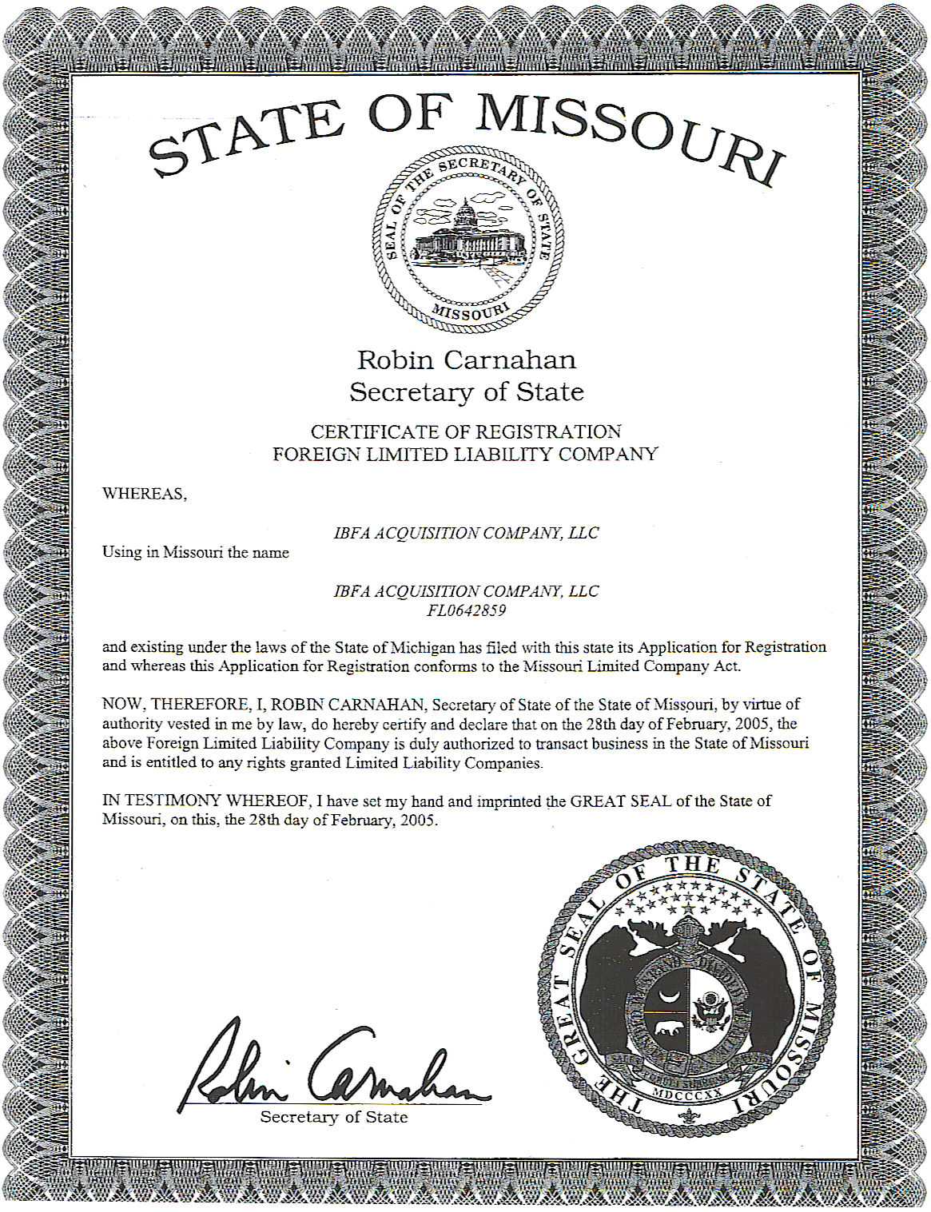

Verification
