Exhibit No.:
Issues: Class Cost of Service

Witness: Hong Hu
Sponsoring Party: MO PSC Staff
Type of Exhibit: Surrebuttal Testimony
Case No.: ER-2004-0570
Date Testimony Prepared: November 24, 2004

MISSOURI PUBLIC SERVICE COMMISSION

UTILITY OPERATIONS DIVISION

SURREBUTTAL TESTIMONY

OF

HONG HU

THE EMPIRE DISTRICT ELECTRIC COMPANY

CASE NO. ER-2004-0570

Jefferson City, Missouri
November 2004
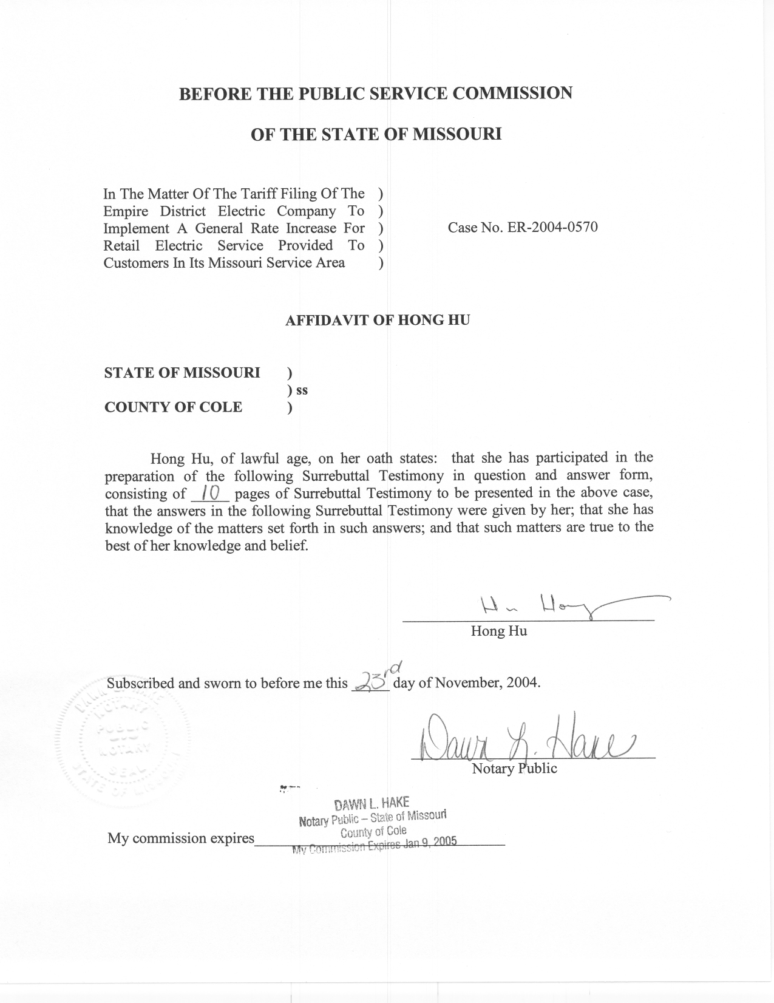

SURREBUTTAL TESTIMONY

OF

HONG HU

THE EMPIRE DISTRICT ELECTRIC COMPANY

CASE NO. ER-2004-0570

Q. Please state your name and business address.
A. My name is Hong Hu and my business address is Missouri Public Service Commission, P. O. Box 360, Jefferson City, Missouri 65102.
Q. Are you the same Hong Hu that previously filed direct and rebuttal testimony in this case?
A. Yes, I am.
Q. What is the purpose of this testimony?
A. The purpose of my Surrebuttal Testimony is to respond to the comments made by Explorer Pipeline Company and Praxair (Industrial) witness Maurice Brubaker, and by The Empire District Electric Company (Empire or Company) witness Edwin Overcast regarding the issues of class cost of service and seasonal cost of service.
Q. What comments did Mr. Brubaker have regarding the Staff’s Class Cost of Service (CCOS) study and the Staff’s seasonal cost of service study?
A. Mr. Brubaker expressed concerns regarding the allocation of generation and transmission costs and the allocation of distribution plant in the Staff’s CCOS study. He also expressed concerns regarding how energy-related costs were allocated to months in the Staff’s seasonal cost of service study.
Q. What comment does Mr. Brubaker have regarding the allocation of generation and transmission costs?
A. On page 11, lines 6-12 of his Rebuttal Testimony, Mr. Brubaker stated that he has the same criticisms of the Staff’s CCOS study as he does of the CCOS study performed by the Office of the Public Counsel (OPC).
Q. What is Mr. Brubaker’s criticism of the OPC cost study?
A. On page 4, line 1 through page 5, line 9 of his Rebuttal Testimony, Mr. Brubaker argues that the OPC’s method of allocation of the generation and transmission costs gives too much weight to energy and loads in non-peak months, and thus “ha[s] no claim to accuracy or the representation of cost causation because the summer peaks drive the need for capacity additions.”
Q. Could you explain how electric generation and transmission capacity costs are incurred?
A. Yes. In short, electric utilities choose a mix of different types of electric generation plants to minimize the total generation cost and to satisfy the entire system load. An electric utility's load varies during the day, generally with heavy demand from 10:00 a.m. to 10:00 p.m. and with much less demand at night. Load also varies during the year, with heavy demand during the heating and air conditioning seasons. An electric utility usually cannot store its production, and therefore must have the generators ready to meet those periods of maximum demand. The generation facilities must be in place even if they are expensive to maintain and stand idle for much of the time. The utility needs to serve the entire load, but it does not need the same kind of power plant to meet all of its capacity and energy requirements.
Theoretically, a utility would want to minimize its investment in plant that is likely to be idle most of the time, and would want the plant that will be in operation most of the time to be as reliable and economical as possible. The solution is to build what are called base load plants to meet the minimum around-the-clock load. Although such plants are large and expensive to build, they are nevertheless attractive for this purpose because their fixed costs can be spread over many hours of operation and they burn relatively low-cost fuels. At the other extreme, a utility builds and runs peaking units for those brief periods of peak demand. Peaking units typically have high fuel costs, but are generally inexpensive to build. The industry also has an intermediate category of generators that are used less than base load and more than peaking units.
Q. Do you believe that proper weights should be given to energy and loads in non-peak periods for a CCOS study as an accurate representation of cost causation?
A. Yes. What we are attempting to do is to allocate the total cost of the entire production system, not only the cost of the peaking units that are needed in the peak months. As I mentioned on page 6, lines 7-9 of my Rebuttal Testimony, in 10 out of 12 months the system peak is above 70% of the maximum system peak and in 6 out of 12 months the system peak is above 80% of the maximum system peak. In other words, a significant portion of the capacity costs is incurred to serve the base load and/or off-peak loads, rather than the peak load. An allocation method can only accurately represent cost causation in this case if it gives proper weight to energy (i.e. base load) and loads in non-peak months.
Q. On page 5, line 12 through page 6, line 11 of his Rebuttal Testimony, Mr. Brubaker doesn’t appear to dispute that a reasonable allocation method should consider both energy consumption and peak loads; instead, he claims that the “Average and Excess” (A&E) method “gives appropriate weighting both to energy consumption and to peak loads” and that the “Average and Peak” (A&P) method that the Staff and OPC adopted “double-counts” average demand. Do you agree?
A. Absolutely not. As I stated in my Rebuttal Testimony, the A&E method is essentially equivalent to the peak only method. Instead of simply allocating the costs according to peak demand, the A&E method breaks the peak demand into two portions, the average demand and the excess demand with excess demand equal to the peak less the average, and then allocates them separately. In essence the A&E method produces almost the same result as the peak only method, only with two steps instead of one, to generate the appearance of giving weight to the average demand (i.e. the energy, or base load). This can be illustrated best using Mr. Brubaker’s own example.

Table 1. Illustration of Allocation Factors
Customer | Average Demand | % | Peak Demand | % | A&E method | A&P method
A | 2 | 20.0% | 6 | 33.3% | 32.3% | 25.5%
B | 3 | 30.0% | 6 | 33.3% | 33.1% | 31.4%
C | 5 | 50.0% | 6 | 33.3% | 34.6% | 43.2%
Total | 10 | 100.0% | 18 | 100.0% | 100.0% | 100.0%
In Table 1, I have summarized the example that was shown by Mr. Brubaker in Schedules 1-3 of his Rebuttal Testimony. In this example, the three customers have the same peak demand (6 kw); however, their total energy consumptions are significantly different (Customer A with a 2 kw average demand; customer B with a 3 kw average demand and customer C with a 5 kw average demand). The second and third columns in the table show the allocation of energy (average demand) among the three customers. The fourth and fifth columns show the allocation of peak demand among them. It is certainly not fair to allocate half of the cost to Customer C simply because it consumes half of the energy delivered by the system (as shown in the third column). It is also not fair to allocate one third of the costs to Customer A simply because it constitutes one third of the total non-coincident peak demand (as shown in the fifth column). A reasonable allocation method would have to consider both the average demand (energy consumption) and the peak demand. A close examination of this example shows the proximity of the allocation results between the A&E method and a method that allocates cost according to the peak demand. The A&E method allocates 34.6% costs to Customer C, just slightly higher than the 33.3% number of the peak demand method, even if the customer actually consumes half of the energy that is delivered by the system. On the other hand, customer A, who only consumes one-fifth of total energy, would be allocated 32.3% of the total cost, not too much less than what is allocated to customer C.
In other words, despite the claim of the Industrials that the A&E method “gives appropriate weighting both to energy consumption and to peak loads,” in fact, the average demand (energy consumption) has received insufficient weight using this method.
Now let’s look at the A&P method. Table 1 above shows that, using this method, Customer A would be allocated 25.5% of total costs, a fair balance between the 20% and 33.3% numbers. And customer C would be allocated 43.2%, again a fair balance between the 50% and 33.3% numbers. Clearly this method has given more reasonable weights to both the average demand and the peak demand, with the weight given to average demand a little higher because of the system load factor (59%). A lower system load factor would mean more costs are incurred because of the peak demand and, thus, more weight should, and would, be given to the peak demand.
Q. What is Mr. Brubaker’s comment regarding Staff’s allocation of distribution costs?
A. On page 12, lines 16 through 17 of his Rebuttal Testimony, Mr. Brubaker states that the Staff “allocated to the Large Power class 40% more distribution plant [than the Company did], and to Praxair about 50% more.”
Q. Do you have any comment about this?
A. Yes. Mr. Brubaker merely stated a difference between the figures in the Company’s study and the Staff’s study. He did not argue which figures are more reasonable. The main reason for the difference between the Staff’s allocation and the Company’s allocation of distribution plant to Praxair is that the Company has chosen to directly assign costs while the Staff believes that it is more reasonable to allocate costs.
In addition, the costs at issue here only constitute about 2-3% of Praxair’s total allocated costs and about 9% of the Large Power Class’s total allocated costs. In other words, different treatments in this issue did not contribute greatly to the end results.
Q. On page 12, lines 6 through 11 of his Rebuttal Testimony, Mr. Brubaker points out that energy-related costs cannot be reasonably allocated to months based upon monthly kilowatt-hour sales, because generation costs and purchased power costs are much higher in the summer than during other months of the year. Do you agree?
A. Yes. This is a valid criticism to the Staff’s seasonal study. I agree that monthly sales are a poor proxy to be used to allocate energy-related costs into months. It would underestimate the energy-related costs in the summer relative to the winter. The Staff, however, was not able to generate a time-of-use (TOU) allocator for the energy-related costs due to resource limitations.
Q. What impact would a better energy-related costs allocator have on the Staff’s seasonal cost study result?
A. On page 4, line 20 of her Direct Testimony filed on Oct 4, 2004, Staff witness Ms. Janice Pyatte presented a table that compares, by winter and summer seasons, the proportion of Empire’s revenues collected in each season with the costs incurred in each season. She shows that summer revenues are 41% of the total revenues while summer costs are 37% of the total costs. If a more reasonable allocator for energy-related costs were utilized in the Staff’s seasonal cost study, more costs would be allocated to the summer months because of the higher average energy cost in summer. In other words, we could reasonably expect a closer comparison of the summer revenue percentage and the summer cost percentage, which actually strengthens Ms. Pyatte’s statement that “no significant changes to the relationship between summer and winter rates are warranted.”
Q. What are the main criticisms of Dr. Edwin Overcast of the Staff’s seasonal cost study?
A. I have identified four major criticisms of Dr. Overcast that are related to the Staff’s seasonal cost study:
1. The Staff assumed a set of costing and rating periods based solely on the rating periods previously adopted by the Commission.
2. The Staff allocates costs to the seasons based on embedded cost.
3. The Staff has incorrectly assumed that the capacity costs of the plant vary with the level of use.
4. The Staff allocated over 70% of capacity costs on an energy basis.
Q. What is Dr. Overcast’s concern regarding seasonal costing and rating periods?
A. On page 8, lines 11 through 16 of his Rebuttal Testimony, Dr. Overcast states that “the Staff incorrectly assumes a set of rating periods based solely on the rating periods previously adopted by the Commission” that “assumes that the calendar months of June, July, August and September constitute a season”.
Q. Do you have any response to that criticism?
A. Yes. Dr. Overcast is correct, on a weather-normalized basis, that the months of June and September have somewhat lower costs than the months of July and August. However, neither the Company nor any other party has requested a change to the summer and winter season determination in this case.
Q. On page 9, line 20 through page 10, line 5 of his Rebuttal Testimony, Dr. Overcast stated that “the Staff allocates costs to the seasons it has assumed based on embedded cost” and that “embedded cost allocation provides no assistance in designing seasonal rates because any allocation between seasons is arbitrary because of joint and common costs.” Do you have any comment?
A. Yes. It is true that the Staff’s seasonal cost study is based on embedded costs. Embedded cost studies seek to fully allocate costs including joint and common costs. Marginal cost studies, on the other hand, although aiming for producing allocative efficiency and correct price signals, cannot be used to generate rates that would recover the full costs of a utility. According to the 1992 Electric Utility Cost Allocation Manual by National Association of Regulatory Utility Commissioners (page 14):
A deficiency of the marginal approach for ratemaking purposes is that marginal cost-based prices will yield the utility’s allowed revenue requirement based on embedded costs only by rare coincidence. Since regulatory agencies are bound not to let the utility over-earn or under-earn, revenues from rates must be reconciled to the allowed revenue requirement. As the rates are reconciled to the revenue requirements and prices diverge from marginal cost, the sought after marginal cost price signals may not be obtained. When prices do not exactly equal marginal cost there is no formal proof that the economic efficiency predicted by theory is achieved.
Q. On page 10, line 7 through 10 of his Rebuttal Testimony, Dr. Overcast states that “the fundamental assumption underlying [the capacity utilization method] is that the capacity costs of the plant vary with the level of use. Such an assumption is incorrect.” Does it appear that Dr. Overcast understands the basic concept behind this method?
A. No. The capacity utilization method attempts to allocate capacity costs according to relative capacity usage in different time periods. A utility incurs fixed capacity costs to satisfy its customers’ energy usages and peak demands. The fact that such cost becomes “sunk” once it is incurred, does not mean that these costs do not have to be included in a cost of service study, or that these costs should be recovered through “fixed charges”, such as customer charges. The proper cost causation relationship needs to be identified so that costs can be reasonably allocated. The level of capacity usage in different time periods is a determinant factor in system planning, where decisions are made as to when capacity costs are to be incurred. In other words, the basic assumption of the capacity utilization method is that “capacity costs of the plant is caused by the level of usage in different time period(s) and should be allocated based on such levels,” not that “capacity costs vary with level of usage after it has incurred,” as Dr. Overcast incorrectly stated.
Q. On page 11, lines 7 through 17 of his Rebuttal Testimony, Dr. Overcast implies that the Staff has allocated over 70% of capacity costs on an energy basis and “such a result is unjustified for the fixed costs of power production that does not change with the level of energy produced by the plant.” Do you have any comment?
A. Yes. Apparently Dr. Overcast had miscalculated by throwing together the portions of capacity cost that the Staff allocated based on demand and the portion of capacity costs that the Staff allocated based on energy. Schedule 3.6 of my Direct Testimony, which was filed on Oct 4, 2004, shows that the Staff has allocated less than one-third of capacity costs on an energy basis. The fact that a portion of capacity costs is allocated based on energy is consistent with our belief that capacity costs are incurred to satisfy the customers’ demand and energy needs throughout the year.
Q. Does this conclude your Surrebuttal Testimony?
A. Yes.

