Johnson Consulting Group
To: | Missouri PSC File No. EO-2012-0142
From: | Katherine Johnson, Johnson Consulting Group
CC: | Scott Dimetrosky, Apex Analytics
Date: | 5/21/2015
Re: | Final Net-to-Gross Estimates for PY2014 of Ameren Missouri Energy Efficiency Programs

Table 1 summarizes the Net-to-Gross (NTG) estimates that were prepared for the Ameren Missouri Evaluation, Measurement & Verification (EM&V) reports for PY2014. The Auditor’s Team does not have any adjustments to the NTG estimates as reported by The Cadmus Group and ADM Associates.

This table will be provided in the Final EM&V Auditor’s Report.

Table 1: Estimated Free Ridership, Spillover Market Effect Rates and NTG for Each Program
Program | Estimated Free Ridership  Rates | Estimated Spillover  Rates | Estimated  Non-participant Spillover | Estimated  Market  Effects | NTG Ratio
Efficient Products | 13.1% | 3.3% | 0.7% | Not estimated | 90.9%
Home Energy Analysis | 17.1% | 1.6% | 0.5% | Not estimated | 85.0%
HVAC | 17.0% | 0.1% | 12.3% | Not estimated* | 95.4%
Lighting | 25.3% | 1.0% | 13.7% | 9.8% | 99.2%
Low Income | 4.2% | 0% | N/A | Not estimated | 95.8%
Energy Star® New Homes | 60.2% | 3.1% | 0% | Not estimated | 42.9%
Refrigerator Recycling | 35.5% | 0% | 6.5% | Not Estimated | 71.0%
BizSavers Custom | 10.6% | 2.6% | 0% | Not Estimated | 92.0%
BizSavers Standard | 4.2% | 0.0% | 0% | Not Estimated | 95.8%
BizSavers New Construction | 0.7% | 0.5% | 0% | Not Estimated | 99.8%
Biz Savers RCx | 5.9% | 0% | 0% | Not Estimated | 94.1%
(Source: PY2014 Evaluation Reports)

The Auditor Team has no changes to the NTG estimates that were reported in the final evaluation reports. We will be highlighting our concerns in the Final EM&V Auditor’s Report.

Please let us know if you have any questions.

Best regards,

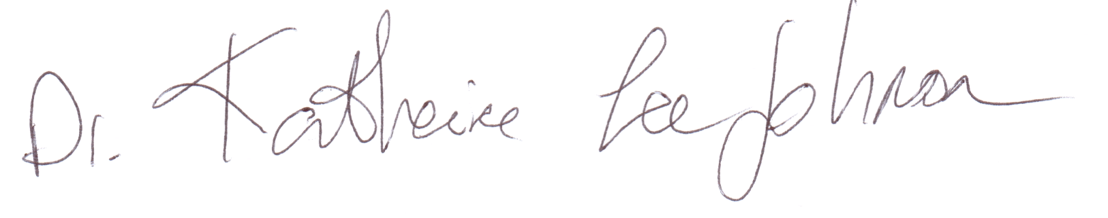
Dr. Katherine Johnson
Johnson Consulting Group

