Johnson Consulting Group
To: | Missouri PSC File No. EO-2012-0142
From: | Katherine Johnson, Johnson Consulting Group
CC: | Scott Dimetrosky, Apex Analytics
Date: | 5/20/2016
Re: | Final Net-to-Gross Estimates for PY2015 of Ameren Missouri Energy Efficiency Programs

Table 1 summarizes the Net-to-Gross (NTG) estimates that were prepared for the Ameren Missouri Evaluation, Measurement & Verification (EM&V) reports for PY2015. The Auditor’s Team does not have any adjustments to the NTG estimates as reported by The Cadmus Group and ADM Associates. Table 1 will also be provided in the Final EM&V Auditor’s Report and contains a PY2015 portfolio NTG ratio of 100.6%.
Table 1: Estimated Free Ridership, Spillover Market Effect Rates and NTG for Each Program
Program | Ex Post Net MWh Savings | Estimated Free Ridership  Rates | Estimated Spillover  Rates | Estimated  Non-participant Spillover | Estimated  Market  Effects | NTG Ratio
Efficient Products | 7,755 | 8.9% | 3.2% | 3.7% | Not Reported | 98.1%
Home Energy Analysis | 333 | 16.2% | 1.6% | 0.9% | Not Reported | 86.3%
Heating and Cooling | 60,677 | 11.9% | 0.1% | 22.9% | Not Reported | 111.1%
Lighting | 60,830 | 20.5% | 1.2% | 3.7% | 4.6% | 89.0%
Low Income | 4,838 | 4.2% | 0.0% | 0.0% | 0.0% | 95.8%
Refrigerator Recycling | 8,237 | 35.3% | 0.0% | 11.8% | Not Reported | 76.9%
New Homes | 0 | NA | NA | NA | NA | NA
Residential Portfolio | 142,669 | 16.5% | 0.7% | 12.2% | 2.0% | 98.4%
BizSavers Custom | 183,922 | 7.8% | 2.1% | 7.9% | 0.0% | 102.0%
BizSavers Standard | 69,540 | 5.2% | 0.0% | 8.8% | 0.0% | 103.8%
BizSavers New Construction | 27,884 | 10.5% | 0.8% | 5.1% | 0.0% | 95.5%
BizSavers Retro-Commissioning | 3,636 | 1.6% | 0.0% | 0.0% | 0.0% | 98.4%
Commercial Portfolio | 284,982 | 7.4% | 1.4% | 7.7% | 0.0% | 101.8%
Overall Portfolio | 427,651 | 10.4% | 1.2% | 9.2% | 0.7% | 100.6%
(Source: PY2015 Evaluation Reports)

The Auditor Team has no changes to the NTG estimates that were reported in the final evaluation reports. We will be highlighting our assessment of the NTG findings in the Final EM&V Auditor’s Report.

Please let us know if you have any questions.

Best regards,

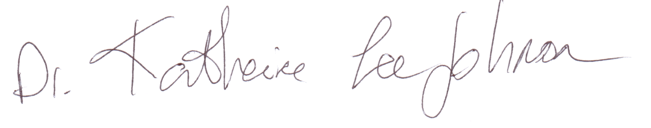
Dr. Katherine Johnson
Johnson Consulting Group

