Exhibit No.:
Issues: DNR

Witness: Lena M. Mantle
Sponsoring Party: MO PSC Staff
Type of Exhibit: Surrebuttal Testimony
Case No.: ER-2004-0570
Date Testimony Prepared: November 23, 2004

MISSOURI PUBLIC SERVICE COMMISSION

UTILITY OPERATIONS DIVISION

SURREBUTTAL TESTIMONY

OF

LENA M. MANTLE

THE EMPIRE DISTRICT ELECTRIC COMPANY

CASE NO. ER-2004-0570

Jefferson City, Missouri
November 2004
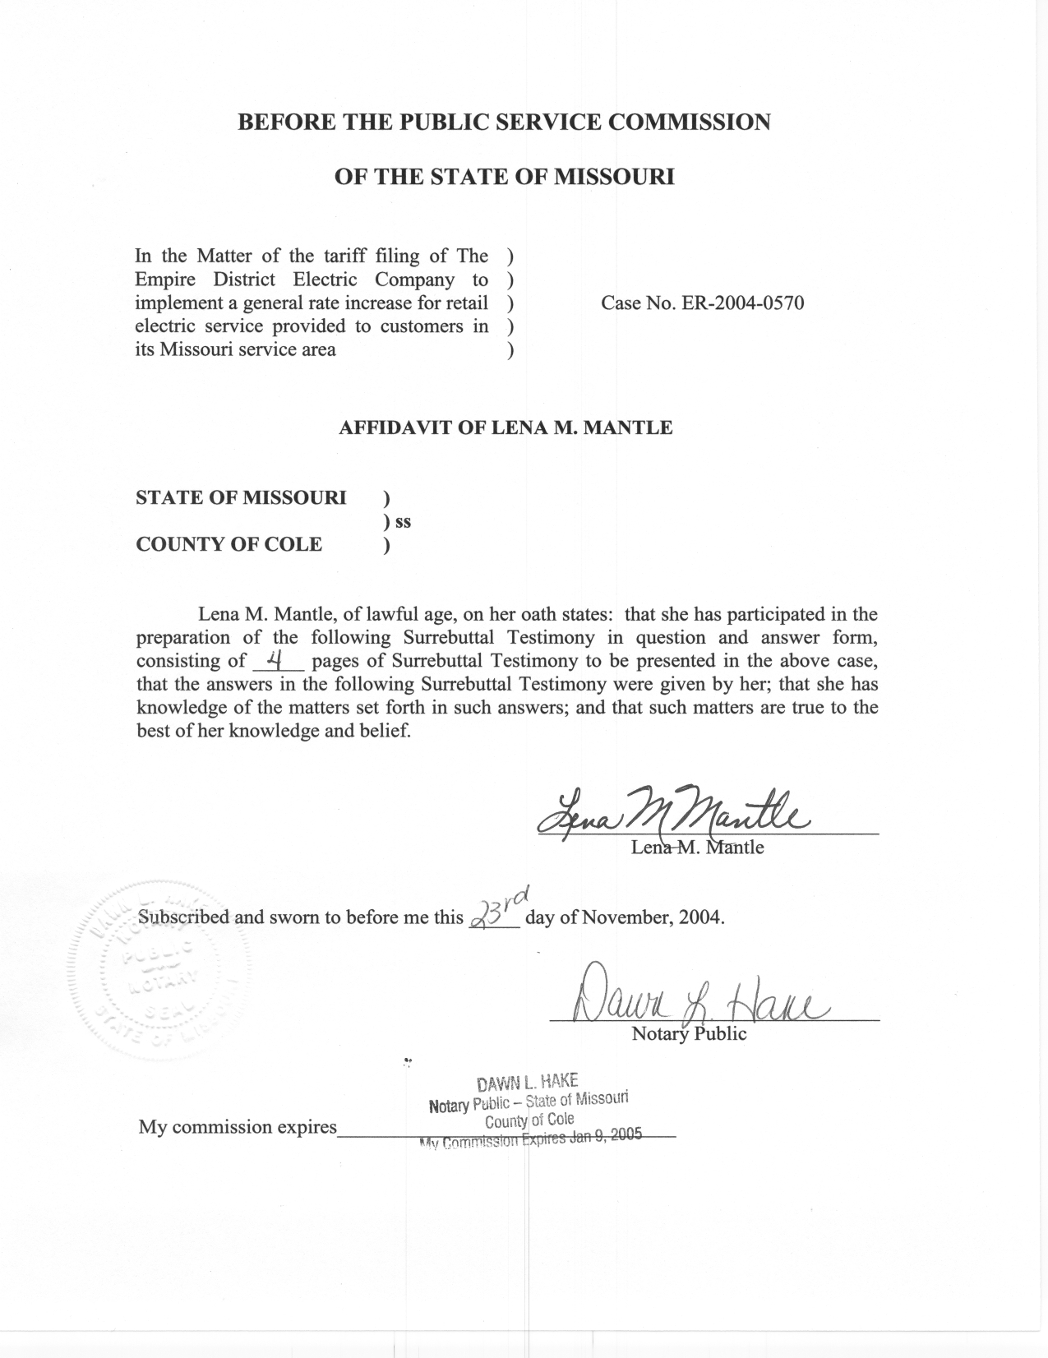

SURREBUTTAL TESTIMONY

OF

LENA M. MANTLE

THE EMPIRE DISTRICT ELECTRIC COMPANY

CASE NO. ER-2004-0570

Q. Please state your name and business address.
A. My name is Lena M. Mantle and my business address is Missouri Public Service Commission, P. O. Box 360, Jefferson City, Missouri 65102.
Q. Are you the same Lena M. Mantle who has filed prepared Direct and Rebuttal Testimony in this case?
A. Yes, I am.
Q. What is the purpose of your Surrebuttal Testimony?
A. The purpose of my Surrebuttal Testimony is: (1) to clarify a statement that I made in my Rebuttal Testimony regarding the Empire District Electric Company’s (EDE or Company) position regarding wind resources, (2) to clarify a statement regarding Staff’s position made by Company witness Michael E. Palmer regarding Staff position on the energy efficiency programs proposed by the Department of Natural Resources –Energy Center (DNR-EC) (Palmer Rebuttal p.5, l. 20 - 22), and (3) address the assertion by DNR-EC witness Anita C. Randolph that requiring EDE to provide energy efficiency services to its customers as alternative resources will address the rising cost of electric service provided by EDE (Randolph Rebuttal p.5. l. 3-6).
Q. What is the statement that you made in your Rebuttal Testimony concerning EDE’s position regarding wind resources that you would like to clarify here?
A. In my Rebuttal Testimony on page 1, line 28, I made the statement that “wind has not been a part of the future resource plans for EDE.” What I meant by this statement is that while EDE has told Staff in its integrated resource planning updates that it has evaluated wind as a future resource and it is a potential future resource, EDE has not signed a contract for wind as a future resource nor has it started the process of acquiring the property (real estate or technology) necessary to obtain energy or capacity from a wind resource. Staff does not consider any energy source, whether a capacity contract or a generating unit, to be a resource until a utility has signed a contract for the resource or otherwise taken action necessary to obtain the resource.
Q. What statement did Mr. Palmer make in his Rebuttal Testimony that you would like to address?
A. On page 5, lines 20 though 22, Mr. Palmer, in reference to the DNR-EC proposals, states “The Company agrees with Staff’s position that the cost of these proposals should be paid for by the beneficiaries, the ratepayers.”
Q. Is this the Staff’s position?
A. No. It is the Staff’s position that no analysis has been conducted to determine if there are any beneficiaries beyond the participants in each program, and that further analysis should be conducted to show that there will be benefits to the ratepayers. If analysis does show that there will be benefits, then it might be appropriate for ratepayers to pay for a pilot program that will give relevant information regarding whether or not the program actually does benefit the ratepayers. At that time, a determination should be made whether or not the program should be fully implemented and paid for by the general body of ratepayers who will benefit from the program.
Q. Might energy efficiency programs not help address the rising cost of electric service provided by EDE as discussed by Ms. Randolph in her Rebuttal Testimony?
A. Ms. Randolph addresses the concern of Company witness William L. Gipson, regarding the rising expenses related to EDE’s increased dependence upon natural gas, by suggesting that energy efficiency programs will reduce the amount of energy that EDE will be required to generate, and, therefore, it will reduce EDE’s dependence on natural gas (Randolph Rebuttal p.4, l. 22 through p.5 line 6).
While a large portion of EDE’s generation is fueled by natural gas, EDE’s generation fleet also contains units fueled by coal. The coal plants are base load plants that typically run as many hours as possible. In addition to the economics of these coal plants that make it more efficient to run them as much as possible, these plants are designed in a manner that make them operate at their most efficient when they run continuously. It is costly to shut these plants down so instead of shutting these plants down, utilities, including EDE, will sell energy produced at these plants at a lose instead of shutting these plants off.
EDE also owns a portion of a combined cycle plant that is fueled by natural gas. This plant must run for a minimum time once it comes on. It cannot follow hourly load changes and it has a cost to shut down.
Generation plant operating characteristics make it very important for a utility to evaluate how an energy efficiency program will impact its generation fleet before fully launching a program. The objective of energy efficiency programs is to impact the energy usage of the utility. However, because of the operating characteristics of the generation fleet of the utility, certain energy efficiency programs could actually increase generation costs because when the energy efficiency program reduces the load requirements is not cost efficient to the generation fleet of the utility.
Q. So are you saying that EDE should not engage in any energy efficiency programs?
A. No, I am not. Energy efficiency programs have value. What I said in my Rebuttal Testimony, and what I want make clear here, is that before EDE implements a energy efficiency program it should analyze how the program will impact the current and future generation requirements of EDE. If it is shown that the program is likely to be beneficial to EDE and its ratepayers, it should be implemented, with on going evaluation, by EDE.
Q. Does this conclude your Surrebuttal Testimony?
A. Yes, it does.

