Exhibit No.:
Issues: Determination of Statewide
Competition, Determination of
Exchange Specific Competition

Witness: Adam McKinnie
Sponsoring Party: MO PSC Staff
Type of Exhibit: Surrebuttal Testimony
Case No.: IO-2003-0281
Date Testimony Prepared: July 3, 2003

MISSOURI PUBLIC SERVICE COMMISSION

Utility Operations Division

Surrebuttal Testimony

OF

Adam McKinnie

CASE NO. IO-2003-0281

Jefferson City, Missouri
July 2003

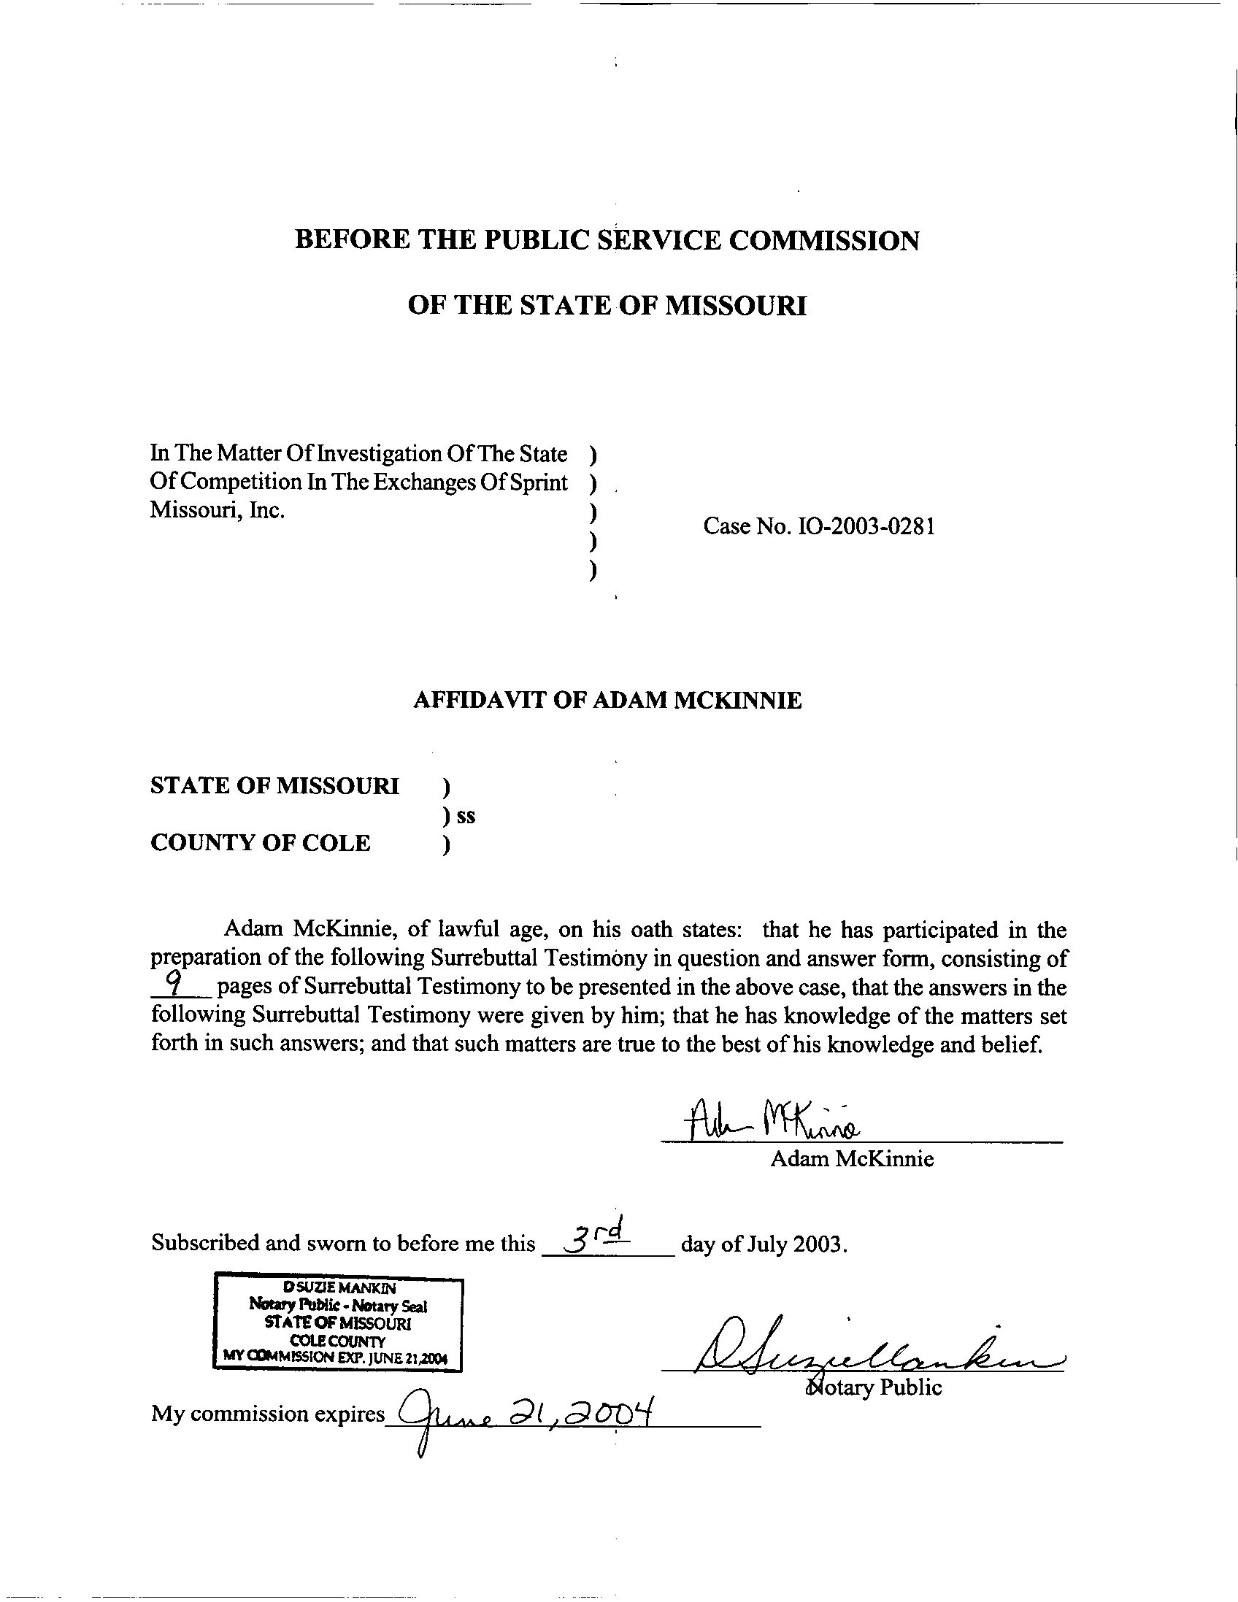
SURREBUTTAL TESTIMONY
OF
ADAM MCKINNIE
SPRINT MISSOURI, INC.

CASE NO. IO-2003-0281

Q. Are you the same Adam McKinnie who filed Rebuttal Testimony?

A. Yes.

Q. What is the purpose of your Surrebuttal Testimony?

A. The purpose of my Surrebuttal Testimony is to respond to the Rebuttal Testimony of Office of Public Counsel witness Meisenheimer, Fidelity Communications Services I, Inc. (Fidelity) witness Taylor and ExOp of Missouri, Inc.d/b/a Unite (ExOp) witness Devoy.
Q. On page 5, lines 8-11 of her Rebuttal Testimony, Ms. Meisenheimer states, “[t]he Commission should consider taking this opportunity to determine that effective competition does not exist for those services and in those exchanges that Sprint [Sprint Missouri, Inc. (Sprint)] does not seek competitive classification at this time.” Do you agree with this statement?
A. Yes. As Section 392.254.5 RSMo states,

Each telecommunications service of an incumbent local exchange telecommunications company [ILEC] shall be classified as competitive in any exchange in which at least one alternative local exchange telecommunications company has been certified under section 392.455 and has provided basic local telecommunications service in that exchange for at least five years, unless the commission determines, after notice and a hearing, that effective competition does not exist in the exchange for such service.

Therefore, Staff recommends the Commission state in its Order that effective competition does not exist for those services and in those exchanges where Sprint does not seek effective competition.
Q. Beginning on page 4, line 4 of her Rebuttal Testimony, Ms. Meisenheimer implies effective competition has to be examined service by service, exchange by exchange. How has the Commission chosen to look at effective competition in the past?
A. Although Section 392.245.5 RSMo seems to contemplate a review as described by Ms. Meisenheimer, in Case No. TO-2001-467, the Southwestern Bell Telephone Company (SWBT) competition case (SWBT Competition Case), the Commission chose to consider all of the Southwestern Bell’s services and exchanges simultaneously. In its Order, the Commission states, “Because alternative local exchange telecommunications companies are currently certified in every exchange in which Southwestern Bell operates, the Commission established this case to review the status of competition in all of Southwestern Bell’s exchanges.” (Page 5) According to Schedule 1, three facilities-based competitive local exchange telecommunications carriers (CLECs) (Everest Midwest Licensee, L.L.C. f/k/a Everest Connections Corporation, Navigator Telecommunications, L.L.C., and Socket Telecom, L.L.C.) are certificated to provide service throughout Sprint’s entire service area. Furthermore, one non-prepaid reseller (Local Line America, Inc.) and a few prepaid resellers are also certificated to provide service throughout the Sprint service area. As this situation is similar to what the Commission cited in the SWBT Competition Case, it makes sense to look at all of Sprint’s exchanges at the same time.
The alternative would be to have a ‘rolling’ case of sorts, where the Commission would consider new services and/or new exchanges on a perpetual basis. It is a much more efficient and logical use of the resources for all parties to consider all of the exchanges and services of a large telecommunications company (such as SWBT or Sprint) at the same time.
Q. On page 17, lines 10-15 of her Rebuttal Testimony, Ms. Meisenheimer discusses using the Herfindahl-Hirschman Index (HHI) to look at market dominance. Is the HHI an appropriate indicator of the status of effective competition in the telecommunications industry in this case?
A. No. Use of the HHI is not appropriate in this case. As Ms. Meisenheimer states, the HHI takes into account the number of firms and their individual market shares to create one number that is intended to represent market concentration (page 17, lines 13-14, Meisenheimer’s Rebuttal Testimony). As discussed below, there are several problems with evaluating the telecommunications market on an exchange-by-exchange basis and then comparing the results to industries other than telecommunications.
First, the telecommunications market is a unique entity. The cost of producing just one full facilities-based telephone line would include, but is not limited to, providing central office equipment, physically providing some sort of access to the customer’s premise, providing customer support, establishing interconnection with other telecommunications companies, etc. As the cost of entry is capital intensive, it is not likely that a large number of companies will be providing full facilities-based telephone service in any one exchange.
Two of the three CLECs (Fidelity and Unite) we are examining in depth in this proceeding are providing telephone service using some of the same facilities they also use to simultaneously provide cable television service. Some of these facilities were already in place prior to offering telephone service, thus mitigating some of the initial cost of providing that service. The third company (Green Hills Telecommunications Company) is providing service utilizing the expertise and facilities of an affiliated ILEC.
Second, the customer base in many of these exchanges is of a size that it would seem unlikely that a large number of facilities-based telecommunications carriers would invest the large amount of capital needed to compete over them. For example, as of December 2001, there were 104 facilities-based business lines and 469 facilities-based residential lines in the Norborne exchange. Taking into account the large entry cost of providing telecommunications service, it is unlikely that a large number of facilities-based competitors would enter this market.
Third, it would be remarkable for five firms to achieve an equal market share where an incumbent has been in place for a long period of time, yet even this scenario would not meet Ms. Meisenheimer’s standard of a market being “moderately concentrated.” For example, five telephone companies each providing service to 20 percent of the market within an exchange would result in an HHI as follows:
20² + 20² + 20² +20² + 20²
400 + 400 + 400 + 400 + 400 = 2000

For the Norborne exchange, this would translate to five carriers with approximately 116 lines per carrier. To satisfy the definition of “moderately concentrated,” the telecommunications market in this exchange would need a minimum of six carriers with similar market shares to have an HHI of 1800.
Furthermore, the HHI does not take into account the difference between an incumbent firm and a competitive firm. The HHI considers all competitors as equal and does not take into account the historic advantages of the ILEC, such as the ability to cultivate long-term relationships with customers and being well-known. A CLEC can be seen as “swimming upstream”, as it has to compete against the historical incumbent for customers that the ILEC may have served for decades.
Considering the high cost of entry borne by competitive facilities-based carriers, the manner in which the HHI treats the incumbent and competitive companies as the same, and the unrealistic expectations this standard has for the telecommunications market within any exchange, Staff does not find the HHI a valuable tool to use in determining effective competition.
Q. On page 3, lines 55-56 of his Rebuttal Testimony, Mr. Taylor states Fidelity is not a “100 percent full facilities based competitor.” Ms. Meisenheimer, on page 13, lines 8-11, of her Rebuttal Testimony, states, in reference to the Fidelity exchanges, “[Sprint] still controls the local loop and customers are still captive to [Sprint] or a CLEC that purchases resold services or unbundled network elements from Sprint.” Do you agree with these characterizations of Fidelity within the Rolla exchange?
A. No. While it is true that Fidelity does not provide 100 percent of their lines using entirely their own facilities, according to a Data Request Response received by Staff from Fidelity, as of December 31st, 2002, in the Rolla exchange, Fidelity had 2,805 full facilities-based residential voice grade equivalent lines; 1,633 full facilities-based business voice grade equivalent lines; three pure resale business voice grade equivalent lines; and six Unbundled Network Element (UNE) voice grade equivalent lines.
Staff agrees that Fidelity cannot currently reach all customers in the Rolla exchange using its own facilities. However, Staff considers the 2,805 residential customers and 1,633 business customers as full facilities-based customers. The 99.8 percent of the lines listed by Fidelity as “full facilities-based” are presumably provided using 100 percent Fidelity owned and controlled equipment, including the local loop; thus, those customers would not be captive to Sprint and Sprint would not control those local loops.
Q. Beginning on page 4, line 19 of his Rebuttal Testimony, Mr. Devoy discusses the increase of Sprint rates in rate Group III. Do you have any comments about this analysis?
A. Yes. When Sprint submitted Tariff File No. 200100493 to the Commission on October 27, 2000, to rebalance rates, it eliminated many separate touch tone and zone mileage charges and rolled them all into the basic rate. Furthermore, Sprint reduced switched access charges and increased basic local service rates as allowed by Section 392.245.9 RSMo.
The Staff Recommendation characterized the impact as follows:
For all residential basic local customers:

    - 27 percent will receive a monthly savings of 40 cents;

    - 58 percent will see an average increase of $1.04 in their monthly dial tone service;

    - 15 percent will see a $3.20 increase in their monthly dial tone service.

As a result of adjustments allowed by Section 392.245.4(1) RSMo and Section 392.245.9 RSMo, Sprint also increased the basic local rates by $1.40 for residential and $1.36 for business in December 2001; and increased the basic local rates for residential $1.50 and business $1.50 in December 2002. Clearly, Sprint’s price increases since 1999 have not been as dramatic as stated by Mr. Devoy.
Q. On page 3, lines 22-28 of his Rebuttal Testimony, Mr. Devoy discusses the possible pending sale of ExOp by its parent company, Aquila, and the concerns about Aquila not funding any future ExOp expansion. What is your opinion on this matter?
A. The current state of competition in the Kearney exchange is sufficient for effective competition. Nowhere in his testimony does Mr. Devoy contemplate ExOp’s current customers in the Kearney exchange being denied telecommunications service from ExOp or its successor.
Q. On page 6, line 124 of his Rebuttal Testimony, Mr. Taylor states, “Only one competitor price competes with Sprint.” How do you respond to this statement?
A. Staff agrees with Mr. Taylor that only one company is capable of price competing with Sprint in the Rolla exchange (Fidelity). Staff would like to add that Fidelity competes with Sprint in the Rolla exchange on both a price and value basis, and a combination of those two factors. Customers in the Rolla exchange have the choice to purchase their telecommunications services from Sprint or Fidelity, and may choose so based on any number of factors, not just price. Mr. Taylor provides excellent examples of how effective competition can and should occur in the telecommunications industry, on page 8, lines 179-182 of his Rebuttal Testimony, while discussing the St. Robert exchange. Mr. Taylor states, “The fact that its [Fidelity’s] affiliate, Fidelity Cablevision, Inc., had been providing cable TV service for approximately eight years was its biggest advantage. It provided Fidelity I with name recognition and a positive quality of service reputation in the community. The existence of a local business office and the synergies available by developing a unique, multipurpose network were significant factors in Rolla.” The multipurpose network cited by Mr. Taylor has allowed Fidelity to differentiate itself from Sprint by allowing Fidelity to offer a wide variety of services and to compete with Sprint not just on price, but also on value.
Q. Ms. Meiseheimer and Mr. Devoy, in Rebuttal Testimony, express concerns as to the sustainability of the CLECs relied upon as providing effective competition. If the Commission decides to declare an exchange effectively competitive, can the Commission in the future remove that declaration?
A. Yes. Section 392.245.5 RSMo states,
The Commission shall from time to time, but no less than every five years, review the state of competition in those exchanges where it has previously found the existence of effective competition, and if the Commission determines, after hearing, that effective competition no longer exists for the incumbent local exchange telecommunications company in such exchange, it shall reimpose upon the incumbent local exchange telecommunications company in such exchange, the provisions of paragraph (c) of subdivision (2) of subsection 4 of section 392.200 and the maximum allowable prices established by the provisions of subsections 4 and 11 of this section, and, in any such case, the maximum allowable prices established for the telecommunications services of such incumbent local exchange telecommunications company shall reflect all index adjustments which were or could have been filed from all preceding years since the company’s maximum allowable prices were first adjusted pursuant to subsection 4 or 11 of this section.

Q. On page 5, lines 99-105 of his Rebuttal Testimony, Mr. Taylor states that in the SWBT Competition Case, the Commission found 51 CLECs were providing business service in the Kansas City exchange, 59 CLEC were providing business service in the St. Louis exchange, and 36 CLECs were providing business service in the Springfield exchange, while noting that competition in Rolla pales in comparison. Further, on page 20, lines 15-19 of her Rebuttal Testimony, Ms. Meisenheimer discusses the actual number of carriers providing service in Sprint’s service territory. What is Staff’s opinion on the number of CLECs cited as providing service in this case?
A. According to Section 386.020(13) RSMo, one of the factors in determining effective competition is “the extent to which the services of alternative providers are functionally equivalent or substitutable at comparable rates, terms and conditions.” Thus, the focus of an effective competition case should be on whether the CLEC(s) are providing functionally equivalent or substitutable service in the exchange(s) of an ILEC, not the number of CLECs providing service within an exchange.
Mr. Taylor notes on page 4, lines 75-76 of his Rebuttal Testimony that eight of the nine CLECs (excluding Fidelity) listed in Sprint’s Rolla phone book are prepaid. Ms. Meisenheimer states on page 14, lines 3-9 of her rebuttal testimony that prepaid service is not functionally equivalent to basic local telecommunications service. As noted in Staff’s Rebuttal Testimony, page 15, beginning on line 22, it is logical to remove those CLECs, or any other CLECs not providing functionally equivalent or substitutable service, from the discussion of effective competition and focus on facilities-based carriers.
Q. Please summarize your testimony.
A. Following is a list of the crucial aspects of my testimony:
- Staff recommends the Commission state in its order that effective competition does not exist for those services and in those exchanges where Sprint does not seek effective competition.

- Staff recommends the Commission consider competition for all requested services in all requested exchanges at this time.

- The Herfindahl-Hirschman Index (HHI) is not appropriate in this case.

- The extent to which competitive services are functionally equivalent or substitutable is a key component when considering the number of carriers providing service in a given market.

Q. Does this end your Surrebuttal Testimony?
A. Yes, it does.

