Exhibit No.:
Issues: Territorial Agreement
Witness: James L. Ketter
Sponsoring Party: MO PSC Staff
Type of Exhibit: Rebuttal Testimony
Case No.: EO-2002-458
Date Testimony Prepared: June 25, 2002

MISSOURI PUBLIC SERVICE COMMISSION

Utility Operations DIVISION

REBUTTAL TESTIMONY

OF

James L. Ketter

Union Electric Company
d/b/a AmerenUE

AND
CALLAWAY ELECTRIC COOPERATIVE

CASE NO. EO-2002-458

Jefferson City, Missouri
June 2002

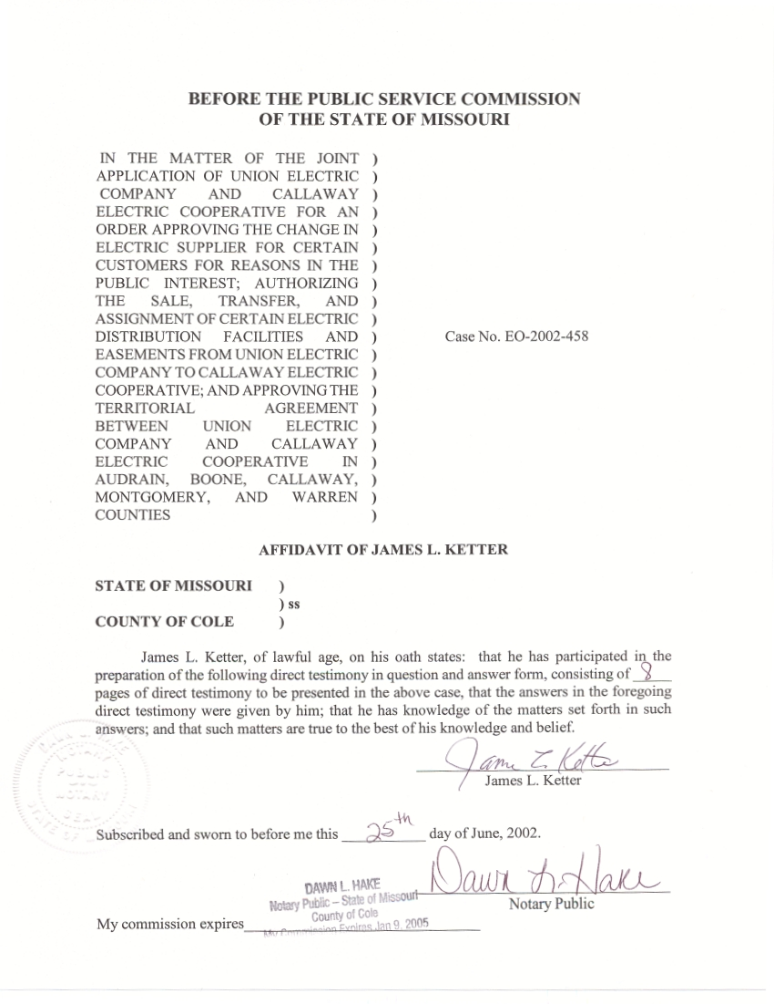
REBUTTAL TESTIMONY
OF
JAMES L. KETTER
UNION ELECTRIC COMPANY
d/b/a AMERENUE
AND
CALLAWAY ELECTRIC COOPERATIVE
CASE NO. EO-2002-458
Q. Please state your name and give your business address.
A. James L. Ketter, P.O. Box 360, Jefferson City, Missouri 65102.
Q. Mr. Ketter, by whom are you employed and in what capacity?
A. I am employed by the Missouri Public Service Commission (MPSC or Commission) as Utility Regulatory Engineer II in the Engineering Analysis section of the Energy Department.
Q. Please summarize your educational background and professional experience.
A. I received a Bachelor of Science degree in Electrical Engineering from the University of Missouri-Columbia in 1970. I served for 4 1/2 years as an officer in the United States Navy and returned to the University of Missouri-Columbia campus to pursue an advanced degree. In December 1977 I received a Masters degree in Business Administration from the University of Missouri-Columbia.
I have been employed by the Commission since 1976. As an engineer on the Staff, I have testified before the Commission on certificates for service areas, electric transmission and power plant certification cases, territorial agreements and I have presented testimony on rate design in electric, steam and gas rate cases. I am a registered Professional Engineer in the state of Missouri; my registration number is E-20056. I am a member of the National Society of Professional Engineers and I am a member of the Jefferson City Chapter of the Missouri Society of Professional Engineers.
Q. What is the purpose of your testimony in this case?
A. I will address the Territorial Agreement filed by Union Electric Company d/b/a AmerenUE (AmerenUE or Company) and Callaway Electric Cooperative (Callaway or Cooperative). Also, I will address the proposed change of electric supplier between AmerenUE and Callaway. The Joint Application filed in this case requests the transfer of approximately 800 AmerenUE structures to Callaway and approximately 600 Callaway structures to AmerenUE.
Q. What is your recommendation concerning this territorial agreement and the transfer of electric customers and facilities between AmerenUE and Callaway?
A. I recommend that the Commission approve the Territorial Agreement, the change of electric supplier and transfer of facilities. The distribution facilities that Callaway has in place to serve this area are better situated geographically to provide good service quality and reliability. The existing AmerenUE distribution facilities are concentrated around the larger communities and rural customers are served from long radial circuits that are more difficult to maintain.
The territorial agreement will allow Callaway to integrate this new service territory into its system. The new customers will provide additional revenue to improve cost recovery of the existing facilities and improve the overall density for Callaway, to benefit all of Callaway members in the future. The agreement and change of supplier will allow one supplier for the designated areas and not allow duplication of facilities so that long-range plans can be made by each utility to serve their designated territory.
In consideration of all these factors, Staff believes that the Territorial Agreement and change of electric supplier is in the public interest and not detrimental to the public interest.
Q. Describe the geographic area that this territorial agreement encompasses.
A. This territorial agreement involves portions of the area served by Callaway and the overlapping service territory of AmerenUE, including portions of Audrain, Boone Callaway, Montgomery and Warren Counties.
Q. How are AmerenUE customers in this area presently served?
A. AmerenUE has extended its electric facilities along highways between communities it serves over the years, with extensions from these facilities. Consequently, the present facilities of AmerenUE are concentrated in the Holts Summit area and along Highway 54 through portions of Callaway County and another section in Montgomery County between Rhineland and McKittrick. In addition, the AmerenUE facilities subject to transfer extend along State Highway C to Mokane and two sections along Interstate Highway 70, near Stephens and Williamsburg. It is typical that the rural customers are served from facilities that are considerably distant from the distribution substations with little opportunity for alternate supply if problems occur.
Q. Will this territorial agreement and change of electric supplier produce a benefit for the reliability of electric service for customers in this area?
A. Yes, it is my opinion that it will. The customers subject to transfer to AmerenUE will be concentrated in areas that UE is most capable of providing good service quality. The customers subject to transfer to Callaway are mostly in rural areas where Callaway has established distribution substations and facilities to provide reliable electric service.
Q. Have the customers subject to a change of electric supplier been notified?
A. Yes, letters were sent to the affected customers and a public meeting was hosted by AmerenUE and Callaway to answer questions on November 27, 2001, in Fulton, Missouri, and November 29, 2001, in Montgomery City, Missouri. Also, a letter was sent to the affected customers of each utility on May 6, 2002, providing information and contacts at the Public Service Commission and the Office of the Public Counsel.
Q. Did you receive calls from customers subject to change of supplier?
A. Yes, I did receive calls from affected customers.
Q. Please summarize the questions and sentiment of these calls.
A. Some callers were unable to attend the informational meetings last November and wanted to understand the proposed change of supplier. Most had an interest in the impact of the rates if a change of supplier was approved. Most felt comfortable with their present electric supplier and expressed a desire to remain on the present supplier.
The present cooperative customers valued local control and accessibility of Callaway, and recognized that the capital credits paid by Callaway reduced their rates. The

present AmerenUE customers recognized that AmerenUE rates are generally lower when compared with Callaway on an annual basis.
Q. What is the rate impact of changing from AmerenUE to Callaway?
A. Outlined below in Table I are the rate structures for AmerenUE and Callaway. Table II outlines annual bills at various average monthly usage levels. The main differences are the customer charges and AmerenUE’s seasonal rates. Seasonal rates for AmerenUE are higher than Callaway’s in the summer but lower in the winter season. Comparison of rates requires an analysis for a yearly period so that these seasonal

Table I

differences are accounted for. Table II shows a comparison at various level monthly usages, which show AmerenUE are lower on an annual basis, though the summer rates are
higher. As seasonal usage levels change, the impact will change.
 | AMERENUE | CALLAWAY
Customer  Charge | $7.25 | $15.00
Winter | First 750 kWh $.05770  over 750 kWh $.03891 | First 750 kWh $.068  750-2000kWh $.057 over 2000 kWh $.051
Summer | All usage $.0813 | First 750 kWh $.068  750-2000 kWh $.057 over 2000 kWh $.051
Table II

KWH  Usage | AmerenUE  Winter  8 months | AmerenUE  Summer  4 months | Annual Bill | Callaway | Annual Bill
0 | $7.25 | $7.25 | $87.00 | $15.00 | $180.00
500 | 36.10 | 47.90 | 480.40 | 49.00 | 588.00
1000 | 60.25 | 88.55 | 836.20 | 80.25 | 963.00
1500 | 79.70 | 129.20 | 1154.40 | 108.75 | 1305.00
2000 | 99.15 | 169.85 | 1472.60 | 137.25 | 1647.00
2500 | 118.60 | 210.50 | 1790.80 | 162.75 | 1953.00

Q. What happens to monthly bills if a customer’s use is higher in the summer or during the winter period?
A. AmerenUE’s summer rates are much higher during the summer period. If a customer has high summer use, the Callaway rate structure may be an advantage. In Table II this is illustrated by comparing a UE summer rate to the non-seasonal rates of Callaway, i.e. at 1500 kWhs for a summer month the AmerenUE bill is $129.20 and the Callaway bill is $108.75.
If a customer has higher use in the winter period, AmerenUE’s rate structure is more favorable. In Table II this is illustrated by comparing a UE winter bill to the non-seasonal bill of Callaway, i.e. at 1500 kWhs for a winter month the AmerenUE bill is $79.70 and the Callaway bill is $108.75. For residential customers, the cost for heating is more favorable on AmerenUE rates, but air conditioning cost is more favorable on Callaway rates.
Q. What is the tax impact on agencies in the counties subject to the exchange of customers and electric facilities?
A. As a public utility, AmerenUE is taxed differently than a cooperative such as Callaway. In general, the ownership of electric plant by a cooperative will mean less tax dollars to the local taxing agencies. Exhibit 6 of the Joint Application contains a summary of the tax impact of various entities. There is very little change in the overall tax recovery, partly because the amount of electric facilities transferred, in accordance with the exchange agreement is approximately equal. AmerenUE pays more tax than Callaway due to different assessment rates.
Q. In the Direct Testimony of Larry D. Merry, illustrative tariffs are referenced in his Schedule 3 that depicts the service area for AmerenUE. Have you reviewed these illustrative tariffs?
A. Yes, I have.
Q. Do you agree with the description of the service area in the illustrative tariffs?
A. No, there are some corrections necessary to accurately identify the service area and the limitations of the territorial agreement. The Staff has reviewed these changes with AmerenUE. On Sheet No. 9 for Callaway County service territory, in Township 44 North, Range 10 West, Section 22 should be underlined; Township 44 North, Range 11 West, Sections 12 and 13 should be underlined; and in Township 46 North, Range 8 West, Sections 22, 30 and 31 need to added and underlined. Also, on Sheet No. 10, Township 48 North, Range 9 West, Sections 10 and 11 should not be underlined. These corrections will accurately identify the sections that are affected by the territorial agreement and the underlined sections reference a footnote on the sheet that identifies this case number and limitations pursuant to the territorial agreement. These corrections are consistent with Paragraph 16 of the nonunanimous stipulation and agreement filed in this case by Staff, AmerenUE and Callaway.
Q. Do you concur with the proposed changes incorporated on the tariff sheets to change the reference of surveys to the township, range and section to identify the AmerenUE service area?
A. Yes. The township, range, and section reference is consistent with other portions of the AmerenUE tariff and this identification is portrayed on county maps.
Q. Do you support the nonunanimous stipulation and agreement filed with the Commission on June 21, 2002?
A. Yes.
Q. Does this conclude your rebuttal testimony?
A. Yes, it does.

