Exhibit No.:
Issues: Quality of Service,
System Operation, & New Construction

Witness: James A. Merciel, Jr.
Sponsoring Party: Mo PSC Staff
Type of Exhibit: Direct Testimony
Case No.: WR-2003-0500 &
WC-2004-0168
Date Testimony Prepared: October 3, 2003

MISSOURI PUBLIC SERVICE COMMISSION

Utility Operations DIVISION

DIRECT TESTIMONY

OF

James A. Merciel

Missouri-American Water Company

CASE NO. WR-2003-0500 & WC-2004-0168

Jefferson City, Missouri
October 2003

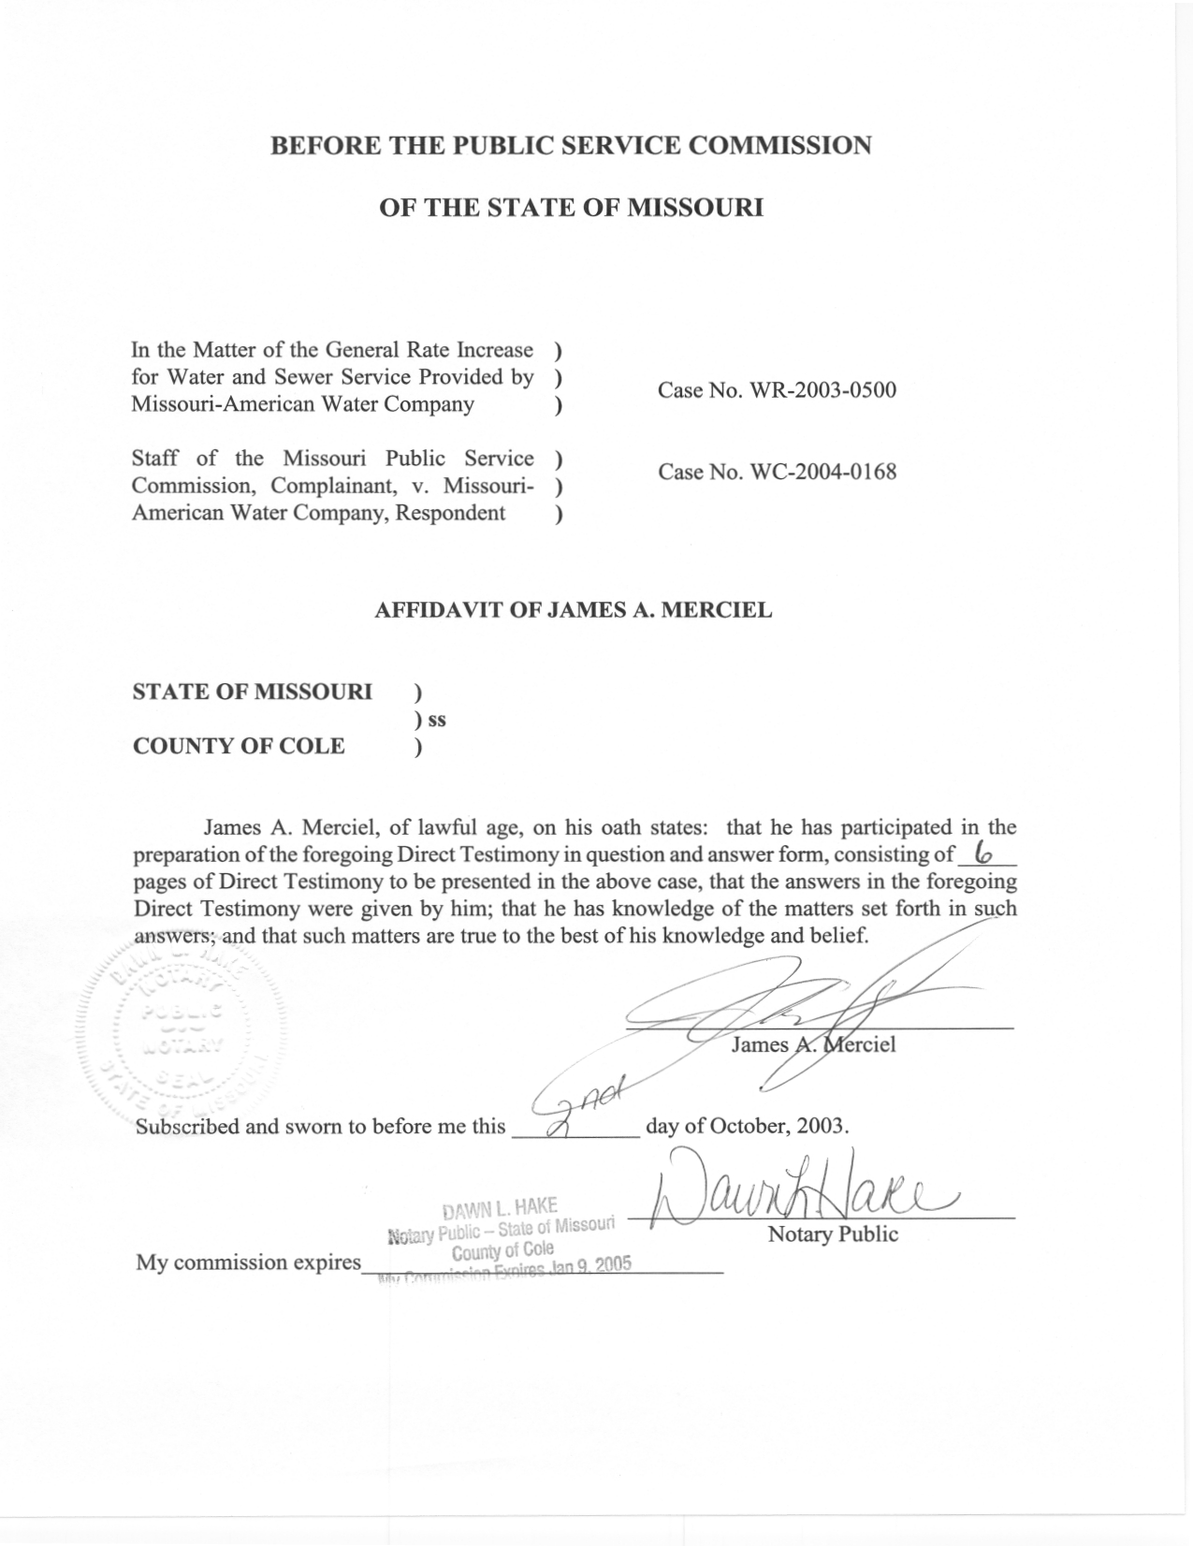

TABLE OF CONTENTS

INTRODUCTION 1
GENERAL OPERATIONS AND QUALITY OF SERVICE 2
THE COMPANY’S CONSTRUCTION PROJECTS 3
EXCESS PLANT CAPACITY 4
SUMMARY 6

DIRECT TESTIMONY
Of
James A. Merciel, Jr.
Case No. WR-2003-0500 & WC-2004-0168
Missouri-American Water Company

INTRODUCTION
Q. Please state your name and business address.
A. James A. Merciel, Jr., P. O. Box 360, Jefferson City, Missouri, 65102.
Q. By whom are you employed and in what capacity?
A. I am employed by the Missouri Public Service Commission (“Commission”) as a Utility Regulatory Engineering Supervisor, in the Water and Sewer Department (“W/S Department”).
Q. Please describe your education and work experience.
A. I graduated from the University of Missouri at Rolla in 1976 with a Bachelor of Science degree in Civil Engineering. I am a Registered Professional Engineer in the State of Missouri. I worked for a construction company in 1976 as an engineer and surveyor, and have worked for the Commission in the W/S Department since 1977.
Q. What is the purpose of your testimony?
A. The purpose is to present testimony regarding quality of service, system operations and new construction.

GENERAL OPERATIONS AND QUALITY OF SERVICE
Q. Are you familiar with the Company’s overall operation of its water systems and its sewer system?
A. Yes. Inspections of the Company’s systems are periodically conducted by individuals from the W/S Department who are under my direct supervision and/or by me. The W/S Department Staff conducts such inspections to evaluate the conditions of the Company’s facilities, to evaluate the Company’s operation of the facilities and to review the various records that the Company maintains about its system operations. The Company has programs such as valve exercising, meter replacements, hydrant exercising and flushing, pump maintenance and leak detection. Records are maintained for these programs, as are operational records pertaining to plant performance, volume of water pumped and storage tank levels. All of these programs and records contribute toward maintaining good water service.
Q. Are there any customer service issues currently being studied?
A. Yes. In the Company’s St. Charles service area, there is an area of some 150 residential customers that are served by the Company’s Camelot Booster facility. A couple of homes at the highest elevation experience low pressure at times, but the real issue is a fluctuation in pressure. This is a result of customer demand both within the area served by the booster, and ahead of the booster where the suction is affected. The Company has been modifying its operation techniques of this facility to see what works best. Customers report that the fluctuation problem has improved recently. However, it is my opinion that the Company may need to improve the facility in order to provide consistent flow and pressure under all hydraulic conditions, perhaps by installing various size pumps, or using a storage tank within the boosted system.
In the St. Louis County service area the Staff is following up on a handful of complaints related to repeated main breaks. The main break issue continues to be somewhat of a problem in St. Louis County, although the company is able to resolve complaints by placing appropriate replacement projects on its schedule.
Except for these two particular issues, I am not aware of any routine or unresolved matters pertaining to deficient water or sewer service, or to the Company’s operation and maintenance of its water and sewer facilities.

THE COMPANY’S CONSTRUCTION PROJECTS
Q. Are there any major items that have been recently constructed in any of the Company’s service areas?
A. Yes. The Company is adding a lime slaker/feed system onto the St. Joseph treatment facility, in order to soften water as a part of the treatment process. Finished water from the new groundwater plant was expected to be somewhat harder than that from the old plant treating river water. After some objections from customers regarding water characteristics, the Company made a decision to soften the water. There are also lagoons to store the process waste, until the sludge is land applied as a fertilizer and the water discharged to a creek. In its Joplin service area, the Company is constructing two additional wells to meet increased water demand. In the Jefferson City service area, the Company has constructed a ground storage tank, which replaces an expired lease arrangement by which the Company used storage facilities of an adjacent water district in exchange for supplying water and operations services.
Q. Do you believe these new facilities are reasonable and necessary?
A. Yes. The lime softening in St. Joseph I believe will result in an improvement of water service to customers. The Joplin wells are necessary because demand has reached the capabilities of the existing water supply on peak days. The tank in Jefferson City is necessary for storage of water for peak hour demand and fire reserve, and takes the place of the water district’s tanks that are no longer available for the Company’s use.
Q. Are these facilities in service now?
A. The Jefferson City tank is in service. However, at the time of the Staff’s visits to Joplin and St. Joseph, on August 21, 2003 and September 17, 2003 respectively, the wells and the lime facility were still under construction and not yet in service. The Staff will want to verify that the facilities are in service prior to the end of this case if the additional associated rate base is to be included in rates.

EXCESS PLANT CAPACITY
Q. Do you have an opinion regarding excess plant capacity at the Company’s St. Joseph service area?
A. Yes. The new St. Joseph water treatment plant, referring to the groundwater treatment facility that replaced the old river water treatment facility in 2000, is capable today of 30 million gallons per day (mgd) production. My opinion in the Company’s last rate case, WR-2000-281, was that a 23 mgd production capacity would have been adequate, based on historical production data, I recommended in my Rebuttal Testimony in that case that rate base associated with certain plant components be excluded from the rate calculations. The specific amount of rate base I recommended for exclusion was $2,271,756. This recommendation for exclusion was accepted by the Commission in its final order in that case, and was excluded from rate calculations. Since that case, water production in St. Joseph on peak days has not increased according to production data provided by the Company. St. Joseph has not experienced an increase in water demand for many years, and in fact recently has experienced the loss of a Friskies Pet Food plant, a major industrial customer. Schedule 1, attached as a part of this testimony, shows peak day production of the well field pumps, which pump groundwater to the treatment facility, for the years 2001, 2002 and 2003 (to the month of July). Based on this data, and also based on peak day usage as was shown in WR-2000-281 and which is included in this testimony as Schedule 2, I still believe that the same disallowance should stand. Schedule 2, attached to this testimony, was also Schedule 2 in my Rebuttal Testimony in WR-2000-281, shows peak flows prior to 2000, and shows how the rate base disallowance was calculated.
Q. What components of the new plant are involved?

A. There are seven (7) vertical wells in the Company’s well field, but I believe five (5) vertical wells, operated along with the horizontal well facility, are currently adequate as the source of water. More vertical wells could be added as additional capacity is needed in the future. Two (2) clarifiers, instead of the existing three (3), would be adequate, with the provision to add a third and then a fourth. The clearwell, which stores finished water on the plant site before pumping to distribution, consists of two (2) one million gallon units, but I believe two (2) 750,000 gallon units would be adequate, with a provision to add a third later. I believe three (3) 300 horsepower distributive pumps, which pump from the clearwell to distribution, instead of the existing two (2) 300 horsepower units and two (2) 200 horsepower units that exist would be adequate, with the provision to add additional pumps. This is the same as my recommendation in WR-2000-281.

SUMMARY
Q. Would you please summarize your testimony?
A. Yes. It is my opinion that the Company is providing good service from a technical standpoint to its customers, is adequately operating and maintaining its existing plant facilities and is adequately planning for facility improvements and future needs. It is also my opinion that the new capital improvement projects that the Company is seeking to include in rates through this case are reasonable and appropriate. However, I believe the Staff should verify that the St. Joseph lime softening system and the Joplin wells are actually in service prior to including associated rate base in rates charged to customers. Finally, it is my opinion that the adjustments I made for the disallowance of plant components at the new St. Joseph Treatment plant in Case No. WR-2000-281 are also appropriate in this case. The St. Joseph district has not experienced an increase in the demand for water that would justify inclusion of the plant capacity that was disallowed by the Staff and ordered by the Commission in the last rate case.
Q. Does this conclude your testimony at this time?
A. Yes.

