Exhibit No.:
Issues: Tariffs
Witness: James A. Gray
Sponsoring Party: MoPSC Staff
Type of Exhibit: Testimony
Case No.: GT-2003-0037
Date Testimony Prepared: September 10, 2002

MISSOURI PUBLIC SERVICE COMMISSION

Utility Operations DIVISION

TESTIMONY

OF

JAMES A. GRAY

ATMOS ENERGY CORPORATION

CASE NO. GT-2003-0037

Jefferson City, Missouri
September, 2002

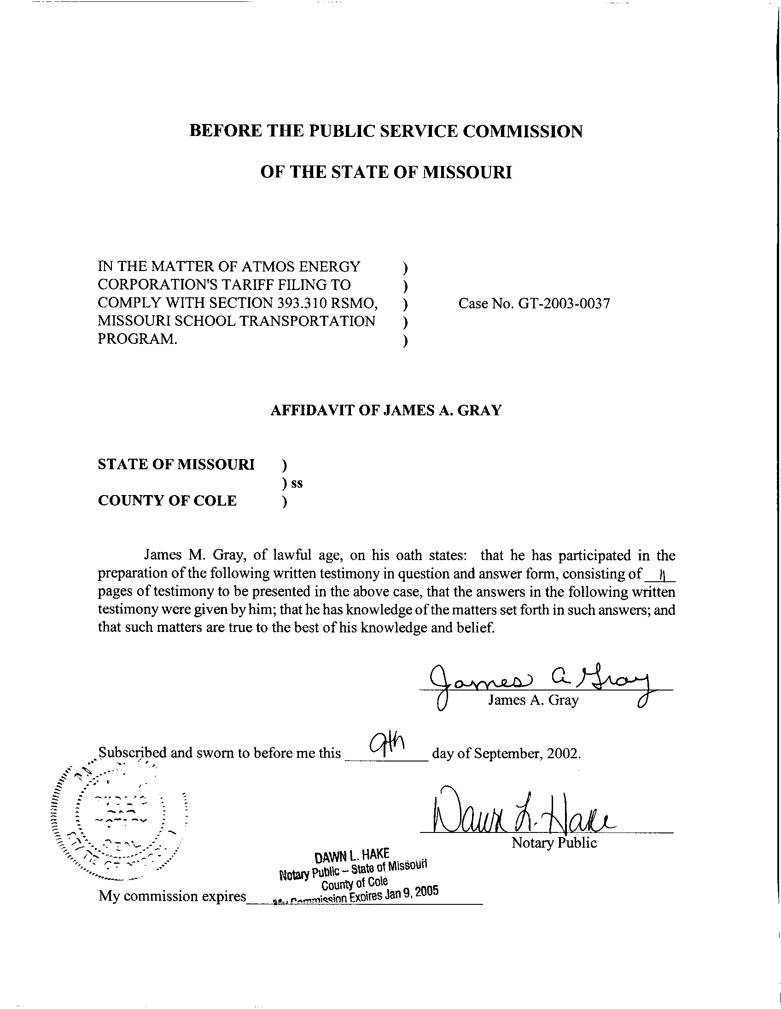
TESTIMONY

OF
JAMES A. GRAY
ATMOS ENERGY CORPORATION

CASE NO. GT-2003-0037

Q. Please state your name and business address.
A. My name is James A. Gray. My business address is P. O. Box 360, Jefferson City, Missouri 65102.
Q. By whom are you employed and in what capacity?
A. I am employed by the Missouri Public Service Commission (Commission) as a Regulatory Economist in the Tariffs/Rate Design Section of the Commission's Energy Department.
Q. How long have been employed by the Commission?
A. I have been employed with the Commission for approximately twenty-two years.
Q. Please state your educational background.
A. I received a degree of Bachelor of Science in Psychology as well as one in General Studies from Louisiana State University (LSU), and I received a degree of Master of Science in Special Education from the University of Tennessee. Additionally, I completed several courses in research and statistics at the University of Missouri - Columbia.
Q. Please state your professional qualifications.
A. Prior to being employed by the Commission, I was a Research Analyst for two and a half years with the Missouri Department of Mental Health where I conducted statistical analyses. In 1980, I began my employment with the Commission as a Statistician in the Depreciation Department where I submitted testimony regarding depreciation rates, trended-original cost, and trended-original cost less depreciation.
Beginning in 1989 as a member of the Economic Analysis Department, I submitted testimony on weather-normalized sales for natural gas, water, and electric utilities. I reviewed residential-electric-load forecasts with the associated detailed end-use studies and the marketing surveys in electric resource plans.
From 1997 through 2001, I was in the Tariffs/Rate Design Section of the Commission's Gas Department. Since July 2001, I have been in the Tariffs/Rate Design Section of the Commission’s Energy Department. I have reviewed tariffs and applications of natural gas utilities. I have submitted testimony concerning weather-normalized sales, complaints, certificates of convenience and necessity, and recommended minimum-statistical-sample sizes for natural gas residential-customer-billing reviews.
Q. Please list all the cases in which you have submitted prepared written testimony before this Commission.
A. The cases in which I have submitted prepared, written testimony are enumerated in Schedule 1, attached to my testimony.
Q. What is the purpose of your testimony?
A. My testimony addresses the proposed tariffs of Atmos Energy Corporation (Atmos or Company) for compliance with § 393.310 RSMo Supp. 2002. First, I will address the timelines required by the statute and which Atmos customers are affected. Second, I will address the definitions or special terms used in the statute. Third, I will address the specific requirements of § 393.310 RSMo Supp. 2002 and whether Atmos’s proposed tariff complies with the statute. Fourth, I will address the tariff items proposed by Atmos that are not required by § 393.310 RSMo Supp. 2002.
Q. Which corporations are affected by § 393.310 RSMo Supp. 2002?
A. The statute states:
393.310.1. This section shall only apply to gas corporations as defined in section 386.020, RSMo.

The statute applies to Missouri investor-owned natural gas utilities, such as Atmos.
Q. When are the Missouri investor-owned natural gas corporations required to file tariff revisions pursuant to § 393.310 RSMo Supp. 2002?
A. The Missouri regulated natural gas utilities are required to file experimental tariffs with the Commission by August 1, 2002, to implement experimental tariffs. The statute states:
3. Each Missouri gas corporation shall file with the commission, by August 1, 2002, a set of experimental tariffs applicable the first year to public school districts and applicable to all school districts, whether charter, private, public, or parochial, thereafter. (§ 393.310.3 RSMo Supp. 2002)

Q. Did Atmos file its proposed experimental tariff sheets by August 1, 2002?
- Yes, on August 1, 2002, Atmos made the required filing. Atmos’s filing date complies with § 393.310.3 RSMo Supp. 2002.
Q. When does the statute require the experimental tariff sheets to become effective?
A. The experimental tariff sheets are required to be in effect by November 1, 2002. Atmos’s proposed experimental tariff sheets bear an effective date of November 1, 2002. Therefore, Atmos’s proposed tariff sheets comply with § 393.310.5 RSMo Supp. 2002.
Q. Does § 393.310 RSMo Supp. 2002 expire?
A. Yes, the statute expires June 30, 2005. The statute states:
7. This section shall terminate June 30, 2005.
(§ 393.310.7 RSMo Supp. 2002)

Atmos’s proposed experimental tariff filing states:

d. This Pilot Program upon approval of the Missouri Public Service Commission will become effective the first day of the month following the month of approval by the Missouri Public Service Commission as a pilot program through June 30, 2005. (Atmos Proposed Tariff Sheet No. 237, Missouri School Pilot Program - Transportation Service) (emphasis added)

Therefore, Atmos’s proposed tariff filing complies with the statute in terminating the proposed experimental tariff sheets no earlier than June 30, 2005.
Q. Which types of customers are affected by the statute?
A. Missouri school districts are affected by the statute. In the first year of the experimental tariff, only the Missouri public school districts are affected. The statute states:
(3) "Eligible school entity", shall include any seven-director, urban or metropolitan school district as defined pursuant to section 160.011, RSMo, and shall also include, one year after the effective date of this section and thereafter, any school for elementary or secondary education situated in this state, whether a charter, private, or parochial school or school district.
(§ 393.310.2(3) RSMo Supp. 2002) (emphasis added

In the second year, the proposed experimental tariff will expand to include other eligible school entities. In this docket, I only address the eligible school entities in Atmos’s natural gas service area.
Q. Do Atmos’s proposed tariff sheets permit Missouri public school districts to aggregate their natural gas purchases?
A. Yes, it does. The Company’s proposed tariff sheets address aggregation for the Missouri school entities for the three years that § 393.310 RSMo Supp. 2002 is in effect:
1. Availability

This service is available to any seven-director, urban or metropolitan school district as defined pursuant to Section 393.310.2(3), RSMo. (Cum.Supp. 2002), and shall also include, one year after the effective date of this section and thereafter, any school for elementary or secondary education situated in this state, whether a charter, private, or parochial school or school district within the Company’s Missouri service area who has purchased natural gas from a third party supplier and desires transportation of those volumes through the Company’s facilities. (Atmos Proposed Tariff Sheet No. 237, Missouri School Pilot Program -Transportation Service)

In my opinion, Atmos’s proposed tariff sheets comply with § 393.310.2(3) RSMo Supp. 2002.
Q. Does the statute address how school districts may purchase natural gas?
A. Yes, briefly, the statute allows an eligible school entity to pool or aggregate its natural gas purchases for all of its various locations. Then, a marketer may purchase the natural gas from the various suppliers, and the marketer may arrange the delivery of the gas to a Atmos delivery point on behalf of the eligible school entities. The statute defines aggregation as the following:
(1) "Aggregate", the combination of natural gas supply and transportation services, including storage, requirements of eligible school entities served through a Missouri gas corporation's delivery system;
(§ 393.310.2(1) RSMo Supp. 2002) (emphasis added)

The statute provides for pooling or aggregating of natural gas purchases by Missouri school entities. Also, the statute addresses purchases of natural gas:
(1) Provide for the aggregate purchasing of natural gas supplies and pipeline transportation services on behalf of eligible school entities in accordance with aggregate purchasing contracts negotiated by and through a not-for-profit school association; (§ 393.310.4(1) RSMo Supp. 2002) (emphasis added)

Q. Do Atmos’s proposed tariff sheets define aggregation?
A. No, Atmos’s proposed tariff sheets implicitly refer to aggregation (or pools) in the context of natural gas purchases. Atmos’s proposed experimental tariff states:
f. Pool Operator is defined as the entity responsible on the Customer’s behalf, to act as an agent for Customer in nominating, scheduling and capacity release activities associated with this program, and cause delivery of, adequate natural gas supplies necessary to meet the Customer’s Forecasted Daily Gas Supply Requirements. The Missouri School Board Association will select the Pool Operator for this Pilot Program.

g. Pool Group is defined as the Customers participating in this Pilot Program. A customer is assigned to a specific pool group on the basis of the connecting pipeline which serves the respective customer. (Atmos Proposed Tariff Sheet No. 238, Missouri School Pilot Program - Transportation Service) (emphasis added)

The statute is more explicit in defining aggregation than Atmos’s proposed experimental tariff. In my opinion, aggregation is adequately defined in Atmos’s proposed experimental tariff sheets.
Q. How is the Company compensated for aggregating and balancing natural gas between deliveries of natural gas and purchases of natural gas for the eligible school entities?
A. Balancing is the equalizing of the volumes of natural gas withdrawn from Atmos’s system, an interstate pipeline system, or both (in this instance, delivered to any eligible school entity under the proposed experimental tariff) with the volumes of natural gas injected into Atmos’s system. The statute permits the Company to charge a fee per therm of natural gas sales delivered to an eligible school entity’s various locations.
Q. What is a therm?
A. A therm is a unit of heat equal to 100,000 British thermal units (Btu), which is the quantity of heat required to raise the temperature of one pound of water by one degree Fahrenheit. In volume, a therm is approximately one hundred cubic feet (Ccf) of natural gas under physical conditions prescribed in FERC-approved interstate pipeline tariffs. A therm is usually slightly more than one (1) Ccf.
Q. What balancing fee does the statute allow?
A. The statute allows a $.004 cent per therm charge to be assessed on gas delivered to each school district. The statute states:
(2) Provide for the resale of such natural gas supplies, including related transportation service costs, to the eligible school entities at the gas corporation's cost of purchasing of such gas supplies and transportation, plus all applicable distribution costs, plus an aggregation and balancing fee to be determined by the commission, not to exceed four-tenths of one cent per therm delivered during the first year; and (§ 393.310.4(2) RSMo Supp. 2002) (emphasis added)

Q. What aggregation and balancing fees do Atmos’s proposed experimental tariff sheets permit?
A. Atmos’s proposed experimental tariff states:
4. Customer (s) Balancing Obligation

a. The Company will be responsible for any imbalances between the Forecasted Daily Gas Supply Requirement and the actual consumption caused by differences between actual weather and forecasted weather. An aggregation and balancing charge of $.04 per Mcf on all throughput will be collected to offset the costs incurred by the Company to provide this service during the first year of availability and as approved by the Commission for subsequent years. No additional daily balancing fees will be imposed during the first year of the Pilot Program. (Atmos Proposed Tariff Sheet No. 239, Missouri School Pilot Program - Transportation Service) (emphasis added)

Atmos’s proposed aggregation and balancing fees do not exceed the $.004 per therm maximum charge set by statute. Therefore, Atmos’s proposed experimental tariff sheets comply with § 393.310.4(2) RSMo Supp. 2002.
Q. Does the statute exempt school districts from special metering devices?
A. Yes, special metering devices are not required for annual usage of one hundred thousand (100,000) therms or less annually. The statute states:
(3) Not require telemetry or special metering, except for individual school meters over one hundred thousand therms annually.
(§ 393.310.4(3) RSMo Supp. 2002)

Q. Does Atmos’s proposed experimental tariff sheets require telemetry or special metering?
A. No, it does not require special metering for eligible school entities. Therefore, Atmos’s proposed experimental tariff sheets do comply with § 393.310.4(3) RSMo Supp. 2002.
Q. Do Atmos’s proposed experimental tariff sheets contain provisions not in the statute?
A. Yes, Atmos has several standard terms in its proposed experimental tariff. These include sections on applicability, nomination procedures, customer balancing obligations, a section on monthly imbalances, overrun charges, billing, and terms of payment. Also, the proposed tariff contains a reporting requirements subsection to report the revenues and expenses incurred in this experimental program. These tariff provisions are customary provisions for transportation customers. Therefore, in my opinion, these provisions are in compliance with § 393.310 RSMo Supp. 2002
Two other subsections are being addressed by addressed by other Staff witnesses.
The proposed experimental tariff filing has a gross receipts tax subsection. § 393.310.5 RSMo Supp. 2002 requires the proposed experimental tariff to not have an affect on taxing authorities. Staff wants the requirements for the payment by the school aggregator to taxing authorities to be noted in the tariff. Staff witness Jennifer Markway of the Energy Department will address this issue in her testimony in this case.
Atmos’s proposed experimental tariff filing has a subsection on capacity release. Atmos is currently taking delivery of natural gas to serve its firm customers from more than one natural gas pipeline. This subsection addresses the allocation of Atmos’s firm capacity on the different pipelines to the various eligible school entities in Atmos’s service territory. Staff witness Thomas M. Imhoff of the Energy Department will address this issue in his testimony in this case.
Q. Please summarize what portions of Atmos’s proposed experimental tariff sheets complies with the statute.
A. First, the proposed experimental tariff sheets comply with the statutory timelines. These are the filing date, the proposed effective date, and the termination of the experimental program, which is no earlier than June 25, 2005, the termination date of § 393.310 RSMo Supp. 2002.
Second, the proposed experimental tariff sheets allow aggregation of eligible school entities in the first year, with the expansion of the aggregation to other schools in the second and third year.
Third, the maximum balancing fee of $.004 per therm for natural gas delivered is not exceeded.
Fourth, Atmos’s proposed experimental tariff filing does not require any special metering equipment for any eligible school entity using less than one hundred thousand (100,000) Ccf annually.
Fifth, Atmos’s proposed experimental tariff filing is designed to allow local tax authorities to receive revenues in the same manner as if the school districts were still firm customers of Atmos.
Q. What are your recommendations?
A. With the exception any Staff concerns with the proposed experimental tariff provisions regarding payments to local tax authorities in an accurate and timely manner and the school aggregator’s reporting these payments to the Staff or capacity release, I would recommend approval of Atmos’s proposed experimental tariff filing on school aggregation, based on Atmos’s compliance with § 393.310 RSMo Supp. 2002.
Q. Does this conclude your testimony?
A. Yes, it does.

Atmos Energy Corporation
Case No. GT-2003-0037

Testimonies Submitted by James A. Gray
COMPANY CASE NO.

Missouri Public Service Company GR-81-312
Missouri Public Service Company ER-82-39
Missouri Public Service Company GR-82-194
Laclede Gas Company GR-82-200
St. Louis County Water Company WR-82-249
Missouri Public Service Company ER-83-40
Kansas City Power & Light Company ER-83-49
Osage Natural Gas Company GR-83-156
Missouri Public Service Company GR-83-186
The Gas Service Company GR-83-225
Laclede Gas Company GR-83-233
Missouri Water Company WR-83-352
Missouri Cities Water Company WR-84-51
Le-Ru Telephone Company TR-84-132
Union Electric Company ER-84-168
Union Electric Company EO-85-17
Kansas City Power & Light Company ER-85-128
Great River Gas Company GR-85-136
Missouri Cities Water Company WR-85-157
Missouri Cities Water Company SR-85-158
United Telephone Company of Missouri TR-85-179
Osage Natural Gas Company GR-85-183
Kansas City Power & Light Company EO-85-185
ALLTEL Missouri, Inc. TR-86-14
Sho-Me Power Corporation ER-86-27
Missouri-American Water Company, Inc. WR-89-265
The Empire District Electric Company ER-90-138
Associated Natural Gas Company GR-90-152
Missouri-American Water Company, Inc. WR-91-211
United Cities Gas Company GR-91-249
Laclede Gas Company GR-92-165
St. Joseph Light & Power Company GR-93-42
United Cities Gas Company GR-93-47
Missouri Public Service Company GR-93-172
Western Resources, Inc. GR-93-240
Laclede Gas Company GR-94-220
United Cities Gas Company GR-95-160
The Empire District Electric Company ER-95-279
Laclede Gas Company GR-96-193
Missouri Gas Energy GR-96-285
Associated Natural Gas Company GR-97-272
Union Electric Company GR-97-393
Missouri Gas Energy GR-98-140
Laclede Gas Company GR-98-374
St. Joseph Light & Power Company GR-99-42
AmerenUE GA-99-107
Laclede Gas Company GA-99-236
Laclede Gas Company GR-99-315
AmerenUE GR-2000-512
Missouri Gas Energy GR-2001-292
Gateway Pipeline Company, Inc., et al. GM-2001-585
Missouri Gas Energy, et al GC-2001-593
Laclede Gas Company GR-2002-356
Laclede Gas Company GA-2002-429
Missouri Gas Energy GT-2003-0033
Aquila, Inc. GT-2003-0038

