BEFORE THE PUBLIC SERVICE COMMISSION
OF THE STATE OF MISSOURI

In the Matter of Level 3 Communications, LLC’s )
Petition for Arbitration Pursuant to Section 252(b) )
of the Communications Act of 1934, as Amended )
by the Telecommunications Act of 1996, and the ) Case No. TO-2005-0166
Applicable State Laws for Rates, Terms, and )
Conditions of Interconnection with Southwestern )
Bell Telephone Company, L.P., d/b/a SBC Missouri )

LEVEL 3 COMMUNICATIONS, L.L.C. AND SOUTHWESTERN BELL
TELEPHONE, L.P., D/B/A SBC MISSOURI’S
JOINT REVISED STATEMENT OF UNRESOLVED ISSUES
(“JOINT DECISION POINT LIST”)

Come now Level 3 Communications, L.L.C. (“Level 3”) and Southwestern Bell Telephone, L.P., d/b/a SBC Missouri (“SBC Missouri”) and file their Joint Revised Statement of Unresolved Issues (“Joint Decision Point List,” or “DPL”) pursuant to Rule 4 CSR 240-36.040(8). This filing is being made on January 20, 2005 as agreed to in a discussion of counsel with the Arbitrator via conference telephone call on Tuesday, January 18, 2005.
Respectfully submitted,

LEVEL 3 COMMUNICATIONS, L.L.C. Southwestern Bell Telephone, L.P.

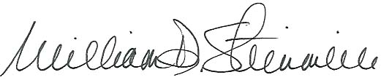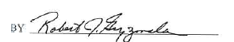 WILLIAM D. STEINMEIER #25689 PAUL G. LANE #27011
MARY ANN YOUNG #27951 LEO J. BUB #34326
WILLIAM D. STEINMEIER, P.C. ROBERT J. GRYZMALA #32454
2031 Tower Drive MIMI B. MACDONALD #37606
P.O. Box 104595 Attorneys for Southwestern Bell Telephone, L.P.
Jefferson City, MO 65110-4595 One SBC Center, Room 3510
573-659-8672 (Telephone) St. Louis, Missouri 63101
573-636-2305 314-235-4094 (Telephone)/314-247-0014 (Facsimile)
wds@wdspc.com robert.gryzmala@sbc.com
myoung0654@aol.com

CERTIFICATE OF SERVICE

I hereby certify that copies of the foregoing document were served to all parties on the below service list by electronic mail on the 20th day of January, 2005.
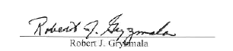
Dana K. Joyce
Missouri Public Service Commission
200 Madison Street, Suite 800
P. O. Box 360
Jefferson City, MO 65102
gencounsel@psc.mo.gov

John B. Coffman
Office of the Public Counsel
200 Madison Street, Suite 650
P. O. Box 2230
Jefferson City, MO 65102
opcservice@ded.mo.gov

William D. Steinmeier
Level 3 Communications, LLC
2031 Tower Drive
P. O. Box 104595
Jefferson City, MO 65110-4595
wds@wdspc.com

