Exhibit No.:
Issues: Payroll;
Payroll Taxes;
Payroll Related Benefits;
Incentive Compensation;
Miscellaneous Expenses
Witness: Leslie L. Lucus
Sponsoring Party: MoPSC Staff
Type of Exhibit: Direct Testimony
Case No.: ER-2002-424
Date Testimony Prepared: August 16, 2002

MISSOURI PUBLIC SERVICE COMMISSION

UTILITY SERVICES DIVISION

DIRECT TESTIMONY

OF

LESLIE L. LUCUS

THE EMPIRE DISTRICT ELECTRIC COMPANY

CASE NO. ER-2002-424

Jefferson City, Missouri
August 2002
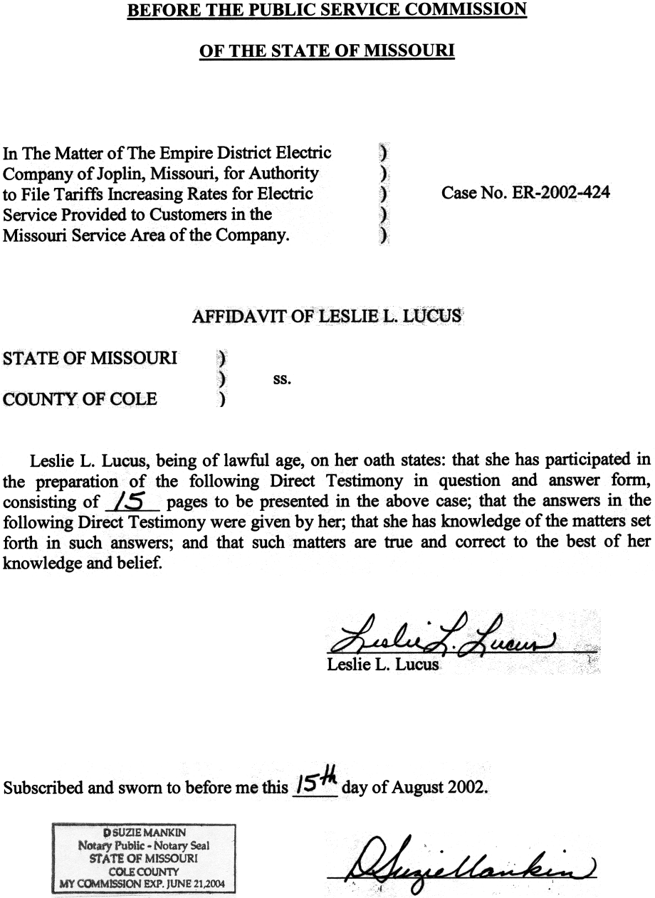
TABLE OF CONTENTS OF
DIRECT TESTIMONY OF
LESLIE L. LUCUS
The Empire District Electric Company
CASE NO. ER-2002-424
PAYROLL 3
PAYROLL TAXES 6
PAYROLL RELATED BENEFITS 7
INCENTIVE COMPENSATION 9
MISCELLANEOUS EXPENSES 14

DIRECT TESTIMONY
OF
LESLIE L. LUCUS
THE Empire District Electric Company
CASE NO. ER-2002-424
Please state your name and business address.
Leslie L. Lucus, Missouri Public Service Commission, Governor Office Building, 200 Madison Street, Jefferson City, Missouri 65102.
By whom are you employed and in what capacity?
I am a Regulatory Auditor for the Missouri Public Service Commission (Commission).
Please describe your educational and employment background.
I graduated from Lincoln University in May 1995 with a Bachelors degree in Accounting. In September 1997, I was employed by the Missouri Department of Social Services as an Auditor for the state Medicaid Agency’s Institutional Reimbursement Unit. In July 1999, I became an associate member of The Association of Certified Fraud Examiners. I commenced employment with the Commission Staff (Staff) in August 2000.
What has been the nature of your duties while employed by the Commission?
I am responsible for assisting in the audits and examinations of the books and records of utility companies operating within the state of Missouri.
Have you previously filed testimony before this Commission?
Yes, I have previously filed testimony in Case Nos. WR-2000-844 (St. Louis County Water Company); GR-2001-292 (Missouri Gas Energy);
GR-2001-629 (Laclede Gas Company) and ER-2002-217 (Citizens Electric Company).
With reference to Case No. ER-2002-424, have you made an examination of the books and records of The Empire District Electric Company? (Empire or Company)?
Yes, in conjunction with other members of the Staff.
What is the purpose of your direct testimony?
The purpose of my direct testimony is to address payroll expense and related overtime, payroll-related taxes, 401(k) plan, incentive compensation and other employee benefits.
What adjustments are you sponsoring?
I am sponsoring the following income statement adjustments:
Payroll S-6.1, S-7.1, S-8.1, S-9.1, S-10.1, S-11.1, S-12.1, S-13.1,
S-14.1, S-15.1, S-16.1, S-17.1, S-19.1, S-20, S-21, S-22, S-23, S-24, S-25, S-26, S-27, S-28, S-49.1, S-50, S-51.1, S-52, S-53, S-54, S-55.1, S-56.1, S-58.1, S-59.1, S-60, S-61.1, S-62, S-63, S-64, S-65, S-66.1, S-67.1, S-68, S-69.1, S-71, S-72.1, S-73.1, S-73.4, S-76.1, S-77.1, S-78.1, S-79.1, S-82.1, S-85.1, S-85.14, S-89.1, S-91.1
Payroll Related Benefits S-85.8, S-85.9, S-85.10, S-85.11, S-85.12, S-85.13
Payroll Related Taxes S-95.1, S-95.2
401(k) Plan S-85.3
Incentive Compensation S-79.4, S-79.5
Miscellaneous Expenses S-51.3, S-56.3, S-61.2, S-67.3, S-72.3,
S-73.4, S-77.6, S-80.5, S-85.5
These adjustments represent the individual annualizations to the various expense accounts (i.e., transmission, distribution, customer accounts, customer services, sales, and administrative and general (A&G) expense).

PAYROLL
What are the different components of the payroll annualization?
The payroll annualization considers full-time union, non-union hourly, salaried, and part-time regular payroll, including overtime.
Please explain the methodology you employed to determine annualized payroll.
The annualized payroll is based upon the Company’s employee levels at June 30, 2002. The wage rate and salary levels are based upon straight time wages/salaries according to the most recent information available through the end of June 30, 2002. Hourly wages were computed for hourly workers using 2,088 hours which represents the number of work hours in a year based on the 12-month period ending June 30, 2002. Salaried rates are computed on an annual basis as of June 30, 2002.
Why were these wage/salary rates and employee levels at June 30, 2002 used to calculate the payroll annualization?
These levels represent the most current information relating to ongoing payroll expense. Using information as of June 30, 2002, which is the end of the update period in this case, provides the most current information that is available regarding employee levels, wage rates and salaries. Use of this information is consistent with other aspects of this case, and is consistent with the ratemaking principle of maintaining the proper relationship of revenues, expenses and investment at a point in time. For a more detailed discussion of the use of information for the update period ending June 30, 2002, see the direct testimony of Staff Accounting witness Phillip K. Williams.
How did you determine total annualized payroll?
The sum of the annualized components discussed above (full-time union, non-union hourly, salaried, and part-time payroll, including overtime) represents the annualized payroll being proposed by the Staff in this case.
Please explain the Staff’s calculation of the overtime portion of the payroll adjustment.
The overtime portion of payroll was calculated using a five-year average of overtime hours worked for the years 1997 through 2001, multiplied by the average hourly overtime rate paid during the 12-months ended June 30, 2002.
Please explain how the Staff determined that a five-year average in the calculation of overtime hours was appropriate.
The Staff performed a five-year historical analysis of overtime hours and dollars to determine the reasonableness of overtime dollars included in the test year payroll. The historical analysis of overtime hours indicated that hours varied by year with no consistently increasing or decreasing trend. Based upon the Staff’s analysis, it was determined that a five-year average of overtime hours would be most representative of a normalized level of overtime hours.
Please explain how the Staff determined that the average hourly overtime rate paid during the 12-months ended June 30, 2002 was appropriate to use in the Staff’s annualization of overtime.
The Staff performed a five-year analysis of the average hourly cost of overtime for the period 1997 through 2001. This five-year analysis indicated that the average hourly cost of overtime was steadily increasing, or trending upwards. Therefore, the Staff determined that use of the average hourly cost of overtime paid during the
12-months ended June 30, 2002 was appropriate.
How did the Staff determine the allocation of the total Empire payroll costs between total Company expense, construction, retirements, nonregulated activities and clearing accounts within the electric utility operations?
The total Company expense allocation was derived from data requested from Empire, identifying the capitalization and expense payroll ratios and the accounts charged.
Did the Staff perform any reconciliation and/or confirmation of the above mentioned percentage distributions?
Yes, the Staff totaled the annualized payroll costs and multiplied this total amount by the total Company expense ratio of 71.61%. The product was then allocated to each FERC account based upon the test year distribution. This distribution includes the allocation of clearing accounts to Operational & Maintenance (O&M) expense, construction expense and retirement expense accounts.
How did the Staff determine the portion of annualized payroll to be charged to Empire’s total Company expense?
I multiplied total annualized payroll by total Company expense factors to derive total annualized payroll to expense. Total annualized Company payroll was then distributed to expense functions based upon the actual distribution of test year payroll.
Has the Staff applied the total Company expense factors to other payroll related adjustments?
Yes. The Staff also applied these total Company expense factors to other payroll-related adjustments such as 401(k) health care costs and other employee benefits, which naturally follow payroll expense.
Which income statement adjustments support the Staff’s payroll adjustments?
The Staff’s payroll adjustment are listed herein, on page 2, lines 14-20.

PAYROLL TAXES
Please explain adjustment S-95.2.
Adjustment S-95.2 annualizes Federal Unemployment Tax (FUTA) by multiplying that portion of each employee’s salary at or under the current $7,000 FUTA limit by the current 2002 rate of 8%. The total Empire FUTA expense adjustment was derived by applying the total Company expense factor of 71.61% to the total Empire FUTA adjustment.
Is the Staff making an adjustment related to SUTA?
No. The test year level of the Company’s SUTA tax liability is representative of the SUTA tax liability that the Company should experience for 2002.
Please explain adjustment S-95.1.
Adjustment S-95.1 represents the annualization of the Federal Insurance Contributions Act (FICA) tax.
Please explain how the Staff annualized the FICA tax.
FICA (Social Security) is comprised of Old-Age, Survivors and Disability Insurance (OASDI) taxes and Medicare taxes. The OASDI tax of 6.2% is limited in calendar year 2002 to the first $80,400 of gross income per employee. The OASDI tax may also be reduced by the employee’s election to set aside a portion of his/her gross salary/wages for healthcare, life insurance and/or dependent care through Empire’s Employee Flexible Benefit Plan. The reduction of OASDI tax related to an employee’s election to participate in the Employee Flexible Benefit Plan also reduces the applicable employer OASDI tax, which in essence is a match to the employee’s OASDI tax. Empire provided the Employee Flex Benefit Plan elections for 2001, updated through June 30, 2002, in response to Staff Data Request No. 98. The Medicare tax of 1.45% applies to the total gross income with no exclusions. The employer matches the OASDI and Medicare tax. I applied the appropriate OASDI and Medicare tax to the annualized wages/salaries for each individual employee. The total Empire FICA tax expense adjustment was derived by applying the total Company expense factor of 71.61% to the total Empire FICA tax adjustment.

PAYROLL RELATED BENEFITS
Please explain adjustment S-85.3.
Adjustment S-85.3 reflects the increase in expenses for the Employee 401K Retirement Plan based upon the employees’ current election. Under the 401(k) Plan, employees have the option of deferring, for receipt in the future, a portion of their salaries or wages. The Company matches 100% of the employee’s deferral, up to a maximum of 3% of salaries/wages. Empire provided the employee 401(k) deferral elections for 2002 in response to Staff Data Request No. 150. These amounts were applied to the annualized wage/salary levels to determine Empire’s 401(k) expense. The total Company expense factor was then applied to the total Company annualized 401(k) employer cost to determine the total Company expense adjustment.
Please explain adjustment S-85.9.
Adjustment S-85.9 annualizes employee benefit costs other than pension and other postretirement benefits (OPEBs) expenses, which have been adjusted separately. FERC account 926.329 includes the health care expense for Empire employees. The Staff completed an analysis of the health care costs for active employees based upon Empire’s response to Staff Data Request No. 123. The analysis shows that health expenses have escalated over the past four years. The Staff annualized employee health care expense to the actual health care plan expense level for 2001 and updated through June 30, 2002. Empire posts entries to FERC account 926.329 when monies are transferred to the VEBA (Voluntary Employee Benefit Association) trusts, which are then used to pay health care and prescription claims to employees along with other costs associated with administering the health plan.
What employee benefits in FERC 926 accounts are included in the adjustments S-85.11, S-85.12 and S-85.13?
The Staff has included group life insurance, accidental death and dismemberment insurance, tuition and education reimbursements, total and permanent disability insurance, fiduciary liability expense and flexible benefit expense in these adjustments. The analysis of these expenses included total expenses in each account for the calendar years 1996 through 2001 and updated information through June 30, 2002. A five-year average was used to normalize the costs if the actual expenses fluctuated over time.
Please define Iatan payroll.
Iatan payroll is the amount of payroll allocated to Empire representing the Company’s 12% interest in the Iatan power plant, principally owned and operated by Kansas City Power & Light Company.
Please explain your method of payroll annualization for Iatan payroll.
I performed an analysis of Iatan payroll covering a five-year time period. The Iatan employee level allocated to Empire is equivalent to 14 full time employees. The actual costs associated with labor at Iatan have increased over the five years analyzed, except for 1997. The test year amount of Iatan payroll was representative of a normal level and no increase or decrease in the test year amount was warranted. Therefore, the Staff made no adjustment to Empire’s test year Iatan Payroll.

INCENTIVE COMPENSATION
Are you making any adjustment related to Empire’s Employee Incentive Compensation Program?
Yes.
Please explain adjustment S-79.5.
Empire has three incentive plans that it provides to its employees. There is an incentive plan for the officers of the Company and a separate plan for non-officers and non-union employees. The officers’ incentive plan is called the management incentive compensation plan (MIP). In addition to these two plans, Empire also offers certain employees lump-sum payments in the nature of bonuses in a program called “Lightning Bolts.”
Please give a brief description of the Company’s MIP.
The Company’s management incentive compensation plan is available to the Company’s senior officers: President and Vice Presidents. On January 31, 2002, the senior officers received an annual MIP award based on their meeting calendar year 2001 targets concerning three corporate goals: (1) return on equity (ROE), (2) O&M expense control, and (3) fuel and purchased power costs.
In addition, the personal goals for each of the five officers were also reviewed. Although the individual goals varied from officer to officer, they fell into two main categories, including general task completion and control of departmental expenses.
The amount of the award determination, expressed as a percentage of the particular officer’s salary at the beginning of 2001, was based upon attainment of a specific performance level by that officer:
1. Threshold (lowest permissible attainment of goals),
2. Par (medium attainment of goals), and
3. Maximum (highest attainment of goals).
What criteria did the Staff use to evaluate Empire’s MIP?
The Staff reviewed the Company’s MIP objectives and the awards granted by the Board of Director’s Compensation Committee for the years 1998 (based upon 1997 operations), 1999 (based upon 1998 operations), 2000 (based upon 1999 operations) and 2001 (based upon 2000 operations). Historically, the Commission has ordered that, at a minimum, an acceptable management performance plan should contain goals that improve existing performance, and the benefits of the plan should be ascertainable and reasonably related to the plan.
Please explain the rationale for Staff’s calculation of the MIP portion of the payroll adjustments.
The Staff performed an analysis of the monetary awards issued for the MIP for 1997 through 2001. As previously mentioned, the amounts awarded are expressed as a percent of the salaries of the senior officers as of the beginning of the year under evaluation. For example, the awards granted in 2002 were based upon operations during calendar year 2001, and the award percentages were applied to the senior officers’ salaries at January 1, 2001.
To calculate the MIP adjustment, which is included in the annualized payroll adjustments, I removed any percentages of awards related to attainment of ROE and/or earnings goals. In addition, the Staff has not included the lump sum payment paid to the President/CEO because no criteria or detail was provided to substantiate the lump sum payment. Basing incentive compensation goals on financial performance creates a circulatory problem. That is, the more money included in Empire’s rates for incentive compensation, the easier it will be for Empire to meet its earnings goals. Under this scenario, Empire ratepayers directly impact the Company’s ability to meet its earnings targets, but receive no direct benefit. This scenario occurs independent of whether or not Empire’s employees are “motivated” by the MIP. In the Staff’s view, since financial goals primarily benefit shareholders, shareholders should bear the cost.
However, the Staff did not remove incentive compensation percentage awards for meeting electric O&M expense and fuel and purchase power goals because these goals, while they do benefit shareholders, also directly benefit customers. Therefore, that portion of the incentive award should be allowed in rates.
Is this treatment consistent with that which the Commission has allowed in past cases?
Yes.
How did the Staff determine the amount to be associated with the previously mentioned O&M expense and fuel/purchase power goals?
I performed an analysis over the most recent five-year period and utilized a five-year average of the allowable percentages awarded to each officer and multiplied this average by the current 2002 salary of each officer.
Why did the Staff choose to use a five-year average instead of the test year amount of MIP expenses related to O&M expense and fuel/purchase power goals?
To set rates based on the test year amount of MIP expenses related to O&M expense and fuel/purchased power goals, would be to assume that in future years the incentive plan objectives benefiting ratepayers will be achieved to the same degree as accomplished for the test year. A consequence of this would create a “lock in” effect for the ratepayer. Thus, an averaging approach was used because the amounts paid out in incentive awards to officers fluctuated over this five-year period. Because of this inherent volatility in the MIP, the Staff used a five-year average of the awards.
Does the Staff have any further concerns regarding Empire’s management incentive compensation program?
Yes, the measurement of appropriate goals is not easily quantified and external forces that affect the goals cannot easily be separated out in the measurement. Easily attained incentive compensation objectives that are not beneficial to the general body of customers, and awards which are exorbitant, even if the objectives are appropriate, should not become moving targets used merely to enhance senior officer salaries.
What other incentive compensation plans does Empire offer its employees?
In addition to the MIP, the Company has a discretionary award pool that it uses to reward employees who have met all items on a specified list of objectives.
Please explain the Staff’s treatment of the Company’s discretionary compensation award pool.
In the Company’s response to Staff Data Request No. 106, the Company provided a list of each employee who received a discretionary compensation incentive award during the test year and a description of the criteria under which the awards were granted. It was discovered that in certain instances employees were being awarded for objectives met that were apart of their normal job duties, and some employees were being awarded for their active involvement with certain charitable contribution campaigns (i.e., United Way and the like). It was also found that employees were being awarded monetarily for job efforts related to non-regulated interests of the Company.
Is the Staff making an adjustment in regards to the incentive compensation plan mentioned above?
Not at this time. Based upon the Staff’s preliminary findings mentioned above, we intend to review a larger sample of the individual goals set forth for Empire employees after the direct filing. This review will serve to determine if these concerns are prevalent within the plan as a whole. The Staff will propose an adjustment, if one is warranted, in a timely fashion at a later date.
What additional award program does Empire offer its employees?
Empire offers an additional discretionary awards program to its employees. These awards are referred to by the company as “Lightning Bolts.” They are typically paid to employees for work on a special project or special effort, or for overall outstanding performance. In the test year in this case, 20 such payments totaling $36,250 were made.
Please explain adjustment S-79.4 relating to said “Lightning Bolts.”
The Staff is proposing a disallowance of these payments, as they do not meet the Commission’s criteria for incentive compensation. There is no set criteria established or attached to the earning of such awards. These payments are made solely at the discretion of the Company.

MISCELLANEOUS EXPENSES
Please explain adjustments S-51.3, S-56.3, S-61.2, S-67.3, S-72.3, S-73.4, S-77.6, S-80.5 and S-85.5.
These adjustments reflect the Staff’s disallowance of ceremonial costs associated with Christmas luncheons and other non-allowable meals. While some documentation was provided by the Company that offered a description of the expense, a portion of the meals were disallowed by Staff due to the Company’s inability to provide the documentation necessary to evaluate and ultimately support the meal expense. These expenses are incurred at the discretion of the Company’s management and are not necessary for the provision of safe and adequate service for the ratepayer thus providing no direct benefit to the ratepayer. Such expenses should be borne by the shareholder until such time the Company puts a system in place to document the reason and purpose of these expenditures.
Does this conclude your direct testimony?
Yes, it does.

