Exhibit No.:
Issue: Depreciation
Witness: Gregory E. Macias
Sponsoring Party: MoPSC Staff
Type of Exhibit: Surrebuttal Testimony
Case Nos.: WR-2003-0500 AND
WC-2004-0168
Date Testimony Prepared: December 5, 2003

MISSOURI PUBLIC SERVICE COMMISSION

UTILITY SERVICES DIVISION

SURREBUTTAL TESTIMONY

OF

GREGORY E. MACIAS

MISSOURI-AMERICAN WATER COMPANY

CASE NOS. WR-2003-0500 AND WC-2004-0168

Jefferson City, Missouri
December 2003
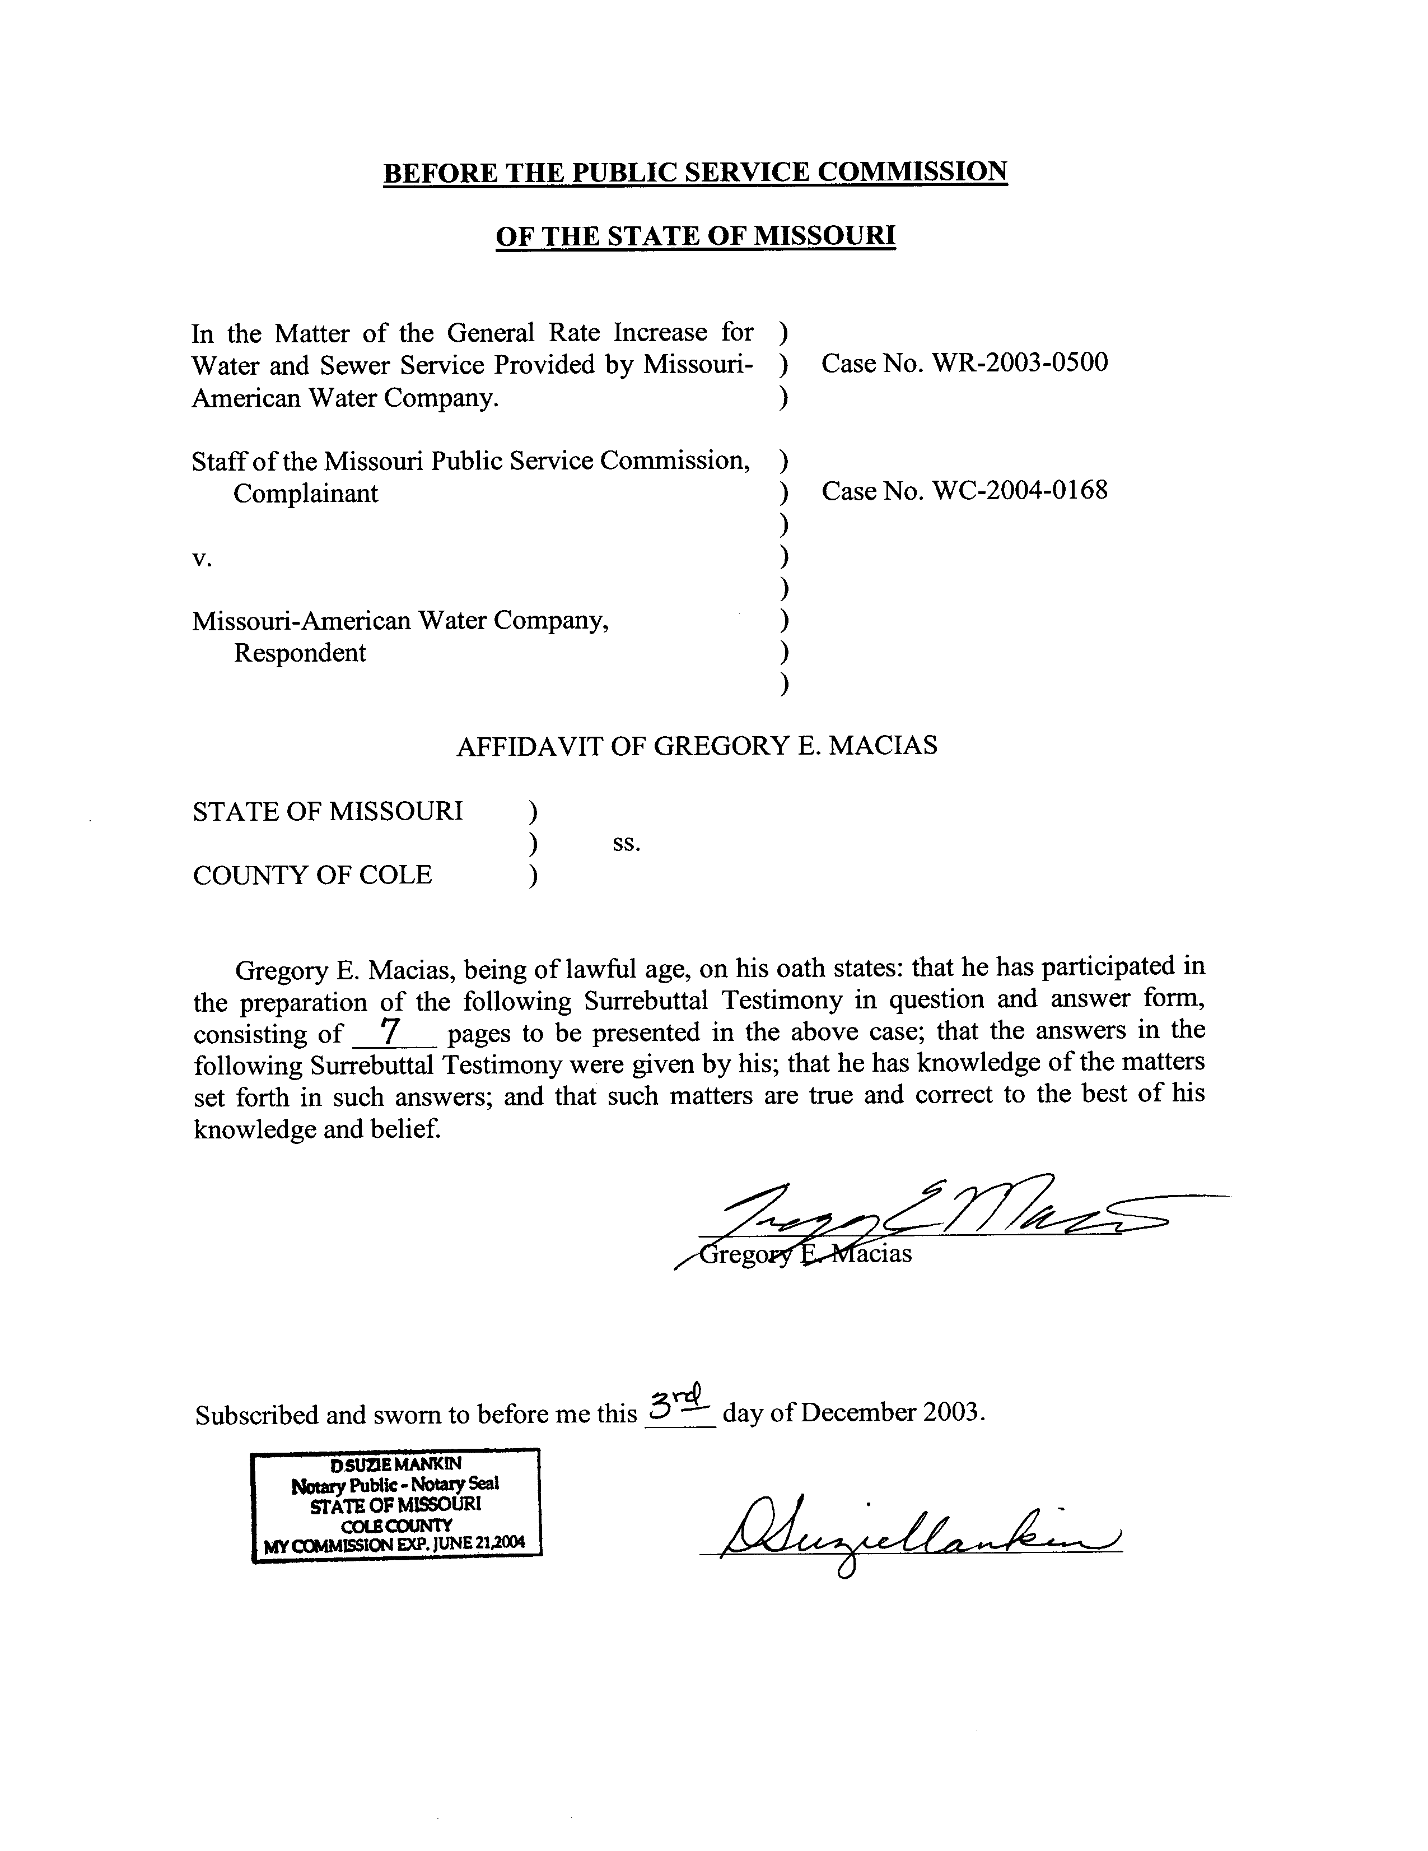
TABLE OF CONTENTS
SURREBUTTAL TESTIMONY OF
GREGORY E. MACIAS
CASE NOS. WR-2003-0500 AND WC-2004-0168

COST OF REMOVAL AND GROSS SALVAGE 2
CASH FLOW 4
SURVIVOR CURVES AND PLANT ACCOUNTING DATA 5
RESERVE VARIANCE 6

SURREBUTTAL TESTIMONY
OF
GREGORY E. MACIAS
MISSOURI-AMERICAN WATER COMPANY
CASE NOS. WR-2003-0500 AND WC-2004-0168

Q. Please state your name and business address.
A. Gregory E. Macias, P.O. Box 360, Jefferson City, MO 65102.
Q. By whom are you employed and in what capacity?
A. I am employed by the Missouri Public Service Commission (PSC or Commission) as a Utility Engineering Specialist II in the Engineering and Management Services Department.
Q. Are you the same Gregory E. Macias who has previously filed direct testimony on behalf of the Staff of the Missouri Public Service Commission (Staff) in this proceeding?
A. Yes.
Q. What is the purpose of your surrebuttal testimony?
A. I will respond to the rebuttal testimony of Missouri-American Water Company (MAWC or Company) witness John J. Spanos.
Q. What issues will you address?
A. I will address cost of removal and gross salvage, the use of the depreciation rate as a cash flow mechanism, survivor curves and plant accounting data, and the treatment of the reserve variance.

COST OF REMOVAL AND GROSS SALVAGE
Q. What treatment of cost of removal and gross salvage has Staff proposed?
A. The Staff has proposed that MAWC collect cost of removal less gross salvage on a current basis that reflects the Company’s recent historical costs.
Q. On page 2, line 3 through 15 of his rebuttal testimony, Mr. Spanos states that he is “…not aware of any authoritative texts on the subject of depreciation that support Staff’s proposal…” to treat cost of removal and gross salvage as an operating expense on a current basis. Is this a true statement?
A. I believe that Mr. Spanos’ statement is wrong and misleading. The excerpt from Public Utility Depreciation Practices that Mr. Spanos provides in his testimony is taken out of context. The full text as noted on page 157 of that publication reads:
Historically, most regulatory commissions have required that both gross salvage and cost of removal be reflected in depreciation rates. The theory behind this requirement is that, since most physical plant placed in service will have some residual value at the time of its retirement, the original cost recovered through depreciation should be reduced by that amount. Closely associated with this reasoning are the accounting principle that revenues be matched with costs and the regulatory principle that utility customers who benefit from the consumption of plant pay for the cost of that plant, no more, no less. The application of the latter principal also requires that the estimated cost of removal of plant be recovered over its life.
Some commissions have abandoned the above procedure and moved to current-period accounting for gross salvage and/or cost of removal. In some jurisdictions gross salvage and cost of removal are accounted for as income and expense, respectively, when they are realized. Other jurisdictions consider only gross salvage in depreciation rates, with the cost of removal being expensed in the year incurred. [italicized text denotes Spanos quote; Spanos Rebuttal, p. 2, ll. 10-15]
While this publication does not appear to be endorsing either method, there is clearly support for Staff’s proposal on the same page of the same authoritative text cited by Mr. Spanos for his supporting statement.
Q. Why has Staff proposed current-period accounting for cost of removal and gross salvage, as opposed to Mr. Spanos’ position of collecting future, unknown, cost of removal less gross salvage ratably over the life of the plant?
A. The Staff chose the current-period accounting position, as set forth in my rebuttal testimony, because:
1) The Company’s estimation of future, unknown, cost of removal and gross salvage is based on a simple formula (ratio) that has no empirical support for its validity. This ratio compares dollars from up to 122 years ago to today’s dollar. Using this ratio to develop a revenue requirement for the cost of removal results in an amount greater than what the Company currently spends for cost of removal less gross salvage.
2) It is unknown and cannot be predicted whether distant future events will necessitate the removal of plant currently in service in the same manner as today, if at all. Plant could be sold or abandoned in place, in which case the Company would experience far less cost of removal than anticipated, if any at all. A practical example of this is abandoned gas mains that have been sold or leased to telecommunications companies to be used as conduit for optical fiber telephone lines rather than being removed.
3) With current-period accounting, future Company management will not face the burden of spending more for cost of removal than they are collecting in rates. For example, if the Company collects $2.4 million more each year than is spent for cost of removal for 5 years, then over some future period the Company must spend $12 million more than is collected in revenue for cost of removal for the balance to be zero.
Q. Mr. Spanos explains that his proposed net salvage accrual exceeds the net salvage cost because of system growth, and only when the growth stops and the plant reaches a steady state will the annual accrual be equal to the actual annual costs. Does Mr. Spanos provide specific details about his proposal?
A. No. Mr. Spanos does not explain when the steady state will occur. Mr. Spanos does not explain what the Company will do with the excess dollars collected for cost of removal before the steady state period is reached. Mr. Spanos does not explain how long the steady state will exist. If the plant remains forever in a steady state, then the Company will never need the excess cost of removal dollars it previously collected from ratepayers. Only if the plant were to experience a reduction could the excess cost of removal dollars be needed. The Company has not demonstrated that it is prepared for this event by retaining the excess cost of removal dollars in a fund where the cash will be available. Mr. Spanos has not addressed this ultimate balancing of the cost of removal accrual with the actual cost of removal.

CASH FLOW
Q. Are you aware of any authoritative text on deprecation that supports the need for cash flow to address infrastructure issues as a consideration in the determination of depreciation rates?
A. No.
Q. What is Staff’s position on manipulating depreciation rates for cash flow goals?
A. The Staff believes that it is not appropriate to use depreciation rates to achieve a targeted level of cash flow. Depreciation is intended to recover the original cost of plant.

SURVIVOR CURVES AND PLANT ACCOUNTING DATA
Q. Why didn’t you use the life span procedure in your depreciation study?
A. The Company has not given any indication of a final retirement of any life span property. The Staff is not aware of any plans for construction of new plant to replace retired life span plant. The Staff does not believe that a final retirement of a life span property is likely to occur in the foreseeable future. Establishing an arbitrary final retirement date for life span plant only serves to artificially raise depreciation rates.
Q. Why did you choose not to use the combined file of the Missouri-American districts used by Mr. Spanos in his depreciation study?
A. The data file for the combined districts used by Mr. Spanos was incomplete and contained multiple erroneous entries. Mr. Spanos did not deny these points in his rebuttal testimony. Mr. Spanos does, however, stand firmly behind the idea that an adequate depreciation study of the MAWC districts, other than St. Louis and Jefferson City, can be performed using incomplete and erroneous data. Mr. Spanos claims that the software utilized by both him and the Staff “…enables the use of a database that consists of retirements for a recent period, say 1984 through 2002, rather than requiring a complete history of retirements.” I agree that the software has that ability, however that is not the approach Mr. Spanos used for his analysis, nor would that approach be appropriate for long lived accounts such as mains.
Mr. Spanos used data files that are not an accurate representation of the Company’s plant in service and relied heavily on his judgment to estimate survivor curves. Mr. Spanos did not explain in his study or testimony filings why his judgment superseded the plots of the data. Mr. Spanos has essentially used survivor curves that were derived from his judgment, without citing supporting evidence, to arrive at average service lives to determine depreciation rates. Whereas Mr. Spanos has apparently used his experience with other water utilities around the Country as a foundation for his judgment-based depreciation rates, the Staff has used actual data from a Missouri utility, which also happens to be a division of MAWC. I believe that the Staff’s surrogate depreciation rates are more appropriate for the MAWC districts, other than St. Louis, than Mr. Spanos’ unsubstantiated, judgment-based depreciation rates.
Q. Will it be possible in the future to use the combined file for survivor curve determinations?
A. Yes. As I stated in my direct testimony, I believe that the Company and Staff can work together to “clean up” the database for use in future depreciation studies.

RESERVE VARIANCE
Q. Mr. Spanos characterizes your recommendation to eliminate the amortizations of the reserve deficiency for the St. Louis district as unreasonable and inappropriate. Please explain why you believe it is necessary.
A. The inclusion of future cost of removal in the calculation of the theoretical depreciation reserve has created a reserve deficiency. The Staff’s position of using
current-period accounting for cost of removal and gross salvage results in lower depreciation rates and a depreciation reserve excess. The Staff has not recommended reducing this reserve excess; however, the reserve excess will only continue to grow if the currently ordered reserve deficiency amortizations are not stopped.
Q. Does this conclude your surrebuttal testimony?
A. Yes.

