Exhibit No.:
Issues: Quality of Service
Witness: James L. Ketter
Sponsoring Party: MO PSC Staff
Type of Exhibit: Rebuttal Testimony
Case No.: EF-2003-0465
Date Testimony Prepared: September 10, 2003

MISSOURI PUBLIC SERVICE COMMISSION

Utility Operations DIVISION

REBUTTAL TESTIMONY

OF

James L. Ketter

AQUILA, Inc.

CASE NO. EF-2003-0465

Jefferson City, Missouri
September, 2003

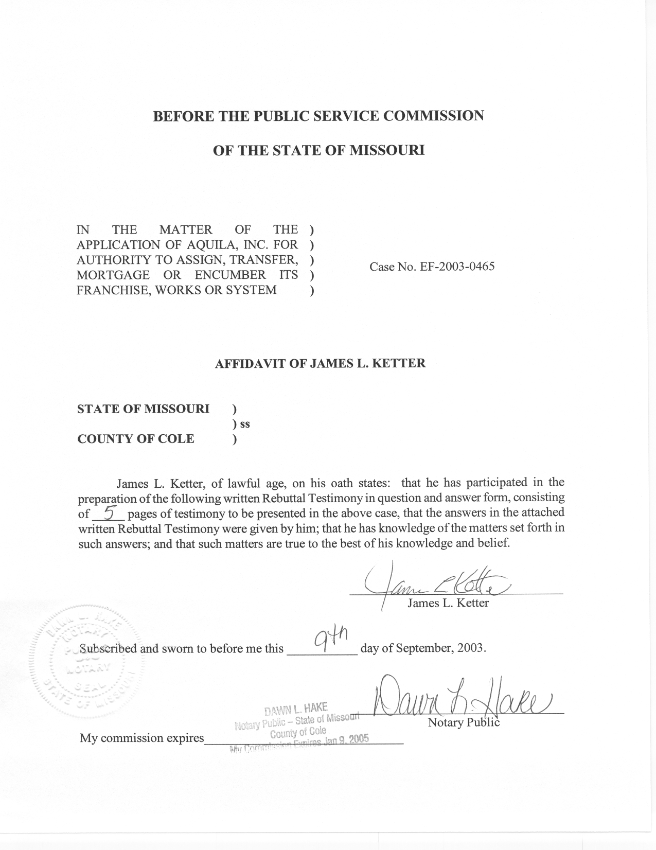
REBUTTAL TESTIMONY
OF
JAMES L. KETTER
AQUILA, Inc.
CASE NO. EF-2003-0465

Q. Please state your name and give your business address.
A. James L. Ketter, P.O. Box 360, Jefferson City, Missouri 65102.
Q. Mr. Ketter, by whom are you employed and in what capacity?
A. I am employed by the Missouri Public Service Commission (MPSC or Commission) as a Utility Regulatory Engineer II in the Engineering Analysis section of the Energy Department.
Q. Please summarize your educational background and professional experience.
A. I received a Bachelor of Science degree in Electrical Engineering from the University of Missouri-Columbia in 1970. I served for 4 1/2 years as an officer in the United States Navy and returned to the University of Missouri-Columbia campus to pursue an advanced degree. In December 1977 I received a Masters degree in Business Administration from the University of Missouri-Columbia.
I have been employed by the Commission since 1976. As an engineer on the Staff, I have testified before the Commission on certificates for service areas, electric transmission and power plant certification cases, and territorial agreements. I have also presented testimony on rate design in electric, steam, and gas rate cases. I am a registered Professional Engineer in the state of Missouri; my registration number is
E-20056. I am a member of the National Society of Professional Engineers and I am a member of the Jefferson City Chapter of the Missouri Society of Professional Engineers.
Q. What is the purpose of your testimony in this case?
A. I address reliability indices utilized within the electric utility industry that provide a measure of a utility’s overall performance in delivering electric service. Indices have been established that provide information regarding the average number of times a customer is without electric service, the average interruption duration for all customers and the average interruption duration for those customers interrupted. The Staff recommends that the Commission direct Aquila, Inc. (Aquila) to submit reliability indices for the Missouri service area of Aquila to Staff until Aquila’s financial condition attains investment grade and the Staff determines reporting this information is no longer necessary. This information will assist the Staff in monitoring the quality of service provided to Missouri customers in the Aquila service area.
Q. Are other Staff witnesses filing testimony regarding quality of service?
A. Yes. Staff witness J. Kay Niemeier is concurrently filing rebuttal testimony concerning customer service measurements for Aquila’s Call Center.
Q. Please identify the reliability indices that are utilized by the electric utility industry.
A. System Average Interruption Frequency Index (SAIFI), System Average Interruption Duration Index (SAIDI) and Customer Average Interruption Duration Index (CAIDI) are the most common reliability indices used for electric utilities. Unadjusted indices, or actual data, reflect the total time or number of outages for the period reviewed. Adjusted indices remove the time and frequency of events that are the result of major storms.
Q. What benefit is gained by removing major storms from the unadjusted data?
A. When major events, such as the ice storm of 2002 or the tornados that struck the western part of Missouri in May 2003, cause extended outages for a utility, the day-to-day operations of the electric system are obscured by the extended electric outages resulting from these events. Damage to electric facilities because of major storms and the subsequent outage that customers experience is important, but the adjusted number will better reflect the operation of the system under normal conditions.
Q. Explain these indices and how they measure reliability.
A. SAIFI (number of occurrences per customer) reflects the average frequency of interruptions per customer and is defined as the total number of customer interruptions for the period covered, divided by the total number of customers served. SAIDI (hours or minutes per customer) reflects the average interruption duration for the period covered and is defined as the sum of all customer interruption durations divided by the total number of customers served. CAIDI (hours or minutes per customer) reflects the average interruption duration and is defined as the sum of all customer interruption durations divided by the total number of customers interrupted.
These reliability indices reflect overall system performance. These measures can help in accessing the performance of the utility in the delivery of electric service by providing a quantitative measure to help define the quality of service. Typically, all of these indices are adjusted to eliminate the effects of adverse weather conditions.
Q. Does Aquila presently calculate and maintain these indices?
A. Yes, this data is collected monthly.
Q. Customers often complain about momentary outages on the electric system. Is there an index to track these outages?
A. Yes, the Momentary Average Interruption Frequency Index (MAIFI) reflects the average number of momentary outages. These outages are the result of devices that interrupt a fault on the system and re-energize after a short delay, without outside human intervention.
Q. Is the MAIFI information complied by Aquila?
A. Yes, this data is compiled on a quarterly basis.
Q. Has the Staff received the SAIFI, SAIDI, CAIDI and MAIFI information from Aquila in the past?
A. Yes. In the UtiliCorp United, Inc. – St. Joseph Light & Power Company merger, Case No. EM-2000-292, Aquila was ordered by the Commission (effective December 24, 2000) to provide Staff with monthly reports of reliability standards for one year. Following the expiration of this period, Aquila has provided this information on an informal basis.
Q. Why is it necessary for the Staff to ask that the Commission require Aquila to report this reliability data?
A. Aquila has continued to provide this information on a voluntary basis to date, but absent a Commission order there is no assurance that Aquila will continue to do so in the future. The financial pressure on Aquila may affect its willingness to collect, calculate and provide this data to Staff. Therefore, Staff is requesting that Aquila be ordered by the Commission to provide its service quality measurements to Staff on a monthly basis until Aquila’s financial condition attains investment grade and the Staff determines that reporting is no longer necessary. Staff will monitor this information to help determine the level of service that customers are receiving from Aquila. Reporting this information monthly will provide an ongoing summary of the transmission and distribution system’s performance as measured by these reliability indices.
Q. What is Staff’s recommendation?
A. Staff recommends that the Commission order Aquila to submit monthly data for Missouri customers of Aquila Networks-MPS and Aquila Networks-L&P for SAIFI, SAIDI and CAIDI in an electronic format, both unadjusted and adjusted indices to exclude major storm events, to Staff within twenty-one (21) days of the last day of the month being reported. In addition, Staff recommends that MAIFI information be provided to Staff on a quarterly basis and transmitted with the monthly data at the end of each quarter. Staff recommends that both reporting requirements extend until Aquila’s financial condition reaches investment grade and the Staff determines that reporting is no longer necessary.
Q. Does this conclude your rebuttal testimony?
A. Yes it does.

