Exhibit No.:
Issues: Quality of Service &
Reliability

Witness: Lena M. Mantle
Sponsoring Party: MO PSC Staff
Type of Exhibit: Direct Testimony
Case No.: ER-2004-0570
Date Testimony Prepared: September 20, 2004

MISSOURI PUBLIC SERVICE COMMISSION

UTILITY OPERATIONS DIVISION

DIRECT TESTIMONY

OF

LENA M. MANTLE

THE EMPIRE DISTRICT ELECTRIC COMPANY

CASE NO. ER-2004-0570

Jefferson City, Missouri
September 2004
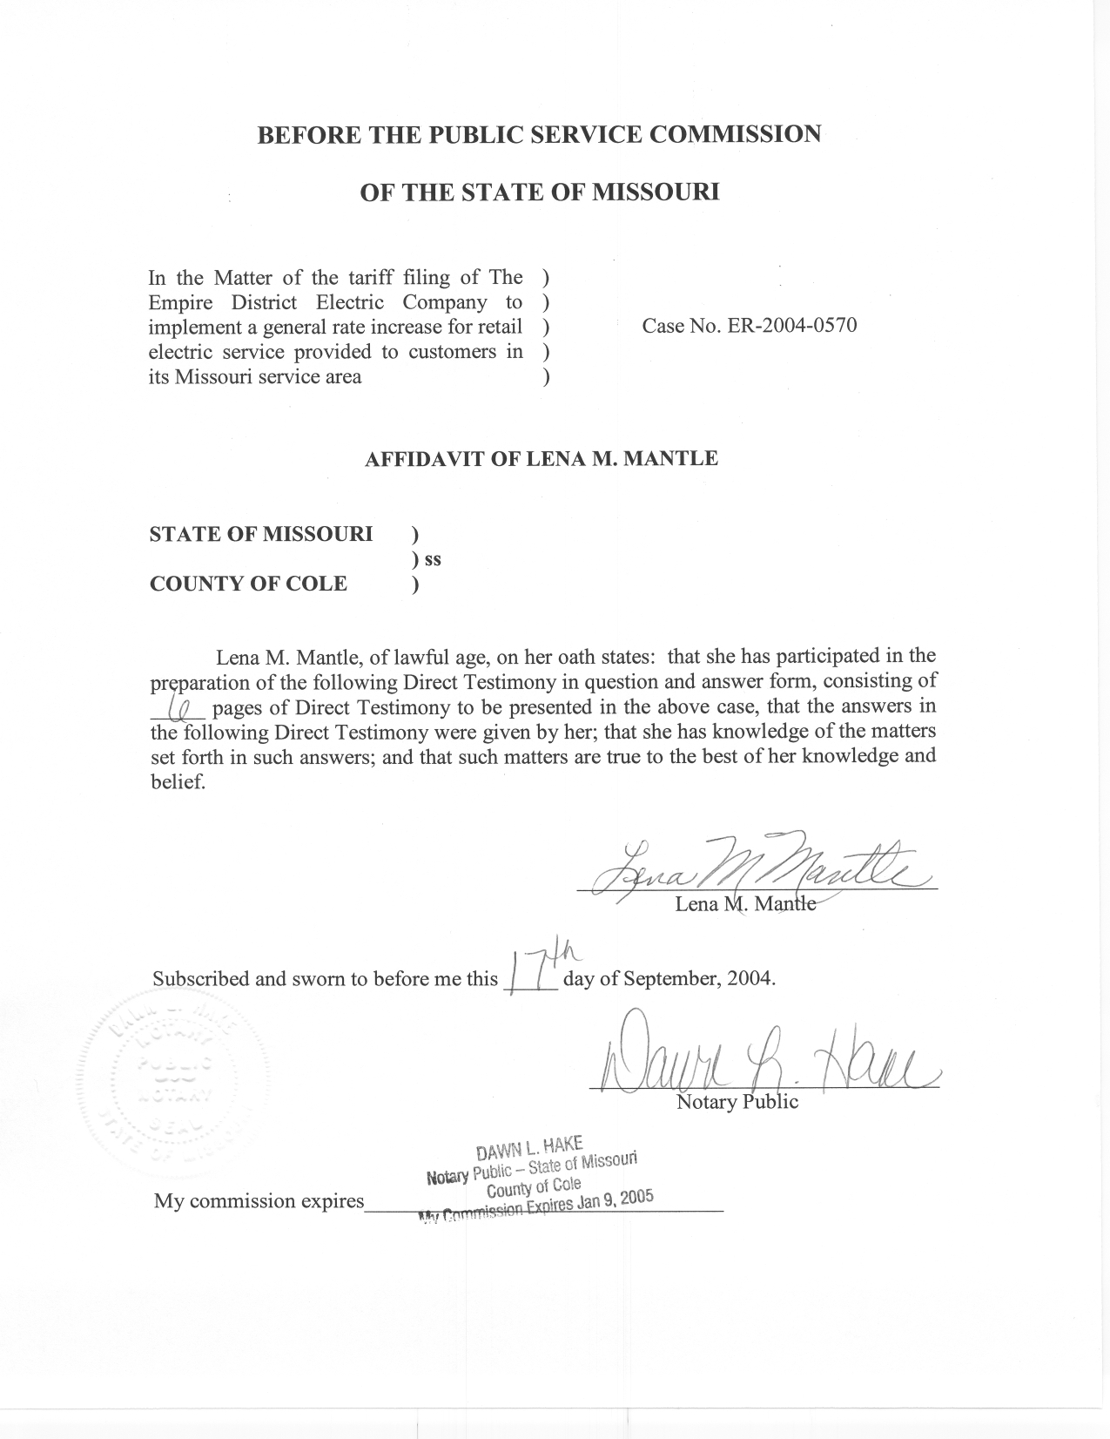

DIRECT TESTIMONY

OF

LENA M. MANTLE

THE EMPIRE DISTRICT ELECTRIC COMPANY

CASE NO. ER-2004-0570

Q. Please state your name and business address.
A. My name is Lena M. Mantle and my business address is Missouri Public Service Commission, P. O. Box 360, Jefferson City, Missouri 65102.
Q. What is your present position with the Missouri Public Service Commission (Commission)?
A. I am the Utility Engineering Supervisor of the Engineering Analysis Section of the Energy Department, Utility Operations Division.
Q. Would you please review your educational background and work experience?
A. I received a Bachelor of Science Degree in Industrial Engineering from the University of Missouri, at Columbia, in May 1983. I joined the Commission Staff (Staff) in August 1983, as a Research Economist. I became an Engineer for the Staff in November 1984. As an Engineer, I have performed various duties for the Staff including weather normalization and electric resource plan review. I was promoted to my current position as Utility Engineering Supervisor of the Engineering Analysis Section of the Energy Department in August 2001. My section is utilized by the Staff in areas where engineering expertise is needed; generally in the areas of fuel and purchase power expense, electric transmission and distribution facilities, customer complaints, electric resource planning and weather normalization. I am a registered Professional Engineer in the State of Missouri.
Q. Have you previously filed testimony before this Commission?
A. Yes, I have. Please see Schedule 1 attached to this testimony for a list of cases in which I have previously filed testimony.
Q. What is the purpose of your Direct Testimony?
A. The purpose of my Direct Testimony is to: (1) present to the Commission the reliability indices for The Empire District Electric Company (Empire) that are commonly used in the utility industry; (2) discuss changes that are taking place at Empire that may affect these reliability indices; and, (3) recommend that the Commission direct Empire to submit these reliability indices to the Staff on a regular basis to assist the Staff in monitoring the quality of service provided to Empire’s customers.
Q. Are other Staff witnesses filing testimony regarding quality of service?
A. Yes. Staff witness John Kiebel is also filing Direct Testimony concerning customer service measurements for Empire’s Call Center.
Q. What are the most common reliability indices that are used by the electric industry?
A. The three most common reliability indices used by the electric industry are the System Average Interruption Frequency Index (SAIFI), the System Average Interruption Duration Index (SAIDI) and the Customer Average Interruption Duration Index (CAIDI). Schedule 2 shows graphs of the SAIFI, SAIDI and CAIDI for Empire for 18 months ending in May 2004. This information was received from Empire in response to Staff Data Request No. 257.
Q. Please explain these indices and how they measure reliability.
A. SAIFI reflects the average frequency of service interruptions in number of occurrences per customer and is defined as the total number of customer interruptions for the period covered, divided by the total number of customers served. It measures the number of service interruptions per customer. SAIDI reflects the average interruption in hours or minutes per total customers served for the period covered and is defined as the sum of all customer interruption durations divided by the total number of customers served. CAIDI is another measure of average interruption duration; it is defined as the sum of all customer interruption durations divided by the total number of customers interrupted. It is also measured in hours or minutes per customer served.
These reliability indices reflect overall system performance. These measures can help in accessing the performance of the utility in the delivery of electric service by providing quantitative measures to help define the quality of service.
Q. Do Empire’s indices show anything that the Commission should be concerned about?
A. In addition to the data shown on Schedule 2, I requested from Empire data back to January 1999. While there are fluctuations in the data, I did not see any long-term trends in the data that I believe the Commission should be concerned about.
Q. There is a large spike in the SAIDI and CAIDI data shown in Schedule 2 for May 2003. What caused that spike?
A. The large spike in the data is due to the tornados that swept through Southwest Missouri in early May 2003. This is shown in Empire’s indices because Empire chooses to not adjust its data for abnormal weather.
Q. Are there benefits that can be gained by adjusting the data for abnormal weather?
A. Yes. Reliability indices are intended to give an indication of the quality of service of the day-to-day normal operations of the electric system. When major events, such as the tornados that struck the Western part of Missouri in May 2003 or the ice storm that occurred in January 2002, cause extended outages for a utility, day-to-day normal service operations are obscured by the extended electric outages resulting from these events. Damage to electric facilities because of major storms, and the subsequent outages that customers experience, are important, but an adjusted number will better reflect the operation of a system under normal conditions. Adjusting data for abnormal weather is an accepted industry practice. If Empire adjusted its indices for abnormal weather, the indices would give a better indication of the quality of service of the day-to-day normal operations of the electric system. Without adjustments, the indices for months with major weather events are not good indications of the overall quality of service that the utility, Empire, offers its customers on a normal basis.
Q. Has Empire made any improvements recently that will likely impact these reliability indices?
A. Yes. Empire recently installed an Outage Management System (OMS). The OMS integrates the Geospatial Management System with the Trouble Analysis System, the Automatic Vehicle Locating System and the Workforce Management System. According to Empire’s response to Staff Data Request No. 259, attached as Schedule 3, Empire had three main objectives for installing OMS: 1) improve internal communications, 2) reduce operating costs, and 3) improve customer service. At the heart of the new OMS is the ability for Empire to more quickly and accurately determine the scope and magnitude of outages. This increase in ability, in turn will enable Empire to more rapidly respond to and repair outages.
As for the impact of the installation of OMS on the reliability indices, Empire stated in its response to Staff Data Request No. 259 attached as Schedule 3:
The reported indices will likely increase when compared with indices before the OMS implementation. The old method was based on manual reporting with inaccurate and incomplete maps. The old system had no method of retrieving customer counts for partial restorations or for outages occurring at a nonprotective device such as an open jumper or open conductor.

We expect to improvement in the real (as compared to reported) indices for the reasons outlined in the objectives of the system.

- Does Empire presently calculate and maintain SAIFI, SAIDI and CAIDI?
A. Yes, this data is collected monthly but it is not routinely reported to the Staff by Empire.
Q. Why does the Staff want Empire to provide these reliability indices to the Staff?
A. Although the Energy Department Engineering Analysis Section Staff does hear from customers when the Staff responds to Empire’s customers who call the Commission seeking assistance in the resolution of inquiries and complaints, the reliability indices would provide the Staff with an alternative method of monitoring the quality of service provided to Empire’s customers. This alternative method of monitoring quality of service is likely a more accurate reflection of overall company performance than customer inquiries and complaints.
Q. What is your recommendation?
A. I recommend that the Commission order Empire to submit monthly to the Staff, within twenty-one (21) days of the last day of the month being reported, data for SAIFI, SAIDI and CAIDI in an electronic format, both (1) unadjusted and (2) adjusted to exclude major storm events.
Q. Is there any electric utility in Missouri that is submitting SAIFI, SAIDI and CAIDI data to the Staff on a monthly basis?
A. Yes, Aquila, Inc. Even before a global settlement was reached in the last Aquila rate increase case, Aquila advised the Staff that it would agree to provide this information on a monthly basis.
Q. Does this conclude your Direct Testimony?
A. Yes, it does

System Average Interruption Frequency Index
System Average Interruption Duration Index
Customer Average Interruption Duration Index

