Exhibit No.:
Issues: DNR Issues

Witness: Lena M. Mantle
Sponsoring Party: MO PSC Staff
Type of Exhibit: Rebuttal Testimony
Case No.: ER-2004-0570
Date Testimony Prepared: November 4, 2004

MISSOURI PUBLIC SERVICE COMMISSION

UTILITY OPERATIONS DIVISION

REBUTTAL TESTIMONY

OF

LENA M. MANTLE

THE EMPIRE DISTRICT ELECTRIC COMPANY

CASE NO. ER-2004-0570

Jefferson City, Missouri
November 2004
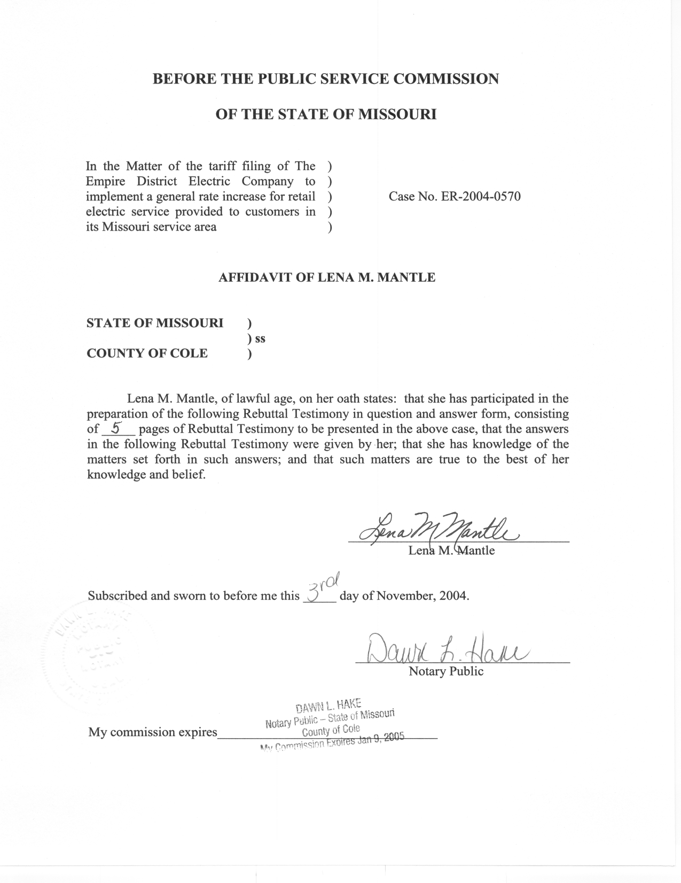

REBUTTAL TESTIMONY

OF

LENA M. MANTLE

THE EMPIRE DISTRICT ELECTRIC COMPANY

CASE NO. ER-2004-0570

Q. Please state your name and business address.
A. My name is Lena M. Mantle and my business address is Missouri Public Service Commission, P. O. Box 360, Jefferson City, Missouri 65102.
Q. Are you the same Lena M. Mantle who has filed prepared Direct Testimony in this case?
A. Yes, I am.
Q. What is the purpose of your Rebuttal Testimony?
A. The purpose of my Rebuttal Testimony is to present the Staff of the Public Service Commission (Staff) position regarding the Department of Natural Resources – Energy Center (DNR – EC) recommendations regarding the Empire District Electric Company (EDE) funding of (1) research regarding wind power as a potential energy resource, (2) energy efficiency programs, and (3) a low income weatherization program.
Q. Is wind power a viable energy resource alternative for EDE?
A. Because of improvements in technology, recent decreases in production costs and the current federal wind tax credit, wind is coming closer to the range of economically viable supply side resource alternatives. However, in EDE’s recent resource planning updates held with the Staff and the Office of the Public Counsel (OPC), wind has not been a part of the future resource plans for EDE.
Q. What benefits would this wind research provide to EDE’s ratepayers?
A. There are many limitations to wind power. Obviously, one of the major limitations is that a wind turbine can only produce energy when the wind blows. The research proposed by DNR-EC would estimate the potential for producing energy in the two sites in EDE’s service territory. In the short run, the benefits to the ratepayers would be limited to the funds spent in the area installing and monitoring the equipment. In the long run, the benefits are tenuous. If the research shows that there is wind potential at either or both of these two sites, it does not necessarily mean that wind resources will be developed at either or both of these two sites. This is just the first step in developing wind resources. Because this information is intended to guide wind resource development (Anderson Direct, p. 6, l. 16), this information may draw interested wind developers, of which EDE may be one, to the sites to develop wind resources. If someone other than EDE develops the wind potential at these sites, EDE’s ratepayers may not see any energy generated from either of these two sites.
Q. Does EDE have a green power tariff which would allow customers to purchase energy generated from wind power?
A. Yes. EDE has had a green power tariff that offers wind power energy since September 28, 2003.
Q. Have any of EDE’s customers taken advantage of wind energy through EDE’s green power tariff?
A. No, they have not been able to because EDE has not been able to obtain wind power to offer to its customers.
Q. Could wind power be generated in Missouri?
A. That is questionable. No large-scale wind resources have been developed in Missouri partially because the national wind study conducted in 1987 showed little potential for Missouri. This 1987 study is currently being updated by DNR-EC. Studies such as the one proposed by DNR-EC in this rate case would help define the wind potential at specific sites in Missouri. The question before the Commission is whether or not EDE ratepayers should pay for the research. Because of the tenuous connection between ratepayer benefits and costs, the Staff does not believe the ratepayers should pay for the wind research project.
Q. What is the cost of the proposed wind research?
A. DNR-EC is requesting that EDE provide funding in the amount of $80,000. (Anderson Direct, p. 6, l. 22)
Q. Are the energy efficiency programs proposed by DNR-EC cost effective?
A. While the programs proposed by DNR-EC are likely to be cost effective for the customer that would take advantage of them, no studies have been conducted to show whether or not these programs would be cost effective for the ratepayers or EDE. No study has been done to show how these programs would impact the future resource needs of EDE. Staff does not believe that ratepayers should pay for such programs unless the programs are identified as demand side resources through EDE’s resource planning process and EDE has developed implementation and evaluation plans for the programs.
Q. Is the low-income weatherization program proposed by DNR-EC similar to what other electric and gas utilities have implemented?
A. Although all of the details of the low-income weatherization program have not been specified by DNR-EC, it does seem that the DNR-EC program is similar to experimental programs implemented by other electric and gas utilities, e.g., Union Electric Company, d/b/a AmerenUE, Missouri Gas Energy and Laclede Gas Company.
Q. Has EDE ever had a similar low-income program?
A. No, it has not. EDE did distribute a weatherization kit containing weather stripping and other low cost weatherization measures to low income customers in the past. Since EDE has not previously implemented a program such as DNR-EC is proposing, Staff is concerned with asking the ratepayers to fund the program at $181, 250 proposed by DNR-EC on an ongoing basis (Wyse Direct p.11, l.17). Staff would propose an annual funding level of $100,000 until the next rate case. At that time, this program should be analyzed for cost effectiveness and a process evaluation should be completed to determine if this program should be continued and, if it is continued, how it can be improved. Staff believes that utilizing the community action agencies that currently provide weatherization assistance to low income households as proposed by DNR-EC is an efficient method of providing weatherization assistance and Staff would look forward to working with DNR-EC, EDE and other parties in this case in a collaborative in designing this program.
Q. Why is Staff proposing funding for the low-income weatherization program and not the wind research or energy efficiency program?
A. While the low-income weatherization program will reduce energy consumption and therefore is a demand side resource alternative, it is likely to have a greater impact in the EDE service territory than other resource alternatives. Low-income weatherization programs have shown to have an impact on the ability of low-income customer’s to pay their energy bills. This in turn, reduces EDE’s amount of arrearages. These types of programs not only reduce the energy usage of dwellings but often the comfort level of the home is dramatically improved. In addition, the safety in some homes may also be improved. For these reasons, Staff believes that low-income weatherization programs are more than demand side resource programs and should be funded, on a limited basis, to determine how effective they are for EDE.
Q. Does this conclude your Rebuttal Testimony?
A. Yes, it does.

