Exhibit No.:
Issues: Capacity Reserve
Witness: Thomas M. Imhoff
Sponsoring Party: MoPSC Staff
Type of Exhibit: Direct Testimony
Case No.: GT-2003-0032
Date Testimony Prepared: September 23, 2002

MISSOURI PUBLIC SERVICE COMMISSION

Utility Operations DIVISION

DIRECT TESTIMONY

OF

THOMAS M. IMHOFF

LACLEDE GAS COMPANY

CASE NO. GT-2003-0032

Jefferson City, Missouri
September, 2002

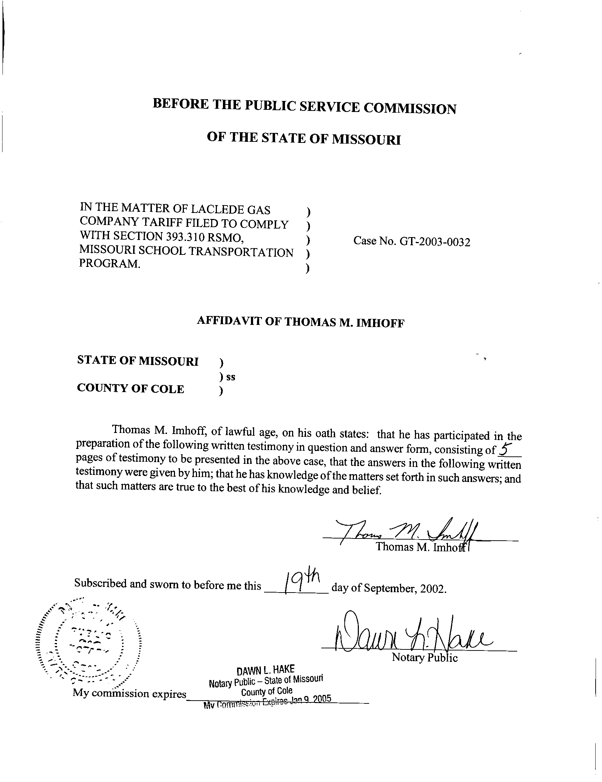
TABLE OF CONTENTS
DIRECT TESTIMONY
OF
THOMAS M. IMHOFF
LACLEDE GAS COMPANY
CASE NO. GT-2003-0032

CAPACITY RESERVATION 2
TRANSITION COSTS 4

DIRECT TESTIMONY
OF
THOMAS M. IMHOFF
LACLEDE GAS COMPANY
CASE NO. GT-2003-0032
Q. Please state your name and business address.
A. Thomas M. Imhoff, P.O. Box 360, Jefferson City, Missouri 65102.
Q. By whom are you employed and in what capacity?
A. I am a Rate & Tariff Examination Supervisor with the Missouri Public Service Commission (Commission).
Q. Please describe your educational background.
A. I attended Southwest Missouri State University in Springfield, Missouri, where I received a Bachelor of Science degree in Business Administration, with a major in Accounting, in May 1981. In May 1987, I successfully completed the Uniform Certified Public Accountant (CPA) examination and subsequently received the CPA certificate. I am currently licensed as a CPA in the State of Missouri.
Q. What has been the nature of your duties with the Commission?
A. From October 1981 to December 1997, I worked in the Accounting Department of the Commission, where my duties consisted of directing and assisting with various audits and examinations of the books and records of public utilities operating within the State of Missouri under the jurisdiction of the Commission. On January 5, 1998, I assumed the position of Regulatory Auditor IV in the Gas Tariffs/Rate Design Department, where my duties consisted of analyzing applications, reviewing tariffs and making recommendations based upon those evaluations. On August 9, 2001, I assumed the position of Rate & Tariff Examination Supervisor in the Energy Tariffs/Rate Design Department (Department), where my duties consist of directing Commission Staff (Staff) within the Department, analyzing applications, reviewing tariffs, and making recommendations based upon my evaluations and the evaluations performed by Staff within the Department.
Q. Have you previously filed testimony before this Commission?
A. Yes. A list of cases in which I have filed testimony before this Commission is attached as Schedule 1 to my direct testimony.
Q. With reference to Case No. GT-2003-0034, have you made an examination and study of the material filed by Laclede Gas Company (Laclede or Company) relating to its proposed school aggregation tariffs?
A. Yes, I have.
Q. What is the purpose of your testimony?
A. The purpose of my testimony is to present the Staff’s position relating to the treatment of capacity reservation for the experimental school district aggregation program (Program).

CAPACITY RESERVATION
Q. What is the Staff’s position regarding capacity reservation as it relates to the Program?
A. The Staff’s position regarding the capacity reservation for the Program is that it allows participants to operate the same as other transportation customers, with the exception of rates. I will discuss the transportation costs later in my testimony. Capacity currently used to supply the participating schools should be made available, in a workable manner, to the school aggregator participating in the program consistent with the requirements of section 393.310 RSMo.
Q. How is Laclede releasing its firm interstate pipeline transportation capacity to participants of the Program?
A. Laclede is releasing its Mississippi River Transmission Corporation (MRT) firm interstate pipeline transportation capacity to participants of the Program, ignoring the capacity from Williams and Panhandle Eastern Pipeline Companies. Laclede provides no explanation about the availability of other transportation, and provides no detail relating to the terms of capacity release on MRT.
Q. Does Staff agree with this?
A. No.
Q. How should Laclede release its firm interstate pipeline transportation capacity to participants of the Program?
A. Laclede’s release of pipeline capacity should be equivalent to the percentage of capacity Laclede uses to provide gas to these customers before the start of the Program. Laclede should release firm interstate pipeline transportation capacity on a temporary basis to participants of the program. Laclede should not recall the capacity unless specifically requested by a participant in the Program. The capacity release shall last during the term of the experimental tariff, unless mutually terminated by agreement of both parties prior to the expiration of the tariff. The release of the capacity should be for a period of one-year with annual notifications by the school aggregator to the Company indicating if they wish to continue using the released capacity. The release should be performed in accordance with the Federal Energy Regulatory Commission (FERC) capacity release procedures and policies to the interstate pipeline.
Q. What should be the cost of transportation to the participants of the Program?
A. Laclede should offer to release its pipeline capacity to participants of the Program at its overall cost of transportation. Under FERC’s capacity release rules, if this prearranged cost is less than the pipeline’s tariffed maximum rate, then these prearranged deals must be posted on the pipeline’s bulletin board allowing other shippers the opportunity to bid a higher price for the capacity (up to the pipeline’s maximum rate). If a higher bid is placed, the Program participants will need to match that bid if they wish to acquire the release capacity. All revenues received by Laclede from these capacity releases shall be credited to transportation cost through the PGA. If the release of the capacity is a lower price than Laclede’s cost, the participants of the Program should pay the balance of Laclede’s cost for capacity. This would ensure “no detriment” to Laclede’s firm customers.

TRANSITION COSTS
- What does Laclede propose to do with “Transition Costs”?
- Lalcede’s tariff language, while vague at best, assumes any costs incurred by Laclede as a result of reforming contracts or those deemed unnecessary as a result of providing this service, to be prudently incurred without any review by the Commission Staff.
- Does Staff agree with Laclede’s proposed “Transition Costs” tariff language?
A. No, because it provides Laclede pre-approval for any costs incurred pertaining to this program. This is unacceptable. Staff should have the rights to audit, verify, and make recommendations to the Commission regarding the propriety and reasonableness of the costs Laclede claims it has incurred for the Program. All other Local Distribution Companies (LDCs) regulated by the Commission have agreed to the Staff reviewing incremental costs and associating revenues incurred by them pursuant to the Program. No pre-approval of incremental costs of the Program has been requested by any of the other LDCs.
Q. Does this conclude your testimony?
A. Yes it does.
LACLEDE GAS COMPANY
CASE NO. GT-2003-0032

Summary of Cases in which prepared testimony was presented by:
THOMAS M. IMHOFF

Company Name Case No.
Terre-Du-Lac Utilities SR-82-69
Terre-Du-Lac Utilities WR-82-70
Bowling Green Gas Company GR-82-104
Atlas Mobilfone Inc. TR-82-123
Missouri Edison Company GR-82-197
Missouri Edison Company ER-82-198
Great River Gas Company GR-82-235
Citizens Electric Company ER-83-61
General Telephone Company of the Midwest TR-83-164
Missouri Telephone Company TR-83-334
Mobilpage Inc. TR-83-350
Union Electric Company ER-84-168
Missouri-American Water Company WR-85-16
Great River Gas Company GR-85-136
Grand River Mutual Telephone Company TR-85-242
ALLTEL Missouri, Inc. TR-86-14
Continental Telephone Company TR-86-55
General Telephone Company of the Midwest TC-87-57
St. Joseph Light & Power Company GR-88-115
St. Joseph Light & Power Company HR-88-116
Camelot Utilities, Inc. WA-89-1
GTE North Incorporated TR-89-182
The Empire District Electric Company ER-90-138
Capital Utilities, Inc. SA-90-224
St. Joseph Light & Power Company EA-90-252
Kansas City Power & Light Company EA-90-252
Sho-Me Power Corporation ER-91-298
St. Joseph Light & Power Company EC-92-214
St. Joseph Light & Power Company ER-93-41
St. Joseph Light & Power Company GR-93-42
Citizens Telephone Company TR-93-268
The Empire District Electric Company ER-94-174
Missouri-American Water Company WR-95-205
Missouri-American Water Company SR-95-206
Union Electric Company EM-96-149
The Empire District Electric Company ER-97-81

Missouri Gas Energy GR-98-140
Laclede Gas Company GR-98-374
Laclede Gas Company GR-99-315
Atmos Energy Corporation GM-2000-312
Ameren UE GR-2000-512
Missouri Gas Energy GR-2001-292
Laclede Gas Company GT-2001-329
Laclede Gas Company GR-2001-629
Missouri Gas Energy GT-2003-0033
Aquila Networks – L&P GT-2003-0038
Aquila Networks – MPS GT-2003-0039
Southern Missouri Gas Company, L.P. GT-2003-0031
Fidelity Natural Gas, Inc. GT-2003-0036
Atmos Energy Corporation GT-2003-0037

