Exhibit No.:
Issues: Expenses
Witness: Jennifer Markway

Sponsoring Party: MoPSC Staff
Type of Exhibit: Direct Testimony
Case No.: GT-2003-0032
Date Testimony Prepared: September 23, 2002

MISSOURI PUBLIC SERVICE COMMISSION

Utility Operations DIVISION

DIRECT TESTIMONY

OF

JENNIFER MARKWAY

LACLEDE GAS COMPANY

CASE NO. GT-2003-0032

Jefferson City, Missouri
September, 2002

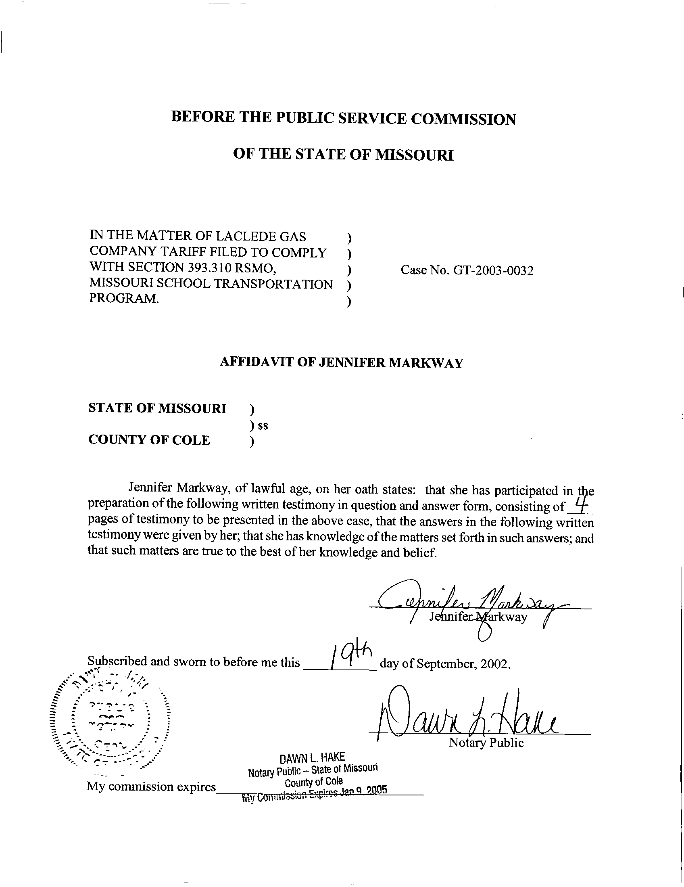

DIRECT TESTIMONY
OF
JENNIFER MARKWAY
LACLEDE GAS COMPANY

CASE NO. GT-2003-0032

Q. Please state your name and business address.
A. Jennifer Markway, P. O. Box 360, Jefferson City, Missouri 65102.
Q. By whom are you employed and in what capacity?
A. I am a Regulatory Auditor with the Missouri Public Service Commission (Commission).
Q. Please describe your educational background and other qualifications.
A. I graduated from Lincoln University, Jefferson City, Missouri with a Bachelor of Science degree in Accounting. Prior to my employment with the Commission, I worked for the Missouri Bankers Association with primary duties in the accounting and titling departments. Before being employed by the Missouri Bankers Association, I served in a management capacity for an international electronics corporation and as an executive member of management for a Jefferson City based business.
Q. With reference to Case No. GT-2003-0032, have you made an examination of the Statute 393.310 RSMo and the tariffs and filings submitted by Laclede Gas Company (Laclede)?
A. Yes, in conjunction with other members of the Commission Staff (Staff).

Q. Please describe your principal areas of responsibility in this case.
A. My principal areas of responsibility are in relation to the methodology of the calculation, collection and the remittance of franchise taxes relating to the entities involved in this statute.
Q. Please explain the staff’s position regarding the calculation of franchise taxes.
- To compute the franchise taxes due the appropriate taxing authorities, actual gas costs incurred by the school districts should be the basis for determining the amount of taxes due, not the Local Distribution Company (LDC) Purchased Gas Adjustment (PGA) rates. The actual gas costs used for this calculation should be the amount the third party aggregator charges the school for the natural gas.
Q. Please explain the staff’s position regarding the collection of franchise taxes.
A. The staff’s position regarding the collection of franchise taxes is coupled with the remittance of those taxes. Staff believes that in order to avoid possible problems with the LDC needing to pay taxes on the franchise taxes received on behalf of aggregators, it is necessary for the aggregator, or their marketer, to pay franchise taxes directly to taxing authorities. The school aggregator or marketer’s payments to taxing authorities in an accurate and timely manner should be a necessity for participation in this experimental program. In order to provide for Staff’s analysis of this program, the aggregators should be required to provide documentation on all franchise tax amounts due and paid by the aggregator to the appropriate taxing authorities no later than June 1st of each year of the program and no later than August 1st of the last year of the program.
Q. Based on the method of calculation, collection and remittance for the franchise taxes you described, is it your opinion that Laclede’s proposed tariff is in compliance with the Staff’s position?
A. No.
Q. Could you please explain the method proposed by Laclede in their tariff?
A. Yes. The tariff proposed by Laclede makes no direct reference to the calculation, collection or remittance of the franchise taxes. It can be reasonably inferred from the language of the proposed tariff that Laclede intends to continue calculating, collecting and remitting the franchise taxes, whereby the schools, individually (not as an aggregated entity), pay the franchise taxes to the LDC and the LDC is then responsible for remitting the taxes to the appropriate taxing authority.
Q. Has Staff considered and evaluated the method proposed by Laclede?
A. Yes. Staff has analyzed the method described in Laclede’s proposed tariffs and, as I stated earlier in my testimony, Staff believes that in order to avoid possible problems with the LDC needing to pay taxes on the franchise taxes received on behalf of aggregators, it is necessary for the aggregator, or their marketer, to pay franchise taxes directly to taxing authorities.
Q. Based on the method of calculation, collection and remittance for the franchise taxes you described, is it your opinion that Laclede’s proposed tariff is in compliance with Section 393.310(5) relating to the “no detriment” clause as it specifically relates to the taxing authorities?
A. Staff witness James M. Russo of the Energy Tariffs/Rate Design Department will address the “no detriment” issue in his testimony.
Q. Does this conclude your testimony?
A. Yes, it does.

