Exhibit No.:
Issues: Large Power Service
Metering
Miscellaneous Charges
Miscellaneous Tariff
Issues

Witness: William L. McDuffey
Sponsoring Party: MO PSC Staff
Type of Exhibit: Direct Testimony
Case No.: ER-2004-0570
Date Testimony Prepared: September 27, 2004

MISSOURI PUBLIC SERVICE COMMISSION

UTILITY OPERATIONS DIVISION

DIRECT TESTIMONY

OF

WILLIAM L. MCDUFFEY

THE EMPIRE DISTRICT ELECTRIC COMPANY

CASE NO. ER-2004-0570

Jefferson City, Missouri
September 2004
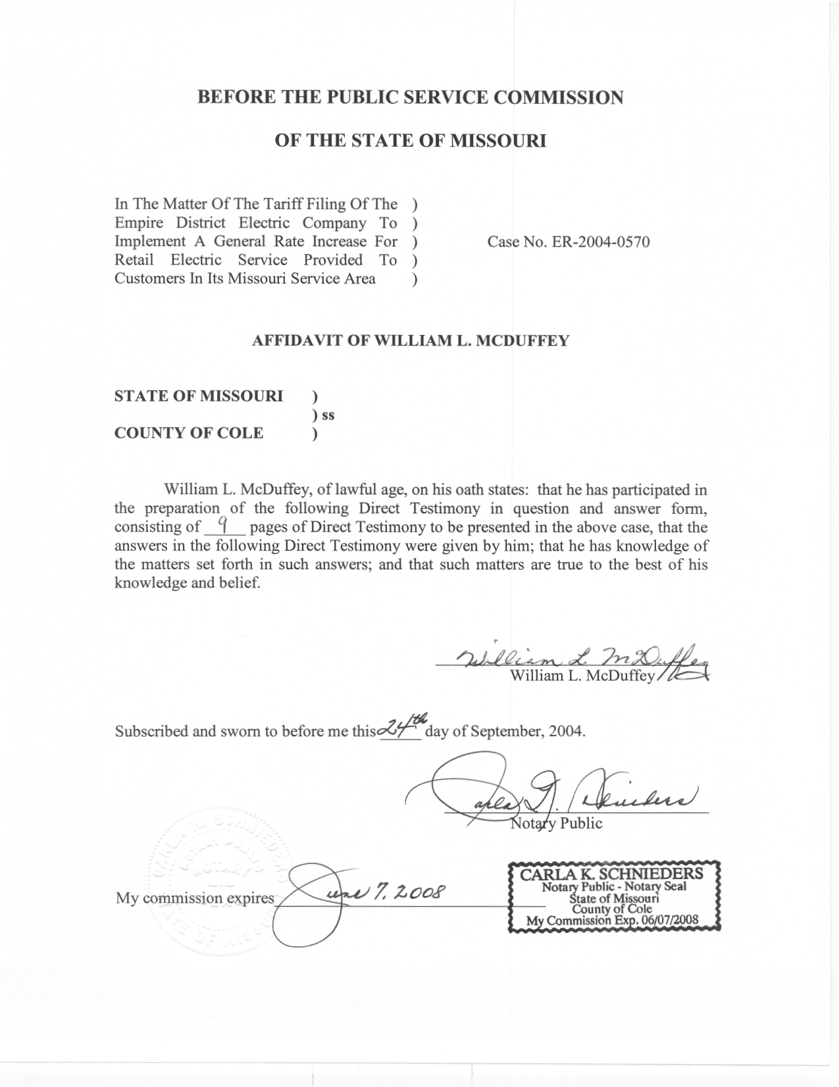

TABLE OF CONTENTS

Large Power Service Metering 2
Miscellaneous Charges 3
Private Lighting Service Transformer 3
Temporary Service Line 4
Insufficient Funds Check 4
Trip to Collect Non-payment Fee 5
Reconnection Fee 5
Meter Treater 6
Late Payment Charge 6
Revenue Requirement Impact 8
Miscellaneous Tariff Issues 8
Employee Purchase Plan 8
Meter Installation 9
Revenue Requirement Impact 9

DIRECT TESTIMONY
OF

WILLIAM L. MCDUFFEY

THE EMPIRE DISTRICT ELECTRIC COMPANY

CASE NO. ER-2004-0570
Q. Please state your name and business address.
A. William “Mack” L. McDuffey, 200 Madison Street, Jefferson City, Missouri 65101.
Q. By whom are you employed and in what capacity?
A. I am employed by the Missouri Public Service Commission (Commission) as a Rate & Tariff Examiner in the Energy Department of the Utility Operations Division.
Q. How long have you been employed by the Commission?
A. I have been employed by the Commission since October 1978.
Q. Have you previously testified before this Commission?
A. Yes, I have filed expert testimony in fifteen cases. In addition, I have been responsible for preparing Staff recommendations in memorandum form in numerous tariff filings and tariff cases.
Q. Please describe your experience, education and qualifications.
A. I have over 26 years of experience working with electric, gas, and steam utility tariff issues. I review filed tariffs for technical and clerical changes, work with regulated electric and steam utilities on the revision of rules and regulations, address customer complaints, compile statistical data, respond to document requests, prepare records for microfilming, update various internal Commission records and maps, and verify service area descriptions in territorial agreements cases and present testimony in formal proceedings before the Commission.
In 1971, I received a Bachelor of Science degree in Business Administration from Southwestern State College of Weatherford, Oklahoma. Upon graduation, I worked one year for Caddo Electric Cooperative of Binger, Oklahoma, in the Engineering Department. I assumed an Engineering Technician position with Oklahoma Gas and Electric Company of Oklahoma City, for five years prior to my employment with the Commission.
Q. What is the purpose of your Direct Testimony in this case?
A. The purpose of my Direct Testimony is to address the Company’s proposed changes to the Large Power Service metering, miscellaneous charges and miscellaneous tariff issues applicable to the electric operations of The Empire District Electric Company (“Empire” or “Company”).

Large Power Service Metering

Q. Please describe the Company’s proposed Large Power Service metering requirement.
A. The Company is proposing to require its Large Power Service Metering customers to provide a telephone line in order to retrieve interval-metering data for billing and load research purposes. These same customers may opt to have the Company provide the telephone line, and pay a monthly charge of $30.
Q. What is the Staff's position relating to this tariff proposal?
A. The Staff disagrees with the Company’s proposed metering requirement. Staff recommends that the Company continue to provide the metering facilities for the Large Power Service Metering Class. If the Company wants to pursue the retrieval of interval metering data for billing and load research purposes then Staff would recommend either that Empire furnish the telephone line or that the Company seek voluntary assists from customers. Other electric companies such as Aquila, Inc. and Kansas City Power & Light Company offer volunteer rate schedules or riders where the customer, in order to receive lower cost service, furnishes the telephone line. No regulated electric company requires the customer to furnish a telephone line for metered service in a general rate schedule.

Miscellaneous Charges

- Which miscellaneous charges will you address?
A. I will address the following changes, referencing Empire’s proposed tariff rates:
1. Private Lighting Service, Transformer – Tariff Section 3, Sheet No. 2
2. Temporary Service Line – Tariff Section 3, Sheet No. 5
3. Insufficient Funds Check - Tariff Section 3, Sheet No. 5
4. Trip to Collect Non-Payment Fee - Tariff Section 3, Sheet No. 5
5. Reconnection Fee, Normal Business Hours - Tariff Section 3, Sheet No. 5
- Meter Treater - Tariff Section 3, Sheet No. 6

Private Lighting Service Transformer

Q. Please describe the Company’s proposed Private Lighting Service Transformer charge.
A. The Company is proposing a monthly charge of $1.43 for its Private Lighting Service customers. The Company currently has no charge for this service. This charge purports to cover the cost of providing a transformer for the installation of private lighting service that requires additions to the existing facilities. This rate ($1.43) is identical to that presently tariffed for the additional facilities, such as wood pole and guy/anchor, that are needed for proper installation.
Q. What is the Staff's position relating to this tariff proposal?
A. The Staff believes the proposed charge of $1.43 is reasonable and is similar to the additional facility rates of other Missouri electric utilities.

Temporary Service Line

Q. Please describe the Company’s proposed Temporary Service Line charge.
A. The Company is proposing a charge of $25 for these customers. The Company currently has a temporary service line charge of $20. This charge covers the cost of installation and removal of the meter, service, and other necessary facilities, but is not applicable when an extension is required.
Q. What is the Staff's position relating to this tariff proposal?
A. The Staff agrees to the proposed charge of $25. It is important that these charges reflect Empire’s cost of performing this service. The individual customers causing the Company to incur these expenses should be responsible for the associated costs.

Insufficient Funds Check

Q. Please describe the Company's proposal relating to the Insufficient Funds Check charge.

A. The Company currently charges $8 for returned checks. They recommend increasing this charge to $30. This amount purports to reflect the Company’s estimated cost of handling returned checks.
Q. What is the staff's position relating to this tariff proposal?
A. The Staff does not agree with Company’s proposed charge of $30 for this service. Staff recommends $20 for the Insufficient Funds Check charge. The Company’s proposed charge is an estimate at best. Staff realizes there are costs involved with this service and Staff’s proposed amount is more in line with what other regulated utilities charge in Missouri.

Trip to Collect Non-payment Fee

Q. Please describe the Company's proposal relating to the Trip to Collect Non-payment Fee.

A. The Company is proposing to increase its charge from $13 to $15 for its disconnect trip fee. This fee would apply to a customer when a Company service technician makes a trip to that delinquent customer’s meter for the sole purpose of disconnecting their service, but does not disconnect the service due to the customer’s payment to the Company’s service technician. The Company’s service technician is authorized to accept payment from customers.

Q. What is the Staff's position relating to this tariff proposal?

A. Staff agrees with the Company recommendation of $15 for the Trip to Collect Non-payment Fee charge.

Reconnection Fee

- Please describe the Company's proposal relating to the Reconnection Fee.

A. The Company is proposing an increase from $25 to $30 for the Reconnection during Normal Business Hours for its customers. The Company does not propose any change to the Reconnection Fee Outside Normal Business Hours of $50.

Q. What is the Staff's position relating to this tariff proposal?

A. The staff supports the company’s proposal of $30. These charges are in line with other regulated electric utilities, and these charges reflect Empire’s cost of performing this service. The individual customers causing the Company to incur these expenses should be responsible for the associated costs.

Meter Treater

- Please describe the Company's proposal relating to the Meter Treater.

A. The Company is proposing a monthly charge of $7 for the Meter Treater service. A Meter Treater is a surge suppressor service to qualified residential customers with 150 and/or 200-ampere bases.

Q. What is the Staff's position relating to this tariff proposal?

A. The staff supports the company’s proposal of $7. This optional service allows residential customers the opportunity to have power surge protection on a monthly payment plan instead of purchasing and maintenance of an expensive electrical device.

Late Payment Charge

Q. What are Empire’s current Late Payment Charges?
A. Staff has listed the numerous Late Payment Charges currently in effect for Empire below:
Tariff Sheet Location Charge Service Schedule
Section 1 Sheet No. 1 1.5% Residential
Section 2 Sheet No. 1 5% Commercial
Sheet No. 2 5% Small Heating
Sheet No. 3 2% / 6% General Power
Sheet No. 4 2% / 6% Large Power
Sheet No. 5 2% / 6% Electric Furnace Primary
Sheet No. 6 5% Feed Mill and Grain Elevator
Sheet No. 7 2% / 6% Total Electric Building
Section 3 Sheet 2a 1.5% Private Lighting - residential
5% Private Lght.– nonresidential
1.5% and 5% delinquent after 21 days; 2% delinquent after 14 days and 6% delinquent from 60 days after due date.
Q. What change is Staff proposing to the late payment charges on delinquent bills?
A. Staff is proposing that the late payment charges on delinquent bills be changed to a simple ½ percent per month of the original net amount due on the delinquent bill. In other words, the late payment charge would not be applied to a previous late charge balance, thus eliminating the compounding effect of the late payment charge. This proposed late payment charge rate would be a simple annual rate of 6 percent.
Q. Why is Staff proposing this change?
A. Staff believes this change reduces the late penalty charge for delinquent bills to correctly reflect current interest rates and the cost to the Company to carry a customer’s bill for an additional billing period. As noted above, the current late payment charge rate for residential customers could exceed 18 percent when computed on an annual basis. This compounds the difficulty customers have when paying their electric bills.
Q. Does Staff have a recommendation regarding the late penalty charge assessed to customers applying for assistance through the Low Income Home Energy Assistance Program (LIHEAP) or Energy Crisis Intervention Program (ECIP)?
A. Yes. The Staff recommends that any late payment charges that accrue during the time that the energy assistance money (LIHEAP or ECIP) is being credited against a customer’s bill should be waived. The Staff recognizes that there exists a time lag between customer’s bills and the distribution of the energy assistance grants. During this time lag, the Staff does not feel a customer should be required to pay late payment charges.
Q. Is there a financial impact of adopting these proposed changes?
A. These changes will have a financial impact on the affected customers; however, there will be no impact on Empire. The proposed change in Empire’s rates will be adjusted to reflect any change in late payment charges.

Revenue Requirement Impact

Q. Are the effects of implementing these recommendations included within the Staff’s revenue requirement recommendation?
A. No. The Staff intends to account for these changes to the miscellaneous charges in the rate design implementation phase of this case.

Miscellaneous Tariff Issues

Q. Which miscellaneous tariff issues will you address?
A. I will address the following changes, referencing the proposed tariff sheets:
  - Employee Purchase Plan – Tariff Section 4, Sheet No. 8
  - Meter Installation – Tariff Section 5, Sheet No. 18

Employee Purchase Plan

Q. Please describe the Company’s proposed changes to the Employee Purchase Plan.
A. The Company is proposing that appliances, insulation and HVAC systems may be financed for terms of twelve (12) to sixty (60) months at an interest rate determined by the Company. The Company currently has appliance and insulation sales that may be financed up to twelve (12) months without interest and HVAC systems may be financed up to sixty (60) months without interest.
Q. What is the Staff's position relating to this tariff proposal?
A. The Staff agrees to these proposed changes.

Meter Installation

Q. Please describe the Company’s proposed changes to the Installation of Meters.
A. The Company is proposing the following: 1) a current transformer metal cabinet will be provided by the customer instead of the Company, 2) self-contained polyphase meters will be “socket type” and not “bottom-connected”, 3) self-contained polyphase meters are to be installed outdoors only, instead of the option of indoors or outdoors, and 4) meter mounting distance from ground or floor has changed from between 5 – 6.5 feet to 4-6 feet.
Q. What is the Staff's position relating to this tariff proposal?
A. The Staff supports these tariff changes, as filed by the Company.

Revenue Requirement Impact

Q. Will the implementation of these tariff recommendations have any effect on Staff’s revenue requirement recommendation?
A. No.
Q. Does this conclude your Direct Testimony?
A. Yes, it does.

