Exhibit No.:
Issues: Bad Debt Expense/
Miscellaneous Tariff
Issues

Witness: Thomas M. Imhoff
Sponsoring Party: MO PSC Staff
Type of Exhibit: Rebuttal Testimony
Case No.: GR-2004-0209
Date Testimony Prepared: May 24, 2004

MISSOURI PUBLIC SERVICE COMMISSION

UTILITY OPERATIONS DIVISION

REBUTTAL TESTIMONY

OF

THOMAS M. IMHOFF

MISSOURI GAS ENERGY

CASE NO. GR-2004-0209

Jefferson City, Missouri
May 2004
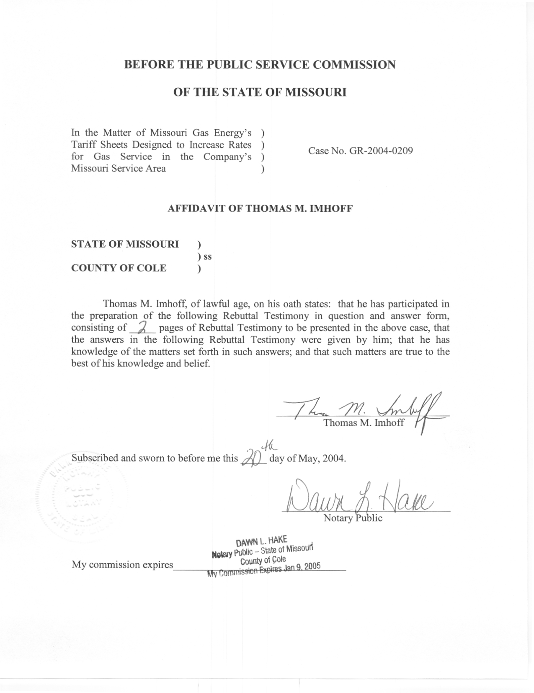

REBUTTAL TESTIMONY

OF

THOMAS M. IMHOFF

MISSOURI GAS ENERGY

CASE NO. GR-2004-0209

Q. Please state your name and business address.
A. Thomas M. Imhoff, P.O. Box 360, Jefferson City, Missouri 65102.
Q. Are you the same Thomas M. Imhoff who filed direct testimony in this case?
A. Yes, I am.
Q. What is the nature of your Rebuttal Testimony?
A. My Rebuttal Testimony addresses Company witness Noack’s uncollectable expense testimony as it relates to the implementation of the recently agreed to Denial of Service Rule (Rule) in Case No. AX-2003-0574.
Q. Do you agree with MGE witness Noack’s perception of the Rule’s impact on uncollectable expense?
A. No.
Q. Why do you disagree with MGE witness Noack’s perception of the Rule’s impact on uncollectable expense?
A. MGE witness Noack assumes that the Company is precluded from collecting on past-due accounts due to the implementation of the Rule. This is an incorrect assumption on MGE’s part. The Rule would require MGE to connect service when an applicant does not have any outstanding balances owed to MGE for services, even though a member of the applicant’s household may have an outstanding balance owed to MGE. However, MGE still has the right to collect on that outstanding bill by posting the outstanding balance on the applicant’s bill. The Rule does not preclude MGE from collecting on that outstanding balance.
Q. Does this conclude your rebuttal testimony?
A. Yes it does.

