Exhibit No.:
Issues: Merger
Witness: Arthur P. Kuss
Sponsoring Party: MoPSC Staff
Type of Exhibit: Rebuttal Testimony
Case No.: TM-2002-465
Date Testimony Prepared: August 15, 2002

MISSOURI PUBLIC SERVICE COMMISSION

UTILITY OPERATIONS DIVISION

REBUTTAL TESTIMONY

OF

ARTHUR P. KUSS

NORTHEAST MISSOURI RURAL TELEPHONE COMPANY
AND
MODERN TELECOMMUNICATIONS COMPANY

CASE NO. TM-2002-465

Jefferson City, Missouri
August, 2002

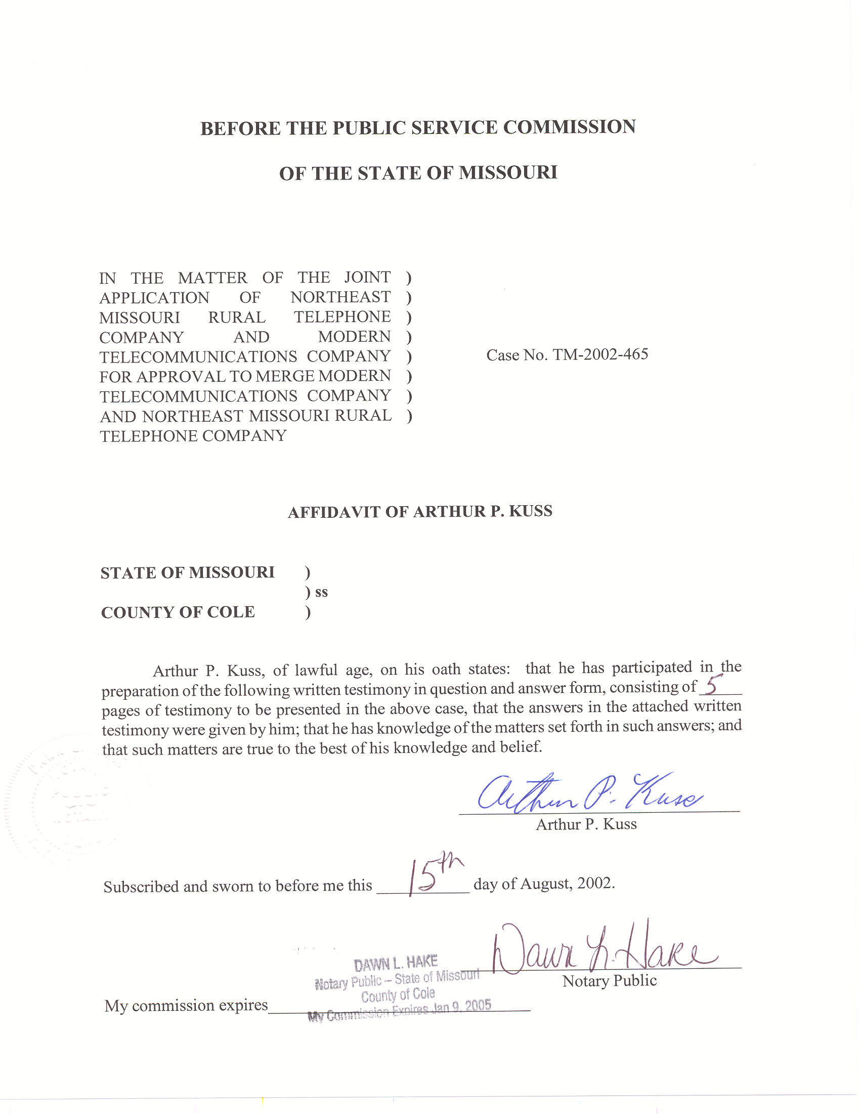

REBUTTAL TESTIMONY

OF

ARTHUR P. KUSS

CASE NO. TM-2002-465
Q. Please state your name and give your business address.
A. My name is Arthur P. Kuss, Governor Office Building, 200 Madison Street, Suite 500, P.O. Box 360, Jefferson City, Missouri 65102-0360.
Q. By whom are you employed?
A. I am employed by the Missouri Public Service Commission (Commission).
Q. How long have you been employed by this Commission?
A. I have been employed by the Commission as a Utility Engineering Specialist since February 1998. My educational background is in electrical engineering. I hold a Bachelors Degree in Electrical Engineering, and a Masters Degree in Engineering Management.
Q. What are your duties at the Commission?
A. My duties include the review and analysis of various telecommunications industry proposals, interconnection agreements, tariff filings, and certificate applications, as well as making recommendations to the Commission.
Q. Have you previously filed testimony?
A. I have filed written testimony and testified before the Commission in Case No. TO-99-254, regarding the Primary Toll Carrier Plan, in Case No. TO-99-615, regarding a Carrier of Last Resort obligation, in Case No. TC-2000-325, regarding cutoff of certain toll-free traffic, and in Case No. TO-2000-667, regarding the availability for resale of certain services by competitive companies.
Q. What is the purpose of your rebuttal testimony?
A. My purpose is to respond to the Direct Testimony of Gary Godfrey, on behalf of Northeast Missouri Rural Telephone Company (NEMO) and Modern Telecommunications Company (Modern), Incumbent Local Exchange Carriers (ILEC).

Considerations of the Proposed Merger
Q. What does Mr. Godfrey propose concerning NEMO’s switched access rates, including Carrier Common Line (CCL) rates, following the merger?
A. Mr. Godfrey has proposed two (2) possible configurations for access rates:
- A uniform access rate structure to apply in all exchanges.
- No change to existing access rates, resulting in a variation of such rates across the company’s service areas.
Q. What is your position concerning switched access rates?
A. Access rates should not vary among the exchanges of any Local Exchange Carrier (LEC), as contemplated in Section RSMo 392.200.2, which prohibits charging differing rates for like services under the same circumstances or conditions. Further, Sections RSMo 392.200.4 (1) and 392.200.5 limit geographic market segregation without showing reasonable necessity. On this basis, I oppose any access rate structure that permits any geographic discrimination or nonuniform service area access rates. It is reasonable, however, to adjust current access rates to allow NEMO to attain neutrality in its expected access revenues after the merger. To minimize discriminatory rate effects, I recommend support for the “blended” access rates first proposed in the tariff revision File No. 200201052, filed June 12, 2002, to be effective January 01, 2003. By

that filing, the current NEMO rates would be decreased while the Modern rates, in effect, would increase. The table below compares the proposed CCL rate changes I support. All decimal figures are in U.S. dollars.
CCL  Per-minute Rate | NEMO Post-merger | Modern Current | Modern Change | NEMO Current | NEMO Change
Originating | .054492 | .02990131 | +82% | .071975 | -24%
Terminating | .104619 | .07141421 | +46% | .129555 | -19%
Q. What will be the effect on the ranking of NEMO’s access rates compared to the other ILECs in Missouri following the merger?
A. In Attachment A, the first two (2) pages illustrate the current CCL rate comparisons of the ILECs serving Missouri, sorted and ranked according to highest-to-lowest IntraLATA or InterLATA rates, and the following two (2) pages illustrate the expected IntraLATA and InterLATA CCL rate comparisons after the merger transaction.
Q. What should be the terms of the merger’s effect on local rates?
A. To be consistent with my statements above concerning the establishment of uniform rates for all parts of the proposed service area, I would oppose the approbation of Mr. Godfrey that there should be no changes felt by local exchange customers at this time. The terms of the merger would include the continuation of existing local service rates, which would result in multiple rates for similar service, based upon the served exchange. However, according to Section RSMo 386.250 (2), the Commission has authority to regulate only the exchange access service of a cooperative company, and by this merger the Commission will lose its authority to regulate Modern’s other rates. Without authority to affect local rates, any
Commission-directed changes to Modern’s local rate structure would become academic immediately upon closure of the transaction. NEMO’s cooperative membership may choose to adjust or restructure its own local rates at any time afterward.
Q. Are there other revenue effects that will be felt due to the merger?
A. The terms of the merger should recognize the uniform extension of NEMO’s charges to Modern’s customers, including the current late-payment fee and a service connection fee. I do not consider these adjustments to be significant detriments to the merger as these charges can be applied only in certain instances to any specific customers, and, as mentioned above, the Commission will not have authority otherwise to direct application of these non-access rates.
Q. Could you support the merger if separate rate structures for the respective NEMO and Modern territories are maintained?
A. I could for a temporary time period. Staff witness David Winter states that Staff is conducting a separate earnings investigation on NEMO and Modern. Rate adjustments could be made at the resolution of Staff’s earnings investigation. Such an approach was used in Case No. TM-93-1 when the former Contel of Missouri, Inc. et al (Contel) and GTE North Incorporated et al properties merged into GTE Midwest, Inc. (GTE). Unfortunately it is premature to indicate what, if anything, will result from a Staff earnings investigation. In this regard, my initial preference is to simply blend NEMO’s and Modern’s access rates into one rate structure. Such a preference eliminates discrimination concerns. Nevertheless I would not object to maintaining separate rate structures until Staff’s earnings investigation is completed.
Q. In summary, what is your opinion of the proposed merger?
A. I support the consummation of the merger. In regards to the resulting rate structure, my preferred recommendation is for the surviving entity to blend the rates of the two companies into one rate structure. Given the surviving entity’s status as a telephone cooperative, the Missouri Commission’s rate jurisdiction will be limited to switched access rates. Specifically I recommend the two separate switched access rate structures consolidate into one set of switched access rates based on my previously described method of blending the two companies’ access rates on a revenue neutral basis. As an alternative, I would not be opposed to maintaining separate rates for the two entities; however such a rate structure should be for a temporary time period until Staff completes its earnings investigation.
Q. Does this conclude your rebuttal testimony?
A. Yes, it does.

Direct Testimony of Gary Godfrey, Page 6, lines 5 through 7.
Ibid., Page 9, lines 21 through 23, and Page 10, lines 1 through 3 and Page 12, lines 22 and 23, and Page 13, lines 1 through 3.
Ibid., Page 12, lines 11 through 20, and Page 13, lines 1 through 13.
Ibid., Page 6, lines 4 and 5.
Ibid., Page 7 line 23, and Page 8, lines 1 through 4.
In the matter of the application requesting authority (1) for GTE North Incorporated to transfer certain assets to GTE Midwest Incorporated, (2) for the merger of Contel of Iowa, Inc., Contel of Missouri, Inc., Contel of Minnesota, Inc., The Kansas State Telephone Company, Contel of Kansas, Inc., and Contel Systems of Missouri, Inc., into GTE Midwest incorporated, and (3) for the transfer of certificates of public convenience and necessity.

