Exhibit No.:
Issues: Late Payment Charge

Witness: William L. McDuffey
Sponsoring Party: MO PSC Staff
Type of Exhibit: Surrebuttal Testimony
Case No.: ER-2004-0570
Date Testimony Prepared: November 24, 2004

MISSOURI PUBLIC SERVICE COMMISSION

UTILITY OPERATIONS DIVISION

SURREBUTTAL TESTIMONY

OF

WILLIAM L. MCDUFFEY

THE EMPIRE DISTRICT ELECTRIC COMPANY

CASE NO. ER-2004-0570

Jefferson City, Missouri
November 2004
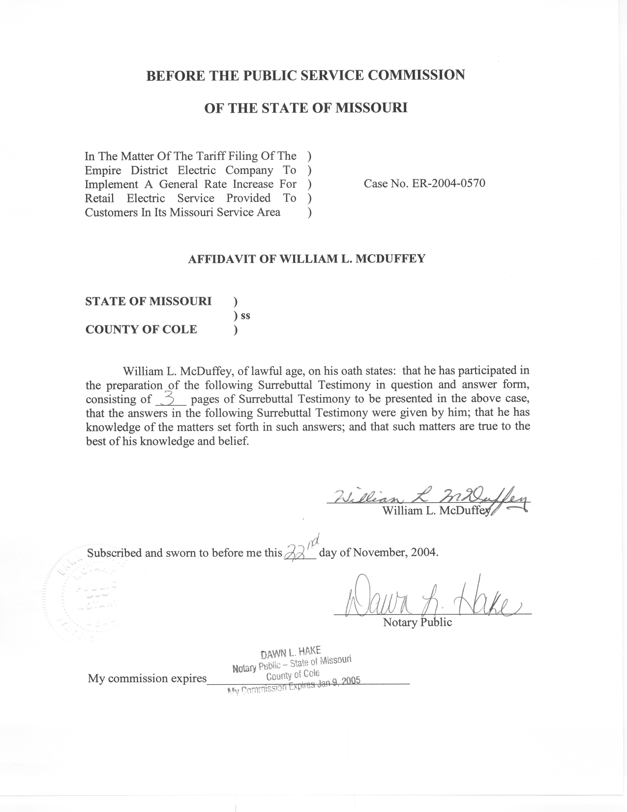

SURREBUTTAL TESTIMONY

OF

WILLIAM L. MCDUFFEY

THE EMPIRE DISTRICT ELECTRIC COMPANY

CASE NO. ER-2004-0570

Q. Please state your name and business address.
A. William “Mack” L. McDuffey, 200 Madison Street, Jefferson City, Missouri 65101.
Q. Are you the same William L. McDuffey who previously filed Direct Testimony in this case?
A. Yes.
Q. What is the purpose of your Surrebuttal Testimony in this case?
A. The purpose of my Surrebuttal Testimony is to address the late payment charges applicable to the electric operations of The Empire District Electric Company (Empire) filed by Empire witness Michael E. Palmer in his rebuttal testimony, pages 8 and 9.

Late Payment Charge

Q. What is Empire witness Palmer’s position regarding late payment charges?

A. In his rebuttal testimony, Mr. Palmer lists the various late payment charges that Empire currently charges its customers, which range from 1.5% to 6.0%. The 1.5% and 5% rates are applied after 21 days; the 2% rates are applied after 14 days and the 6% rates are applied after 60 days. He claims that a reduction to the current late payment charges would be detrimental to Empire and would increase arrearages because customers may find it cheaper to constantly maintain arrearages than keep current with their bill.

Q. Do you agree with Empire’s position that its late payment charges should not be reduced because it would be detrimental to Empire and would increase customer arrearages?

A. No. In Empire’s response to Staff Data Request No. 0280, they stated; “After checking back 20 years I find that these rates have not changed in that time. I do not have any idea when these rates were first used and have no documentation on the reasoning for the late payment charge rate.” Staff finds it interesting that Empire alleges detriments and increases of arrearages in its rebuttal testimony of the proposed late payment fee change, without performing any studies or computations that actually assesses the impact on customer payment patterns of late payment fees.

Q. What is Staff’s position relating to the late payment charge issue?

A. The Staff believes that the late payment charge should be set at 0.5% of a customer’s initial delinquent bill. The late payment fee should be more reflective of the current short-term cost of money for Empire. Staff’s recommendation of 0.5% per month is much closer to the present money market than Empire’s current charges. The present monthly charges of 1.5% to 6% are compounded and are not reflective of the current borrowing environment for short term debt. Staff is not aware of other utilities compounding their late payment charges to their customers.

Q. Has the Staff studied the effects of the level of late payment charges on arrearages?

A. No.

Q. Are there other Missouri regulated electric utilities that have adopted the Staff’s recommended 0.5% late payment charge?

A. Yes. Aquila, Inc. has adopted the simple 0.5% late payment charge for its electric, gas and steam services. Missouri Gas Energy has also adopted the simple 0.5% late payment charge for its gas operations. Union Electric Company will adopt the simple 0.5% late payment charges for both electric and gas service when its next electric rate case is completed. This was agreed to in its last gas rate case so that the rate could be applied to combination electric and gas customers at the same time.

Q. Mr. McDuffey, has your position regarding the late payment charges changed from your direct testimony?

A. No, I will summarize my position:
- Late payment charges should be 0.5% of the current month’s delinquent amount.
- Late payment charges should not be assessed pending receipt of energy assistance payments, and
- Late payment charges should not be compounded.
Q. Does this conclude your surrebuttal testimony?
A. Yes, it does.

