Exhibit No.:
Issues: Late Payment Fees/
Miscellaneous Tariff
Issues

Witness: Thomas M. Imhoff
Sponsoring Party: MO PSC Staff
Type of Exhibit: Surrebuttal Testimony
Case No.: GR-2004-0209
Date Testimony Prepared: June 14, 2004

MISSOURI PUBLIC SERVICE COMMISSION

UTILITY OPERATIONS DIVISION

SURREBUTTAL TESTIMONY

OF

THOMAS M. IMHOFF

MISSOURI GAS ENERGY

CASE NO. GR-2004-0209

Jefferson City, Missouri
June 2004
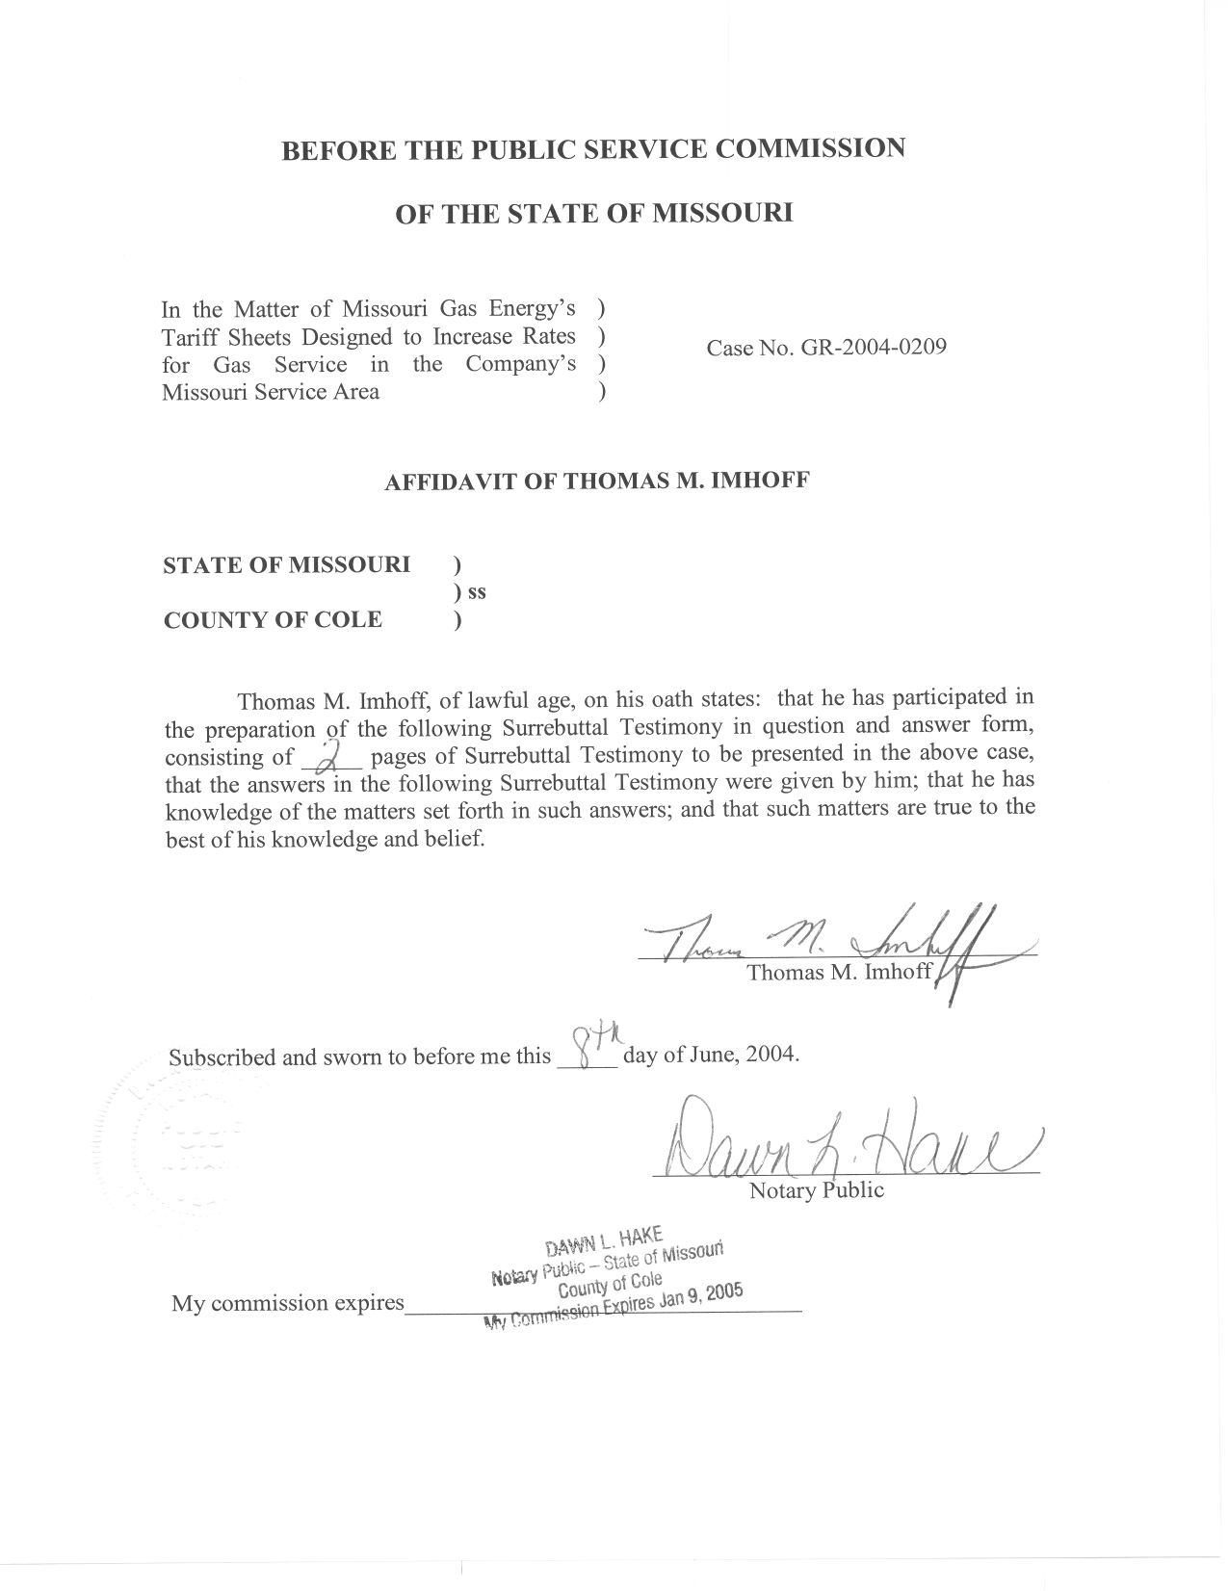

SURREBUTTAL TESTIMONY

OF

THOMAS M. IMHOFF

MISSOURI GAS ENERGY

CASE NO. GR-2004-0209

Q. Please state your name and business address.
A. Thomas M. Imhoff, P.O. Box 360, Jefferson City, Missouri 65102.
Q. Are you the same Thomas M. Imhoff who filed Direct and Rebuttal testimony in this case?
A. Yes, I am.
Q. What is the nature of your Surrebuttal Testimony?
A. My Surrebuttal Testimony addresses Company witness Michael R. Noack’s rebuttal testimony concerning late payment fees (LPF).
Q. What is your observation of MGE witness Noack’s estimate of the cost impact on MGE if the Commission approves the Staff’s proposed reduction of the late payment fees percentage from 1.5% to .5%?
A. Mr. Noack states that this proposed reduction in the LPF charge will increase the average amount of time MGE customers take to pay their bills, and accordingly will increase the Company’s revenue lag calculation as measured in the Cash Working Capital accounting schedule. Mr. Noack does not provide a specific estimate of the dollar impact on MGE due to this alleged increase in the MGE revenue lag.
Q. Do you agree with Mr. Noack’s statements concerning the negative impact on its revenue lag of the Staff’s proposed change to the LPF?
A. No. Staff finds it interesting that MGE alleges a negative cost impact in its rebuttal testimony of the proposed LPF change, without performing any studies or computations that actually assesses the impact on customer payment patterns of LPF. In its response to Staff Data Request No. 0209, MGE indicated that they had performed no studies on the costs MGE incurs when LPFs are assessed.
Q. What is Staff’s position relating to the LPF issue?
A. The Staff believes that the LPF should be set at .5% of a customer’s initial delinquent bill. The LPF should be more reflective of the current short-term cost of money for MGE, which is not 18% per year.
Q. Are you aware of any other companies who have, or will be implementing the .5% monthly LPF?
A. Yes. Aquila, Inc. has implemented the .5% LPF for its electric and gas operations, and AmerenUE will be implementing the .5% LPF for its electric and gas operations in the near future.
Q. Does this conclude your surrebuttal testimony?
A. Yes it does.

