BEFORE THE PUBLIC SERVICE COMMISSION
OF THE STATE OF MISSOURI

In the Matter of the Determination of Carrying Costs for the Phase-In Tariffs of KCP&L Greater Missouri Opperations Company. | )  )  )  ) | Case No. ER-2012-0024

MOTION TO WITHDRAW - ROBERT WAGNER

COMES NOW Robert Wagner, Pro Se Intervener, and hereby files his Motion to Withdraw. In support of this request, Robert Wagner respectfully states as follows to the Missouri Public Service Commission (“Commission”):
1. On July 22, 2011, the Commission issued an order opening a new case (File No. ET-2012-0017) regarding the carrying costs for the phase-in tariffs for KCP&L Greater Missouri Operations Company (“GMO”).
2. With its July 22 order in File No. ET-2012-0017, the Commission provided that parties to File No. ER-2010-0356, GMO’s recently completed rate case, shall be made parties to the new proceeding without the need for further intervention. The July 22 order also established dates for the filing of testimony and set a date for an evidentiary hearing regarding the carrying costs for GMO’s phase-in tariffs.
3. On July 25, 2011, the Commission closed File No. ET-2012-0017, opened File No. ER-2012-0024, and stated that the procedural schedule adopted in ET-2012-0017 shall be the procedural schedule in this matter (ER-2012-0024).
4. Robert Wagner was granted intervention as a party to and participated in GMO’s rate case (ER-2010-0356). Pursuant to the Commission’s July 22nd order, Robert Wagner was automatically made a party to File No. ET-2012-0017 and then to this proceeding (ER-2012-0024).
5. This proceeding (File No. ER-2012-0024) involves the limited issue of the carrying costs for GMO’s phase-in tariffs, and Robert Wagner hereby seeks to withdraw from this proceeding due to the fact that it is beyond his original scope of intervention (outdoor lighting).
WHEREFORE, Robert Wagner respectfully requests an order of the Commission granting his motion withdraw from this case. Robert Wagner requests such other and further relief as the Commission deems just and proper under the circumstances.
Respectfully submitted,
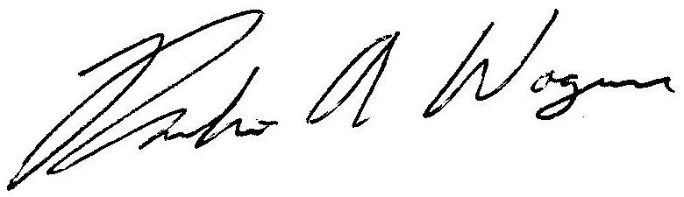

___________________________________
Robert Wagner
Pro Se Intervener

9005 N Chatham Avenue
Kansas City, MO 64154
(913) 244-7608 (Telephone)
Email: rwagner@eruces.com

Certificate of Service
I hereby certify that copies of the foregoing have been mailed, hand-delivered, or transmitted by
facsimile or electronic mail to all counsel of record this 12th day of September 2011.

__________________________________

