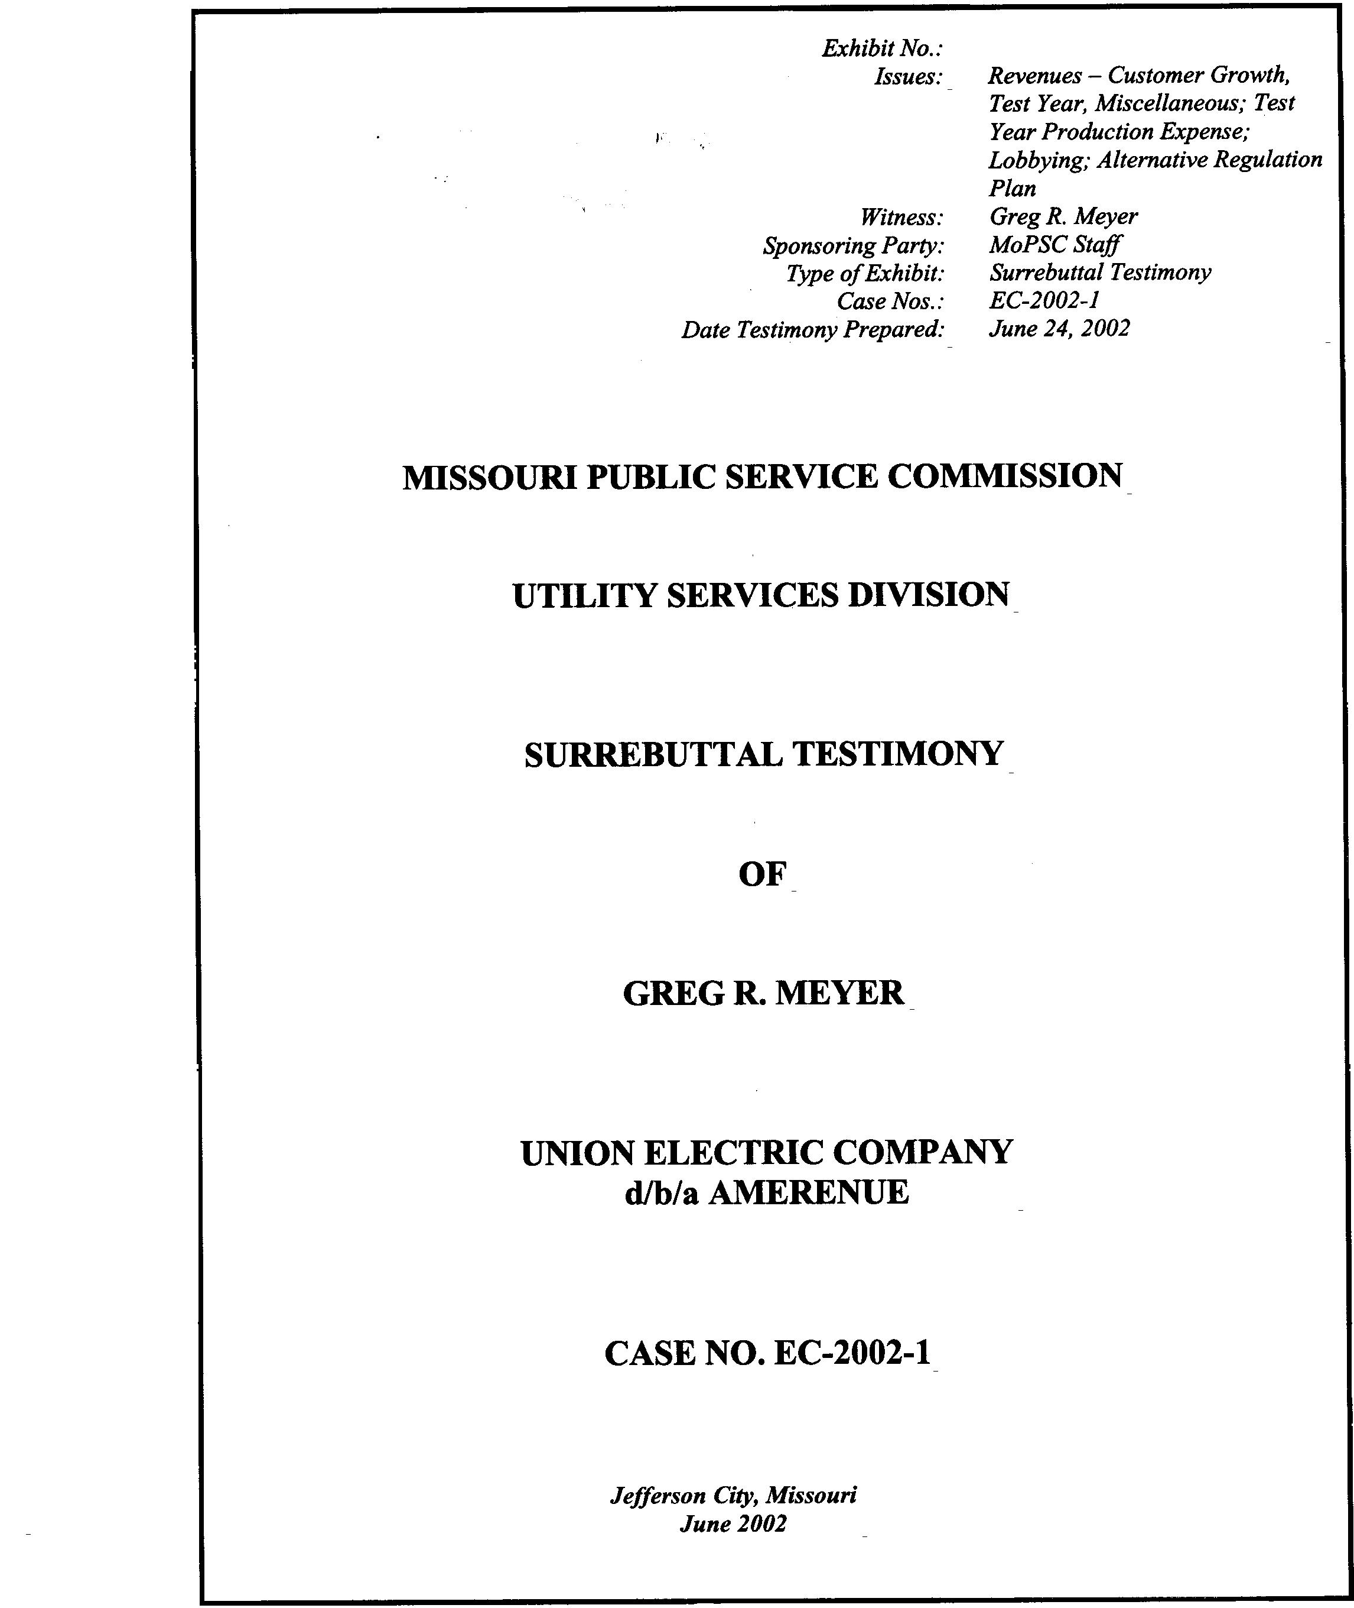
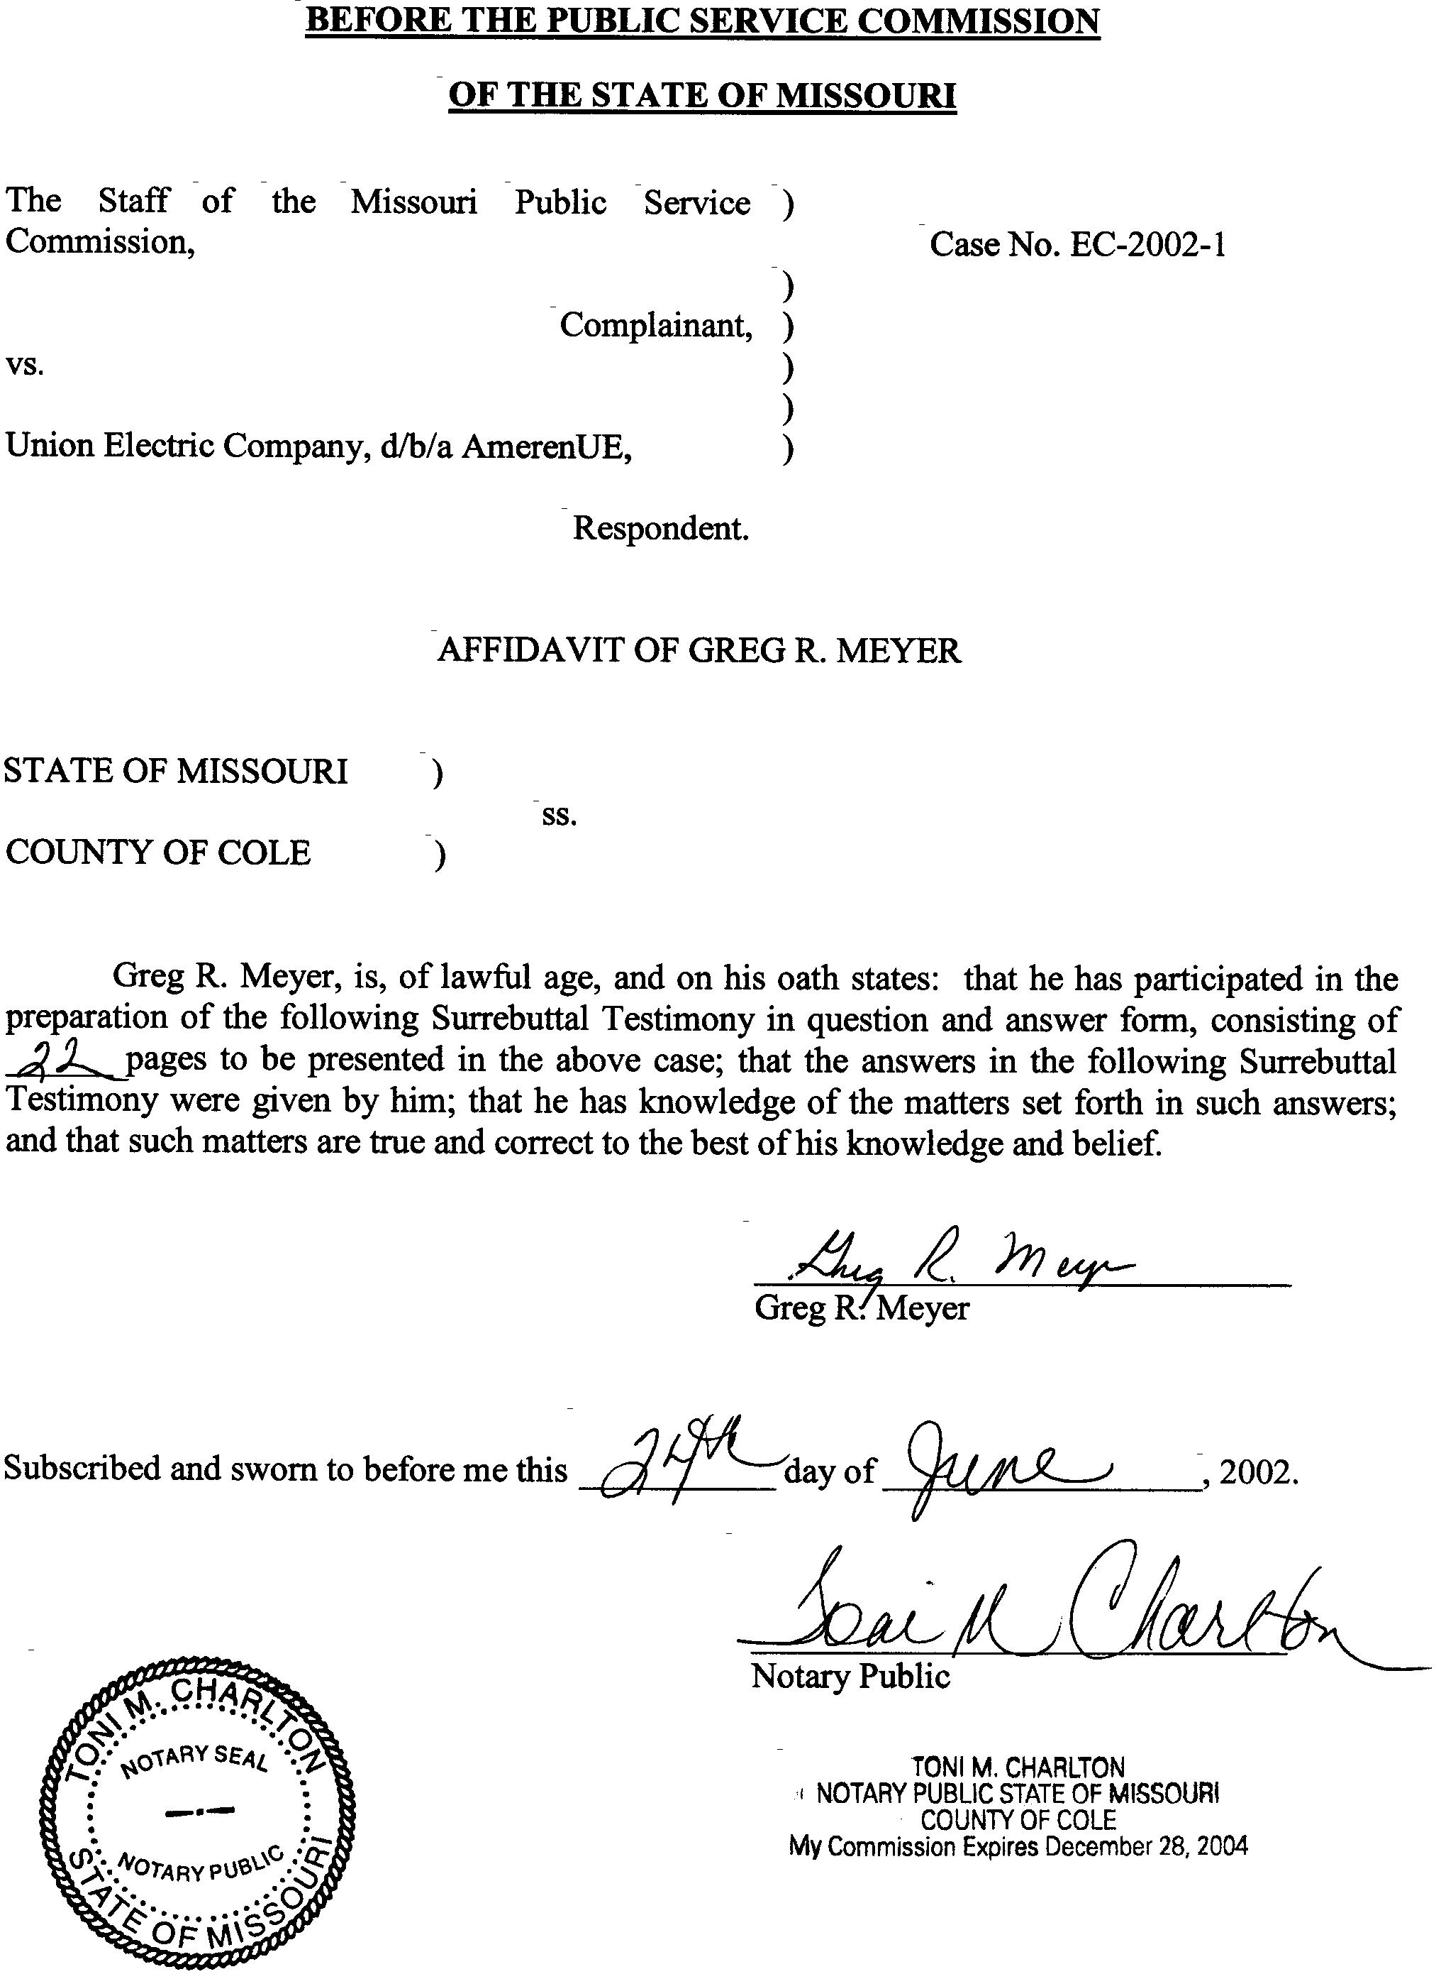

TABLE OF CONTENTS
GREG R. MEYER
UNION ELECTRIC COMPANY
d/b/a AMERENUE
CASE NO. EC-2002-1
REVENUES 2
CUSTOMER GROWTH 2
MISCELLANEOUS REVENUES – SO2 14
TEST YEAR REVENUES 15
TEST YEAR PRODUCTION EXPENSE 15
LOBBYING 20
AEM-UEC vs. COMBUSTION TURBINES 21
ALTERNATIVE REGULATION 21

SURREBUTTAL TESTIMONY
OF
GREG R. MEYER
UNION ELECTRIC COMPANY
d/b/a AMERENUE
CASE NO. EC-2002-1
Please state your name and business address.
Greg R. Meyer, 815 Charter Commons Drive, Suite 100B, Chesterfield, Missouri 63017.
By whom are you employed and in what capacity?
I am a Regulatory Auditor V with the Missouri Public Service Commission (Commission).
Are you the same Greg R. Meyer who caused to be filed direct testimony in this complaint case?
Yes, I am.
What is the purpose of this surrebuttal testimony?
My surrebuttal testimony will discuss the following areas of AmerenUE’s (Company or UE) rebuttal testimony:
Issue Witness
Customer Growth Richard J. Kovach
Miscellaneous Revenues/
SO2 Allowances Gary S. Weiss
Sales Ryan Kind
Test Year Revenues Gary S. Weiss
Test Year Production Expense Gary S. Weiss
Alternative Regulation Plan - Warner Baxter
Performance and February 1,
2001 Report

REVENUES
Did you file direct testimony in the area of revenues for the Staff’s complaint case?
No, I did not. Mr. Doyle Gibbs of the Staff’s Accounting Department provided direct testimony in the revenue area. However, because of health reasons, Mr. Gibbs is not able to continue in this proceeding. I, and other members of the Accounting Department, have adopted various portions of Mr. Gibbs’ testimony. Therefore, I am adopting Mr. Gibbs direct testimony on the area of revenues.
What revenue areas will you discuss in your surrebuttal testimony?
I will provide testimony on the issues of customer growth, miscellaneous revenues and test year revenues.

CUSTOMER GROWTH
In the area of customer growth revenues, please summarize the Staff’s and Company’s position.
The Staff annualized customer growth during the test year (July 2000 – June 2001) by reflecting the level at the end of September 30, 2001 (update period). The Staff contends that the level of customers has continued to increase over the historical period. Therefore, annualizing customer growth at September 30, 2001 correctly captures this historical increase.
The Company merely included the 12 months of revenues through September 30, 2001. By doing this, the Company claims it has captured the growth in customers during the test year and update period. The Company asserts that the ordered test year and update period precludes a party from any further adjustment to revenues. The Staff disagrees.
Furthermore, since discreet adjustments were not made to the test year of June 30, 2001, the Staff contends that the Company has violated the Commission’s test year Order. The test year argument will be explained later in this testimony.
On page 4 of Mr. Kovach’s rebuttal testimony, he identifies four reasons why the Staff’s customer growth annualization is not appropriate. Please summarize those four reasons.
Listed below are the four reasons identified by Mr. Kovach:
1) Staff’s proposal violates the Commission’s Order establishing the test year and update period.
2) Staff’s “phantom” revenues will not be realized by the Company during the test year or may never be realized.
3) Other than fuel expense, Staff allowed no other direct or indirect Company costs associated with serving the growth in customers.
4) The Staff’s proposed customer growth is not included in the development of both the Missouri jurisdictional demand and energy allocation factors.
Do you agree with Mr. Kovach’s first argument that the Staff’s customer growth adjustment violates the Commission’s Order establishing the test year?
No. Mr. Kovach does not address the basic purpose and theory of a test year. Furthermore, Mr. Kovach argues against a concept that is actually reflected in other areas of the Company’s case.
Have you reviewed the Commission’s Order Establishing Test Year And Procedural Schedule dated December 6, 2001?
Yes, I have.
Do you have any comments regarding Mr. Kovach’s assertion on test year violation?
Yes, after reviewing the Commission’s Order, the Staff can find no language within the Order to support Mr. Kovach’s assertion. In contrast, the Commission’s Order on page 3 states:
Irrespective of the test year used, the Commission has a common practice of updating test year data with post-period data in order to provide a better basis for future projection.
The common practice referred to above is the annualization and normalization of test year and update information. This practice clearly supports the Staff’s position regarding customer growth.
Are you aware of Commission decisions in this proceeding that would support the Staff’s argument against Mr. Kovach?
Yes, on April 25, 2002, the Commission issued an “Order Denying Motion To Strike.” Within that Order, the Commission again stated a purpose for the test year: It reads:
A test year is a tool designed to help the Commission set rates that will be appropriate in the future.
The Commission further discussed in this Order the use of isolated adjustments proposed by a party:
The Commission has typically been willing to consider proposed adjustments based on known and measurable changes that occur after the end of the test year and update period. The Commission frequently includes the following statement in an order establishing a test year:
A party may also request isolated changes, such as those imposed by governmental bodies, as part of its case and the Commission will consider whether those isolated changes are known and measurable, and whether they should be included in the Company’s revenue requirement. An issue to be considered in this determination is whether the proposed adjustment affects the matching of rate base, expenses and revenues.
The Commission will follow this practice in this case.
The Staff’s position is consistent with the Commission’s Order in this and other rate proceedings. By allowing the filing and consideration of isolated adjustments, the Commission has found that Mr. Kovach’s strict adherence to his test year principles are without merit.
On page 8 of Mr. Kovach’s rebuttal testimony, Mr. Kovach asserts that the only customer growth that can be recognized is that growth which occurred within the confines of any 12 month period or historic test year. Do you agree?
No. The test year is generally a 12-month period that forms the starting basis for the development of a party’s cost of service. The update period is used to examine more recent data for the larger components of a case. Examination of this data may result in changes to the cost of service.
The test year and update period are not intended to be inflexible barriers to hinder a party from annualizing certain aspects of a case. Instead, a test year and update period should be viewed as the mechanism needed to analyze the ongoing operations of a utility. Parties should not be restricted to recognizing only the 12-month historical test year and/or update period revenues actually experienced.
Are you aware of other areas in the Company’s case where expense annualizations have been proposed which were not fully recognized in the test year or update period?
Yes. In the Company’s cost of service calculation, there exists several instances where the Company annualized an expense which had not been fully experienced or expensed during the test year or update period. Listed below are the examples the Staff was able to easily identify:
Payroll – The Company proposes to annualize payroll to reflect a 3.93% wage increase for management employees effective April 1, 2001 and a 3% wage increase for the Company’s union employees effective July 1, 2001. The total effect of these wage increases will not be experienced or reflected in the Company’s book until March 31, 2002 and June 30, 2002, respectively.
Rate Case Expense – The Company proposes to amortize its estimated additional rate case expenses of $2,634,000, which includes rate case expense through 2002.
Depreciation Expense – The Company proposes to annualize depreciation expense using the Company’s proposed depreciation rates applied to the September 30, 2001 depreciable plant balances. The depreciation expense resulting from the use of these rates cannot be experienced until the 12-months following the Commission’s Order in this complaint.
On pages 5-6 of Mr. Kovach’s rebuttal testimony, he states:
The Commission issued its ORDER APPROVING JOINTLY FILED REVISED PROCEDURAL SCHEDULE in this case on January 3, 2002. Paragraph 3 of page 3 of that Order, items (a) and (b), state that “the test year in this proceeding will be the twelve months ended June 30, 2001 (the Test Year)”, and “the Test Year may be updated through September 30, 2001.” It is very clear from this language in the Commission’s Order that any additional Company operating expenses, plant investment, customer sales or revenues that are incurred, or expected to occur, after September 30, 2001 should not be included in the test year in this case. To include such items, as the Staff has done in its proposed customer growth adjustment, is a direct violation of the aforementioned provisions of the Commission’s order.
Given Mr. Kovach’s statement, the Staff would argue that the Company’s three annualizations/amortizations described above would not be consistent with Mr. Kovach’s position. Company Witness Martin J. Lyons, Controller for Ameren, also makes similar arguments regarding the test year concept. Mr. Lyons wants to include a rate case expense amortization based on future expenditures, yet argues that the known and measurable change associated with the PSC Assessment violates the test year concept.
Please summarize the Staff’s position regarding the Company’s arguments involving the test year and update period.
The Staff contends that the Company has incorrectly applied the Commission’s Orders involving test year in instances where the Company’s over-earnings would be negatively impacted (for example, customer growth and PSC Assessment). However, in instances where annualizations increase, the Company’s cost of service (for example payroll, rate case expense and depreciation expense) test year arguments are ignored and expenses are included.
The Staff contends that the adjustments contained within its cost of service do not violate the Commission’s test year Orders and establish the proper revenue, expense, investment relationships required by the Commission.
The test year and update period were established by Commission Orders. The test year and update period are the specified time periods established for the audit of the Company’s books and records. The purpose of adjusting the test year based on more recent and update period data is to establish the revenue, expense, investment relationship that will be in effect the year rates are in effect.
Mr. Kovach’s second argument against the Staff’s customer growth adjustment alleges that the Staff’s “phantom” revenue adjustment will not be realized in the test year and may never be realized. Do you agree with this statement?
No. The Staff agrees that the revenue annualization proposed by the Staff represents revenues that were not collected in the test year. The test year and update period books and records are the data parties utilize to calculate normalization and annualization adjustments to cover the prospective period when the rates will be in effect.
On page 7, lines 6-7, Mr. Kovach suggests that the Staff’s customer growth adjustment “creates a distortion of the Company’s actual test year customers and normal patterns of customer growth.” Further, on page 7, line 10, Mr. Kovach testifies the Staff’s adjustment “is clearly a deviation from historic revenue.” Do you agree with these statements?
No, absolutely not. Attached to this testimony are Schedules 1-1 through 1-3. These Schedules clearly demonstrate that the Staff’s customer growth annualization is proper and should be accepted by this Commission. In addition, these schedules will negate any arguments Mr. Kovach suggests that the Staff’s revenues are “phantom.”
Please describe Schedules 1-1 through 1-3 attached to this testimony.
Schedule 1-1 is a table that lists the residential customer levels by month from January 1995 through April 2002.
What is the significance of this schedule?
This schedule clearly reveals that the Staff’s methodology for annualizing customer growth based on September 30, 2001 customer levels is appropriate and reflects the level of revenues the Company will, at a minimum, collect.
Why is the month of September highlighted with a box?
The month of September was highlighted for each year to show that the level of residential customers for each succeeding month is in excess of the number of residential customers in September. In other words, the September 30, 1995-2001 level of residential customers is the lowest level (except for one occurrence) of customers reported by UE for any succeeding month in the future. This trend has remained constant for 78 consecutive months (September 1995-April 2002 with the exception of October 1997). Mr. Kovach’s claims that the Staff’s customer growth adjustment represents “phantom” revenue when compared to a 78-month customer growth trend is without merit.
Q. Please describe Schedule 1-2.
A. Schedule 1-2 graphically displays the customer growth that has occurred in the residential class for Missouri retail customers. This graph again reveals that the September 30, 2001 level of customers is a conservative estimate of future levels of customers that will exist during the period rates resulting from this complaint are in effect. As can be seen from this graph, Mr. Kovach’s argument, that the Staff’s revenues annualized for customer growth will not materialize, is unfounded. To the contrary, as the graph reveals, the residential customer levels as of September 30, 2001 is already understated by approximately 6,000 customers when compared with April 2002.
Q. Does the Staff propose to use the April 2002 residential customer levels for annualizing customer growth?
A. No. The Staff would not suggest that adjustment as it clearly would violate the test year and update period as ordered by the Commission.
Q. Please describe Schedule 1-3.
A. Schedule 1-3 graphically tracks the residential customer growth that UE has experienced since the beginning of the test year (July 2000) through the most current data available (April 2002). As can be seen by the graph, the level of residential customers has continuously increased over the period.
Q. The graph reveals a slight variance in growth for the months May through August 2002. Please explain.
A. There exists a small deviation in growth each year when comparing the September 30 level of customers to those customer levels during the preceding calendar year as shown on Schedule 1-1. However, the growth pattern shown on Schedule 1-1 shows that the level of customers reported in September is typically lower than the level realized during the succeeding 12 months.
Q. Are you aware of any other documents or views expressed by the Company which would support the Staff’s position regarding customer growth?
A. Yes. Company witness William M. Stout, P.E. sponsors Schedule 5 in his rebuttal testimony which includes anticipated customer levels into the future. By reviewing Mr. Stout’s Schedule 5, it is obvious that for purposes of his position, customer growth was considered.
In addition, the Company in its rebuttal testimony on tree trimming argues that Staff witness Paul Harrison’s adjustment to tree trimming expense is unjustified for several reasons. One argument presented by the Company against Mr. Harrison is that his adjustment does not account for customer growth which would increase tree trimming expense.
The arguments above show that the positions of some Company witnesses are not consistent with the positions taken by other Company witnesses in UE’s rebuttal case.
Q. In reference to Mr. Kovach’s third argument regarding the Staff’s customer growth annualization, Mr. Kovach asserts the Staff has not included any additional expenses associated with additional customers. Please comment.
A. The Staff agrees, in part, with Mr. Kovach’s testimony. As a result, the Staff has included in its revised cost of service calculation an adjustment to increase postage expense. Adjustment S-13.7 increases expense to reflect the increase in postage resulting from the Staff’s customer growth annualization.
After further analysis of the expenses recorded in the Company’s Customer Accounting area, the Staff believes that no additional expense adjustments were necessary.
Q. Mr. Kovach also criticizes the Staff regarding the fuel expense associated with the Staff’s customer growth annualization. Do you agree with Mr. Kovach’s position?
A. No. Mr. Kovach argues that the Staff priced the fuel expense to meet the customer growth annualization by using the annual average energy (fuel) costs of 1.00 cent per kilowatthour. Mr. Kovach obtained this energy amount (1.00 cent per kilowatthour) from the Staff in a letter sent to Mr. Kovach on April 19, 2002. Attached as Schedule 2 is a copy of the letter and fuel calculation performed by the Staff.
The Staff would note that this letter and the fuel calculation was provided to the Company as a result of a technical conference held on April 10, 2002. Mr. Kovach in his testimony fails to mention that at this conference, he was informed that the Staff included the load associated with the customer growth adjustment to annualize fuel expense calculated by the Staff’s production model. The model calculated the fuel expense necessary to meet the load associated with customer growth, not an average, but at the time this load was experienced on UE’s system
Q. Finally, Mr. Kovach argues that the results of the Staff’s customer growth adjustment should be reflected in the demand and energy allocation factors. Please comment.
A. It is my understanding that the Staff has updated the energy allocation factor to include the Staff’s customer growth adjustment. The demand allocation factor was not adjusted as the Staff does not have the information available to perform such a calculation. Please refer to the surrebuttal testimony of Staff Witness Alan J. Bax for a discussion of this area.
Q. Is the method that the Staff utilized for annualizing customer growth consistent with the Staff’s annualization of revenues for other utilities?
A. Yes, this customer growth method has been used numerous times by the Staff. In fact, an annualization method similar to the one proposed in this case was used by the Staff in the Company’s last gas case. In that case, Mr. Kovach reviewed the methodology and was aware of the Staff’s position.
Q. Please summarize the Staff’s position regarding customer growth.
A. The adjustment to annualize customer growth as presented by the Staff should be accepted by the Commission. The Company, while annualizing expenses, has tried to ignore the annualization of customer growth by falsely claiming a test year violation. This annualization is necessary to provide consistency among revenues, expenses and investment in both the Staff’s and the Company’s cases.
The Company has made other adjustments to expense that under Mr. Kovach’s standard would be “phantom” (e.g., depreciation, payroll and rate case expense). The schedules attached to this testimony clearly indicate customer growth is occurring and should be included in a cost of service calculation.
Finally, the Staff calculation has been consistently applied to many of the utilities that operate in Missouri. The Staff’s adjustment is valid and should be adopted by the Commission.

MISCELLANEOUS REVENUES – SO2
Q. Please describe Staff Adjustment S-4.3 to the Staff’s revised cost of service calculation.
A. Adjustment S-4.3 increases miscellaneous revenues to reflect the proceeds from the level of SO₂ emission credit sales for the twelve month period ending September 30, 2001. Upon reviewing the testimony of both the Company and Office of the Public Counsel (OPC), the Staff concluded that the level of SO₂ emission credit revenues at September 30, 2001 was not an issue between OPC and the Company. OPC witness Ryan Kind proposes several adjustments to the June 30, 2001 level of SO₂ revenues. Likewise, Company witness Gary S. Weiss sponsors revenue testimony which supports the inclusion of September 30, 2001 levels of revenues. The Staff has concluded from this review that the level of SO₂ revenues at September 30, 2001 should not be contested by any party and therefore this level is reflected in the Staff’s revised cost of service calculation.
Q. Does the Staff have other concerns related to the area of miscellaneous revenues?
A. Yes. The Staff discovered that there exists a large difference in the amount of miscellaneous revenues entitled Other Miscellaneous Revenues between June 30, 2001 and September 30, 2001. The September 30, 2001 level is larger than the test year level. The Staff submitted a data request to the Company to quantify and explain this difference. The Staff will review this request and determine if that area of revenues should also be updated.

TEST YEAR REVENUES
Mr. Weiss testifies on page 16, lines 7-10 in his rebuttal testimony that the Company’s cost of service calculation reflects the revenues for the 12 months ending September 30, 2001. Does the Staff believe the Company is in compliance with the Commission ordered test year?
No. The Staff contends that the Company should have made distinct adjustments to the revenues as booked at June 30, 2001. The Company’s position presents problems when parties must reconcile the revenues issues. Please refer to the surrebuttal testimony of Staff Witness Janice Pyatte for further discussion in this area. Ms. Pyatte attempted to reconcile the Company and Staff’s revenues. However, due to the fact that the Company did not begin with the June 30, 2001 revenues as ordered by the Commission any reconciliation is speculative at best.

TEST YEAR PRODUCTION EXPENSE
Q. Please describe the differences between the Staff and the Company in the area of production expense.
A. The differences between the Company and the Staff in production expense results from the Company violating the Commission ordered test year. The Company includes in its case the production expense for the twelve months ending September 30, 2001. The Company made no adjustments to the June 30, 2001 production expense levels, but instead merely included the September 30, 2001 actual production expense levels in its cost of service as the Total Per Books amounts.
The Staff however, began with the June 30, 2001 levels of production expense and made distinct adjustments to those levels for such items as payroll and fuel expense. This procedure is consistent with the ordered test year of the Commission and its past practice.
Q. What is the magnitude of the change in production expenses from June 30, 2001 to September 30, 2001?
A. The annual (12 months) change in production expense between the two periods is approximately $81.6 million dollars.
Q. Is there any Company testimony which supports the use of the September 30, 2001 production expense levels?
A. Yes. Company witness Gary S. Weiss testifies on page 18, lines 5 through 8:
The actual production expenses through September 30, 2001 are known. The revenues and kWh sales were updated through September 30, 2001 and in order to provide a proper matching of revenues and expenses the cost of producing these kWhs must also be updated through September 30, 2001.

Within these four lines of testimony the Company proposes to increase production expense on $81.6 million on an annual basis with minimal justification. Company witness Garry Randolph testifies to current levels of production maintenance expense, yet does not specifically address the movement of the test year to September 30, 2001 for production expenses.
Q. Please explain your last statement.
A. A test year is ordered by the Commission to require all parties to begin with a common revenues/expenses/rate base starting point for audit. This test year is established to make certain that all parties know what the starting balances are, so that issues and areas can be reconciled. This process allows all parties and the Commission to value each issue that must be addressed. When a party, in particular the Company, does not adhere to the ordered test year, the ability to reconcile or quantify issues between parties is extremely difficult, if not impossible. In order to reconcile the areas of disagreement with different 12-month periods used, as test year starting points, amounts will have to be grouped into a category titled “Unreconciliable” or “Test Year Variance” for the reconciliation.
Has the Staff attempted to reconcile the differences between June 30, 2001 and September 30, 2001 levels of production expense?
Yes. However, the Staff believes this task should not have been required. The Company violated the Commission-ordered test year by moving the test year for production expenses to September 30, 2001.
Please describe the Staff’s reconciliation of production expenses.
I reconciled the per book amounts for the 12 months ending June 30, 2001 (Commission-ordered test year) and the 12 months ending September 30, 2001 (update period). Those book balances at June and September represent the $81.6 million difference I identified earlier. Ten categories of costs were identified for purposes of the Staff’s reconciliation. Staff witness Dr. Michael S. Proctor provides testimony on the change in interchange margin from June 30, 2001 to September 30, 2001. The area of fuel expense to meet native load is addressed in the testimonies of Staff witness Leon Bender and Company witness Timothy D. Finnell. The remaining eight areas of reconciliation are not supported by Company testimony.
What is the largest dollar variance in the remaining eight areas between booked production expenses at June 30, 2001 and September 30, 2001?
The Maintenance Costs-Other category represents the largest variance in the remaining categories. Production maintenance expense, excluding payroll, increased by $5.7 million annually between June 2001 and September 2001. The Company, in the testimony of Mr. Garry Randolph, provides only minimal justification for this increase.
Is the Staff aware of any information that can be used to dispute the level of maintenance expense the Company proposes to include in its cost of service?
Yes. Attached to this testimony are Schedules 3-1 and 3-2 which are bar graphs detailing production maintenance expense for the following categories: Company’s historical level, Staff’s and Company’s annualized levels and Company’s budgeted level.
Please describe Schedule 3-1.
Schedule 3-1 illustrates the historical annual amounts of production maintenance expense, the test year level, and the Staff’s and Company’s proposed levels of production maintenance expense reflecting the different test years. As can be seen from the graph, the Company is proposing to include in its cost of service, the highest level of production maintenance expense that has occurred since 1996.
Please describe Schedule 3-2.
This schedule clearly demonstrates that the level of maintenance expense proposed by the Company due to a shift in the test year to September 30, 2001 is unreasonable. Although the Company claims Mr. Randolph is supportive of the maintenance expense levels as of September 30, 2001, the levels are not supported by Mr. Randolph’s Schedules. Schedule 4 attached to Mr. Randolph’s testimony is the projected level of production maintenance expense that UE expects to incur. The amounts from Mr. Randolph’s Schedule 4 were incorporated into Schedule 3-2. Schedule 3-2 compares the present test year level and the Company’s and the Staff’s annualized levels of production maintenance expense to the projected levels of production expense supported by Mr. Randolph.
This schedule clearly demonstrates that the level of maintenance expense in either the Staff’s or Company’s cost of service is excessive compared to future projections.
Does the Staff propose to adjust production maintenance expense to reflect this decreasing trend?
No. However, the Staff contends that the Company’s position must be rejected. The Staff would point out that not only is the Company’s production maintenance expense proposal in violation of the test year, the level of expense is unjustifiable.
Did the Staff attempt to find other support for the Company’s proposed level of production expense, included in its cost of service?
Yes. The Staff submitted Data Request No. 187 which asked Company Witness Weiss for all information which supported the Company’s position regarding production expense. A copy of the Staff Data Request and Company response are attached as Schedule 4 to this testimony.
In reviewing the Data Request response, the Staff would argue that the Company’s basis for adopting its position is unacceptable. The analysis Mr. Weiss performed mirrors the four lines of Company testimony to support their position. Again, the Staff would contend that the Company’s position must be rejected for the reasons previously discussed.
Please summarize the Staff’s position regarding the level of production expense that should be included in the cost of service calculation as it relates to the Commission’s ordered test year.
The Staff contends that the starting level of production expense must be based on the test year for 12-months ending June 30, 2001. Adjustments to this level must be supported by testimony and should reflect the consideration of identifiable items which are known and measurable.
The Company has ignored these conditions and has instead arbitrarily included the 12 months ending September 30, 2001 as the proper level of production expense. The Company offers four lines of testimony to support an $81.6 million per book shift. The Staff believes that the Company has failed, through its rebuttal testimony, to justify its position and the deviation from the Commission’s test year Order. Finally, the Staff contends, based upon the above discussion, that the Company’s position should be rejected.

LOBBYING
Has the Staff formulated a final position regarding the OPC’s lobbying adjustment proposed by OPC witness Ted Robertson?
No. However, the Staff has historically disallowed lobbying expenses in its cost of service calculations. The Staff discovered during its review that an amount in excess of the OPC adjustment was identified on the Company’s books and records. The Staff has submitted a data request to the Company to determine the amount of lobbying in Staff’s cost of service. Once the data request is answered and reviewed, the Staff will have a more definite position regarding this area. However, it continues to be the Staff’s position that lobbying costs should not be included in its cost of service calculation.

AEM-UEC vs. COMBUSTION TURBINES
Company witness Richard A. Voytas, attached a schedule (Schedule No. 4) to his rebuttal testimony, which compares the costs of the Company’s AEM-UEC capacity contract to the Staff’s position on the company addressing its capacity needs with additional combustion turbines. Do you agree with the calculations on Schedule 4 of Mr. Voytas’ rebuttal testimony?
No. Mr. Voytas has incorrectly calculated the rate base affect of the Staff’s position. Attached as Schedule 5 is a correction of Mr. Voytas’ calculation. The attached Schedule also corrects the revenue requirement impact of the Staff’s proposed variable operation and maintenance expense which has been included in the Staff’s revised cost of service calculations.
The new calculation as reflected on Schedule 5 to my surrebuttal testimony shows that the revenue requirement differential is now approximately $5.2 million. Please refer to the surrebuttal testimony of Staff Witness Dr. Michael S. Proctor for a complete discussion regarding this area.

ALTERNATIVE REGULATION
Please describe your testimony as it relates to alternative regulation.
Attached to my surrebuttal testimony as Schedule 6 is the Staff’s February 1, 2001 report to the Commission addressing the Staff’s position on the Experimental Alternative Regulation Plans that UE operated under from July 1, 1995 through June 30, 2001.
This report is being provided to the Commission and other parties of this case as it reflects, in addition to the surrebuttal testimony of Staff witness Robert E. Schallenberg, the latest evaluation the Staff has performed regarding alternative regulation. This report, in conjunction with the Staff witnesses’ current surrebuttal testimony, should provide information for the Commission’s evaluation of the Company’s current proposal on Alternative Regulation Plan.
Does this conclude your surrebuttal testimony?
Yes, it does.

