Exhibit No.:
Issues: Weather Normalization
Witness: Lena M. Mantle
Sponsoring Party: MoPSC Staff
Type of Exhibit: Direct Testimony
Case No.: ER-2002-424
Date Testimony Prepared: August 16, 2002

MISSOURI PUBLIC SERVICE COMMISSION

UTILITY OPERATIONS DIVISION

DIRECT TESTIMONY

OF

LENA M. MANTLE

THE EMPIRE DISTRICT ELECTRIC
COMPANY

CASE NO. ER-2002-424

Jefferson City, Missouri
August, 2002

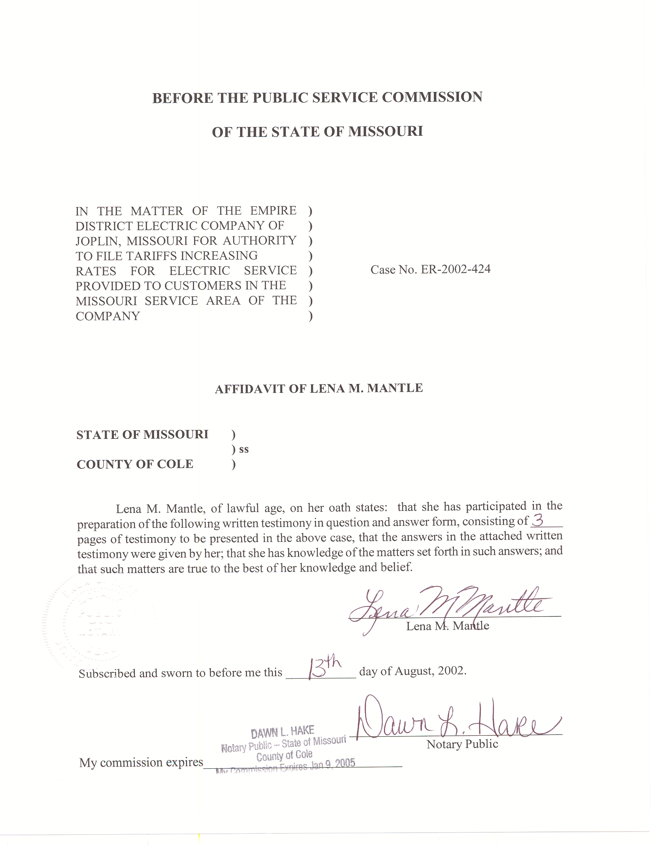

DIRECT TESTIMONY
OF

LENA M. MANTLE

THE EMPIRE DISTRICT ELECTRIC COMPANY

CASE NO. ER-2002-424

Q. Please state your name and business address.
A. My name is Lena M. Mantle and my business address is Missouri Public Service Commission, P. O. Box 360, Jefferson City, Missouri 65102.
Q. What is your present position with the Missouri Public Service Commission (Commission)?
A. I am the Utility Engineering Supervisor of the Engineering Analysis Section of the Energy Department, Utility Operations Division.
Q. Would you please review your educational background and work experience?
A. I received a Bachelor of Science Degree in Industrial Engineering from the University of Missouri, at Columbia, in May 1983. I joined the Commission Staff (Staff) in August 1983. I have been weather normalizing electricity usage and hourly loads for the Staff since 1988. I am a registered Professional Engineer in the State of Missouri.
Q. Have you previously filed testimony before this Commission?
A. Yes, I have. Please see Schedule 1 attached to this testimony for a list of cases in which I have previously filed testimony.
Q. What is the purpose of your direct testimony?
A. The purpose of my testimony is to describe the method that was used to calculate the daily normal weather variables that were used in both the weather normalization of class usage and the normalization of hourly net system loads.
Q. What did you use to represent normal weather in these calculations?
A. The normal weather used in both the normalization of class usage and hourly net system loads was calculated using Staff’s ranking method and daily weather values for the time period January 1, 1971 through December 31, 2000. Staff’s ranking method estimates daily normal values for the test year, which range from the temperature value that is “normally” the hottest to the temperature value that is “normally” the coldest.
Using ranked normals to estimate the weather adjustment to usage is important because electricity use does not respond to temperature by a constant factor. Customer response to a change in temperature of one degree from 70 to 71 is very different from a change in temperature of one degree from 90 to 91. The ranking method of calculating normals allows for a more accurate estimate of changes in usage due to deviations from normal weather.
Using ranked normals is also important in estimating fuel and purchased power expense because these expenses are greatly impacted by daily weather extremes. Since every year has days with extreme temperatures, the daily normals should also contain extremes. The ranking method that was used estimates normal extremes.
Q. How are the daily normals derived?
A. The daily normal variables are calculated by ranking the temperatures in each year of the history. These temperatures are then averaged by rank, not by the day of the year. This results in the normal extreme being the average of the most extreme temperatures in each year of the history. The second extreme normal variable is based on the average of the second most extreme day of each year and so forth. The normal variables calculated from this ranking are then assigned to the days in the test year based on the rankings of the actual temperatures in the year. This assignment results in as little weather normalization occurring on each day as is possible.
Q. Who supplied the history of daily temperatures used in your calculation of daily normals?
A. Staff witness Dennis Patterson supplied the history of daily temperatures that
I used in calculating the daily normal weather values.
Q. Does this conclude your direct testimony?
A. Yes, it does.

PREVIOUS TESTIMONY OF

LENA M. MANTLE

CASE TYPE OF ISSUES
NUMBER TESTIMONY

ER-84-105 Direct Demand-Side Update

ER-85-20 Direct Demand-Side Update

ER-85-128, et. al Direct PURPA Standards

EC-87-114, et. al. Surrebuttal Annualization & Normalization of Sales

EO-90-101 Direct, Weather Normalization of Sales
Rebuttal, and Normalization of Net System
Surrebuttal

ER-90-138 Direct Normalization of Net System

EO-90-251 Rebuttal Promotional Practice Variance

EO-91-74, et. al. Direct Weather Normalization of Class Sales
Normalization of Net System

ER-93-37 Direct Weather Normalization of Class Loads
Normalization of Net System

ER-94-163 Direct Normalization of Net System

ER-94-174 Direct Weather Normalization of Class Sales
Normalization Net System

EO-94-199 Direct Weather Normalization of Sales

ET-95-209 Rebuttal and New Construction Pilot
Surrebuttal

ER-95-279 Direct Normalization of Net System

ER-97-81 Direct Weather Normalization of Class Hourly
Loads, TES Tariff, Normalization of Net System

PREVIOUS TESTIMONY

OF LENA M. MANTLE (cont.)

CASE NUMBER TYPE OF ISSUES
TESTIMONY

EO-97-144 Direct Weather Normalization of Class Loads
Normalization of Net System

ER-97-394, et. al. Direct, Weather Normalization of Class Loads
Rebuttal and Normalization of Net System Surrebuttal Energy Audit Tariff

EM-97-575 Direct Normalization of Net System

EM-2000-292 Direct Normalization of Net System
Load Research

ER-2001-299 Direct Weather Normalization of Class Loads
Normalization of Net System

EM-2000-369 Direct Load Research

ER-2002-1 Direct Weather Normalization of Class Loads
Normalization of Net System

ER-2001-672 Direct and Weather Normalization of Class Loads
Rebuttal Normalization of Net System

EC-2002-1 Direct Weather Normalization of Class Loads
Rebuttal Normalization of Net System

