BEFORE THE PUBLIC SERVICE COMMISSION
OF THE STATE OF MISSOURI

In the Matter of The Empire District )
Electric Company of Joplin, Missouri )
For authority to file tariffs increasing ) Case No. ER-2006-0315
Rates for electric service provided to )
Customers in the Missouri service area )
Of the Company. )

MOTION FOR FURTHER CONTINUANCE

COMES NOW, Praxair, Inc. (“Praxair”) and Explorer Pipeline, Inc. (“Explorer”) and in support of their Motion For Further Continuance respectfully state as follows:
1. On March 24, 2005, The Empire District Electric Company (“Empire”) filed its Motion for Clarification. In its Motion, Empire requests a Commission determination finding that it could prematurely terminate its existing three-year IEC and, in its place, implement a fuel adjustment clause in this pending case.
2. On March 30, 2006, the Office of the Public Counsel (“OPC”) filed its request, supported by Staff and Praxair / Explorer, for a two-week extension of time in which to respond to Empire’s Motion for Continuance. Said request for extension was granted by the Commission, under delegation of authority, on March 31, 2006.
3. Recognizing the short time for responses under the granted extension, Praxair / Explorer filed its Motion for Expedited Discovery on March 31, 2006. In its Motion, Praxair Explorer noted that the extension of time would be effectively moot without some provision for expedited discovery from Empire. On April 3, 2006, the Commission, under delegation of authority, granted the Motion for Expedited Discovery and ordered data request responses be completed by Empire within 10 days.
4. Prior to filing its Motion for Expedited Discovery, Praxair / Explorer had submitted several data requests to Empire designed to understand Empire’s interpretation of the IEC and how it presented that interpretation to its Board of Directors, analysts, bankers and investment community. Under the Order Granting Motion for Expedited Discovery, Empire should have completed all such responses by April 10, 2006. In general, Empire has been very responsive and completed these responses by the ordered date. Nevertheless, relying upon paragraph C of the Commission’s Standard Protective Order, Empire has designated certain materials for review only at its premises in Joplin. Furthermore, Empire has insisted that such review only be made available with two days prior notice.
5. On April 12, 2006, Praxair / Explorer notified Empire that it wished to review the designated information at Empire’s premises in Joplin on Friday, April 14, 2006. On April 13, 2006, Empire informed Praxair / Explorer that its office would be closed that day in recognition of the Good Friday holiday. In an effort to complete this review as soon as possible, Praxair / Explorer immediately informed Empire that it wished to view this information on the next business day, April 17, 2006. Recognizing that this is the same date as is currently scheduled for submission of parties’ responses to the pending Empire Motion for Clarification, Praxair / Explorer, through no fault of its own has been rendered incapable of completing its discovery and incorporating that discovery into its response.
6. As such, Praxair / Explorer requests a further one-week continuance in order to allow it to visit Empire’s premises in Joplin, complete its discovery, and finalize its response to the Empire Motion for Clarification. Praxair / Explorer has consulted with both OPC and Staff and has been informed that both parties support this request for further continuance.
7. The granting of this request will have no effect on the timely resolution of this case. The parties continue to conduct their audits and believe that this continuance will have no effect on the previously ordered procedural schedule. Moreover, recognizing the possibility that special amortizations may be called into play by Empire’s earnings, regardless of the outcome of the pending Empire Motion, this matter will also not have an effect on the number of issues to be determined by the Commission in this case.
WHEREFORE, Praxair and Explorer respectfully request the Commission issue its Order granting the parties a continuance of one week in which to file its responses to the pending Empire Motion for Clarification.
Respectfully submitted,
FINNEGAN, CONRAD & PETERSON, L.C.
_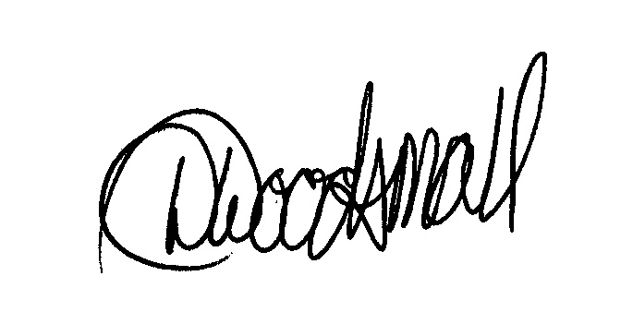__________
Stuart W. Conrad, MBE #23966
David L. Woodsmall, MBE #40747
3100 Broadway, Suite 1209
Kansas City, Missouri 64111
(816) 753-1122 Ext. 211 (Telephone)
Facsimile: (816) 756-0373
Internet: dwoodsmall@fcplaw.com

ATTORNEY FOR PRAXAIR, INC. and
EXPLORER PIPELINE INC.
CERTIFICATE OF SERVICE

I HEREBY CERTIFY that I have this day served the forgoing pleading by email, facsimile or First Class United States Mail to all parties by their attorneys of record as provided by the Secretary of the Commission.

David L. Woodsmall

Dated: April 13, 2006

See, Empire Regulatory Plan, Case No. EO-2005-0263.

