Exhibit No.:
Issues: Analysis of
Non-Wireline Services

Witness: Adam McKinnie
Sponsoring Party: MO PSC Staff
Type of Exhibit: Surrebuttal Testimony
Case No.: TO-2005-0035
Date Testimony Prepared: January 21, 2005

MISSOURI PUBLIC SERVICE COMMISSION

UTILITY OPERATIONS DIVISION

SURREBUTTAL TESTIMONY

OF

ADAM MCKINNIE

SOUTHWESTERN BELL TELEPHONE, L.P.,
D/B/A SBC MISSOURI

CASE NO. TO-2005-0035

Jefferson City, Missouri
January 2005
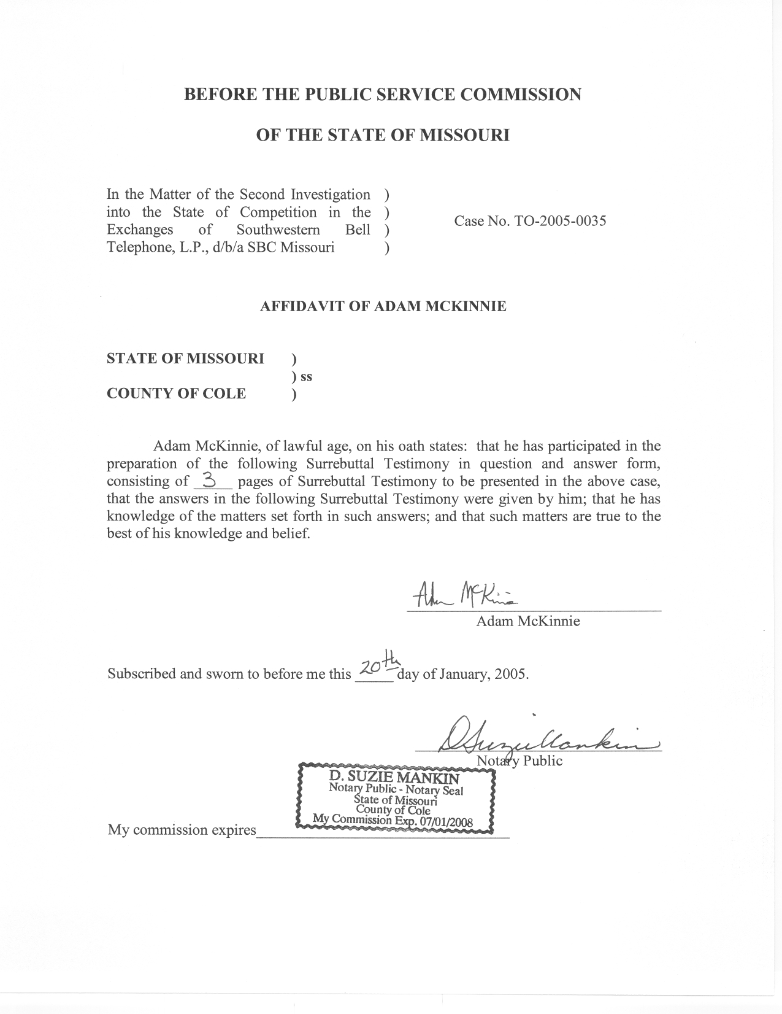

SURREBUTTAL TESTIMONY

OF

ADAM MCKINNIE

SOUTHWESTERN BELL TELEPHONE, L.P.,
D/B/A SBC MISSOURI

CASE NO. TO-2005-0035

Q. Are you the same Adam McKinnie who filed Rebuttal Testimony in this case?
A. Yes, I am.
Q. What is the purpose of your Surrebuttal Testimony?
A. The purpose of my Surrebuttal Testimony is to supplement the record with additional information provided by SBC Missouri, Inc. (SBC) with regard to the VoIP and Cable Modem schedules in SBC witness Craig Unruh’s Direct Testimony, and discuss how this new information affects Staff’s recommendation, if at all.
Q. On page 16, beginning on line 1 of your Rebuttal Testimony, you wrote:
Staff continues to try and gather the source data and criteria used for inclusion in these schedules through discussions with SBC. If Staff receives this information, an analysis of this data will be included in Surrebuttal Testimony.
What information was received?
A. In response to Data Requests, SBC provided the source data used in the construction of two schedules in SBC witness Craig Unruh’s Direct Testimony, Unruh Direct Schedule 16 and Unruh Direct Schedule 17.
Q. Did the source data address Staff’s concerns about the inclusion of various areas as “active” markets in the schedules?
A. No it did not. In most instances, the source data consisted of various HC schedules and attachments that could not be opened without proprietary software. The portion of SBC’s response that could be opened by Staff did not provide any further explanation as to how SBC determined what areas were “active” areas. There still was a disconnect between the two schedules. In order to have VoIP, some sort of broadband connection should be available. While Schedule 17 showed those areas with cable modem service, those areas did not necessarily correspond to the areas in Schedule 16, where VoIP markets were defined. Since I still had concerns about how SBC determined a VoIP market was “active”, I contacted SBC regarding its criteria for inclusion of certain areas within Unruh Direct Schedule 16, concerning the availability of VoIP throughout SBC exchanges. Through these discussions, Staff was able to confirm that the areas marked “Vonage VoIP Active M[ar]k[e]t” were, in fact, areas where broadband Internet access is available through either cable modem service (as stated in Unruh Direct Schedule 17) or DSL provided by an SBC affiliate. SBC is responding to a Staff Data Request to confirm this fact. The data request response should be available by the date of the hearing.
Q. Do you have any comments regarding SBC’s criteria for the inclusion of these areas as “Vonage VoIP Active M[ar]k[e]t” areas?
A. Yes, I do. On pages 16 and 17 of my Rebuttal Testimony, I discuss how areas should not be considered as competition where either local telephone numbers are not available from Vonage and / or where a customer would have to purchase DSL service from an SBC affiliate. SBC’s confirmation that the Vonage VoIP areas are areas where broadband service is available cements Staff’s position regarding those schedules.
Q. Does any of the information provided by SBC cause Staff to take a different position from those taken in Rebuttal Testimony?
A. No, it does not. The final recommendations of which areas Staff is recommending for competitive classification does not change by the receipt of this information.
Q. Does this conclude your testimony?
A. Yes, it does.

