Exhibit No.:
Issues: Accounting Schedules;
Separation Factors;
Plant in Service and
Depreciation Reserve;
Revenues; Payroll and
Payroll Related Benefits;
Other Expenses
Witness: Amanda C. McMellen
Sponsoring Party: MoPSC Staff
Type of Exhibit: Direct Testimony
Case No.: TC-2002-1076
Date Testimony Prepared: August 5, 2002

MISSOURI PUBLIC SERVICE COMMISSION

UTILITY SERVICES DIVISION

DIRECT TESTIMONY

OF

AMANDA C. McMELLEN

BPS TELEPHONE COMPANY

CASE NO. TC-2002-1076

Jefferson City, Missouri

August 2002
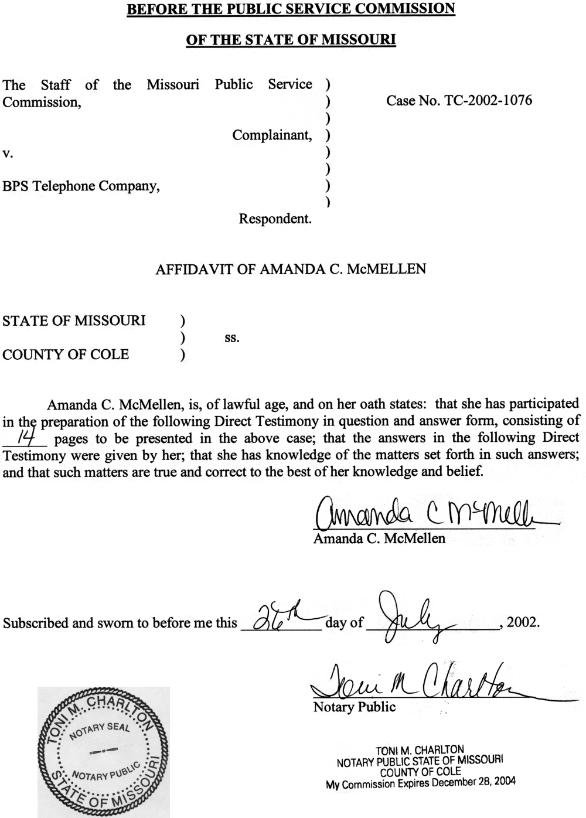
TABLE OF CONTENTS
OF
DIRECT TESTIMONY OF
AMANDA C. McMELLEN

BPS TELEPHONE COMPANY

CASE NO. TC-2002-1076
ACCOUNTING SCHEDULES 3
SEPARATION FACTORS 6
PLANT IN SERVICE & DEPRECIATION RESERVE 7
REVENUES 8
PAYROLL AND PAYROLL RELATED BENEFITS 9
OTHER EXPENSES 10

DIRECT TESTIMONY
OF
AMANDA C. McMELLEN

BPS TELEPHONE COMPANY
CASE NO. TC-2002-1076
Q. Please state your name and business address.
A. Amanda C. McMellen, PO Box 360, Suite 440, Jefferson City, MO 65102.
Q. By whom are you employed and in what capacity?
A. I am a Regulatory Auditor for the Missouri Public Service Commission (Commission or PSC).
Q. Please describe your educational and employment background.
A. I graduated from DeVry Institute of Technology in June 1998, with a Bachelors of Science degree in Accounting. I commenced employment with the Commission Staff (Staff) in June 1999.
Q. What has been the nature of your duties while employed by the Commission?
A. I am responsible for assisting in the audits and examinations of the books and records of utility companies operating within the state of Missouri.
Q. Have you previously filed testimony before this Commission?
A. Yes, I have. Please refer to Schedule 1, which is attached to this direct testimony, for a list of cases in which I have previously filed testimony.
Q. Have you made an investigation or study of the books and records of the BPS Telephone Company (Company or BPS) in Case No. TC-2002-1076?
A. Yes I have, along with the assistance of other members of the Staff.
Q. What is the purpose of your testimony?
A. The purpose of this testimony is to discuss the results of the Staff’s earnings investigation of BPS.
Q. What test year did the Staff utilize in this proceeding?
A. The Staff utilized a test year of the 12 months ending December 31, 2001.
Q. Would you please describe a test year and how it is used?
A. The test year is a 12 month period, which is used as the basis for the audit of any rate filing or complaint case. This period serves as the starting point for review and analysis of the utility’s operations to determine the reasonableness and appropriateness of the rate filing. The test year forms the basis for any adjustments necessary to remove abnormalities that have occurred during the period and to reflect any increase or decrease to the accounts of the utility. Adjustments are made to the test year level of revenues, expenses and investment to determine the proper level of investment on which the utility is allowed to earn a return. After the recommended rate of return is determined for the utility, a review of existing rates is made to determine if any additional revenues are necessary. If the utility’s earnings are deficient, rates need to be increased. In some cases, existing rates generate earnings in excess of recommended levels, which may indicate the need for rate reductions. The test year is the vehicle used to evaluate and determine the proper relationship between revenue, expense and investment. This relationship is essential to determine the appropriate level of earnings for the utility.
Q. Why did the Staff recommend a test year of the 12 months ended December 31, 2001?
A. The December 31, 2001, test year represents the latest information available to the Staff during the entire course of the audit.
Q. What Accounting Schedules are you sponsoring?
A. I am sponsoring the following Accounting Schedules:
Accounting Schedule 1 – Revenue Requirement
Accounting Schedule 2 – Rate Base
Accounting Schedule 3 – Plant in Service
Accounting Schedule 4 – Adjustments to Total Plant
Accounting Schedule 5 – Depreciation Expense
Accounting Schedule 6 – Depreciation Reserve
Accounting Schedule 7 – Adjustments to Depreciation Reserve
Accounting Schedule 8 – Income Statement
Accounting Schedule 9 – Adjustments to Income Statement
Accounting Schedule 10 – Income Tax
Q. What Accounting adjustments are you sponsoring?
A. I am sponsoring the following Income Statement adjustments:
Plant in Service P-1.1
Depreciation Reserve R-1.1
Current Income Tax S-1.1
Depreciation Expense S-2.1
Revenues S-3.1, S-3.2, S-4.1, S-6.1, S-7.1
Dues S-5.1
Donations S-5.2
Customer Deposits S-5.3
Payroll S-5.4
Payroll Benefits S-5.5
PSC Assessment S-8.1
Property Taxes S-9.1
Cost of Removal and Salvage S-10.1

ACCOUNTING SCHEDULES
Q. Please explain Accounting Schedule 1.
A. Accounting Schedule 1 is the Staff revenue requirement calculated at the rate of return sponsored by Staff witness David Murray of the Financial Analysis Department.
Q. Please describe Accounting Schedule 2, Rate Base.
A. Accounting Schedule 2 takes the Company’s adjusted jurisdictional plant in service balance from Accounting Schedule 3, Total Plant in Service, and deducts the Company’s adjusted jurisdictional depreciation reserve from Accounting Schedule 6, Depreciation Reserve, to compute the net plant in service. Added to net plant in service are amounts for materials and supplies and prepaid expenses. Rate base deductions include deferred income taxes and customer deposits. The mathematical total of these items is the Rate Base amount incorporated in the Gross Revenue Requirement recommendation shown on Accounting Schedule 1, Revenue Requirement, discussed earlier in this testimony.
Q. Please describe the items added to net plant in service on Accounting Schedule 2.
A. Materials and Supplies and Prepaid Expenses are represented by 13 month averages. Due to the cyclical nature of these two items, 13 month averages are developed to smooth out seasonal variances.
Q. Please describe the items deducted from net plant in service on Accounting Schedule 2.
A. The amount for Deferred Income Taxes is the year ending December 31, 2001, balance plus the unamortized deferred income tax balance as ordered by the Commission in Case No. TM-95-135. Customer Deposits is represented by a 13 month average. Due to the cyclical nature of this item, a 13 month average is developed to smooth out seasonal variances.
Q. Please explain Accounting Schedule 3.
A. Accounting Schedule 3, Total Plant in Service, lists in Column B BPS’s total Company plant balances as of December 31, 2001. Column D lists the Missouri jurisdictional plant separation factors. (The separation factors were developed from the most recent cost study provided by the Company and discussed in detail below.) Column F contains the Staff’s Missouri-adjusted jurisdictional plant in service balances.
Q. Please explain Accounting Schedule 4.
A. Accounting Schedule 4, Adjustments to Total Plant, details the Staff’s individual adjustments to total Company plant in service, which are listed in Column C of Accounting Schedule 3.
Q. Please explain Accounting Schedule 5.
A. Accounting Schedule 5, Depreciation Expense, lists in Column B the Missouri-adjusted jurisdictional plant in service balances from Accounting Schedule 3, Column F. Column C contains the depreciation rates proposed by Staff witness Paul W. Adam of the Engineering and Management Services Department. The rates in Column C are then applied to the plant balances in Column B to determine the annualized level of depreciation expense that appears in Column D.
Q. Please explain Accounting Schedule 6.
A. Accounting Schedule 6, Depreciation Reserve, lists in Column B BPS’s total Company depreciation reserve balances as of December 31, 2001. Column D lists the Missouri jurisdictional reserve separation factors. (Again, these factors were developed from the cost study referred to earlier.) Column F contains the Staff’s Missouri-adjusted jurisdictional depreciation reserve balances.
Q. Please explain Accounting Schedule 7.
A. Accounting Schedule 7, Adjustments to Depreciation Reserve, details the Staff’s individual adjustments to total Company depreciation reserve, which are listed in Column C of Accounting Schedule 6.
Q. Please explain Accounting Schedule 8, Income Statement.
A. Accounting Schedule 8 is the Income Statement for the test year ending December 31, 2001. Each adjustment amount listed on the Income Statement is a summary of adjustments itemized on the Accounting Schedule 9.
Q. Please explain Accounting Schedule 9.
A. Accounting Schedule 9, Adjustments to Income Statement, contains a listing of the Staff’s adjustments to the Income Statement along with a brief description of each adjustment.
Q. Please explain Accounting Schedule 10.
A. Accounting Schedule 10, Income Tax, reflects the Staff’s calculation of current and deferred income taxes based on the adjusted net operating income before taxes (NOIBT) taken from Column F, Accounting Schedule 8, Income Statement. I will discuss the various details concerning the income tax calculation later in this testimony.

SEPARATION FACTORS
Q. What is the separations process?
A. The separations process is based on the cost study procedures prescribed by the Federal Communications Commission (FCC) in Part 36 of its rules. The intent of the Part 36 rules is to apportion telecommunication property costs, revenues, expenses, taxes and accumulated reserves between the interstate and intrastate jurisdictions for the purpose of obtaining cost recovery in the interstate jurisdiction. This Commission has regulatory authority over a telephone company’s intrastate operations while the FCC is the jurisdictional authority responsible for cost recovery of a telephone company’s interstate costs. A telephone company is classified as either an “average schedule” or a “cost” company. These classifications define how a company recovers its interstate access costs in the interstate jurisdiction. A cost company receives interstate settlements based on a company’s actual costs as determined by a Part 36 cost study. In turn, an average schedule company recovers its interstate costs on the basis of an “average schedule” cost study rather than specific individual company studies. Average schedule formulas for the Universal Service Fund (USF) are developed by the National Exchange Carrier Association (NECA) annually and submitted to the FCC for approval based on analysis of a national sample of cost study companies. The approved average schedule formulas are then applied by the “average schedule” company to recover their interstate costs
Q. For separations purposes, is BPS a cost or average schedule company?
A. BPS is a cost company for interstate settlement purposes.
Q. What was the source of the Staff's separations factors?
A. The Staff used separations factors taken from the Company's 2001 Annual Separations Study.
Q. Did the Staff make any adjustments to these separation factors?
A. No.

PLANT IN SERVICE & DEPRECIATION RESERVE
Q. Please explain Plant adjustment P-1.1.
A. Adjustment P-1.1 is to adjust test year ending total plant in service balances at December 31, 2001, to exclude plant associated with non-regulated operations.
Q. Please explain Reserve adjustment R-1.1.
A. Adjustment R-1.1 is to adjust test year ending total reserve balances at December 31, 2001, to exclude reserve for plant associated with non-regulated operations.

REVENUES
Q. Please explain adjustment Income Statement S-3.1.
A. Adjustment S-3.1 eliminates Switched Access interstate test year revenues.
Q. Please explain adjustment S-3.2.
A. Adjustment S-3.2 annualizes the USF revenues received by BPS from the NECA.
Q. What is the USF?
A. The USF is a fund established in 1983 and administered by NECA to help compensate telephone companies for providing telecommunications services at just and affordable rates in all areas of the country. Data is collected and submitted to NECA by local exchange companies (LECs) as to the amount of each company's actual investment, expenses and taxes. USF provides support for the “last mile” of connection for rural companies in service areas where their cost to provide service exceeds 115% of the national average per access line. Adjustment S-3.2 represents the best estimate of the ongoing level of actual receipts by BPS from the USF.
Q. For ratemaking purposes, how has the Staff traditionally treated USF dollars?
A. The Staff traditionally includes USF payments on a dollar-for-dollar basis in cost of service.
Q. Please explain adjustment S-4.1.
A. Adjustment S-4.1 normalizes intrastate wireless access revenues. This adjustment was calculated using the most current data available. Since there were only nine months of data available, an average was calculated by excluding the high and low amounts, dividing the result by seven, and then multiplying it by 12. The high and low months were excluded, and an average of the remaining months calculated, due to the volatility of this account from month to month.
Q. Please explain adjustment S-7.1.
A. Adjustment S-7.1 is an adjustment to the revenues received by BPS as a result of BPS’s provision of billing and collection services related to interstate revenues. The Staff deducted the test year per books amount to arrive at the adjustment.
Q. Did the Staff adjust local revenues?
A. No. The Staff reviewed local revenues and determined that no adjustment was needed.

PAYROLL AND PAYROLL RELATED BENEFITS
Q. Please explain adjustment S-5.4.
A. Adjustment S-5.4 annualizes payroll and payroll taxes. The calculation was based on the wage rates and employee levels in effect at December 31, 2001. Payroll taxes were calculated by multiplying that portion of all the Company’s employee salaries that were at or under the current tax limits by the current tax rates. This adjustment annualizes the Federal Insurance Contributions Act taxes (FICA or Social Security), Federal Unemployment Taxes (FUTA) and State Unemployment Taxes (SUTA) paid by the Company.
Q. Was overtime expense included in adjustment S-5.4?
A. Yes, overtime was annualized and included in total payroll. An overtime rate was calculated by dividing the total number of overtime hours worked per employee in 2001 by the total amount paid out in overtime in 2001. Then, a three-year (1999 through 2001) average of total overtime hours was calculated. Finally, the overtime rate was multiplied by the three-year average hours to calculate the annualized overtime amount.
Q. Please explain adjustment S-5.5.
A. Adjustment S-5.5 annualizes the employer’s portion of its 401K Savings Plan. This adjustment was calculated by multiplying the Staff’s annualized wage rates by the employer’s contribution percentage. All company employees currently participating in the plan are contributing the minimum amount to receive the company’s maximum contribution.

OTHER EXPENSES
Q. Please explain adjustment S-1.1.
A. Adjustment S-1.1 adjusts book current income taxes to reflect the Staff’s annualized level of revenues and expenses.
Q. How are tax timing differences presented in the Staff’s case?
A. Tax timing differences are represented on Accounting Schedule 10, Income Tax, as additions and/or deductions from NOIBT.
Q. Please explain the additions used to arrive at net taxable income in this case.
A. Annualized book depreciation is added back to NOIBT in order to reflect the gross tax depreciation deduction.
Q. Please list the deductions used to arrive at net taxable income.
A. The deductions are interest expense and book depreciation expense.
Q. Please explain the deduction for interest expense and how it was calculated.
A. Interest expense is calculated by multiplying the jurisdictional rate base by the Staff’s calculated weighted cost of long term debt (1.09%), which is sponsored by Staff witness Murray. This methodology assures that the amount of interest expense used in the calculation of income tax expense, for ratemaking purposes, equals the interest expense the ratepayer is required to provide the Company in rates. Since the revenue requirement recommended by the Staff is based on a rate of return computation, the interest synchronization method described here allows an interest deduction consistent with the rate of return computation that is applied to rate base.
Q. Please explain the deduction for book depreciation expense.
A. Book depreciation expense is the Staff’s calculation of tax book depreciation. This depreciation expense is deductible for income tax purposes and is not required to be normalized for ratemaking purposes.
Q. Please explain adjustment S-2.1.
A. Adjustment S-2.1 adjusts book depreciation expense for the test year ended December 31, 2001, to an annualized level based on Missouri jurisdictional plant in service at December 31, 2001. Annualized depreciation expense is calculated on Accounting Schedule 5 by multiplying the amount in each Missouri jurisdictional plant in service account by the annual depreciation rate for that account. The total annualized depreciation expense, shown on Accounting Schedule 5, is compared to the depreciation expense booked during the test year ended December 31, 2001, and the difference between the two is the amount of the adjustment.
Q. Please explain adjustment S-5.1.
A. Adjustment S-5.1 decreases test year expenses relating to various dues the Company has included in its cost of service. Such dues have been excluded because they are not necessary for the provision of safe and adequate service, and thus do not provide any direct benefit to ratepayers.
Q. Please explain adjustment S-5.2.
A. Adjustment S-5.2 decreases test year expenses relating to various donations the Company has included in its cost of service. Such donations have been excluded because they are not necessary for the provision of safe and adequate service, and thus do not provide any direct benefit to ratepayers. To allow the Company to recover these expenses through rates causes the ratepayer to involuntarily contribute to these organizations.
Q. Please explain adjustment S-8.1.
A. This adjustment normalizes expense for the most current Commission Assessment.
Q. Please explain adjustment S-9.1.
A. Adjustment S-9.1 annualizes property tax expense. This adjustment was calculated by developing a property tax rate to be applied to total telephone plant in service as of December 31, 2001. The property tax rate was developed by dividing the amount of total Company telephone property taxes paid in 2001 by the total Company telephone property (plant in service) assessments as of January 1, 2001. This property tax rate was then applied to total telephone plant in service at December 31, 2001, to arrive at annualized property taxes. The annualized property tax expense was then subtracted from test year property tax expense to arrive at the adjustment.
Q. Please explain adjustment S-10.1.
A. Adjustment S-10.1 annualizes cost of removal and salvage.
Q. What is cost of removal and salvage?
A. Cost of removal is incurred when utility property is retired from service. Generally, removing property from service causes the utility to incur costs to physically dismantle, tear down or otherwise remove the property from service. Salvage is the residual value or scrap value that some property has when it is removed from utility service. After a piece of property is dismantled or removed from service, utilities can, in some instances, sell or receive some value for the displaced property. Utilities track the costs relating to removal and salvage value on an ongoing annual basis. Typically, removal costs exceed salvage value, resulting in a “net negative salvage” value. The net effect of cost of removal and salvage was included in the Staff’s determination of the overall revenue requirement.
Q. How did the Staff determine the proper level of cost of removal and salvage value to include in this case?
A. The staff reviewed the cost of removal and salvage values by year for the period 1996 to 2001 (excluding 1997 because the information was unavailable). Based on this information, the Staff calculated the cost of removal and salvage values based upon a two-year average for the period 2000 through 2001. The result of the two-year average is that BPS incurred net negative salvage value over this period. This amount was included in Adjustment S-10.1.
Q. Why did the Staff use a two-year average to determine the level of cost of removal and salvage value to include in the revenue requirement?
A. Based upon the review of the Company’s cost of removal data, it was determined that there was a downward trend in cost of removal and salvage expenses. The Staff believes that the last two years (2000 and 2001) reflect the Company’s cost of removal and salvage expenses on a going forward basis. Using a two-year average for fluctuating costs, such as the net negative salvage amount, removes or smoothes out the differences from one year to the next. Averaging costs for fluctuations is commonly used in the ratemaking process and is consistent with how other costs have been treated in this case.
Q. Have cost of removal and salvage value been treated this way in prior BPS rate cases?
A. Not to my knowledge. Typically, cost of removal and salvage value is reflected in the overall depreciation rate and thus, an amount for these items was included in depreciation expense. However, recently the Staff has proposed to remove from the depreciation rates the accrual of the removal costs and salvage value. Staff witness Adam is sponsoring the Staff’s position in this case to remove these items from the accrual of depreciation. Consistent with this proposal, the Staff has included the cost of removal and salvage value in the cost of service determination as a current expense item rather than part of the depreciation accrual process.
Q. What were the results of the Staff’s earnings investigation of BPS?
A. The Staff’s revenue requirement shows an excess earnings amount of $898,005. The Staff recommends that the Commission order a revenue reduction for BPS of that amount.
Q. Does this conclude your direct testimony?
A. Yes, it does.
SUMMARY OF RATE CASE TESTIMONY FILED

Amanda C. McMellen

COMPANY CASE NO.

Osage Water Company SR-2000-556

Osage Water Company WR-2000-557

Empire District Electric Company ER-2001-299

UtiliCorp United, Inc./ d/b/a Missouri Public Service ER-2001-672

In the matter of Joint Application of GTE Midwest Incorporated and BPS Telephone Company for the Authority to Transfer and acquire part of GTE Midwest Incorporated Missouri franchise, facilities or system located in the State of Missouri.

