BEFORE THE PUBLIC SERVICE COMMISSION
OF THE STATE OF MISSOURI

In Re: Union Electric Company’s )
Utility Resource Filing Pursuant to ) Case No. EO-2007-0409
4 CSR 240 – Chapter 22 )

REPORT OF THE MISSOURI INDUSTRIAL ENERGY CONSUMERS ON AMERENUE’S INTEGRATED RESOURCE PLAN

Comes now Anheuser-Busch, Boeing, BioKyowa, Chrysler, Doe Run, Enbridge, Explorer Pipeline, General Motors, Hussmann, JW Aluminum, Monsanto, Nestlé Purina, Pfizer, Precoat, Procter & Gamble, Solutia and US Silica, hereafter referred to as the Missouri Industrial Energy Consumers or “MIEC”, and files its comments on AmerenUE’s Integrated Resource Plan (IRP). For its comments, the MIEC states as follows:
1. MIEC representatives participated extensively in the technical forums that AmerenUE conducted in order to explain the development of its IRP. MIEC is appreciative of AmerenUE’s efforts to conduct a comprehensive participatory process as part of its IRP development. Participants were always offered the opportunity to present their views, even if contrary, and AmerenUE was receptive to discussing the merits of its approach and proposals, as well as alternatives. MIEC believes this process has contributed to a much better understanding of the electrical requirements of AmerenUE’s service territory, the options to meet them, and the associated costs. While AmerenUE was receptive to, and made adjustments to its IRP in response to the collaborative sessions, it must be emphasized that AmerenUE alone retains responsibility for the analysis, development and execution of its IRP.
2. MIEC has reservations about the specifics of certain aspects of the IRP, particularly the energy efficiency (EE) programs. This aspect of IRP is largely unchartered territory in the AmerenUE service territory. Estimates of the efficacy of the various EE programs, including costs to implement, marketing techniques, required level of incentives, and customer response are based on experience in other states and may or may not be representative of Missouri customers. These are all critical issues and are matters of first impression in the AmerenUE service territory. Further analysis and development will be required to refine these estimates.
3. An important related concern is the modeling techniques used to estimate the costs avoided by the EE programs and also the revenue lost as a result of customers using less energy. MIEC’s analysis revealed that the models employed by AmerenUE do not accurately calculate the revenue losses resulting from implementation of EE. Consequently, the impact on rates is understated in the Rate Impact Measure (RIM) test calculation. The RIM test is an indication of the impact of a program or measure on the level of rates, and a RIM measure less than 1.0 means that rates will be higher with the program or measure installed than they would be if, instead, new generation was built. Rates that are 3% higher may not be an issue for a program participant who buys 5% less energy as a result of a measure being installed, but clearly is an issue for non-participants because their total costs would increase beyond what they would be if generation had been built. This is an especially critical issue for those customers who have improved their efficiency of use of electricity at their own expense.
4. Lost revenue also is EE program participant electric bill savings, so an inaccurate estimate of participant savings will lead to an erroneous conclusion about the level of incentives that must be paid to customers to induce them to participate in an EE program. Thus, an accurate measure of lost revenue also is critical to program design.
5. MIEC has discussed these concerns with AmerenUE and is satisfied that AmerenUE understands them and is in agreement that there are a number of limitations on the determination of the impact of DSM programs in its service territory and on the calculation of lost revenues. Further, MIEC understands that as part of the development of a marketing program, as well as the Evaluation and Measurement of the DSM programs, AmerenUE will analyze these issues in more detail with the objective of improving its knowledge of these issues.
6. While MIEC would prefer that these issues be clarified and resolved before embarking on expenditures for DSM programs, MIEC recognizes that to a large extent it is necessary to move forward with a certain level of commitment to EE programs in order to actually determine the impact of these programs in the AmerenUE service territory. As a result, while MIEC expresses its reservations about the specifics of the EE programs, it does not assert an objection to or disagreement with the IRP as filed by AmerenUE.
/tmp/in/input.doc

Respectfully submitted,

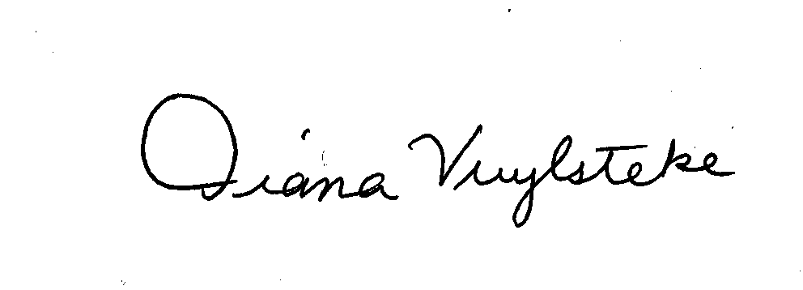
BRYAN CAVE, LLP

By:______________________
Diana M. Vuylsteke, # 42419
211 N. Broadway, Suite 3600
St. Louis, Missouri 63102
Telephone: (314) 259-2543
Facsimile: (314) 259-2020
E-mail: dmvuylsteke@bryancave.com

Attorney for The Missouri Industrial Energy Consumers

CERTIFICATE OF SERVICE

I do hereby certify that a true and correct copy of the foregoing document has been hand-delivered, transmitted by e-mail or mailed, First Class, postage prepaid, this 18th day of June, 2008, to all parties on the Commission’s service list in this case.

______________________________________________

