Exhibit No.:
Issue: Depreciation
Witness: Gregory E. Macias
Sponsoring Party: MoPSC Staff
Type of Exhibit: Rebuttal Testimony
Case Nos.: WR-2003-0500 AND
WC-2004-0168
Date Testimony Prepared: November 10, 2003

MISSOURI PUBLIC SERVICE COMMISSION

UTILITY SERVICES DIVISION

REBUTTAL TESTIMONY

OF

GREGORY E. MACIAS

MISSOURI-AMERICAN WATER COMPANY

CASE NOS. WR-2003-0500 AND WC-2004-0168

Jefferson City, Missouri
November 2003
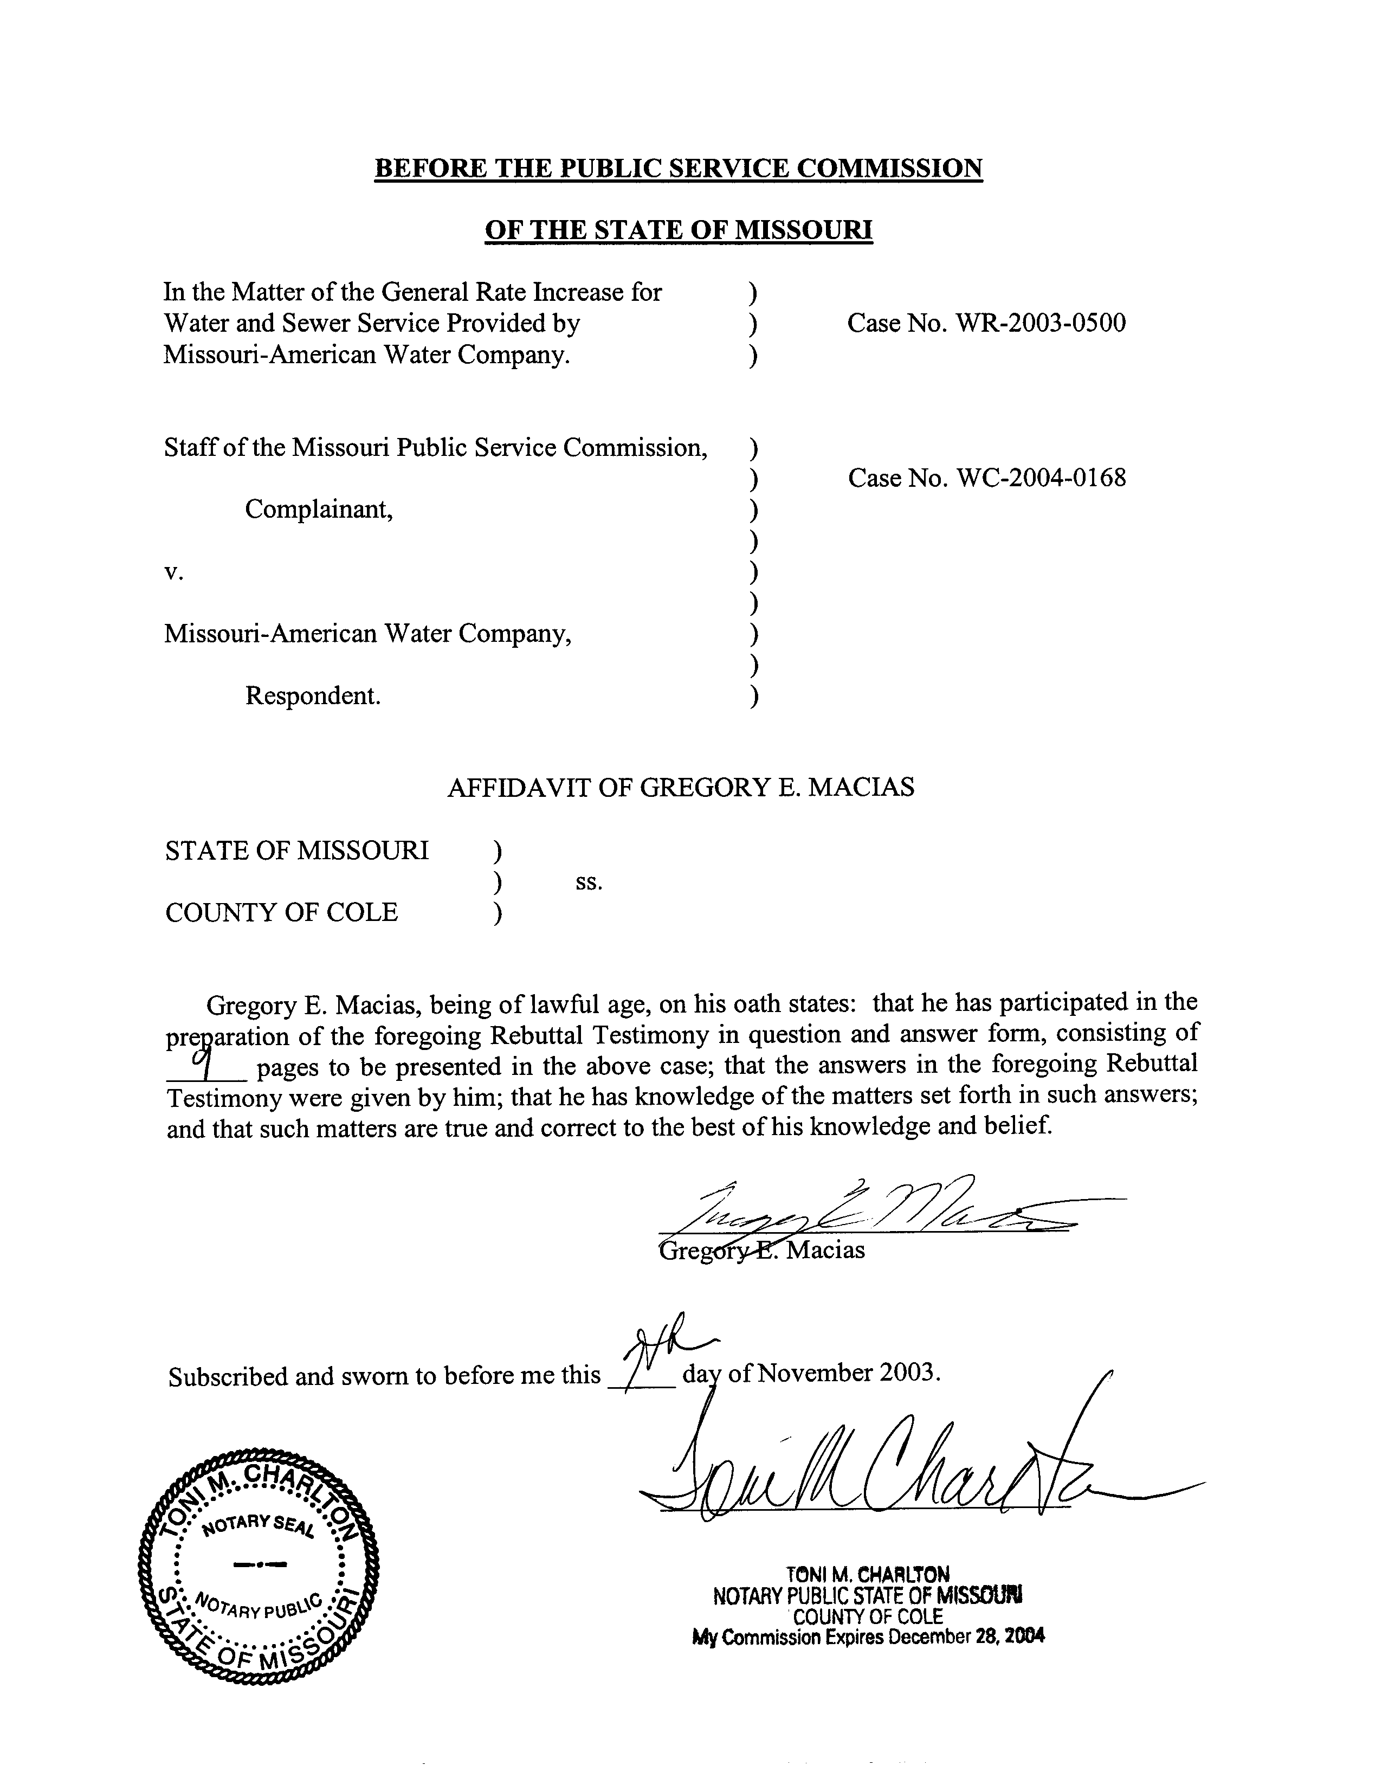
TABLE OF CONTENTS
REBUTTAL TESTIMONY OF
GREGORY E. MACIAS
CASE NOS. WR-2003-0500 AND WC-2004-0168
COST OF REMOVAL AND GROSS SALVAGE 3
REMAINING LIFE DEPRECIATION RATES 6
AVERAGE SERVICE LIFE (ASL) 8

REBUTTAL TESTIMONY
OF
GREGORY E. MACIAS
MISSOURI-AMERICAN WATER COMPANY
CASE NOS. WR-2003-0500 AND WC-2004-0168

Q. Please state your name and business address.
A. Gregory E. Macias, P.O. Box 360, Jefferson City, MO 65201.
Q. By whom are you employed and in what capacity?
A. I am employed by the Missouri Public Service Commission (PSC or Commission) as a Utility Engineering Specialist II in the Engineering and Management Services Department.
Q. Are you the same Gregory E. Macias who filed direct testimony on behalf of the Staff of the Missouri Public Service Commission in this case?
A. Yes.
Q. What is the purpose of your testimony?
A. The purpose of my testimony is to present the Staff’s rebuttal to Missouri-American Water Company (MAWC or Company) witness John J. Spanos.
Q. What issues will you address?
A. I will address the following issues as they relate to the MAWC districts of Brunswick, Joplin, Mexico, Parkville, St. Charles, St. Joseph and Warrensburg (Missouri-American districts) capital plant accounts: 1) the calculation of cost of removal and gross salvage; 2) the use of the remaining life technique to determine the depreciation rate; and 3) the determination of average service life (ASL).

COST OF REMOVAL AND GROSS SALVAGE
Q. Could you please define cost of removal and gross salvage?
A. Cost of removal is the cost associated with the retirement from service and disposition of depreciable plant. Gross salvage is the recovered marketable value of retired plant. In many cases the cost to remove plant from service exceeds the gross salvage value of the plant that is retired.
Q. What specific aspect of Mr. Spanos’ testimony regarding cost of removal and gross salvage do you disagree with?
A. I disagree with Mr. Spanos’ position of collecting future, unknown, cost of removal and gross salvage in the annual depreciation accrual, and with his method of calculating future cost of removal and gross salvage.
Q. How are cost of removal and gross salvage calculated in Mr. Spanos’ depreciation study?
A. Historical data is used to calculate a ratio of the current cost of removal amount divided by the original cost of plant associated with regular retirements in a year (cost of removal percent) and a ratio of the current gross salvage amount divided by the original cost of plant associated with regular retirements in the same year (gross salvage percent). The gross salvage percent less the cost of removal percent is the net salvage percent experienced in that year.
The Company proposes to use the cost of removal and gross salvage percentages for the past 15 years as a basis for predicting the cost of removal and gross salvage that will be experienced by current plant in service for decades into the future. It is important to understand that these ratios are calculated from retirements of plant that were placed in service anywhere from one year to 122 years ago.
Q. What is the significance of the age of the retirements with respect to the Company’s proposed method?
A. The Company’s method compares the original cost of plant that was placed in service between the years 1880 and 2002, to the cost of removal and gross salvage experienced for the years 1987 to 2002. This comparison of retired plant dollars (from one to 122 years old) to cost of removal and salvage dollars (within 15 years) is used to forecast future, unknown cost of removal and gross salvage. The use of this method implies that for plant placed in service today, the cost of removal and gross salvage can be accurately predicted over 100 years into the future.
Developing cost of removal and gross salvage percentages by comparing relatively recent cost of removal and gross salvage amounts to the original cost of retired plant amounts as old as 122 years, produces net salvage percentages as high as 60%. To clarify, the Company is proposing to collect as much as an additional 60% of the original cost of plant in service for cost of removal less gross salvage.
Q. What other concerns do you have with the Company’s formula for calculating future cost of removal and gross salvage?
A. My concern is that this formula is not substantiated by empirical evidence and the Company provides no evidence of the formula’s accuracy. Furthermore, I am not aware of any report or study establishing that the cost of removal and gross salvage many decades into the future can be accurately determined using this method.
Q. Doesn’t it seem reasonable, disregarding the lack of any empirical evidence, that the percentage of the cost of removal and gross salvage will be relatively constant far into the future?
A. No. Distant future events such as the compound rate of inflation, environmental regulations, and technological advances cannot be predicted, nor can it be assumed that historical patterns will be consistently repeated.
Additionally, future practices may not necessitate the removal of plant in the same manner as today. Retired plant could be sold or abandoned in place. There is no assurance that plant will in fact be removed or that the Company will actually experience any cost of removal or gross salvage. It is not appropriate to increase depreciation rates to allow the Company to build up large reserves for costs it may or may not experience, at some unspecified date, far into the future.
Q. Given that the future cost of removal and gross salvage formula proposed by MAWC is inappropriate for ratemaking, what is the Staff’s position on the collection of monies that the Company should collect in rates for cost of removal and gross salvage?
A. The Company should collect in rates the costs associated with the removal of plant after its useful life. Because these costs are unknown until the plant has been retired, dismantled and discarded or sold, the Staff’s position is to allow the Company to collect the cost of removal less gross salvage based on the Company’s recent historical costs. The amount that the Staff believes is appropriate based on this position was presented in the direct testimony of Staff witness Edward J. Began.
Q. What other benefits does Staff’s method provide to the Company and ratepayers?
A. This method reduces the risk that customers will overpay for the future, unknown, cost of removal that may or may not be experienced. Staff’s method also relieves future Company management from the burden of collecting less money in rates than the cost of removal less gross salvage at some time in the future.
Q. What do you mean by collecting less money in rates than the cost of removal less gross salvage in the future?
A. If the Company is collecting more money in rates for cost of removal today than is being spent, as the Company is proposing (building reserves), then there will be a point in the future when the Company must collect less money in rates for cost of removal than is required (deducting from reserves), if the intention is to only collect the amount of money necessary to retire and remove plant. There in no indication that the Company is retaining the customer-supplied cash until the time it will be needed.

REMAINING LIFE DEPRECIATION RATES
Q. Would you explain your disagreement with Mr. Spanos’ use of the remaining life method of adjustment?
A. There are three points of disagreement. First, the remaining life formula as used by the Company has future, unknown, cost of removal and gross salvage incorporated into the depreciation rate. The Staff has established the position that the current cost of removal and gross salvage should be collected in expense, and therefore no consideration should be given to cost of removal and gross salvage in the depreciation rate. Second, there is an adjustment for the accrued reserve inherent in the remaining life formula, which the Staff does not believe is warranted at this time. Third, the Company has not provided any reasons for switching from the whole life technique – which is the basis for the Company’s currently ordered rates – to the remaining life method of adjustment.
Q. Please explain further your second point of disagreement regarding the inherent adjustment for the accrued depreciation reserve.
A. The remaining life formula adjusts for an excess or deficiency of the accrued depreciation reserve over the remaining life of the current plant in service. It would be inappropriate at this time to adjust the accrued depreciation reserve associated with recovery of the original cost of plant in service because a reliable estimate of an excess or deficiency of the reserve is not possible given the condition of the Company’s depreciation database.
Q. What prevents the Company’s depreciation database from estimating a depreciation reserve adjustment?
A. Problems with the Company’s data were discussed extensively in my direct testimony. The Company apparently combined the data from the Missouri-American districts into one database for analysis. This database contains the errors that became apparent in the individual district’s databases when reviewed by the Staff. Those errors, such as the Joplin and St. Joseph districts’ accounts with no retirements posted for over 100 years, were identified in my direct testimony.
Q. Please explain your third point of disagreement with MAWC’s proposal to switch from the whole life technique.
A. The Company has not demonstrated a compelling reason for a change from the whole life technique to the remaining life method of adjustment. The Company has not shown that the whole life technique is inadequate to recover the original cost of its investment in plant. In addition, the Company has not shown that the accrued depreciation reserve associated with recovery of original cost is either excessive or deficient and in need of correction.
Q. Has the Commission ever ordered depreciation rates based on the remaining life method of adjustment for a water utility in the past?
A. No. The Commission has only granted the use of remaining life depreciation rates to telephone utilities. Remaining life was adopted for telephone utilities as a way to address the rapid change in technology in that industry.

AVERAGE SERVICE LIFE (ASL)
Q. Your final rebuttal topic is Mr. Spanos’ determination of average service life (ASL) for the Missouri-American district’s capital plant accounts. Please explain your disagreement with his ASL determinations.
A. My disagreement with Mr. Spanos’ ASL determinations for the Missouri-American districts is based on the condition of the Company’s depreciation database, as previously discussed. I believe that the errors and omissions present in the data preclude an ASL determination for the plant in service at the Missouri-American districts.
Also, the survivor curve presentations in Mr. Spanos’ depreciation study exclude some of the calculated survivor determinations. Mr. Spanos does not note these exclusions from the original survivor curve, nor does he provide any justification for these exclusions.
Q. Could you please provide an example?
A. Yes, Schedule 1 shows a comparison of the graphical presentation of account 331.00 - Transmission and Distribution Mains from Mr. Spanos’ depreciation study (company exhibit JJS-1 page III-68) with data points eliminated (Schedule 1-1), and the same analysis showing all data points (Schedule 1-2). Mr. Spanos chose an Iowa 90-R2.5 survivor curve to smooth the data. The Iowa 90-R2.5 smooth survivor curve suggests that at age 100 years, 40% of plant is surviving. However, the graph showing all data points (Schedule 1-2) demonstrates that this is not the case for account 331.00. Mr. Spanos provides the original life table for account 331.00 that shows at age 100 years there is approximately 85% of plant surviving (company exhibit JJS-1 page III-71). Mr. Spanos did not provide an explanation in either his testimony or his depreciation study for ignoring these data points or for the omission of these points from the plot of the original survivor curve.
Q. Is account 331.00 the only account with original survivor curve points omitted?
A. No, every account presented in Company exhibit JJS-1 has had points omitted from the original survivor curve except account 310.20 – Boiler Plant Equipment. Mr. Spanos did not provide an explanation for omissions of points from the original survivor curves for any of the accounts.
Q. What has the Staff proposed as an alternative?
A. I believe the use of surrogate depreciation rates is appropriate for the Missouri-American districts. This use of a surrogate was discussed in my direct testimony.
Q. Does this conclude your rebuttal testimony?
A. Yes.

