Exhibit No.:
Issues: Capacity Release

Witness: Thomas M. Imhoff

Sponsoring Party: MoPSC Staff
Type of Exhibit: Testimony
Case No.: GT-2003-0034
Date Testimony Prepared: September 24, 2002

MISSOURI PUBLIC SERVICE COMMISSION

Utility Operations DIVISION

TESTIMONY

OF

THOMAS M. IMHOFF

union electric company
d/b/a amerenue

CASE NO. GT-2003-0034

Jefferson City, Missouri
September, 2002

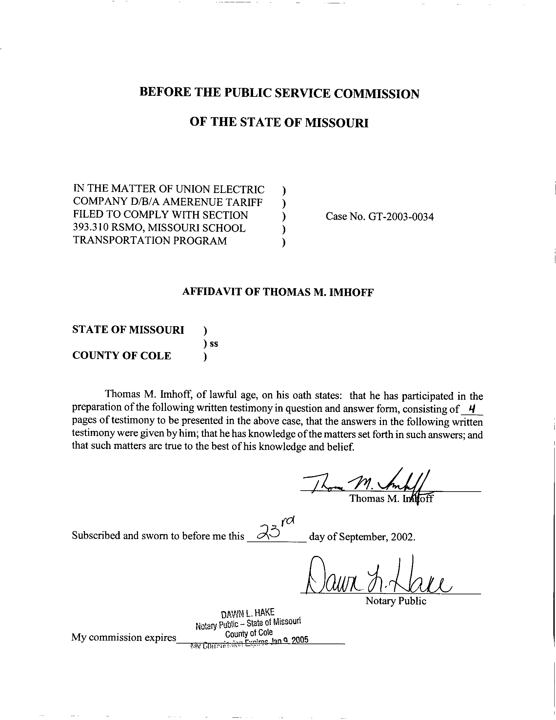
TESTIMONY
OF
THOMAS M. IMHOFF
UNION ELECTRIC COMPANY d/b/a AMEREN UE
CASE NO. GT-2003-0034
Q. Please state your name and business address.
A. Thomas M. Imhoff, P.O. Box 360, Jefferson City, Missouri 65102.
Q. By whom are you employed and in what capacity?
A. I am a Rate & Tariff Examination Supervisor with the Missouri Public Service Commission (Commission).
Q. Please describe your educational background.
A. I attended Southwest Missouri State University in Springfield, Missouri, where I received a Bachelor of Science degree in Business Administration, with a major in Accounting, in May 1981. In May 1987, I successfully completed the Uniform Certified Public Accountant (CPA) examination and subsequently received the CPA certificate. I am currently licensed as a CPA in the State of Missouri.
Q. What has been the nature of your duties with the Commission?
A. From October 1981 to December 1997, I worked in the Accounting Department of the Commission, where my duties consisted of directing and assisting with various audits and examinations of the books and records of public utilities operating within the State of Missouri under the jurisdiction of the Commission. On January 5, 1998, I assumed the position of Regulatory Auditor IV in the Gas Tariffs/Rate Design Department, where my duties consisted of analyzing applications, reviewing tariffs and making recommendations based upon those evaluations. On August 9, 2001, I assumed the position of Rate & Tariff Examination Supervisor in the Energy Tariffs/Rate Design Department (Department), where my duties consist of directing Commission Staff (Staff) within the Department, analyzing applications, reviewing tariffs, and making recommendations based upon my evaluations and the evaluations performed by Staff within the Department.
Q. Have you previously filed testimony before this Commission?
A. Yes. A list of cases in which I have filed testimony before this Commission is attached as Schedule 1 to my direct testimony.
Q. With reference to Case No. GT-2003-0034, have you made an examination and study of the material filed by Union Electric Company d/b/a Ameren UE (Ameren or Company) relating to its proposed school aggregation tariffs?
A. Yes, I have.
Q. What is the purpose of your testimony?
A. The purpose of my testimony is to present the Staff’s position relating to the treatment of capacity reservation for the experimental school district aggregation program (Program).

CAPACITY RESERVATION
Q. What is the Staff’s position regarding capacity reservation as it relates to the Program?
A. The Staff’s position regarding the capacity reservation for the Program is that it allows participants to operate the same as other transportation customers, with the exception of rates. I will discuss the transportation costs later in my testimony. Capacity currently used to supply the participating schools should be made available, in a workable manner, to the school aggregator participating in the program consistent with the requirements of section 393.310 RSMo.
Q. How should Ameren release its firm interstate pipeline transportation capacity to participants of the Program?
A. Ameren should release firm interstate pipeline transportation capacity on a temporary basis to participants of the program. Ameren should not recall the capacity unless specifically requested by a participant in the Program. The capacity release shall last during the term of the experimental tariff, unless mutually terminated by agreement of both parties prior to the expiration of the tariff. The release of the capacity should be for a period of one-year with annual notifications by the school aggregator to the Company indicating if they wish to continue using the released capacity. The release should be performed in accordance with the capacity release procedures and policies contained in the applicable interstate pipeline’s Federal Energy Regulatory Commission (FERC) approved tariff. In the event multiple pipelines can serve participants of the Program, the allocation for the release of capacity to these participants should be equivalent to the percentage of capacity Ameren uses to provide gas to its customers before the start of the program.
Q. What should be the cost of transportation to the participants of the Program?
A. Ameren should charge it’s overall cost of transportation to participants of the Program. If the release of the capacity is at a higher price than Ameren’s cost, the participants of the Program should be responsible for that cost, and the revenues received from the capacity release shall be credited to transportation cost through the PGA. Staff believes that FERC capacity release rules do not allow return of the difference between Ameren’s actual cost and the capacity release price to the school aggregator. If the release of the capacity is a lower price than Ameren’s cost, the participants of the Program should pay the balance of Ameren’s cost for capacity. This would ensure “no detriment” to Ameren’s firm customers.
Q. Does this conclude your testimony?
A. Yes it does.
Terre-Du-Lac Utilities SR-82-69
Terre-Du-Lac Utilities WR-82-70
Bowling Green Gas Company GR-82-104
Atlas Mobilfone Inc. TR-82-123
Missouri Edison Company GR-82-197
Missouri Edison Company ER-82-198
Great River Gas Company GR-82-235
Citizens Electric Company ER-83-61
General Telephone Company of the Midwest TR-83-164
Missouri Telephone Company TR-83-334
Mobilpage Inc. TR-83-350
Union Electric Company ER-84-168
Missouri-American Water Company WR-85-16
Great River Gas Company GR-85-136
Grand River Mutual Telephone Company TR-85-242
ALLTEL Missouri, Inc. TR-86-14
Continental Telephone Company TR-86-55
General Telephone Company of the Midwest TC-87-57
St. Joseph Light & Power Company GR-88-115
St. Joseph Light & Power Company HR-88-116
Camelot Utilities, Inc. WA-89-1
GTE North Incorporated TR-89-182
The Empire District Electric Company ER-90-138
Capital Utilities, Inc. SA-90-224
St. Joseph Light & Power Company EA-90-252
Kansas City Power & Light Company EA-90-252
Sho-Me Power Corporation ER-91-298
St. Joseph Light & Power Company EC-92-214
St. Joseph Light & Power Company ER-93-41
St. Joseph Light & Power Company GR-93-42
Citizens Telephone Company TR-93-268
The Empire District Electric Company ER-94-174
Missouri-American Water Company WR-95-205
Missouri-American Water Company SR-95-206
Union Electric Company EM-96-149
The Empire District Electric Company ER-97-81
Missouri Gas Energy GR-98-140
Laclede Gas Company GR-98-374
Laclede Gas Company GR-99-315
Atmos Energy Corporation GM-2000-312
Ameren UE GR-2000-512
Missouri Gas Energy GR-2001-292
Laclede Gas Company GT-2001-329
Laclede Gas Company GR-2001-629
Missouri Gas Energy GT-2003-0033
Aquila Networks – L&P GT-2003-0038
Aquila Networks – MPS GT-2003-0039
Southern Missouri Gas Company, L.P. GT-2003-0031
Fidelity Natural Gas, Inc. GT-2003-0036
Atmos Energy Corporation GT-2003-0037
Laclede Gas Company GT-2003-0032

