BEFORE THE PUBLIC SERVICE COMMISSION
OF THE STATE OF MISSOURI

In the Matter of the Application of Grain Belt Express )
Clean Line LLC for a Certificate of Convenience and )
Necessity Authorizing it to Construct, Own, Operate, )
Control, Manage, and Maintain a High Voltage, Direct ) Case No. EA-2016-0358
Current Transmission Line and an Associated Converter )
Station Providing an interconnection on the Maywood- )
Montgomery 345 kV Transmission Line )

MOTION FOR EXPEDITED TREATMENT AND MOTION TO DISMISS
APPLICATION, OR ALTERNATIVELY, TO HOLD CASE IN ABAYANCE

Comes now the Missouri Landowners Alliance (MLA), pursuant to Rules 4 CSR 240-2.116(4) and 240-2.080(14) , and for the reasons set forth below respectfully requests that the Commission dismiss the Application filed in this case by Grain Belt Express (Grain Belt) on August 30, 2016, or failing that, to hold this case in abeyance for a period not to exceed six months, as discussed below. In support of this Motion, the MLA states as follows:
Earlier today the Western District of the Missouri Court of Appeals issued a decision on the appeal of the ATXI case, decided by the Commission on April 27, 2016 in Case No. EA-2015-0146. In that case, over the objection of a landowners group, the Commission issued a CCN to ATXI, conditioned on ATXI subsequently obtaining the necessary County Commission consents pursuant to Section 229.100. (Report and Order, p. 38 et seq.)
A copy of the Opinion from the Court of Appeals in the ATXI case is attached. Whether or not one agrees with the Court’s decision, it ruled in no uncertain terms that the Commission cannot issue a CCN conditioned upon subsequent receipt of the County Commission consents pursuant to Section 229.100. All of the necessary county receipts must be obtained and filed with the Commission before any CCN may be issued.
Key findings and conclusions from the Court of Appeals included the following:
Citing Section 393.170.2 and Commission Rule 4 CSR 240-3.105(1)(D)1, the Court stated as follows: “By statute and by rule, the PSC is authorized to issue a CCN only after the applicant has submitted evidence satisfactory to the PSC that the consent or franchise has been secured by the public utility. Neither statute nor rule authorizes the PSC to issue a CCN before the applicant has obtained the required consent or franchise. (Opinion, p. 6; emphasis by the Court)

Accordingly, county commission assents required by section 229.100 and 4 CSR 240-3.105(1)(D)(1) must be submitted to the PSC before the PSC grants a CCN. (Opinion, p. 8; emphasis by the Court)

The PSC’s issuance of a CCN contingent on ATXI’s subsequent provision of required county commission assents was unlawful as it exceeded the PSC’s statutory authority. (Id.)

The PSC’s Report and Order is vacated as it was entered in excess of the PSC’s statutory authority. (Opinion, p. 9)

In the present case, no party is contesting the fact that Grain Belt does not have a currently effective franchise from the County Commission of Caldwell County. In addition, at the appropriate time the MLA expects to also argue that several of the other county commission consents have since been rescinded. Regardless of the merits of that latter claim, pursuant to the attached Opinion of the Court of Appeals, the Commission may not issue a CCN to Grain Belt, due to the lack of consent from Caldwell County. Any such Order from the Commission would undoubtedly be vacated on appeal, for the same reasons stated in the ATXI opinion.
The Commission rule cited by the Court of Appeals provides that “If any of the items required under this rule are unavailable at the time the application is filed, they shall be furnished prior to the granting of the authority sought.” Here, the evidentiary record is now closed, and if Grain Belt had successfully acquired the franchise from the Caldwell County Commission it was incumbent upon them to present that evidence while the other parties still had the opportunity to review and possibly contest the validity of any new document purporting to meet the requirement of Section 229.100.
Because Grain Belt has failed to provide all of the evidence required by statute to support the issuance of a CCN, at this point the MLA submits that the Commission should in all fairness simply dismiss Grain Belt’s Application for a CCN. It has failed, once again, to meet its burden of proof on each of the elements needed for the issuance of the CCN.
If the Commission nevertheless decides not to dismiss the Application, at a minimum this case should immediately be held in abeyance until Grain Belt provides a valid consent from the Caldwell County Commission pursuant to Section 229.100. For all we know at this point, that consent may never be forthcoming. Grain Belt’s earlier franchise from Caldwell County was voided by the Circuit Court on October 7, 2015 – or nearly a year and a half ago. If Grain Belt has been unsuccessful in securing a new franchise during that time, there is no reason to believe it will be able to secure one at any time in the near future. Thus it makes little sense to require the parties to spend the next three weeks in writing briefs that in effect may never be of any consequence, or for the Commission to digest those briefs and then issue an Order which will not now and may never have any effect.
Given the time that Grain Belt already has had to secure the necessary consent from the Caldwell County Commission, the MLA respectfully submits that this case be held in abeyance for no more than six months. If by that point Grain Belt has not obtained the needed permission from Caldwell County, then the case should be dismissed. The people of the eight counties in question have had the threat of the Grain Belt project looming over their heads for some five years now. The Commission should not allow that situation to continue for some indefinite period of time while Grain Belt attempts to do what it should have been doing for the past year and a half. The people of northern Missouri deserve better than that.
Until all of the necessary county consents are obtained, the Commission not only is prohibited from issuing a conditional CCN, but it is also unable to issue a report of some sort explaining what it would have decided on the merits of the CCN case if Grain Belt had secured the necessary county approvals. Doing so would amount to a mere “advisory” opinion from the Commission. But the same rule traditionally applied to the courts of this state applies as well to the Commission: it cannot issue such opinions. As stated in its Order Directing Filing, issued on January 23, 2013 in Case No. EO-2013-0359
The Commission cannot issue an advisory opinion. The function of [the Commission and reviewing courts] is to resolve disputes properly presented by real parties in interest with existing adversary positions. The Commission should not issue decisions with no practical effect and that are only advisory as to future, hypothetical situations. A request for relief in an administrative action must present a real, substantial, presently existing controversy admitting of specific relief as distinguished from an adevisory or hypothetical situation. (footnotes, internal quotation marks and citations omitted)

Here, unless and until Grain Belt secures the consent at least of the Caldwell County Commission, this Commission has no authority to issue a CCN, conditional or otherwise. Thus any pronouncements on the merits of the other issues presented to the commission in this case would amount to no more than advisory opinions as to what the Commission might have done if had the authority to do what it cannot do.
Grain Belt was obligated to provide all of the needed consents before it could lawfully expect the Commission to issue the CCN. It has failed to do so, and thus the opposing parties should not be required to expend their time and efforts in going forward with a case which at this point is effectively moot.
Pursuant to Rule 4 CSR 240-2.080(14) regarding requests for expedited treatment, the MLA respectfully asks that the Commission act on this Motion at its earliest possible convenience, but no later than April 3, 2017 (7 days before the initial briefs are due). By acting on this Motion before the initial briefs must be filed, the Commission would help to minimize the time and effort expended by the parties in writing those briefs, and the Commission’s time in reading at least a dozen briefs from the various parties. The MLA further states that it filed this Motion promptly after the attached decision was issued by the Court of Appeals.
WHEREFORE, for the reasons stated above, the MLA respectfully asks the Commission to immediately dismiss the Application filed in this case by Grain Belt on August 30, 2016. If the Commission declines to do so, then in the alternative the MLA respectfully asks the Commission to immediately order that this case be held in abeyance for a period not to exceed six months, pending the receipt from Grain Belt of the lawful consent of the Caldwell County Commission pursuant to Section 229.100, or pending the unlikely reversal of today’s decision by the Court of Appeals. The MLA respectfully asks that in order to potentially avoid the wasted cost and effort of all of the parties in submitting briefs on matters which may well be moot, such order include the suspension of the briefing schedule adopted in this case by Commission Order of October 19, 2016, and for such further relief as the Commission deems appropriate.
Respectfully submitted,

/s/ Paul A. Agathen
Paul A. Agathen
Attorney for the Missouri Landowners Alliance
485 Oak Field Ct.
Washington, MO 63090
(636)980-6403
Paa0408@aol.com
MO Bar No. 24756

CERTIFICATE OF SERVICE

I certify that a copy of the foregoing document was served by electronic mail upon counsel for all parties this 28th day of March, 2017.

/s/ Paul A. Agathen
Paul A. Agathen
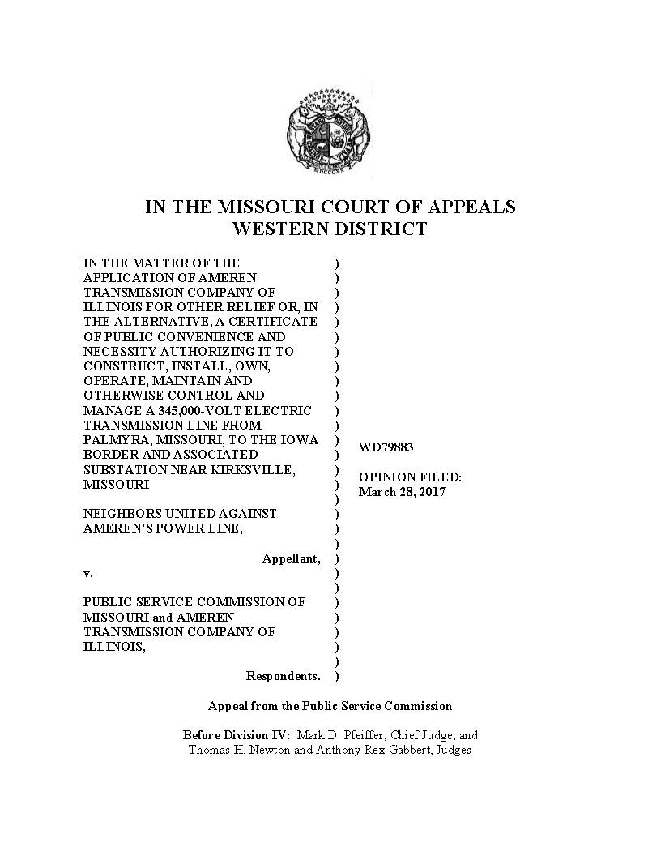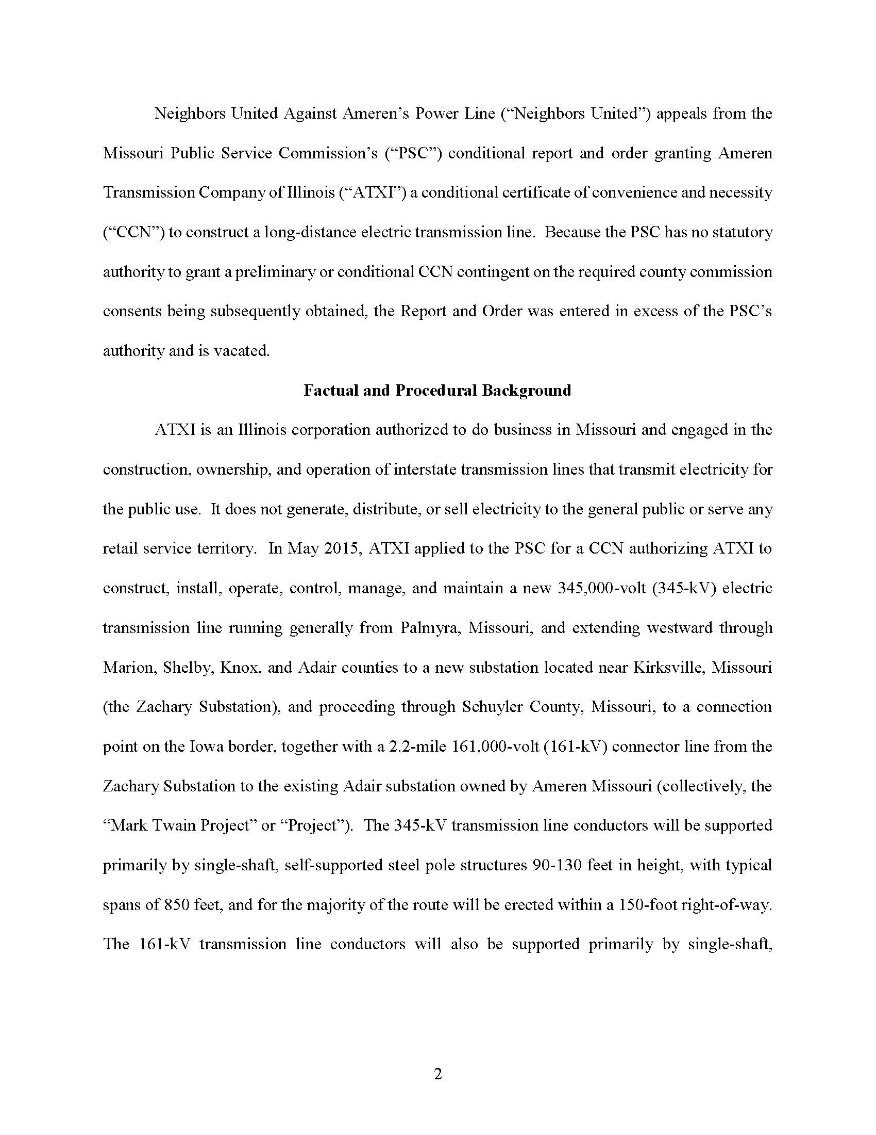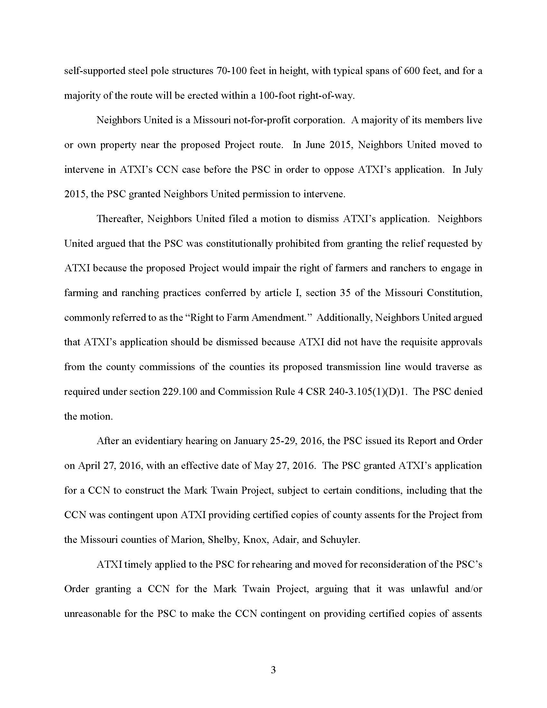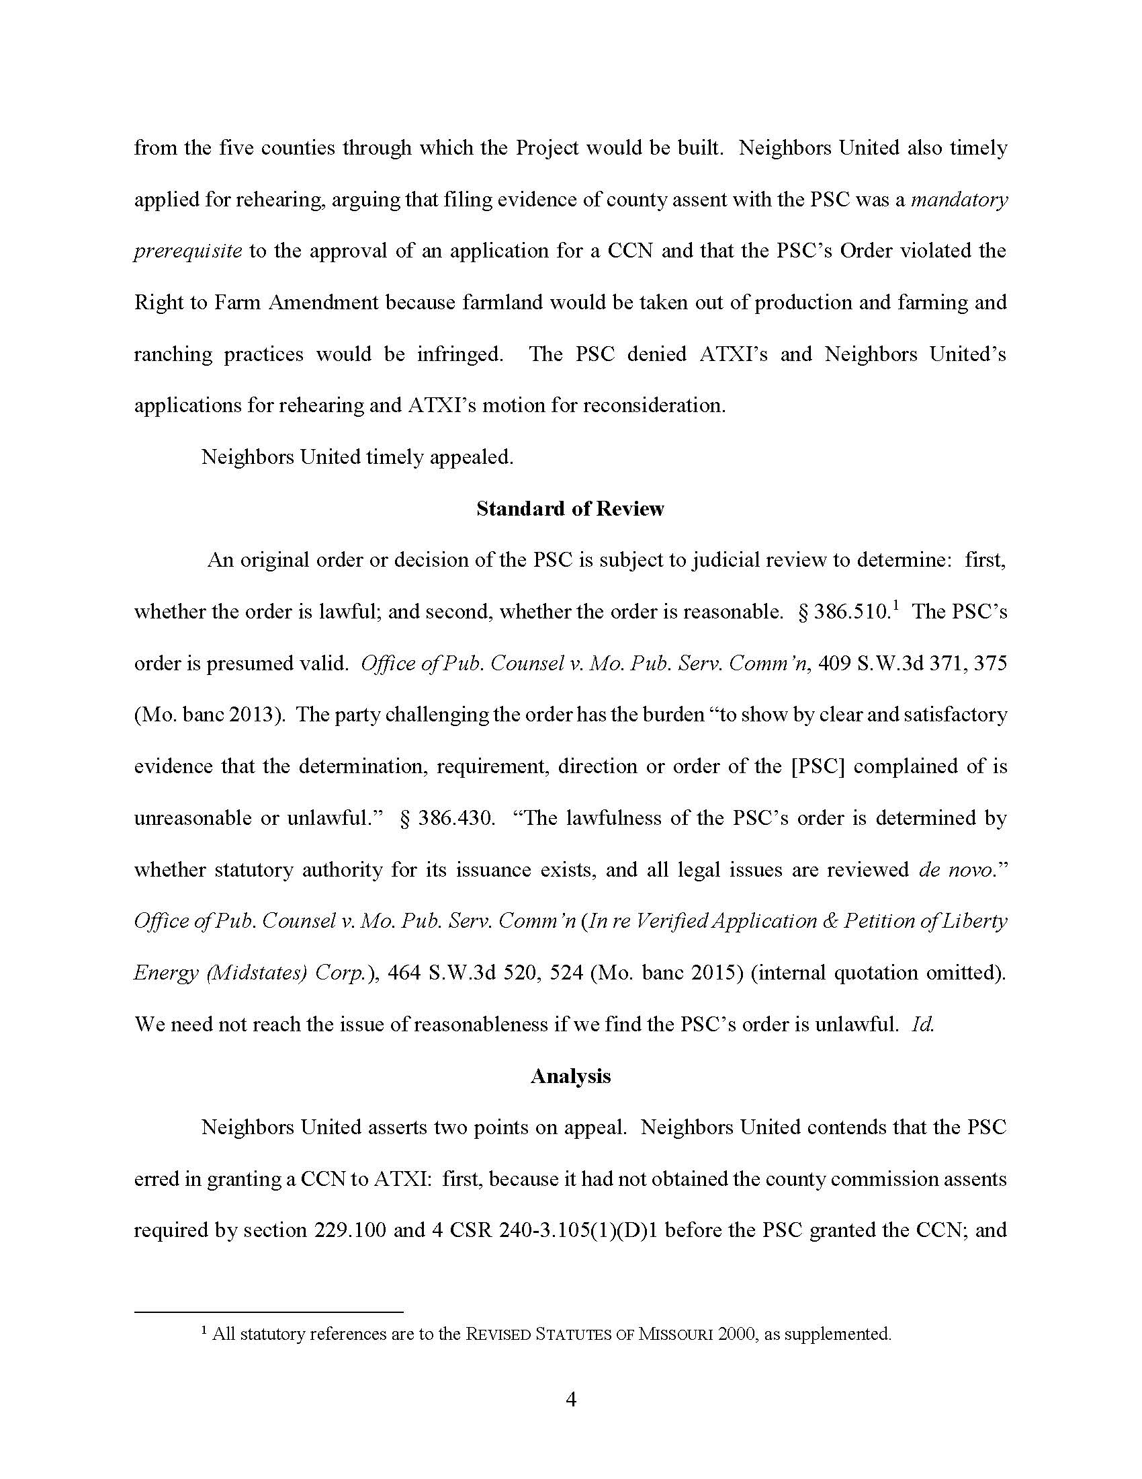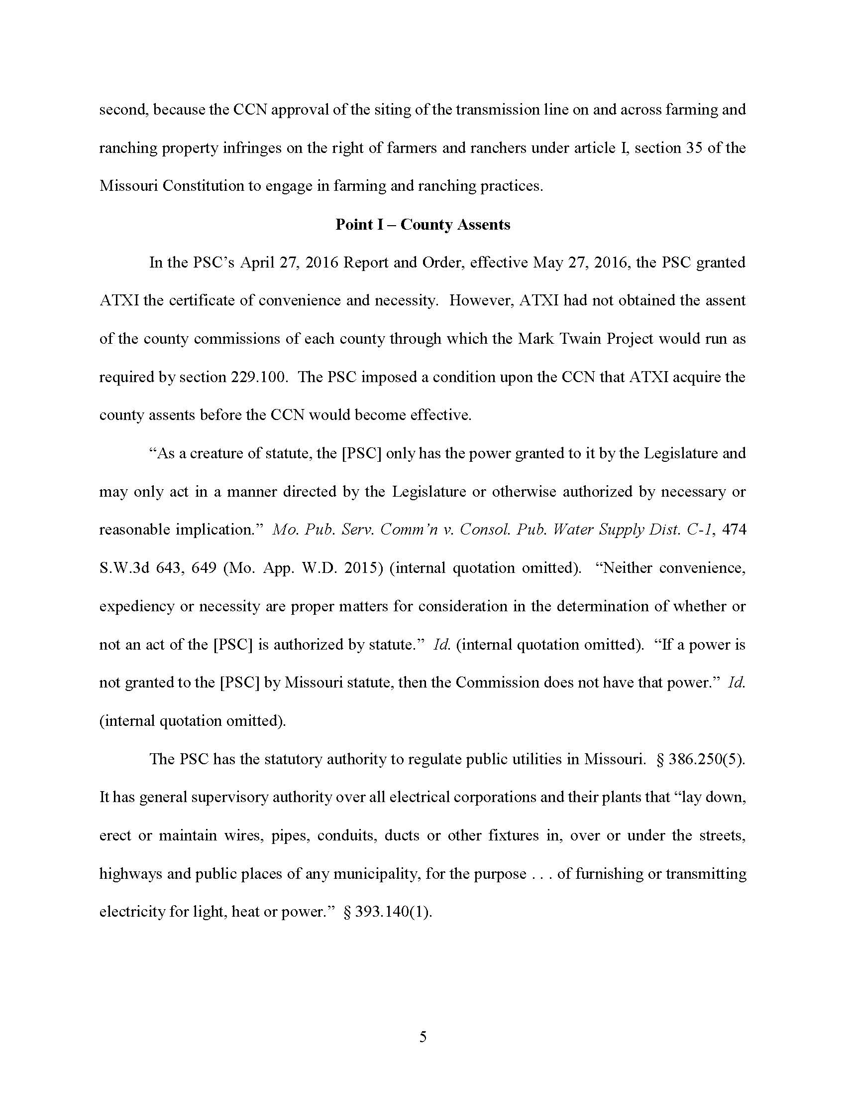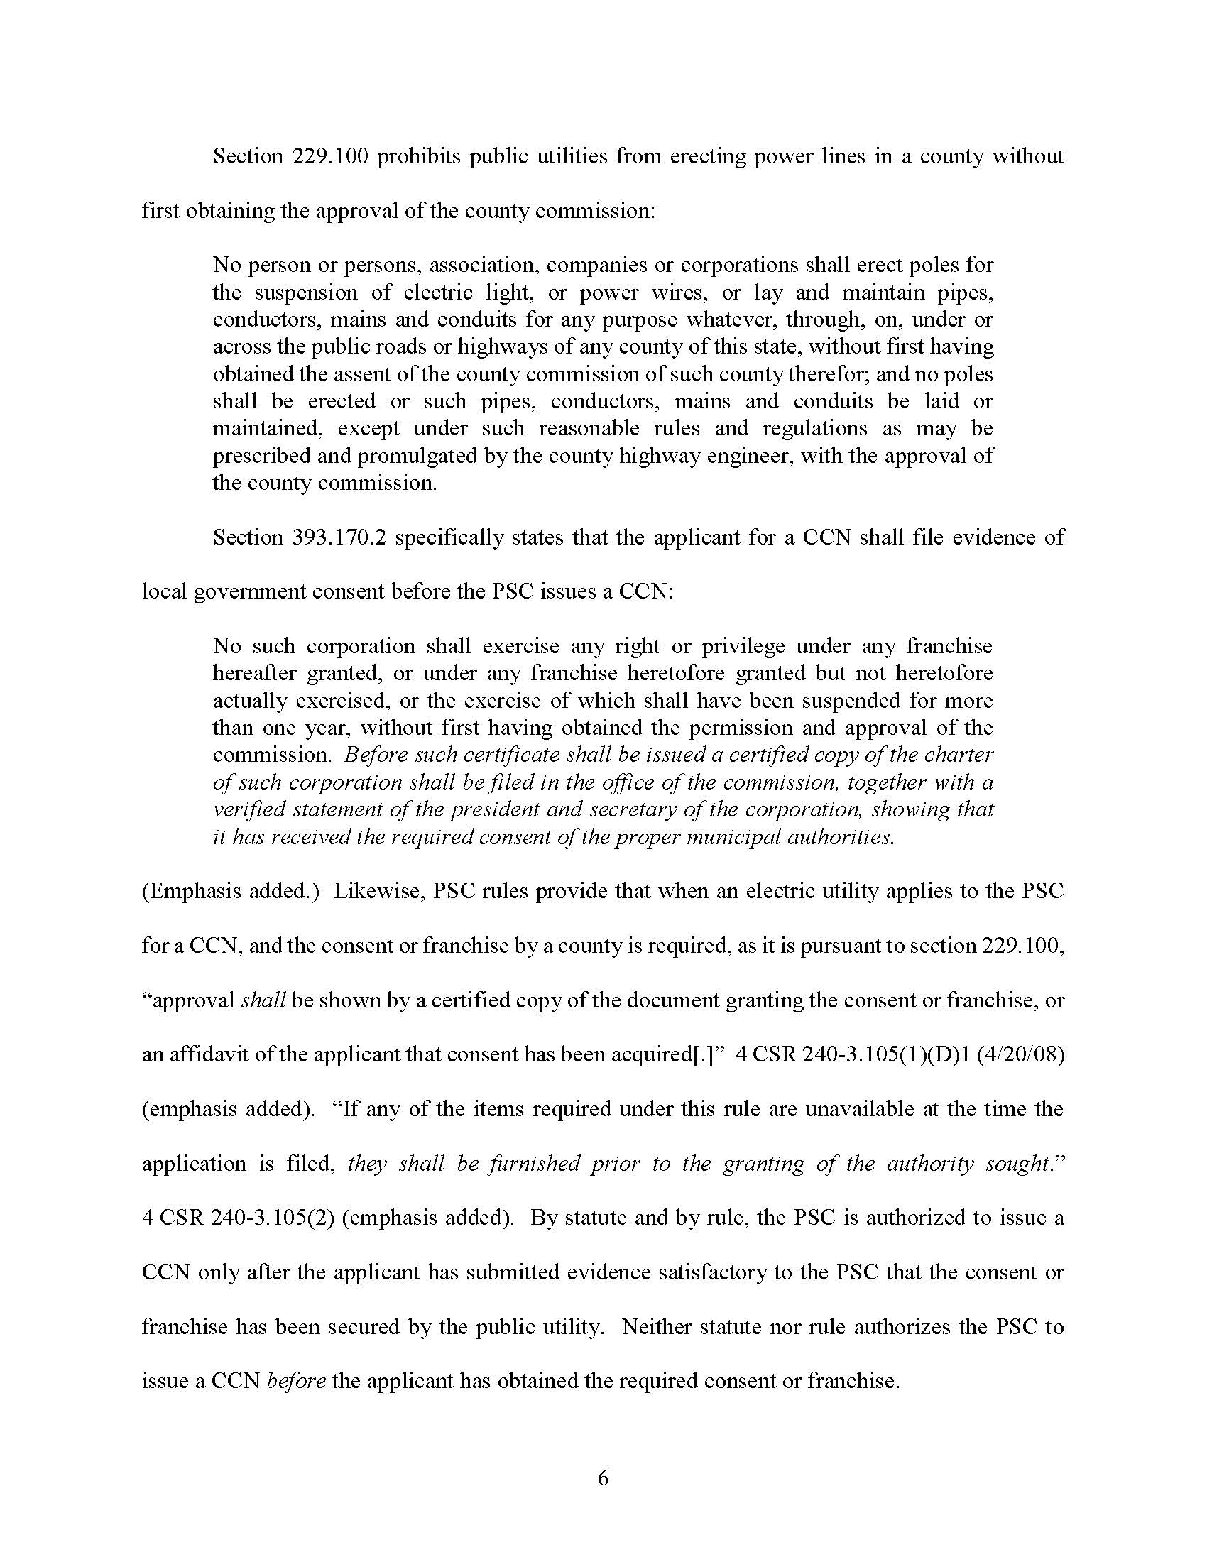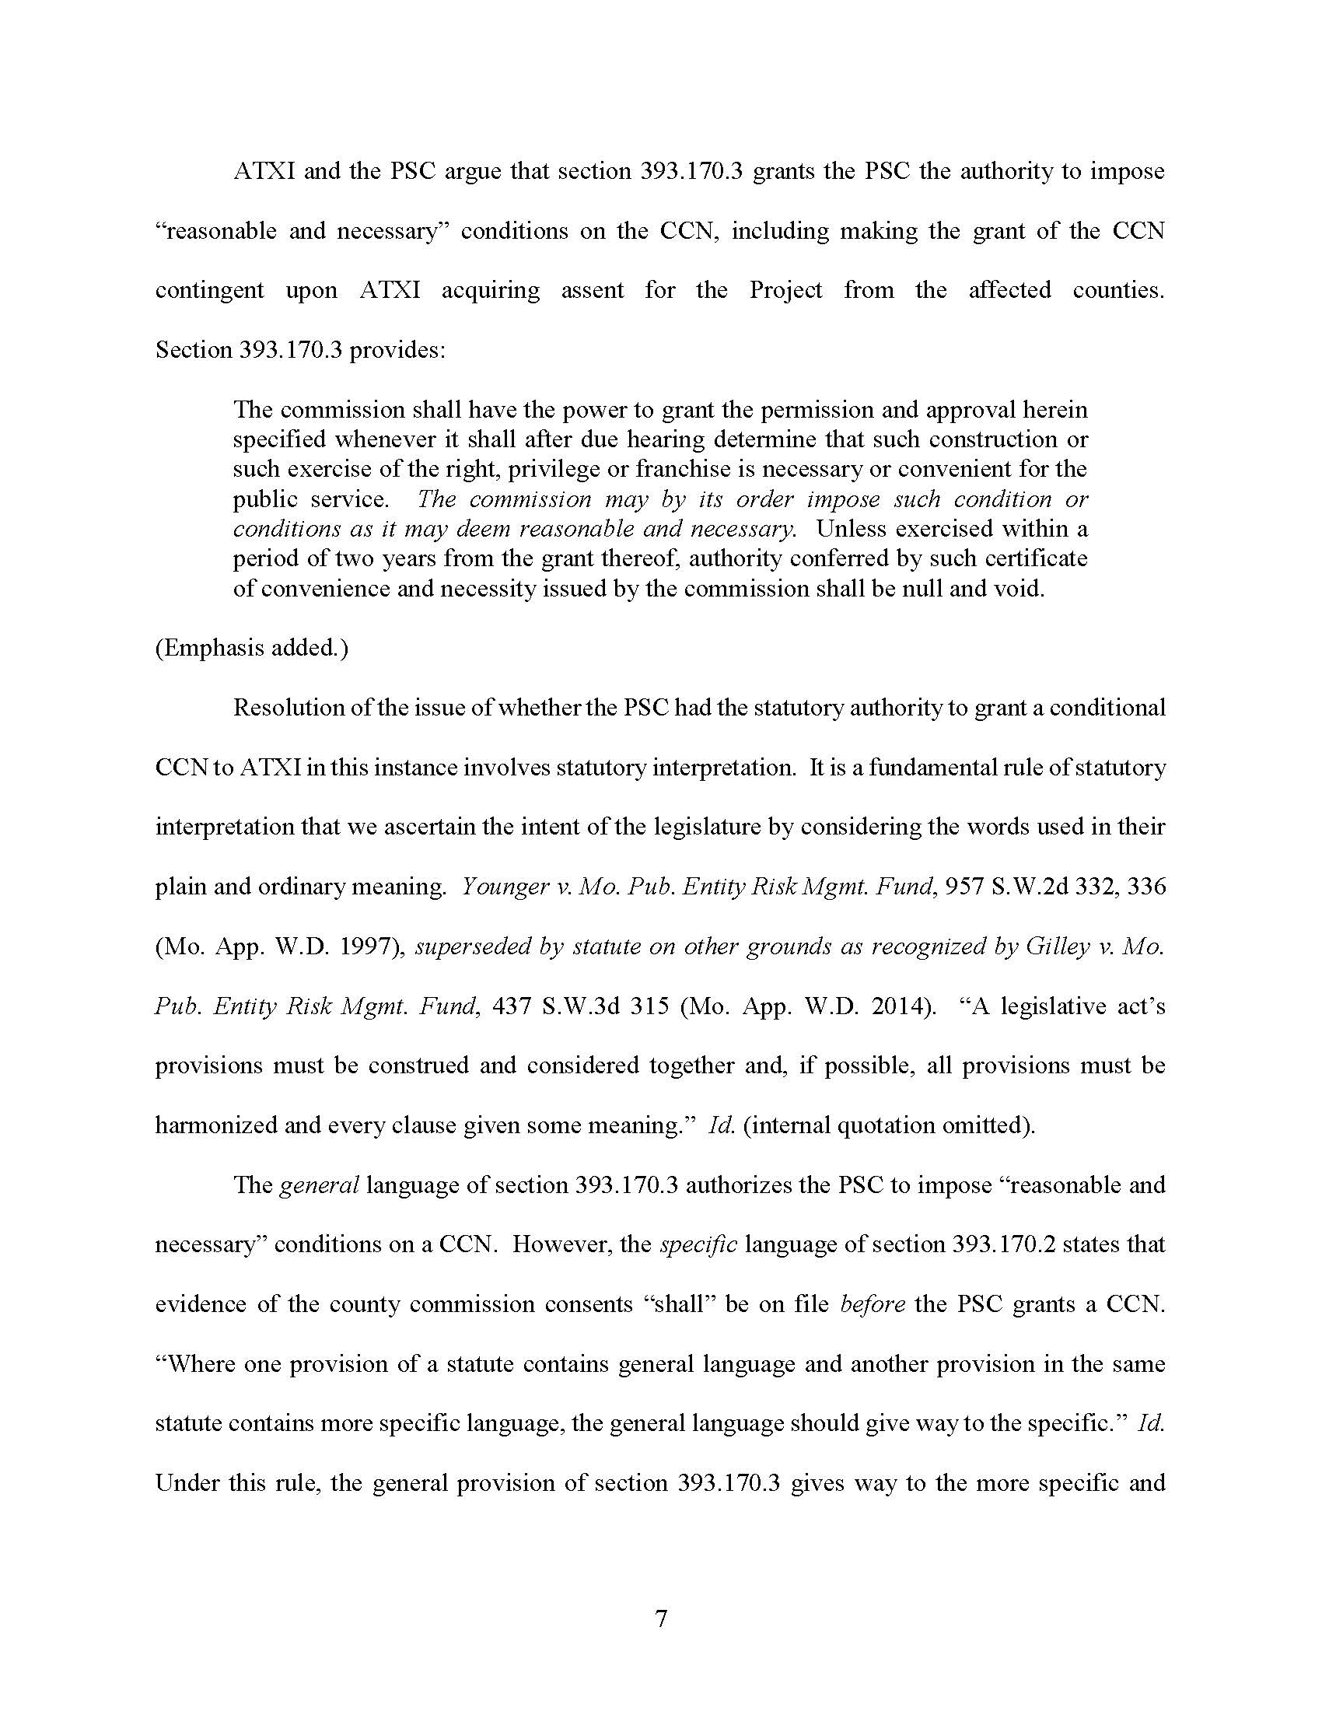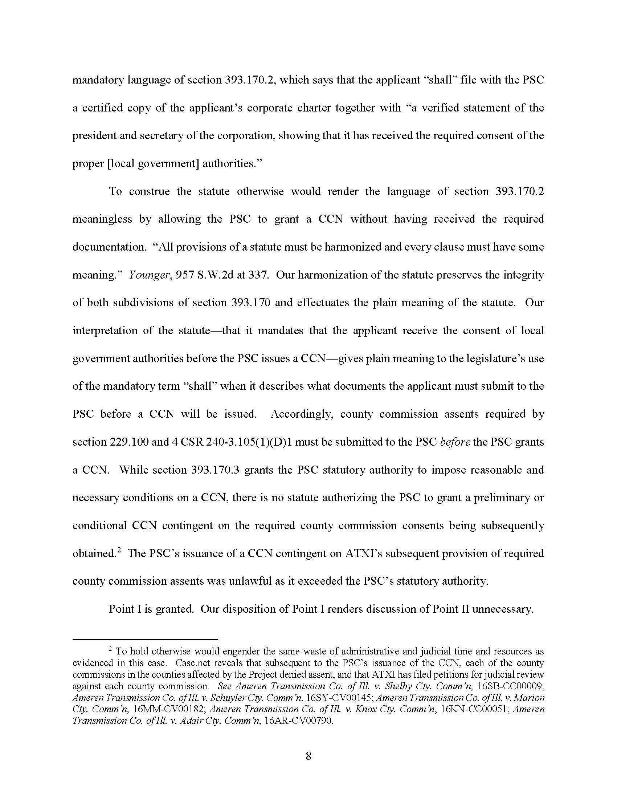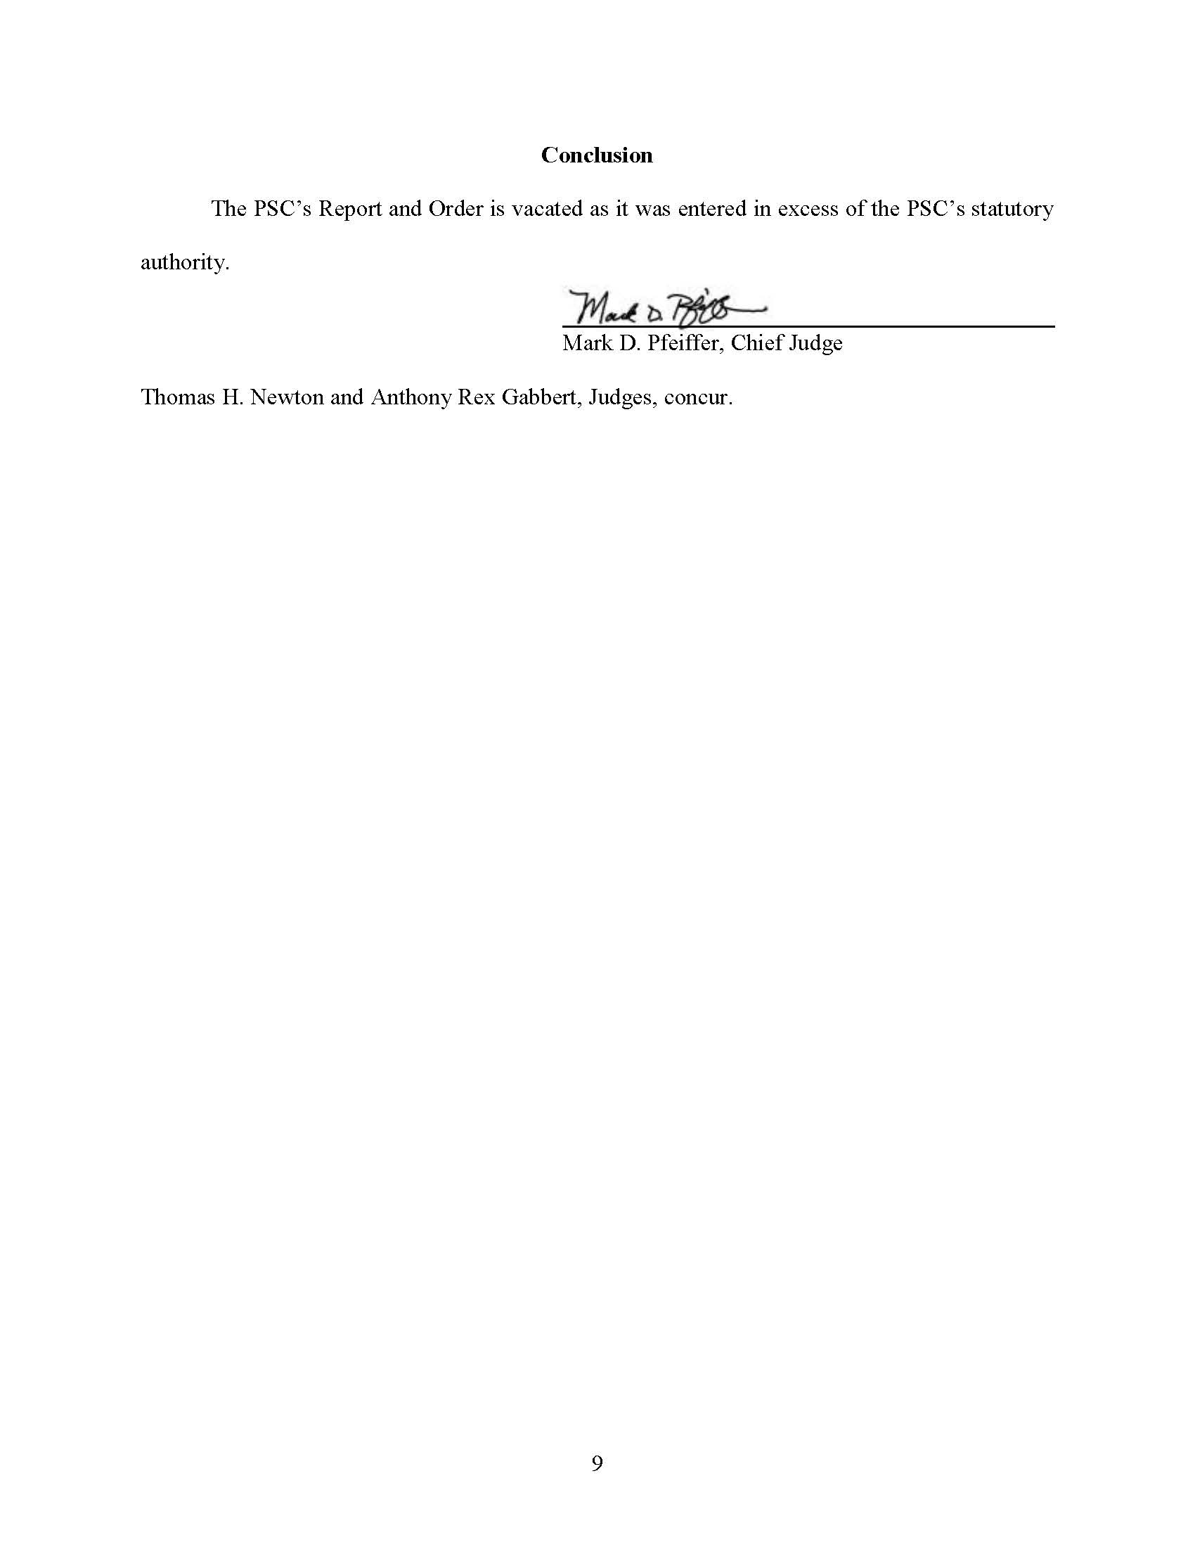

Exhibit 320. Although the transcripts of the evidentiary hearings were not yet available when this Motion was filed, Mr. Michael Skelly also conceded during cross-examination that Grain Belt does not have the needed consent from the Caldwell County Commission.
Exhibit 320, p. 4.
See Order at EFIS No. 2, p. 2.

