Exhibit No.:
Issues: Miscellaneous Charges;
Miscellaneous Tariff
Issues

Witness: William L. McDuffey
Sponsoring Party: MO PSC Staff
Type of Exhibit: Rebuttal Testimony
Case No.: ER-2004-0034
& HR-2004-024
Date Testimony Prepared: January 26, 2004

MISSOURI PUBLIC SERVICE COMMISSION

Utility Operations DIVISION

REBUTTAL TESTIMONY

OF

William L. McDuffey

Aquila, Inc. d/b/a Aquila Networks L&P
and Aquila Networks MPS

CASE NOS. ER-2004-0034 & HR-2004-0024
(CONSOLIDATED)

Jefferson City, Missouri
January 2004
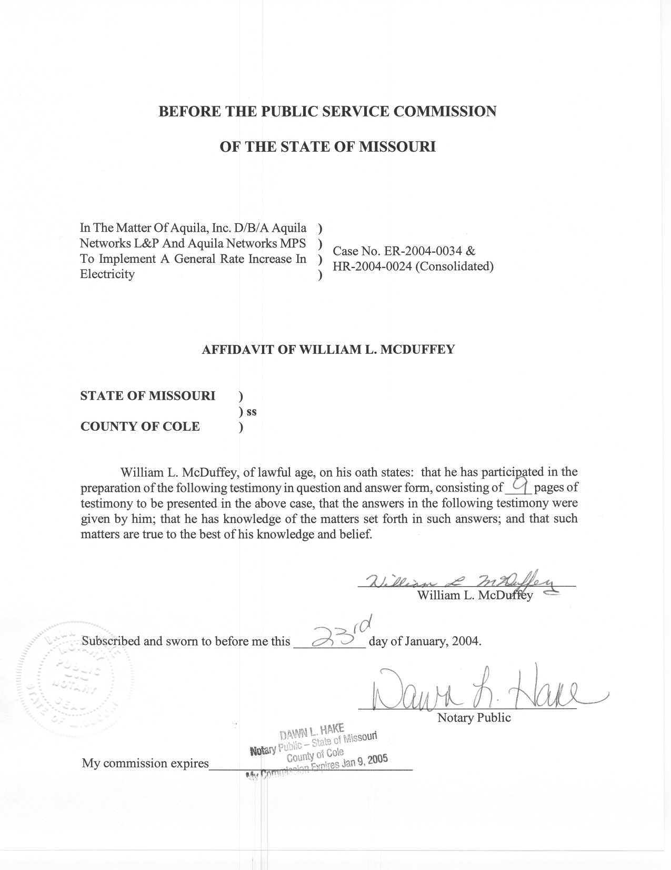
TABLE OF CONTENTS

Miscellaneous Charges 1
Reconnection Charge 2
Connection Charge 2
Collection Charge 3
Returned Check Charge 3
Special Meter Reading Charge 3
Temporary Meter Set Charge 4
Excess Service Line Length 5
Revenue Requirement Impact 5
Miscellaneous Tariff Issues 5
Moving Structures 6
Level Payment Plan 6
Extension of Electric Facilities 7
Electric Power and Curtailment Plan 7
Promotional Practices 8
Energy Audit Program 8
Service Extenders 8
Revenue Requirement Impact 9

REBUTTAL TESTIMONY
OF
WILLIAM L. MCDUFFEY
AQUILA, INC.
D/B/A AQUILA NETWORKS-MPS
AND AQUILA NETWORKS-L&P
CASE NOS. ER-2004-0034 AND HR-2004-0024
(CONSOLIDATED)
Q. Please state your name and business address.
A. William “Mack” L. McDuffey, 200 Madison Street, Jefferson City, Missouri 65101.
Q. By whom are you employed and in what capacity?
A. I am employed by the Missouri Public Service Commission (Commission) as a Rate & Tariff Examiner in the Energy Department of the Utility Operations Division.
Q. Are you the same William L. McDuffey who previously filed Direct Testimony in this case?
A. Yes.
Q. What is the purpose of your Rebuttal Testimony in this case?
A. The purpose of my Rebuttal Testimony is to address the Company’s proposed changes to the miscellaneous charges and miscellaneous tariff issues applicable to the electric operations of Aquila, Inc. (“Aquila”) d/b/a Aquila Networks-L&P (“L&P”) and Aquila Networks-MPS (“MPS”).

Miscellaneous Charges
- Which miscellaneous charges will you address?
A. I will address the following changes, referencing the proposed tariff sheet:
1. Reconnection Charge – Tariff Sheet No. R-20 and R-66
2. Connection Charge – Tariff Sheet No. R-20 and R-66
3. Collection Charge – Tariff Sheet No. R-20 and R-66
4. Returned Check Charge – Tariff Sheet No. R-21 and R-66
5. Special Meter Reading Charge – Tariff Sheet No. R-38 and R-66
6. Temporary Meter Set Charge – Tariff Sheet No. R-51 and R-67
7. Excess Service Line Length – Tariff Sheet No. R-53 and R-67

Reconnection Charge

Q. Please address the Reconnection Charges proposed by the Company.
A. Company proposes to retain the present reconnection charges of $30 during normal business hours and $50 outside of normal business hours for the L&P division and increase these charges to the same level for the MPS division. MPS’s present charges for reconnection are $17 during normal business hours and $31 for reconnections made outside normal business hours. This equalizes the charges for the L&P and MPS divisions. These charges are in line with other utilities within the state and reflect the Company’s costs to provide these services. The Staff supports the Company’s proposal.

Connection Charge

Q. Please describe the Company's Connection Charge proposal.

A. This is a new charge for both the L&P and MPS divisions. A connection charge of $50 would apply to a customer that requests that initial service be established outside of normal business hours. Initial service connections made during normal business hours would continue to be made at no charge to the customer. This charge reflects the Company’s cost of performing this optional service. The Staff supports the Company’s proposal.

Collection Charge

Q. Please describe the Company's proposal relating to the Collection Charge.

A. This is a new charge for both the L&P and MPS divisions. A collection charge would apply when the Company makes a trip to the delinquent customer’s meter for the purpose of disconnecting their service, but does not disconnect the service because the customer makes a payment to the Company’s service technician. The Company has proposed a collection charge of $30, which is the same as the reconnection charge during normal business hours, which is the time period in which this occurrence would take place. The Staff supports the Company’s proposal.

Returned Check Charge

Q. Please describe the Company's proposal relating to the Returned Check Charge.

A. The Company currently charges $10 for L&P and $15 for MPS for returned checks. The Company is proposing to increase these charges to $20. This level reflects the Company’s cost of handling returned checks. The Staff supports the Company’s proposal.

Special Meter Reading Charge

Q. Please describe the Company's proposal relating to the excess cost of a meter reading by special appointment.
A. The Company is proposing a special meter reading charge of $30 during normal business hours and $50 outside of normal business hours for this service. The Company’s proposal would increase the MPS division’s charges from $12 to $30 for this service during normal business hours and from $16 to $50 for the performance of this service outside of normal business hours. This would be a new charge for L&P.
Q. What is the Staff's position relating to these tariff proposals?
A. Staff recommends no change from the current tariffs for special meter reading charges because the Company provided no support for these charges in its response to Staff Data Request Number 190.

Temporary Meter Set Charge

Q. Please describe the Company’s proposed Temporary Meter Set Charge.

A. The Company is proposing a charge of $100 for both MPS and L&P division customers. The Company’s MPS division currently has a temporary meter set charge of $100. L&P customers are presently charged the actual cost of installing and removing the temporary meter set.

Q. What is the Staff's position relating to this tariff proposal?

A. The Staff opposes the Company’s proposed charge for L&P division customers at this time. The Staff recommends that before any change is considered for the L&P division, the Company initiate a job cost study to determine the variability of the actual costs incurred by the Company to provide a temporary construction meter installation. If little variation is discovered in the actual costs, I recommend that the charge correspond to the average cost actually incurred by the Company for this service; otherwise, no change should be made for the L&P division. This method of determining the charge assures that the Company will recover its cost of performing the temporary construction meter installation and removal from the customer requesting the service.

Excess Service Line Length

Q. Please describe the Company's proposal for Excess Service Line Length.

A. The Company proposes to charge both MPS and L&P division customers $2.52 per foot for the excess length of a service line. This rate is identical to the rate currently in effect for the Company’s MPS division. L&P customers are charged the actual cost if not justified by the revenues generated by the customer.

Q. What is the Staff's position to this tariff proposal?

A. The Staff supports this proposal. This rate reflects the Company’s current cost to extend the service line beyond the distance allowed in the tariff and does not vary from installation to installation on a per-foot basis.

Revenue Requirement Impact

Q. Are the effects of implementing these recommendations included within the Staff’s revenue requirement recommendation?

A. No. The Staff intends to account for these changes to the miscellaneous charges in the rate implementation phase of this case, i.e., any authorized overall increase in the Company’s revenues will be implemented as a combination of changes to the miscellaneous charges and changes to rates.

Miscellaneous Tariff Issues

Q. Which miscellaneous tariff issues will you address?

A. I will address the following changes, referencing the proposed tariff sheet:
- Moving Structures – Tariff Sheet No. R-30 (4.09)
- Level Payment Plan – Tariff Sheet No. R-40 (6.05)
- Extension of Electric Facilities – Tariff Sheet Nos. R-46 to R-54 (7.)

- Electric Power and Curtailment Plan – Tariff Sheet Nos. R-55 to R-58 (8.)

- Promotional Practices – Tariff Sheet Nos. R-59 to R-62 (9.)
- Energy Audit Program – Tariff Sheet Nos. R-63 and R-64 (10.)
- Service Extenders – removed

Moving Structures

Q. Please describe the Company's proposal for Moving Structures.

A. The present L&P tariff allows the Company to charge for all of the associated costs incurred to ensure that no company facilities will make contact with a structure being moved through the Company’s service area. The present MPS tariff does not have such a provision; therefore, the Company proposes consistency between the two divisions by making this provision in the present L&P tariff applicable to both the MPS and L&P divisions. The Staff supports the Company’s proposal.

Level Payment Plan

Q. Please describe the Company's Level Payment Plan proposal.
- The Company’s level payment plans are similar for the MPS and L&P divisions. The Company has proposed the language of the MPS division’s rule for both divisions.

Q. What is Staff's position relating to this tariff proposal?

A. The Staff supports the Company’s proposal.

Extension of Electric Facilities

Q. Please describe the Company's Extension Of Electric Facilities proposal.
- The Company’s L&P division overhead residential customer is allowed one span plus two years expected revenue. The L&P division’s underground residential customer pays the difference between the overhead and underground construction costs less two years of expected revenue. The MPS division’s overhead residential customer is allowed 100 feet plus standard adders that are determined from a feasibility model (electric end use and project type). The Company’s proposal adopts the MPS division’s extension of electric facilities rule for two reasons: 1) The MPS division’s rule has been recently updated and 2) the MPS division’s rule identifies and utilizes detailed costs and revenues to determine investment amount.

Q. What is Staff's position relating to this tariff proposal?

A. The Staff supports the adoption of the MPS division’s extension of electric facilities rule for its L&P division customers. The MPS division’s extension of electric facilities rule uses a formula that considers five years of data in a feasibility model to determine a construction allowance provided by the Company.

Electric Power and Curtailment Plan

Q. Please describe the Company's proposal for Electric Power and Curtailment Plan.

A. The Electric Power and Curtailment plan sets forth a sequence for reducing electrical power delivery to its customers in case of emergency. The Company’s MPS and L&P divisions’ plans are similar. The Company proposes to move the plan from the rates section to the rules section of the tariff and make the present MPS plan applicable to both divisions. The Staff supports the Company’s proposal.

Promotional Practices
Q. Please describe the Company's Promotional Practices proposal.
A. The Company has proposed combining the MPS division’s promotional practices rules and the L&P division’s promotional practices rules, making it an all-inclusive rule.

Q. What is the Staff's position relating to this tariff proposal?
A. The Staff supports this tariff change, as filed by the Company.

Energy Audit Program
Q. Please describe the Company's Energy Audit Program proposal?
A. The Company proposes to make its MPS energy audit program available to its L&P customers. The L&P division’s Residential Conservation Service (RCS) Program appears in its tariff, but the program was terminated in the late 80’s due to the federal government’s repeal mandating the expiration of the program. The program was eliminated because of the political climate at that time and not due to any negative performance. The Staff supports this proposal because it will allow L&P customers the opportunity to have an energy audit performed on their homes.

Service Extenders
- Please describe the Company's proposal for removing the service extenders rule from their tariff.
A. Service Extenders are equipment that can be installed to allow a customer, who potentially would be disconnected, an additional six days of reduced capacity service in order to settle the amount due on the customer’s account. If the customer did not pay or make payment arrangements, disconnection of service would occur. The Company no longer installs Service Extenders, nor do any of the other regulated electric utilities in Missouri; therefore, the tariff language should be removed. The Staff supports the Company’s proposal.

Revenue Requirement Impact

Q. Are the effects of implementing these recommendations included within the Staff’s revenue requirement recommendation?
A. No. Implementing these changes with have little or no impact on the Company’s revenue requirement.
Q. Does this conclude your Direct Testimony?
A. Yes, it does.

