Exhibit No.:
Issues: | Billing Complaint
Witness: | Arthur P. Kuss
Sponsoring Party: | MOPSC Staff
Type of Exhibit: | Rebuttal Testimony
Case No.: | XC-2003-0011
Date Testimony Prepared: | May 27, 2003

MISSOURI PUBLIC SERVICE COMMISSION

UTILITY OPERATIONS DIVISION

REBUTTAL TESTIMONY

OF

ARTHUR P. KUSS

Tri-Lakes Net, Inc., Complainant
v.
MCI WorldCom Communications, Inc., Respondent

CASE NO. XC-2003-0011

Jefferson City, Missouri
May 27, 2003

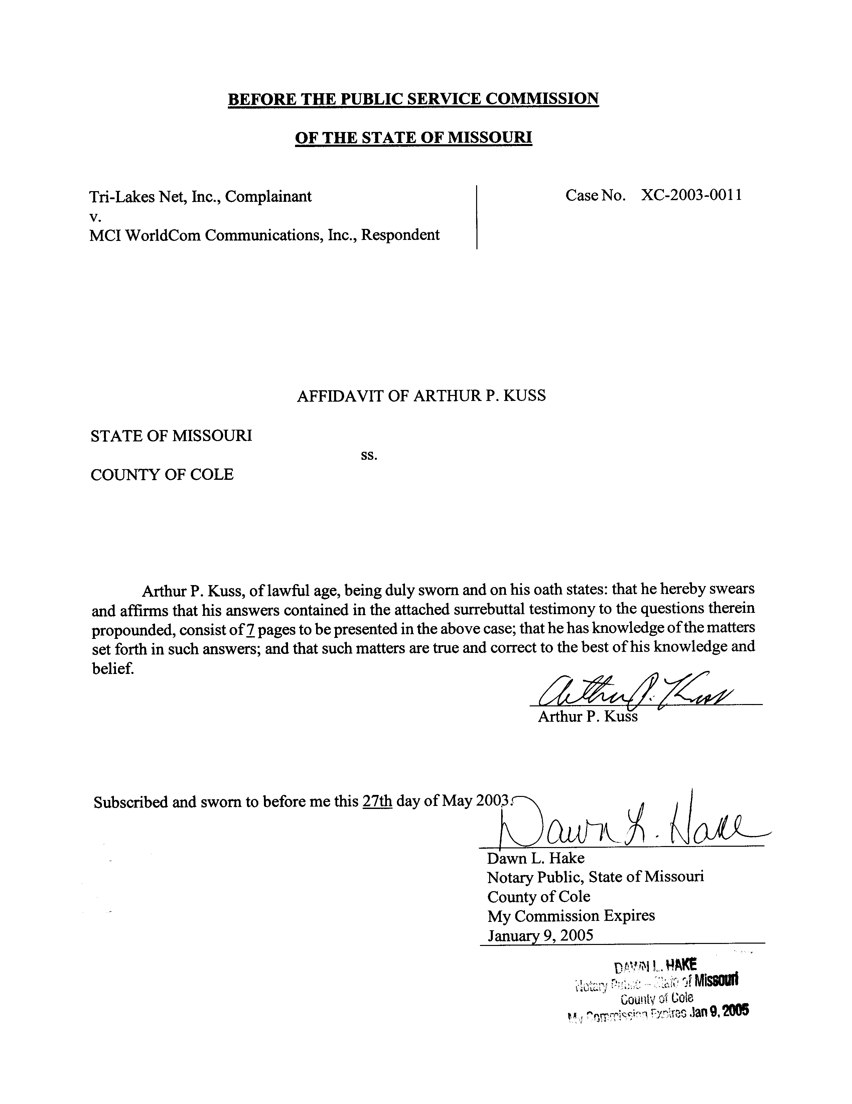

REBUTTAL TESTIMONY
OF
ARTHUR P. KUSS
IN
CASE NO. XC-2003-0011
Tri-Lakes Net, Inc., Complainant,
v.
MCI WorldCom Communications, Inc., Respondent
May 27, 2003

Qualifications.
Q. Please state your name and give your business address.
A. My name is Arthur P. Kuss, Governor Office Building, 200 Madison Street, Suite 500, P.O. Box 360, Jefferson City, Missouri 65102-0360. I am employed by the Missouri Public Service Commission (Commission).
Q. How long have you been employed by this Commission?
A. I have been employed by the Commission as a Utility Engineering Specialist since February 1998. My educational background is in electrical engineering. I hold a Bachelors Degree in Electrical Engineering, and a Masters Degree in Engineering Management.
Q. What are your duties at the Commission?
A. My duties include the review and analysis of various telecommunications industry proposals, interconnection agreements, tariff filings, and certificate applications, as well as making recommendations to the Commission.
Q. Have you previously filed testimony?
A. I have filed written testimony and testified before the Commission in Case No. TO-99-254, regarding the Primary Toll Carrier Plan; in Case No. TO-99-615, regarding a Carrier of Last Resort obligation; in Case No. TC-2000-325, regarding cutoff of certain toll-free traffic; and in Case No. TO-2000-667, regarding resale of certain services by competitive companies.

Rebuttal Testimony.
Q. What is the purpose of your rebuttal testimony?
A. My purpose is to respond to the Direct Testimonies of James R. Arend and Joanie Ellis, representing Tri-Lakes Net, Inc. (Tri-Lakes).
Q. What is the issue of contention in this Case?
A. Tri-Lakes contracted to lease facilities and purchase certain services provided by MCI WorldCom Communications, Inc. (MCI). MCI has attempted to assess charges and has billed amounts different from Tri-Lakes’ understanding of the contracted rates. In addition, Tri-Lakes has supplied a listing of operational quality deficiencies and complaints of service failures and service interruption.
Q. Does the Commission have jurisdiction in this Case?
A. I am uncertain. The dispute involves services that are subject to interstate Federal Communication Commission (FCC) jurisdiction. The jurisdictional situation is analogous to that concerning the ongoing controversy regarding Digital Subscriber Line (DSL), and the role of state regulation. Further, the application of these facilities and services involves Internet access, which is viewed by some as not subject to state regulation. The Missouri Commission may have jurisdiction in that all of the facilities involved are located within the state, and are technologically applicable to usages other than Internet.
Q. What services and facilities are at issue?
A. There are 13 Permanent Virtual Circuits (PVC) services under contract listed in the complaint. It is not entirely clear as to how many Frame Relay Service (FRS) physical circuits are at issue. There are apparently thirty-five (35) FRS circuits contracted. There is one other FRS circuit identified by Tri-Lakes as being non-existent, but that has been billed by MCI.
Q. How would you characterize the nature of this Case?
A. This appears to be exclusively a contract dispute. Neither party is advancing an argument relevant to regulation or the role of the Commission.
Q. What resources are available to evaluate the claims by the parties?
A. First, Tri-Lakes described certain of the values in billing discrepancies with its initial complaint. Listings of specific facilities of interest were supplied by Tri-Lakes as part of its initial and amended complaints. Tri-Lakes personnel have mentioned quotations from MCI’s sales representative as being the basis for its contracted rates and therefore its expected charges. Second, in response to MoPSC’s Data Request 2502 (DR), I received documents classified as Highly Confidential (HC) under MoPSC Protective Order from MCI, describing the contracts and billing for the facilities and services provided to Tri-Lakes. These MCI documents included a copy of e-mail correspondence from MCI’s Mark A. Carver, which described a series of processes for MCI’s arrival at its various billing rates. MCI’s billing records to Tri-Lakes were provided for periods over as long as the past 3 years. MCI also supplied a detailed analysis of monthly bills for each FRS circuit, compiled over a period of a year.
Q. What rate elements are involved?
A. FRS circuits are applied according to transmission speed or bandwidth, and are composed of ports and access facilities. The total Monthly Recurring Charges (MRC) for each FRS circuit and PVC have a base rate, plus other elements which are subject to modification by mileage, promotional discount, usage volume, minimum billing and contract term commitments.
Q. What has been your procedure for evaluating the dispute?
A. I attempted to compare the rates established in relevant tariffs with the billed amounts, the original quoted amounts, and the claimed corrected amounts with the actual contracted values between the Parties.
Q. Have you established a correlation among the various figures?
A. No. I have not been able to discern a direct match between the figures supplied in the MCI documents with the figures Tri-Lakes maintains to be correct.
Q. Are the rates in question listed in MCI’s tariff?
No. Except for FRS ports, which are listed in MCI’s state tariff, I have been unable to locate tariffed rates. Due to the lack of detailed pricing breakdown in MCI’s bills, it was not possible to verify whether MCI was charging those tariffed rates for the various ports. However, Revised Statutes of Missouri (RSMo) Section 392.200.8 permits the application of customer-specific rates for private line and dedicated access services.
Q. Has either party exhibited a source for the original rates?
No. Neither party identified specific contracted rates to any component or service. No clarification has been provided by any party as to any contract’s direct correspondence to any of the specific listed elements or their rates. MCI has submitted that its base rates are listed in certain of its internal pricing guides and former Federal Communication Commission (FCC) tariffs. Explanation by MCI as to how the final figures have been established to be advanced in its argument is complex. MCI has maintained in its response to the DR that the rates shown in the contracts as originally established are subject to extensive modification due to additions, expiration or ineligibility for promotional or special rates, and rate changes. From MCI’s analyses of its billing practices, it is evident that it is difficult for MCI’s own personnel to interpret its contracts, or to be assured that proffered bills can be accurate. If MCI could provide satisfactory guidance to Tri-Lakes as to how it ultimately arrived at its billed figures, as it has attempted in the afore-mentioned e-mail from Mr. Carver, it would appear that the dispute could be resolved by direct consultation between the parties.
Q. Has MCI established a history of reliable billing?
A. No. I am dismayed to note that, according to its own DR data, MCI has compiled a lengthy history of incorrect billing. In fact, MCI’s submitted analyses acknowledge repetitive errors in virtually every bill ever issued to Tri-Lakes. As noted in Ms. Ellis’s Direct Testimony, there also exists a repeated history of quality of service and billing disputes and revenue adjustments between the parties.
Q. Has Tri-Lakes provided supporting documentation in its direct testimony?
A. No. Tri-Lakes has not cited a source for its prices, provided an interpretation of the current contracts, or described how it arrived at its expected rate values.
Q. Please summarize your rebuttal testimony.
A. Tri-Lakes believed it purchased certain services based upon contracts concluded through an MCI sales representative. MCI has attempted to charge for services based upon criteria that it declares altered the original contracts. Despite MCI’s evident shortcomings, Tri-Lakes has not provided support to refute the billings of MCI. Lacking suitable information, I am unable to create an opinion concerning the other complaints addressing quality of service and interruptions. As there is no dispute otherwise concerning regulation or violation of Missouri Statutes, Rules, or MCI’s Missouri tariff, I must recommend dismissal of the complaint.
Q. Does this conclude your rebuttal testimony?
A. Yes, it does.

Direct Testimony of Joanie Ellis, Page 3, Lines 3 through 7.
MCI MO PSC Tariff No. 4, Page No. 237.

