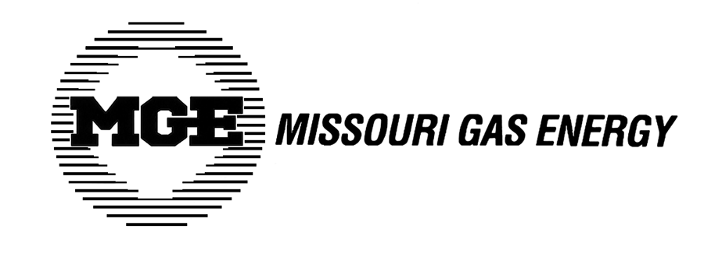

NEWS RELEASE

MGE seeks to adjust delivery rates and reduce Cost of Gas charge

KANSAS CITY, MO (April 2, 2009) – Missouri Gas Energy (MGE), a division of Southern Union Company (NYSE: SUG), today filed two rate proposals with the Missouri Public Service Commission (MPSC).
- MGE proposes to increase delivery rates applicable to all customer classes by approximately $32.4 million, or 4.7%. The proposed increase, if approved by the MPSC, would amount to approximately a $5.21 increase per month for typical residential customers.

- MGE also proposes to reduce its Cost of Gas charge (COG) from the current $0.77358 per hundred cubic feet (ccf) to $0.54190 per ccf. The proposed reduction, if approved by the MPSC, would amount to approximately a $6.22 decrease per month for the typical residential customer during the non-winter months of April-October.

The proposal to increase delivery rates is driven by increased environmental costs, employee-related cost increases primarily related to recently approved collective bargaining agreements, continued increases in uncollectibles expense, and cost increases associated with operating and maintaining MGE’s 8,000-mile distribution system.

The proposal to increase delivery rates is not related to MGE’s request to reduce the Cost of Gas charge, which makes up approximately 70% of a typical residential customer’s overall bill. The Cost of Gas charge is comprised of the wholesale price of natural gas plus interstate transportation and storage costs and includes no markup or profit. MGE does not derive any profit from the Cost of Gas charge, only on the rates charged for delivering natural gas to customers. If approved by the MPSC, this will be the third Cost of Gas charge reduction for MGE customers since November 2008.

The MPSC is expected to rule on the Cost of Gas reduction request within 30 days. A ruling on MGE’s proposal to increase delivery rates may take up to 11 months and therefore those rates are not expected to go into effect until March 2010.
###
Missouri Gas Energy is a natural gas distribution company headquartered in Kansas City, Missouri with facilities in St. Joseph, Lee’s Summit, Warrensburg, Joplin, Republic, Neosho and Monett. MGE serves over half-million customers in 155 western Missouri communities and is a division of Southern Union Company (SUG). Its business is regulated by the Missouri Public Service Commission.
About Southern Union Company
Southern Union Company, headquartered in Houston, is one of the nation’s leading diversified natural gas companies, engaged primarily in the transportation, storage, gathering, processing and distribution of natural gas. The company owns and operates one of the nation’s largest natural gas pipeline systems with approximately 20,000 miles of gathering and transportation pipelines and North America’s largest liquefied natural gas import terminal, along with serving more than half a million natural gas end-user customers in Missouri and Massachusetts. For further information, visit www.sug.com.

Media Contact: Pam Levetzow (816)360-5753

