November 3, 2011

Utility Services Division
Missouri Public Service Commission
200 Madison Street
Jefferson City, Missouri 65101

RE: Southern Missouri Gas Company, L.P. d/b/a Southern Missouri Natural Gas
School Aggregation Program – ACA Follow Up Report, September 2011

On July 8, 2011, Southern Missouri Natural Gas (“SMNG”) filed its response to the recommendation by the Staff of the Missouri Public Service Commission (“Staff”) in Case No. GR-2010-0218, the 2010-2011 Actual Cost Adjustment. In its response, the Company stated it would provide an update on the resolution of the capacity release for the Schools.

The Company is discussing solutions with both staff and Seminole to resolve the total amount due based on capacity release amounts designated in the updated contract between SMNG and Seminole.

Please contact me with any questions or concerns.

Respectfully Submitted
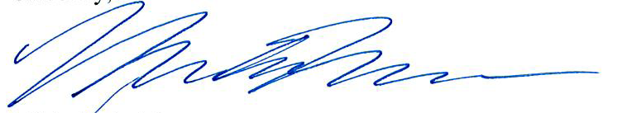

Michelle A. Moorman
Manager of Regulatory Affairs
Missouri Gas Utility, Inc.
for Southern Missouri Gas Company, L.P.
d/b/a/ Southern Missouri Natural Gas

Telephone: 720-981-2127
Email: mmoorman@summitutilitiesinc.com

Cc: Dave Moody, Southern Missouri Natural Gas
Timothy Johnston, Summit Utilities, Inc.

